Virtual Memory Systems with Cache Memory :

A typical computer system will contain a cache, a virtual memory, and a TLB. When a virtual address is received from the processor, a number of different scenarios can occur, each dependent on the availability of the requested item in the cache, the main memory, or the secondary storage. The following figure shows a general flow diagram for the different scenarios.

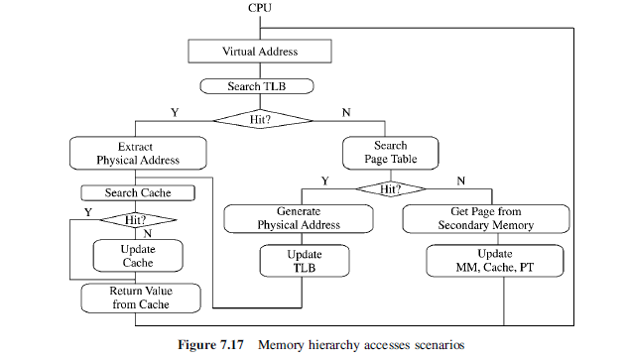

Paging

- permits the physical address space of a process to be noncontiguous
- whole process in main memory, but does not have to be contiguous
- split physical memory into fixed-sized blocks called frames
- split logical memory into blocks of same size called pages
- last page of process may not occupy an entire frame (i.e., some internal fragmentation)
- frame and page size are an efficiency issue; page size is between 512 bytes and 16 MB depending on the computer architecture
- paging increases context switch time, but overhead of page table decreases as page size increases

Segmentation :

• A segment is a block of contiguous locations of varying size.

• Segments are used by the operating system (OS) to relocate complete programs in the main and the disk memory.

• Segments can be shared between programs.

• They provide means for protection from unauthorized access and/or execution. It is not possible to enter segments from other segments unless the access has been specifically allowed.

• Data segments and code segments are separated. It should also not be possible to alter information in the code segment while fetching an instruction nor should it be possible to execute data in a data segment.

Segment Address Translation:

In order to support segmentation, the address issued by the processor should consist of :a segment number and a displacement within the segment.
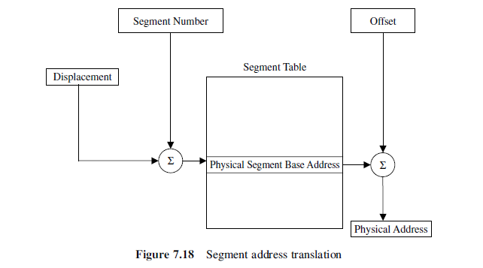
Address translation is performed directly via a segment table.

* The starting address of the targeted segment is obtained by:
adding the segment number to the contents of the displacement .

* Adding the physical segment base address to the offset yields the required physical address

Paged Segmentation:

• Both segmentation and paging are combined in most systems.

• Each segment is divided into a number of equal sized pages.

•The basic unit of transfer of data between the main memory and the disk is
the page, that is, at any given time, the main memory may consist of pages from various segments.

In this case, the virtual address is divided into a segment number, a page number, and displacement within the page.

