Input/output system(IO)

IO Interface for an Input Device
The address decoder, the data and status registers, and the control circuitry required to coordinate IO transfers constitute the device’s interface circuit

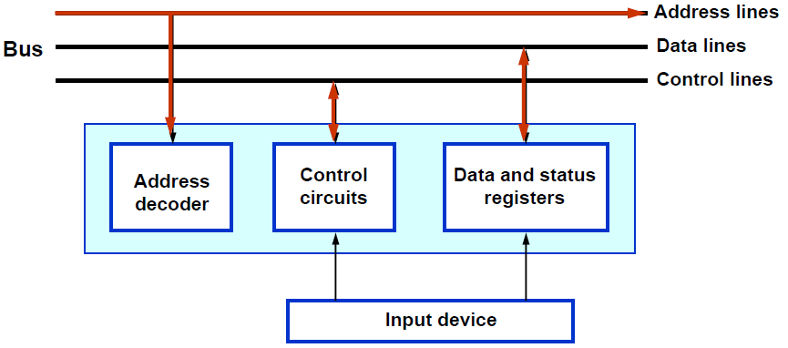
address decoder : is used for IO device identification.

status registers: It is used to determine the status for each IO device, whether it is ready to transfer data to the processor

There are two methods in which the processor can address the input/output devices:

1-Shared IO:

• IO devices are assigned particular addresses, isolated from the address space assigned to the memory.
• An input and output instructions are used to input and output data.
• The address and data lines from the CPU can be shared between the memory and the IO devices.
• A separate control line will have to be used. This is because of the need for executing input and output instructions.

•The main advantage of the shared IO arrangement is the separation between the memory address space and that of the IO devices. Its main disadvantage is the need to have special input and output instructions in the processor instruction set.

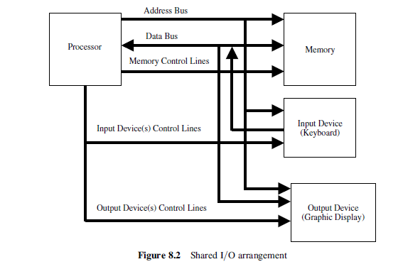
-memory-mapped IO:

• It deal with input and output registers as if they are regular memory locations
•It uses Read and Write (memory instruction).
• The main advantage of the memory-mapped IO is the use of the read and write instructions of the processor to perform the input and output operations, respectively. It eliminates the need for introducing special IO instructions.

• The main disadvantage of the memory-mapped IO is the need to reserve a certain part of the memory address space for addressing IO devices, that is, a reduction in the available memory address space.
