Data transfer to and from IO devices may be handled in one of the following techniques:

1-PROGRAMMED IO :

• The processor repeatedly checks a status flag to achieve the required
synchronization between the processor and an input or output device.

• CPU stays in the program loop until IO indicates it is ready for data transfer

• It is time consuming process since it keeps processor busy needlessly.

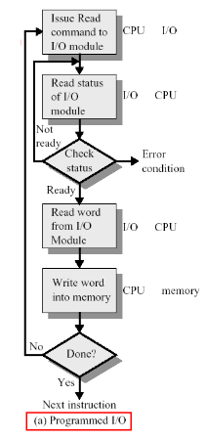
2- Interrupt:

• When an IO device is ready to send (receive) data to (from) the CPU, it interrupts the CPU for its attention.
• No need to poll device status.
• As soon as the CPU finishes the current instruction, it transfers its execution to an interrupt-service routine(ISR) which responds to the external interrupt.

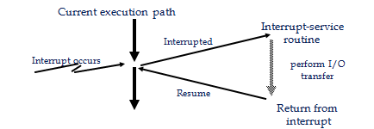
• Before executing the ISR, any information that may be altered during the execution of that routine must be saved. This information must be restored before the interrupted program is resumed.

There are two ways of choosing the branch address:
1- vector interrupt where the source that interrupt the CPU provides the branch address.

2- non vector interrupt where the branch address is assigned to a fixed address in the memory.

Priority interrupt:

System that assigned priority over the different IO devices when two or more devices are requested services at the same time. Devices with high transfer speed are given higher priority and slow devices given lower priority. There are two types of interrupt priority:

1-Polling: Used to identify the highest priority device with software means.
2-Daisy chain: Used to identify the highest priority device by hardware means. the device with the highest priority is placed first
