2-Fully Associative Mapping: According to this technique, an incoming main memory block can be placed in any available cache block. Therefore, the address issued by the processor need only have two fields. These are the Tag and Word fields. The first uniquely identifies the block while residing in the cache. The second field identifies the element within the block that is requested by the processor.
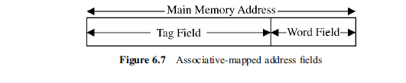
1. Word field = log₂ B, where B is the size of the block in words
2. Tag field = log₂ M, where M is the size of the main memory in blocks
3. The number of bits in the main memory address = log₂ (B x M)

the tags are stored in an associative memory (content addressable). This allows the entire contents of the tag memory to be searched in parallel (associatively), hence the name, associative mapping.

The main advantage of the associative-mapping technique is the efficient use of the cache. This stems from the fact that there exists no restriction on where to place incoming main memory blocks. Any unoccupied cache block can potentially be used to receive those incoming main memory blocks.
The main disadvantage of the technique, is the hardware overhead required to perform the associative search conducted in order to find a match between the tag field and the tag memory as discussed above.

Example 3: Compute the above three parameters for a memory system having the following specification: size of the main memory is 4K blocks, size of the cache is 128 blocks, and the block size is 16 words. Assume that the system uses associative mapping:

Word field = log₂ B = log₂ 16 = log₂ 2⁴ = 4 bits

Tag field = log₂ M = log₂ 2⁷ x 2¹⁰ = 12 bits

The number of bits in the main memory address = log₂ (B x M) =
log₂ (2⁴ x 2¹²) = 16 bits.

