CPU BASICS

A typical CPU has three major components:
1- register set,
2- arithmetic logic unit (ALU),
3- control unit (CU).
The figure below shows the internal structure of the CPU .
The CPU fetches instructions from memory, reads and writes data from and to memory, and transfers data from and to input/output devices.

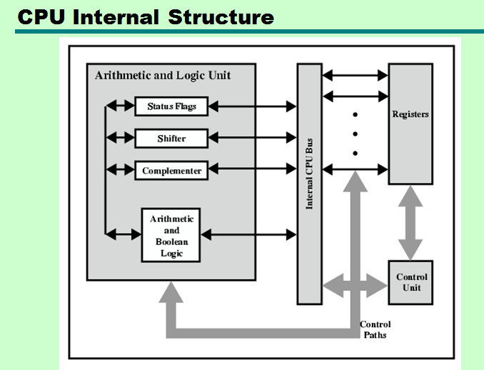
Instruction execution cycle:
1- fetch: fetching next instruction( using PC) from memory into IR.
2-decode:decoding the instruction.
3- execute: executing the instruction.

REGISTER SET:

• The register set differs from one computer architecture to another. It is usually a combination of general-purpose and special purpose registers

• General-purpose registers can be used for multiple purposes and assigned to a variety of functions by the programmer.

• Special-purpose registers are restricted to only specific functions.

Memory Access Registers:

Two registers are essential in memory write and read operations: the memory data register (MDR) and memory address register (MAR). The MDR and MAR are used exclusively by the CPU and are not directly accessible to programmers.

In order to perform a write operation into a specified memory location, the MDR and MAR are used as follows:
1. The word to be stored into the memory location is first loaded by the CPU into MDR.
2. The address of the location into which the word is to be stored is loaded by the CPU into a MAR.
3. A write signal is issued by the CPU.

Similarly, to perform a memory read operation, the MDR and MAR are used as follows:
1. The address of the location from which the word is to be read is loaded into the MAR.
2. A read signal is issued by the CPU.
3. The required word will be loaded by the memory into the MDR ready for use by the CPU.

Instruction Fetching Registers:
Two main registers are involved in fetching an instruction for execution: the program counter (PC) and the instruction register (IR). The PC is the register that contains the address of the next instruction to be fetched. The fetched instruction is loaded in the IR .
Condition Register: Program status word (PSW) register contains bits that are set by the CPU to indicate the current status of an executing program. These indicators are typically for arithmetic operations, interrupts,…etc.

Special-Purpose Address Registers:
• In index addressing, the index register holds an address displacement which when added to a constant, the address of the operand is obtained.

• A segment register holds the address of the base of the segment.

• A specific register, called the stack pointer (SP), is used to indicate the stack location that can be addressed. In the stack push operation, the SP is incremented and in pop operation the SP is decremented.

