Multiple –Bus Organization:

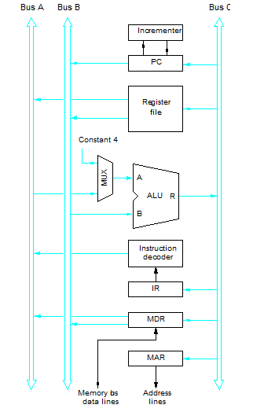
Example: Write the control steps to fetch and execute the following instruction in multiple- bus CPU:
ADD R4, R5, R6

1 PC_{out}, R=B, MAR_{in}, Read, Inc PC
2 WMFC
3 MDR_{out B}, R=B , IR_{in}

4 R4_{out A}, R5_{out B}, Select A, Add, R6_{in,} End.

EX: Write the control steps to fetch and execute the following instruction in multiple- bus CPU: Add (R4), R5,R6

1 PC_{out}, R=B, MAR_{in}, Read, Inc PC
2 WMFC
3 MDR_{out B}, R=B , IR_{in}

4 R4_{out B} , R=B, MAR_{in} , Read
5 WMFC
6 MDR_{out B} , R5_{out A}, Select A, Add, R6_{in,} End.

