***Chapter Two***

***Theoretical Aspects***

**2.1 Introduction**

The light and the quality of the most important factors affecting the vision of human, when the light can be seen and without nothing can be seen, where there is a different between the quantity and the quality of lighting, so you must take into account the quality of light rather than for quantity. So the result will not be weak in the space lighting even though the quantity is correct [37].

Images are the optical sensation for the detector which receives signal, or it can be define as an optical representation for rays that reach the sensor from objects (they might be reflected or emitted or both). Vision occurs by the reflection of light rays from objects to human eye, which itself form an image for this object on the Retina, then the formation of this image is transmitted to the brain. Human eye doesn′t have the ability to see in the dark. Cameras also capture images of objects through the reflection of the light rays from these objects as they pass on the sensor or the film which in the end forms the image of these objects. The Camera forms images by light that is the electromagnetic waves which represent the photonic energy. When the particles (photons) reach to the photonic sensor, they change the sensation form, or it changes them of an electrical signal that fits exactly the light intensity reach the sensor and according to the wavelength in this light [38].

**2.2 Light Resources**

Light is emitted from a body due to incandescence, electric discharge, electro luminescence, and photoluminescence. Images cannot exist without light. To produce an image, the scene must be illuminated with one or more light sources. This section will focus on the interaction of light with surface and some artificial light sources. Moreover, we have been determined the general factors that effect on the light quality assessment. There are two types of light resources [39].

**2.2.1 The Natural Lightness Resources**

The natural light resources (such as, the sun and the candle flame) could be identified as a light resource that has high qualification with spectral colors completion, when the natural light gives a clear reflection and shows color that vary in their brightness. In general, sun is the main source of energy and lightness in particular [40]. Figure (2-1) shows light intensity distribution for different light source.



Figure (2-1) Light intensity distribution for number of light source [41].

**2.2.2 Manufactured Light Resources**

The artificial light is a light that produced from or by the elements manufacturing, which is produced by the effect of lighting resulting from the power supply or other techniques, and can control the sources of artificial light to represent the sources dot-matrix, linear, superficial, and volumetric.

There are many different types of lamps for everyday lighting and for color imaging lighting. Many of the major categories for everyday lighting are incandescent, tungsten halogen, florescent, mercury, metal halide, sodium, and Light Emission Diode (LEDs). For color imaging (photography), the major category is the electronic flash lamp.

The light output of a lamp decreases during its life. Also, the spectral power distribution of tungsten light depends on the voltage at which it is operated. Therefore, for critical color calibration or measurement, we cannot always assume that the spectral power distribution of a lamp will remain the same after hours of use or at various operating temperatures; Tungsten-halogen lamps are incandescent light sources, which use a white-hot tungsten filament as the light source. Achieve full intensity within 0.5 seconds after power on, can be restarted without delay after being turned off [42].

While, the basic principle of operating behind light emitting diodes LEDs is that it stimulates the conduct by negative carriers (n-type) and some by (p-type). When charged carriers are recombined from different types, the released energy may emit light [43]. LED specifications are trade name ALZAHAWI 1708-D107, Ac 70-265v, power 1 W, color white, flux 75lm, and temperature 76 c0[44]. While LED lamps emit visible light in a very narrow spectral band, they can produce "white light". Features of LED are no UV or IR radiation, high brightness, high energy efficiency – low power consumption, 120 0 beaming angle, and life span 50000 hours see Figure (2-2).

|  |  |
| --- | --- |
|  |  |

Figure (2-2) Illustrate Tungsten halogen and LED lamp [44].

**2.3 Image Quality**

The basic factor determining image clarity is image quality that of the radiographic image may be defined as the ability of the film to record each point in the object as a point on the film. Image quality is influenced by resolution [45].

Resolution or resolving power is the ability to record separate images of small objects that are placed very closely together. An imaging system may have the ability to record sharp edges but be unable to resolve fine details. Sharpness and resolving power are different [46].

The clarity (resolution) of the digital image can be expressed in several different ways [47]:

1. Spectral Resolution
2. Radiometric Resolution
3. Spatial Resolution
4. Temporal Resolution.

Depending on how much prior information is available and on how a perfect candidate image should look like, objective image quality algorithms can be classified as following:

**2.3.1 Full Reference image quality**

Full reference image quality assessment mostly interprets image quality as accuracy or similarity with a “reference” or “perfect” image in some perceptual space. The image quality assessment algorithms attempt to achieve consistency in quality prediction by modeling salient physiological and psycho visual features of the HVS, or by signal fidelity measures [48].

**2.3.2 Reduced Reference image quality**

Reduced-reference measures occur between full-reference and no-reference measures .The Reduced-reference image quality measures prepare to predict the visual quality of distorted images with partial information about the reference images. Reduced-reference approaches are clearly introduced in video

Applications [49]

* + 1. **No reference image quality**

No reference image quality refers to the problem of predicting the visual quality of image without any reference to an original optimal quality image. This assessment is the most difficult problem in the field of image objective analysis [50], since many unquantifiable factors play a role in human perceptions of quality, such as aesthetics, cognitive relevance, learning, context etc. [51]. No reference image quality is useful to many still image applications as assessment equality of high resolution image, JPGE image compressed [52] moreover, this objective method can measure image equality depending on verity of lightness and contrast.

* 1. **Image quality measurements (IQM):**

Measuring the quality of image is a complicated and hard process since humans opinion is affected by physical and psychological parameters. Many techniques are proposed for measuring the quality of the image but none of it is considered to be perfect for measuring the quality. Image quality assessment plays an important role in the field of image processing [53]. Image quality metrics are divided in to two kinds subjective and objective, human visual system (HVS) is an example of subjective IQM. Most IQM are related to the difference between two images (the original and distorted image) and this type is called reference IQM, other IQM are not related to the difference between the two images like reduce reference IQM and no reference IQM. There are four no-reference scales used:

1. **The Entropy (AED) Image**

The entropy is defined as follows [54]:

𝐻 (𝜒) = Σ P(𝑥𝑘) log2 [P(x)] (2.1)

Where 𝜒 is a discrete random variable with possible outcomes *x*1*, x*2*,... x n*; (𝑥𝑘)is the probability of the outcome 𝑥𝑘 . The outcome is understood as a gray level in the lightness image, and its probability is calculated by:

P (𝑥𝑘) = 𝑛𝑘/ i (2.2)

Where 𝑘 = 1 , 2 , . . . 𝑛, is the total number of possible lightness in the image, I is the total number of pixels, and *n* k is the number of pixels that have lightness level 𝑥𝑘. The higher entropy value denotes a better contrast in the image.

1. **Average Gradient**

Average gradient shows the fine contrast, texture characteristic, and clarity of an image. The higher value of average gradient indicates that the image has more intensity levels and is clearer [55], the average gradient, ̅ can be defined as follows:

$∇2 G=\frac{1}{\left(M-1\right)\left(N-1\right)\sqrt{∇}} f2\left(i,j\right)+ ∇2f\left(i,j\right)/2$ (2.3)

Where ( i) and (j ) are the gradients on the row and column direction, respectively. *M* and *N* are the numbers of the row and column of the enhanced image, respectively.

1. **Measure of Enhancement (EMEE)**

Measure of enhancement (EMEE) is a no-reference or blind-image quality metric. EMEE measures the image enhancement or image contrast measure which is principally evaluated by dividing the image into *k*1 *k2* blocks. If an image *X(n,m)* is split into *k*1 *k*2blocks of size *I1 I*2, EMEE of the image for a given class {*Φ*} of orthogonal transforms, is given by Equation (2.4).

EMEE =1/k1 k2⅀⅀20 log 𝑰max k, l / (𝑰min k, l+ C ) (2.4)

where I min k, l and Imax k, l(*Φ*) and (*Φ*) are the minimum and maximum intensity levels of the image *x(n,m)* inside the block after processing the block by *Φ* transform based enhancement algorithm. *C* is a small constant which is equal to 0.0001 to avoid dividing by (0). This measure of enhancement is used to find the average ratio of maximum to minimum intensities in decibels. Intuitively it makes sense, since it takes the average ratio of maximum to minimum points in each block over the entire image. A high value of EME is desired as it demonstrates the better image quality and higher edge detection capabilities [56].

* 1. **Physics of Color**

Color is an important feature of many applications and processes, including our everyday life. Color can be defined in several ways. When we look at an object, we can usually straightaway tell which hue it has, i.e. what color “class” it belongs to, whether it is red, green, yellow, blue and so on. We can also distinguish between the color’s brightness, i.e. if the color is light or dark, with these different features in mind. Color is complex because it depends on more than wavelength contrast alone. The terms hue, saturation, brightness were used to define color. Hue defines the wavelength contrast aspect of color, such as Yellow or Blue and Green or Red. Saturation defines the mixing of Hue and White, Gray or Black. A saturated color has strong Hue with little or no White, i. e. blood red. An unsaturated color has its hue washed away by White, i.e. Pink. The chromaticity term was contained the hue and saturation of light. Another quality of color is brightness, which is less than obvious than the other two. Yellow and White tend to be bright but Blue and Black tend to be dark [58].

* 1. **Color Space**

We need a space to describe them exactly and therefore be able to differentiate between single colors. In 1931 the CIE proposed the XYZ space which contains all colors human beings can see and is based on three imaginary primary colors. The HSV, CIELAB and CIELUV or the YIQ spaces are subsets of the CIE XYZ space and therefore represent only a fraction of all possible colors. Moreover, most color spaces in this section are not visually uniform .That is, distances in the color space do not reflect perceived distances between two colors [59].

It is also known color coordinate or color model. Color space is three dimensional color system that can measure and evaluate color. Imaging systems, cameras, and display devices use the basic color space RGB, while basic color space RGB do not always give similar results to the realization of human perception of color. Therefore, many color spaces have been designed based on human perception of color. They are basically derived from the basic color space RGB [60, 61].

Color space can be classified into three general types, they are [59]:

1. Basic color space
2. Television color space
3. Perceptual color space, which can be sub classified to:
4. Perpetual non uniform color space
5. Perceptual uniform color space.

The RGB space is the most frequently used color space for image

processing. Since color cameras, scanners and displays are most often provided with direct RGB signal input or output, this color space is the basic one, which is, if necessary, transformed into other color spaces [62]. The RGB color model is made of three additive primaries Red, Green, and Blue. It is the system used in almost all color in the Cathode Ray Tube (CRT) monitors, and is device dependent (e.g. the actual color displayed depends on what monitor you have, and what its settings are). It is called additive, because the three different primaries are added together to produce the desired color. The color model is shown as a cartesian cube, with usually Red being the x- axis, Green being the y-axis, and Blue being the z-axis. Each color, which is described by its RGB components, is represented by a point and can be found either on the surface or inside the cube. All grey colors are placed on the main diagonal of this cube from black *(R=G=B=0)* to white *(R=G=B=max)*, the colors with a P are the primary colors. The dashed line indicates where to find the grays, going from *(0, 0, 0)* to *(max , max, max)*, where the *max* value equal 255 or 1, see Figure (2-3).

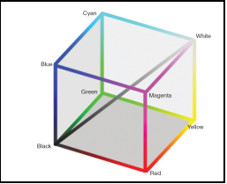

Figure (2-3) The cubic of color gamut in RGB space [63].

* 1. **Color Vision**

A human sense color due to the nature of light that reflects from a body which reflects all wavelengths in the visible range in the same degree is a white body. A body that absorbs most of the light wavelengths and reflects green wavelength its color is green. The monochromatic or a chromatic color consists of one wavelength, and its intensity represents the property of this light.

Color vision is the ability of differentiate between different colors by fumbling the wavelengths. The observation of color is human eyes starts in the cones when the retina is adapted to the little light. There are three types of cones which are sensitive to the optical spectrum color RGB see Figure (2-4). The white light recognize by the optical spectrum that called Trichromatic, this is basics of the theory of seeing the optical spectrum [64].

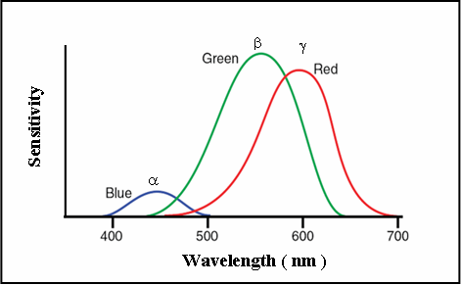

Figure (2-4) Curves of the absorption spectrum for eye cones [65].

* 1. **Measurements of color space**

Color is extremely subjective and objective. To deduce the color objectively we can use the following formula that used to calculate the contrast of the color with the background [66]:

Contrast (Ct) = Imax - Imin / Imax + Imin (2.6)

Where:

Ct: Michelson Contrast

Imax: Maximum luminance.

Imin: Minimum luminance.

For obtaining the luminance for each color we use the following formula [66]:

I = 0.229 R + 0.587 G + 0.114 B (2.7)

Where:

R, G, B represents the basic colors

Also the range between the color and the background can be measured the following formula [67]:

Range (R) = Imax - Imin (2.8)

* 1. **HSV Color Model**

The three components in HSV color model are hue (H), saturation (S) and value (V). Hue is an attribute associated with the dominant wavelength in a mixture of light waves [68]. For example, a light wave with central tendency of 565 to 590 nm will be perceived as “yellow” by human observer. In HSV color model, hue represents the dominant color as observed by the human eye and measured in degree from 0° to 360°. Saturation measures how vivid or pure a color is and the purity refers the amount of “white” color mixed with a hue [69]. A highly saturated color implies a pure color while no saturation makes the hue appear grey. The degree of saturation is inversely proportional to the amount of white light added and white color has zero saturation. Value represents brightness of a color. While hue and saturation defines chromaticity, value represents the achromatic notion of its intensity. Pure achromatic colors range

from black to white with all the possible gray colors in between. HSV color space can be represented in various ways [70]. One typical representation is using a hexagonal disk model The saturation S and hue H components specify a point inside the hexagonal disk, Saturation for a given level of V is defined as the relative length of the vector that points to the given color to the length of the vector that points to the corresponding color on the border or the hexagonal disk [71].

* 1. **Histogram equalization**

# Histogram equalization is a simple and effective image enhancing technique. But in some conditions, the luminance of an image may be changed significantly after the equalizing process, this is why it has never been utilized in a video system in the past. A novel histogram equalization technique, equal area dualistic sub-image histogram equalization, putted forward in this study. First, the image is decomposed into two equal area sub-images based on its original probability density function. Then the two sub-images are equalized respectively. Finally, we obtain the results after the processed sub-images are composed into one image. The simulation results indicate that the algorithm can not only enhance the image information effectively but also preserve the original image luminance well enough to make it possible to be used in a video system directly. There are four types of histogram equalization [72]:

1. Histogram Stretching.
2. Histogram Shrinking.
3. Histogram Sliding.
4. Histogram Equalization.

The algorithm involved in the histogram equalization method is summarized by the following steps:

1. Compute the probability density function (P(i)) of the gray level (i) where (i = 1,2,3,……255), from the following equation:

P (i) = $\frac{ni}{n}$ (2.10)

P (i): Probability of the ith gray level.

ni : The number of pixel .

n: The total number of pixels in the image.

1. Obtain the cumulative probability , using the following formula:

$Cp(i)=\sum_{k=0}^{n}{P(k)}$ (2.11

1. Use the following equation to obtain gray level transformation T (i):

T (i) = round INT [255 x p (i)] (2.12)

Where T(i): The new gray level value in the enhanced image, instead of the original value (i) [73].

**2.11 Image Enhancement Techniques**

Image enhancement involves taking an image and improving it visually, typically by taking advantage of the human visual system , s response. Enhancement methods tend to solve specific problem.

Denote a two-dimensional image of gray level intensities by I. The image I is ordinarily represented in software accessible from as MxN matric containing indexed elements I( i, j), where [ 0.i . M -1, 0. j. N – 1].The elements I( i, j) represent samples of the image intensities. Usually called pixels (picture elements). Typically, the pixel represent optical intensities, but they may be also represent by other attributes of sensed radiation, such as radar, electron micrograph, X-ray, or thermal imagery [74].

There are so many image enhancement methods available; we survey only some fractions of the available techniques.

Image enhancement techniques can mostly be divided into the following two categories:

1. Spatial domain method
2. Frequency domain method
3. Retinex enhancement method.

**2.12 Edge Detection and Analysis**

Edge detection plays a vital role in computer vision and image processing. Edge of the image is one of the most significant features which are mainly used for image analyzing process.Edge appear in the image when there is a substantial difference in intensity at different sides of image location (i. e. the most prominent part of partial intensity in changes in the images). An edge is a boundary between two regions of different constant grey level [75]. Physical edges provide important visual information since they correspond to discontinuities in the physical, photometrical, and geometrical properties of scene objects. The principal physical edges correspond signify variation in the reflectance, illumination, orientation, and depth of scene surfaces .

The most common types of image intensity variations are steps, lines, and junctions. Several factors degrade the edges that are actually found[76]:

1. Photon noise (quantum effects).
2. Blurring or defocusing.
3. Irregularities of the surface structure of the objects.

Edge detection techniques transform images to edge images benefiting from the changes of gray tones in the images. As a results of this transformation, edge image is obtained without encountering any changes in physical qualities of the main image. there for, Image intensity is often proportional to scene radiance; physical edges are represented in the image by changes in the intensity function [77]. There are three processes to detect image edges, namely filtering process, enhancement and detection, these as follow:

1. Enhancement process: in order to simplify the image edges detection, to find changes the neighbourhood of image point-values.
2. Detection process: is performed by image gradient threshold; the choice of a propertied threshold directly determines the image edge results.
3. Filtering process: the images are always corrupted by random noise. However, there is a trade – off between image edge strength and removing noise reduction. Filtering produce more noise reduction in a loss of image edge strength [77].

**2.13 Wavelet Transforms**

[A wavelet is a wave-like oscillation with amplitude that begins at zero, increases, and then decreases back to zero.](https://en.wikipedia.org/wiki/Wavelet)  Wavelet transforms is the one of the important and benefit tool of Image processing , it has been used in image processing, data in Compression, and signal processing . The wavelet transform showed as figure (2-5) for 1 level decomposition using haar transform [78], and the histogram for HL component for the original images. Wavelet transforms is the one of the important and benefit tool of Image processing , it has been used in image processing, data in Compression, and signal processing [57]. Discrete wavelet transform that is used in ( [JPEG2000](https://en.wikipedia.org/wiki/JPEG2000)). The original image is high-pass filtered, yielding the three large images, each describing local changes in brightness (details) in the original image. It is then low-pass filtered and downscaled, yielding an approximation image; this image is high-pass filtered to produce the three smaller detail images, and low-pass filtered to produce the final approximation image in the upper-left.

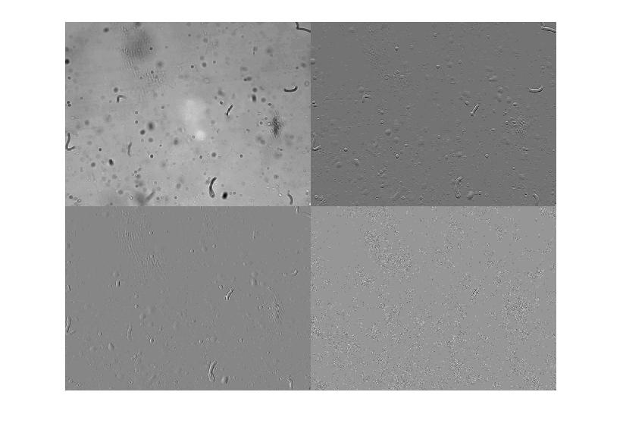

LH

LL

HH

HL

{\displaystyle \varphi (t)={\begin{cases}1\quad &0\leq t<1,\\0&{\mbox{otherwise.}}\end{cases}}}

**Figure(2-5) illustrate haar wavelate transform.**