Chapter Three
Materials and Methods
3.1 Materials
This chapter describes the solid state nuclear track detector CR-39 and expresses the methods to preparation of samples (boric acid) in addition to the apparatus and material and This chapter presents the main experimental work with the introduced algorithms by MATLAB in image processing technique.

3.1.1 Track detector CR-39
In this study solid state nuclear track detectors-SSNTD CR-39 used, manufactured by TASTRAK Pershore Moulding. Track Analysis System Ltd., UK and Kodak-Pathe - France respectively. It is a plastic detector of about 500µm thickness, density 1.36 gm /cm³, and area of about 1x1 cm² was used in the present study which is sensitive to alpha particles of energy up 40 MeV.
3.1.2 Sensitive balance
Figure (3-1) illustrates a very sensitive balance for a little weight, readability of 0.0001 g and maximum weight of 250 g manufactured in Germany type of Mettler AC100 was be used in this study for weighting sodium hydroxide (NaOH) have been used in the preparation process of etchant solution.
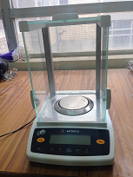
Figure (3-1) Sensitive balance.
3.1.3 Pressing
Piston used to press samples of boric acid, it is the type of Carver manufactured in the USA, weight it 0.5 g under force 2000 kg for 30s of time with diameter 1.5 cm and thickness 1 mm.
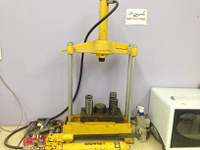
Figure (3-2) Sketch of pressing system.

3.1.4 Boric acid
Boric acid (H3BO3) is a boron compound which is soluble, colorless, water-soluble and salt-like white powder. Boric acid used as pellets to show thermal neutron tracks as ${}_{}^{10}B(n,α){}_{}^{7}{Li}$.see Figure (3-3).
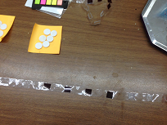
Figure (3-3) Sketch of the preparation of boric acid pellets with CR-39 detector.

3.5.1 The Americium
Americium is first produced in 1944 by the group of Glenn T. Seaborg at the University of California, it is an artificial element, and thus a standard atomic mass cannot be given. Americium has (19) radioisotopes.
3.1.5.1 Americium-241
The Americium is a radioactive chemical element with a symbol (Am) and atomic number (95), this member of the actinide series in the periodic table. It has activity 8.9 µCi and emitted alpha particle energy in the air (5.485) MeV and a half-life (432.2) year. It was founded in radioactivity lab-department of physics-college of science-Mustansiriyah University. And to obtain different energies less than from mean of alpha energy emitter, we changed the distance between irradiation source and the detector.

3.1.5.2 ²⁴¹Am-Be Neutron Source
In this study, we used the thermal neutron irradiation source the first consists of a rod of ${}_{}^{241}{Am}-{}_{}^{9}{Be}$ source surrounded by paraffin wax. The paraffin wax was used to moderating the fast neutrons to thermal neutrons energies. The source of thermal neutron was ${}_{}^{241}{Am}-{}_{}^{9}{Be}$with activity 12 Ci, neutron flux${10}^{5} n.cm^{-2}.s^{-1}$. It was found in nuclear lab- department of Physics - College of Education for Pure Sciences - Ibn Al-Haitham - Baghdad University.
3.1.6 Water Bath
The water bath was used to regulate the etchant solution temperature. It is the type of manufactured in China, it included a thermostat operating over a range of 37 °C to 100 °C and temperature regulation accuracy better than ± 0.2 °C. The chemical etching was carried out at 60 ± 1C˚. Distilled water was used as the bath liquid, see Figure (3-4).
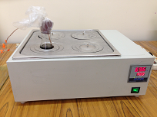
Figure (3-4) Water bath instrument.

3.1.7 Optical Microscope
Optical microscope (Pro. Way made in China). It is capable of giving magnification by an objective (4X, 10X, 40X, and 100X) and eye pieces (10X) to calculate the number of track, see Figure (3-5).
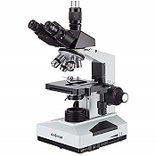
Figure (3-5) Sketch of optical microscopy.

3.1.8 Digital eyepiece for microscope
Digital camera (Conscope model HDCE-50B made in Canada), a digital video camera which used in this study has 5 Mega pixel high resolution USB 2.0 color digital image system. It captures microscope images and displays live video on the PC screen. It offers full-screen-size display and the same resolution as your computer screen. This microscope image system comes with a 1280 x 1024 pixel digital camera, user-friendly software, compatible with Windows 2000 / XP / Vista, and adapters for microscopes. As well as a real time video or capture still images and save them as JPG file.
3.1.9 A Lux meter device (LX801)
Shown in Figure (3-6) is used to measure environment illumination during detection and control. This device is helpful to study the light effect on recording quality in different light conditions. The important device details are listed below:
- Brief specifications: 2, 000-20, 000-50, 000 lux.
- High Accuracy and rapid response.
- Light Sensitivity: at a wavelength 500-640nm Max.
- High linearity.
- It is used in computer and control units.
- Used in electronic circuits integrated in the electronic industries.
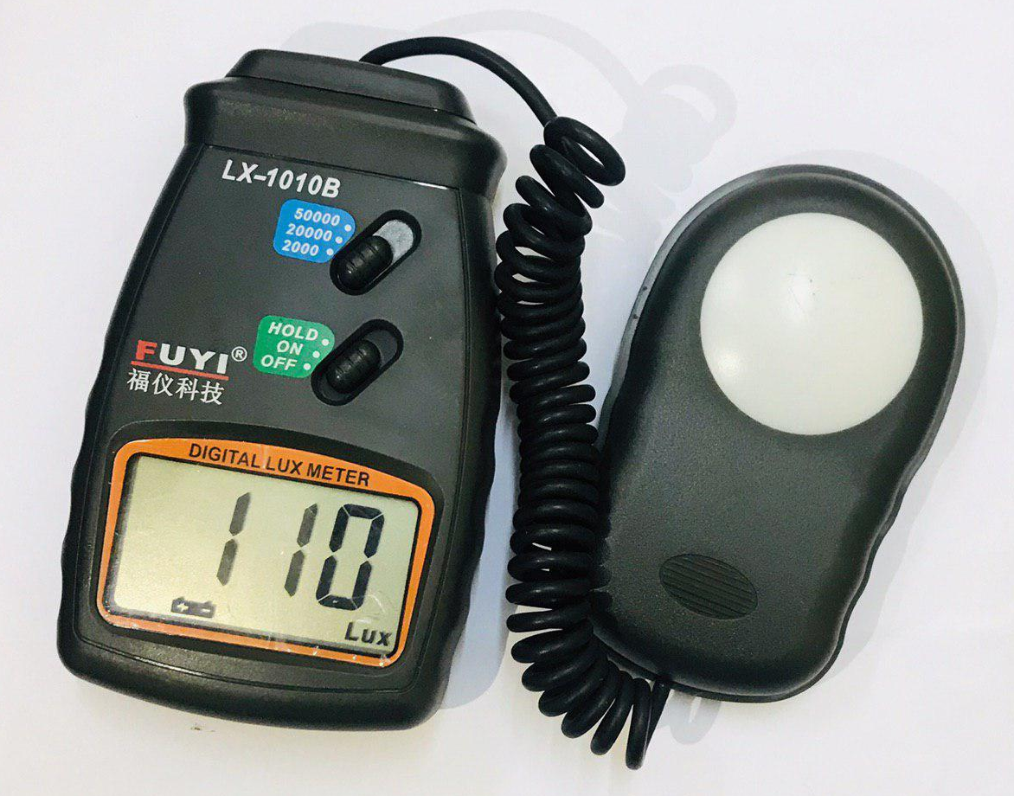

Figure (3-6) Lux meter.
3.1.10 MATLAB program
MATLAB is the high-level language and interactive environment used by millions of engineers and scientists worldwide. It lets you explore and visualize ideas and collaborate across disciplines including signal and image processing, communications, control systems, and computational finance. When used MATLAB in projects such as modeling energy consumption to build smart power grids, developing control algorithms for hypersonic vehicles, analyzing weather data to visualize the track and intensity of hurricanes, and running millions of simulations to pinpoint optimal dosing for antibiotics. MATLAB 2017a, and Origin 2015 software that runs on Windows 10, core i7, RAM 16 GB are used to design and plot data.

3.2 Methods
3.2.1 Preparation of SSNTD
Solid state nuclear track detector SSNTD which is CR-39 in the form of sheets with thickness 1 mm and 0.1 mm for CR-39 was used, These sheets were cut into sixteen small pieces, sixteen pieces for each detector with dimensions 1cm × 1cm.

3.2.2 Preparation the boric acid pellets
Prepared eight samples of boric acid powder, four samples for each detector, each sample has weight 0.5 g. pressed samples of boric acid in the piston for 30s under 150 par of the force in steel piston with thickness 1mm and diameter 1cm. The pellet was covered with CR-39 detector

3.2.3 Thermal neutron irradiation
CR-39 detector covered with pellets of boric acid ($H_{3}{BO}_{3}$) to convert free neutrons into charge-particle by equation ${}_{}^{10}B(n,α){}_{}^{7}{Li}$, put a pellet around the paraffin wax and irradiation samples with thermal neutron at a distance of 5 cm from neutron source ${}_{}^{241}{Am}-{}_{}^{9}{Be}$ with a flounce of thermal neutron ${10}^{5} n.cm^{-2}.s^{-1}$. The irradiation times - TD were 1h, 2h, 3h and 4h for CR-39 detector as shown in Figure (3-7).
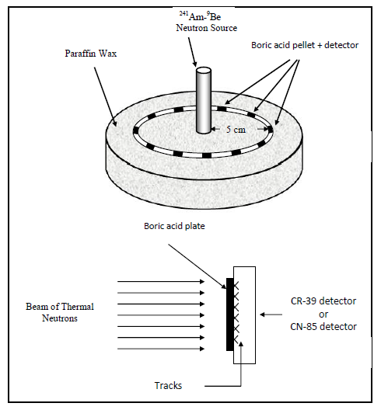

Figure (3-7) The irradiation by thermal neutron on CR-39 detector which covered with boric acid pellets.

3.2.4 Design New Irradiation Technique
In this study, we made irradiation suit to help changing distance between radiation source and detector. Figure (3-8) showed The irradiation system contains two plate upper plate and lower plate made of nickel metal have two dimensions (10 X 10) cm², four long screws, and straightened ruler. The upper plate contains (1.5) mm hole, place the CR-39 detector on the hole .In addition to the upper plate is moving while the lower plate stationary. The benefit of this is to change the distance between the radiation source and detector subject to the upper plate. Where it can be extracted from different distances by mathematical equation of alpha particles energies unit (M eV) [78].
E (α) = Eα (0) ( 1 – X/R)^{2/3} (3.1)
E (α): indicate to the energy of the alpha particle falling on the reagent material from distance (X).
Eα (0): indicate to energy of alpha emission from source (5.485 M eV).
X: indicate to distance between source and detector (cm).
R: the range of the alpha particle in the air (4.01 cm).
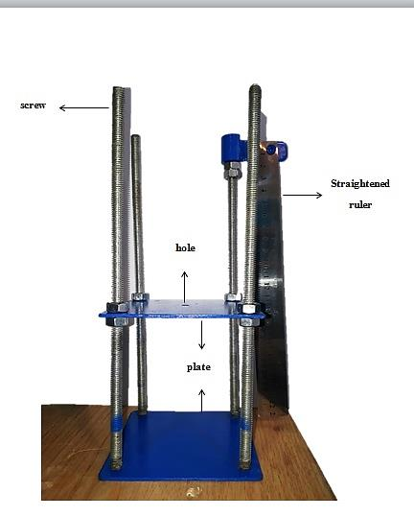
Figure (3-8) Sketch of a new irradiation technique.

3.2.5 Chemical etching
After irradiation and remove pellets of boric acid from the prepared detectors chemical etching solution, Sodium hydroxide NaOH solution with 6.25N, 2.5N has been used for the etching process for CR-39. The etchant solution was prepared using volumetric flask and applying the following equation:
W = Weq x N x V (3.2)
Where:
W: the weight of NaOH needed to prepare the given normality.
Weq: the equivalent weight of NaOH.
N: normality and equals to 6.25 N, and 2.5 N for CR-39.
V: volume of distilled water (250 ml).
Molecular weight of NaOH is sum of the atomic weight of sodium, oxygen and hydrogen,
i. e. Weq = 22.98977 + 15.9994 + 1.00794 = 39.99711 g/mol = 40

3.2.6 Preparation of images
After chemical etching processes the detectors were putted under optical microscope after changing light source by light emitting diode instead of tungsten light and install the digital camera on the microscope and defined it on computer, then take image and video clips then segment to images for detectors which contain on the nuclear tracks, and store these images (pixel unit) in computer at the form (bmp) and has special name, after that insert these images to image processing programs for analysis, where the one pixel in these images was equal to convert factor 0.4225 μm which calculated by using of role scale in optical microscope and take into account in the image processing of MATLAB program. Figure (3-9) shows a digital system which consists of optical microscope, digital camera, and computer.

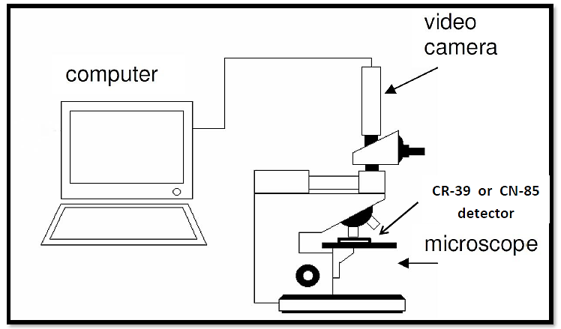

Figure (3-9) Sketch of a digital system which illustrates optical microscope, video camera and personal computer.

3.2.7 Preparation program

3.2.7.1 A New Algorithms to calculation the quality of image
The steps of new algorithms using MATLAB software program for calculation new (No-Reference Image Quality Assessment Based on Wavelet Transform (NIQWT)) scale are as follows:

1. Input color image c(x, y,i); where i= 1,2,3,
2. Convert c image to lightness image by using
I =(0.299*c(:,:,1)+0.587*c(:,:,2)+.114*c(:,:,3))
3. Calculating wavelate transform W_{T for} I component.
4. Estimating LH component only for I .
5. Finding histogram for LH component to get W _{H}.
6. Calculating NIQWT by the equation: 1 / W_{H} .

3.2.7.2 Algorithms of 3D track plot by MATLAB program in image processing technique
The Figure describes can get a direct visualization of size as well as the depth of structure. Moreover, A 2D image of a CR-39 SSNTD after etching four hours by chemical process, showing a track for different intensity of light.
1. Input color image G(x,y,i)
Where i= (1,2, 3,…...,n) RGB image.
2. Crop track image C_{c}= (x,y,i)
3. G final image I_{min} = min [ C_{c}(x, y, i)]
4. Plot 3D graph by meshing I_{min}.
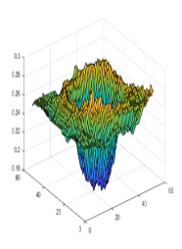

3.2.7.3 Algorithms of Track Detection Based on The Contrast Enhancement and Morphological analysis
Overlapping object detection and counting is a challenge in image processing whereas, The block diagram of algorithm is shown in Figure (3-10) where the MATLAB algorithms like contrast enhancement used to determine the track detection, by the way, enhanced RGB image.
Contrast enhancement by using ce=colres(double(co))

123
Input color image
Convert to gray image by using I=ce(:,:,1 )

Convert I image to I_{b} binary image when th = 0.7
For small region applied median filter on I_{b} when size of image equal 7*7 to remove small objects
Remove small region by using this condition if I_{N > 700} then I_{N} = 1 else I_{N}= 0

_{I}
If
Calculation value by using
I_{NCN} = abs (I – I _{NC} )

For very large region applied negative image for delete objects greater than 700 pixel by using I_{N} = abs (1 – I_{b})

Subtraction for delete large region by using
I _{br} = abs ( I _{NcN} - I_{b} )
I

Figure (3-10) Block Diagram of Image Index Algorithm.
A-Track Detection Based on The Contrast Enhancement and Morphological analysis
Track detection by track region boundaries [B1,L,N1,A] = bwboundaries(bw2)

In this study we captured nuclear track under optical microscopic for CR-39 detector, the Figure (3-11) illustrates alpha particle track of microscopic image We will notice maximum distribution for green color by using MATLAB program, but it is probability less than red and blue components. We can increase distribution through enhancement.
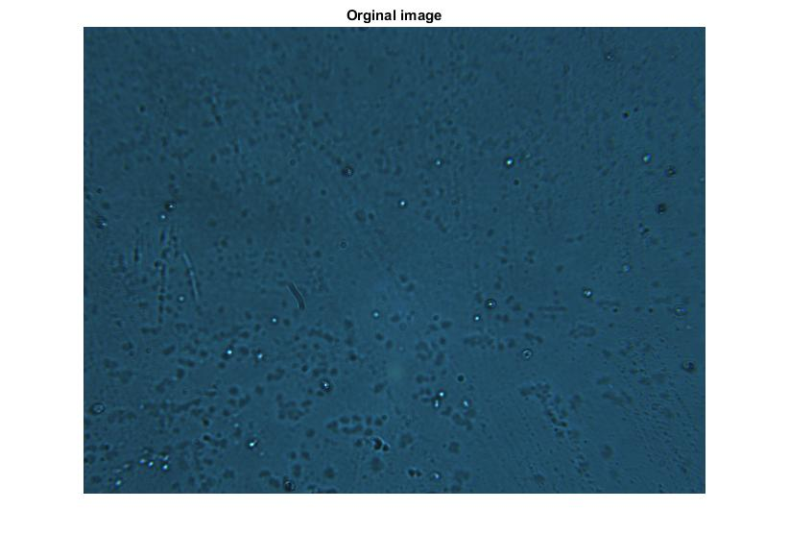
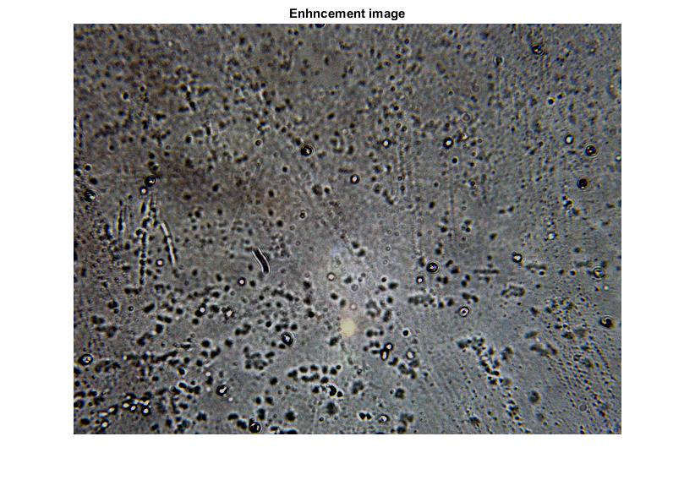
Figure (3-11) Microscopic image of alpha particle track and enhancement image.

We propose input colour image $C(x,y,i), i=1, 2, 3$ (red, green, blue) components and perform image colour restoration. Firstly, the mean value and standard deviation in red, green and blue ($RGB$) channels are calculated. Secondly, the maximum and minimum of each channel in the alpha particle track image are calculated.
${c }_{max,i}={c }_{mean,i}+∝{c }_{std,i}$ (3.3)

${c }_{min,i}={c }_{mean,i}-∝{c }_{std,i}$ (3.4)

where ${C }_{mean,i}$and ${ I}_{var }^{s}{C }_{std,i}$ are the mean value and standard deviation in the c channel; $∝$ is a parameter to control the image dynamic; and${C }_{max,i} and {C }_{min,i}$ are the maximum and minimum of the i channel, respectively. The colour-restored image is obtained by

${c }_{r,i}= \frac{{c }_{i}-{c }_{min,i}}{{c }_{max,i}-{c }_{min,i}}×255.$ (3.5)

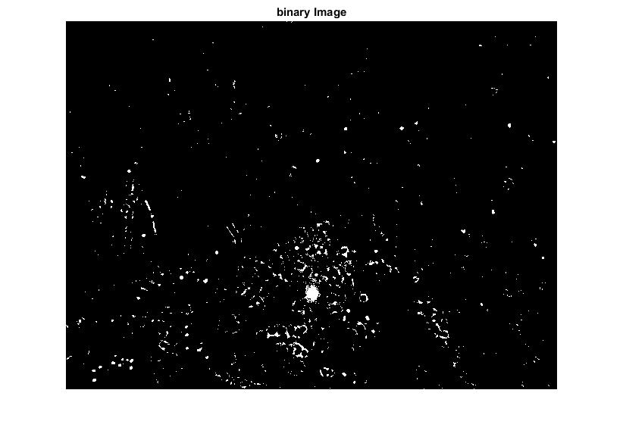

Figure (3-12) Microscopic of RGB image convert to a binary image.
I= R +B+ G /3 (3.6)

I_{n} = I / 255 (3.7)

Now, we worked lightness component through equation (5) convert enhancement image to binary image as shown in Figure (3-12). After we extract the green component then convert the image to a binary system through:
$ifIn>th1 bw(x,y)=1$
$else bw(x,y)=0$ (3.8)
In the binary image when threshold value ($th)$ equals 0.7, in order to get rid of undesirable (small) areas with few spaces, apple the median filter to the binary image has window (7*7),by condition of the volume (822*851) when the image size is bigger we can give a larger window size.
${bw}_{m}\left(x,y\right)=medianfilter(bw\left(x,y\right))$ (3.9)
Figure (3-13) illustrates the binary image and the elimination of unwanted areas through the median filter

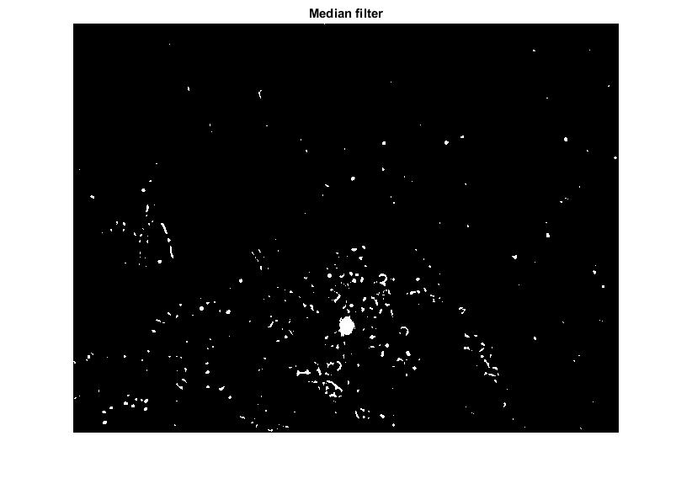

Figure (3-13) Contrast enhancement of a microscopic binary image and the elimination of unwanted areas by the median filter.
Delete very large region with size P who produced from distortion because physical variation like (such as noise, color shift, inverse transform for any operation and lightness change), and the larger region do not represent alpha particle track, the equation by using:
If any region in ${bw}_{m} (ʋ)$ (3.10)
Where $ʋ=1,2,3$ , number of region.
If bwm$(ʋ$ ) ˂ P
bwm$(ʋ$ ) =0
eles
bwms ($ʋ)=bwm(ʋ)$
end

bw2 abs (1- bwm) (3.11)
bw4 = abs (bw2 – bwm_{s})
And find a negative binary image using:
bwf= abs(1-bw4); (3.12)

In the final negative image as in Figure (3-14) areas are the classified and final image we remove big region from equation (3-13), We detect the alpha particle tracks on binary image.

Figure (3-14) Detection track on the binary image.

ava=sum(area)./NT (3.13)

R=sqrt (ava./pi); (3.14)

The database permitted to measure the accuracy of the three main methods presented in this paper: total number of track, the average of track, the median region (areas) of track, and in the digital image also calculation the radius by measuring the distance between two opposed pixel on the border of a sharp and enlarged image .
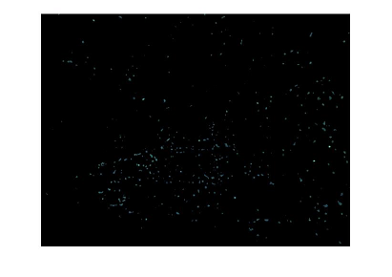
Figure (3-15) Detection track on the RGB image.

When we detected track on the RGB image that contains intermediate region (tracks) then delta the larger and smaller region, shown in (3-15).
B- Classification track depending on depth.
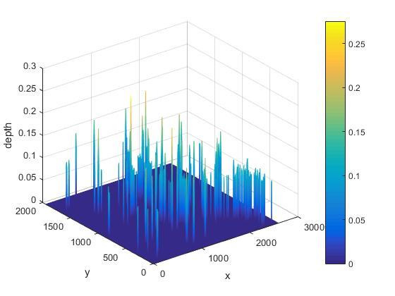

Figure (3-16) Detection track on the RGB image in 3-D.

I_{d} = min( R,G,B ) for lightness component (3.15)
Max - depth = max I_{d} (:) (3.16)
Min - depth = min I_{d} (:) (3.17)
Figure (3-16) describes the calculation of track depth when analysis tracks depending on the depth. When maximum and minimum indicate to maximum depth and minimum depth of track in the present RGB image.
C- Histogram of alpha particle track (intermediate region)
A novel histogram equalization technique, equal area dualistic sub-image histogram equalization, putted forward in this study. First, the image is decomposed into two equal area sub-images based on its original probability density function. Then the two sub-images are equalized respectively. Finally, we obtain the results after the processed sub-images are composed into one image, see Figure (3-17).
Compute the probability density function (P(i)) of the gray level (i) where (i = 1,2,3,……255), from the following equation:
P (i) = $\frac{ni}{n}$ (3.18)

P (i): Probability of the (ith) gray level.
n_{i} : The number of pixels.
n: The total number of pixels in the image.
Figure (3-17) Histogram of the RGB image of nuclear track.

