Chapter Four
Results and Discussions

4.1Introduction
It has been divided this chapter and reviews his results, discussion through precedent axes in the first, second, and third chapter. In this chapter, we will list all procedures that have been done to obtain the nuclear track features of the CR-39 detector using the MATLAB programs in image processing.
4.1.1 Step One: Improving an illumination system in the microscopic imaging of nuclear tracks using a light emitting diode source
In this study, images vision of nuclear tracks was increased using two methods. The first is to design a new light system based on Light-Emitting Diodes (LED) light instead of traditional tungsten light used in the optical microscope. Due to the high dynamic range of the LED light, a high vision and an extra number of tracks were obtained during shooting. The second method is to establish a new scale depended on counting nuclear tracks. That is called No-Reference Image Quality Assessment Based on Wavelet Transform (NIQWT) scale. Quality of captured images was evaluated and no-reference scales like Entropy of First Derivative (EFD), Average Gradient (AG), the Measure of Enhancement by Entropy (EMEE), and (NIQWT) were calculated to be recommended. Then a good correlation coefficient was obtained for these scales. The best correlated coefficient 0.9089 was for (NIQWT) scale. Whereas, the statically results illustrated photography when using LED light much better than tungsten light in the optical microscopy. Therefore, these processes led to augment numbering of nuclear tracks discovered.
Images with good lighting and contrast are of great importance in statistics and get a clear vision of the nuclear tracks. So image quality analysis is important for these tracks. This study determined the quality of the image that changes the light and contrast by controlling the level of light captured by the tracks images under the optical microscope. A new lighting system was used with the light emitting diode (LED) to generate different levels of lightness from (93)Lux to (1255)Lux as needed. In this work, the CR-39 detector was selected with a thickness of 500mm and an area of (1X1) cm. It was exposed to the radioactive source for a period of 3 minutes and it was placed at 3.5 cm far from the detector. The chemical etching was then performed for 240 minutes, after which the tracks were dried. Video images were then taken at different illumination levels using LED light rather than tungsten light.The light levels were measured by Lux meter device, with (HDEC-50B) camera size (5) Megapixel and zoom (40x) under optical microscope. The aim of this work was to answer the question: What is the best level of illumination to capture the picture under the optical microscope?
The answer is to propose a no-reference scale of images based on the number of nuclear tracks, as tabulated in Table (4-1). Then calculate the correlation coefficient for all images for different levels of lighting and for different no-reference scales such as (AED, AG, EMEE, and NIQWT).
At the light level (949)Lux, the highest correlation coefficient using the (NIQWT) scale was found depending on the counting of the tracks, which means that the detected nuclear tracks will be increased in these levels. These results are described in the table (4-2).
Thus, different levels of lighting were applied that make the image with high quality as shown in the figure [4-1.a- 4-1.i] which show that the use of a no-reference NIQWT scale of correlation coefficient is better than other scales and mathematically by MATLAB program:
A. We implementation New Scale Called; No-Reference Image Quality-Assessment Based On Wavelet Transform (NIQWT) is one of the most important and beneficial tools for image processing.It has been used in image processing, data Compression and signal processing. in MATLAB program worked on the histogram for HL component for the original images means that discrete wavelet transform, there are only a limited number of wavelet coefficients for each bounded rectangular region in the upper half plan. Then the HL transform image histogram has been created. Finally, we calculate the WH which represents the inverted of a maximum histogram. This method is called No-reference quantitative assessment of image quality (NQWIT) which is one of the most pressing and difficult problems of image processing. This feature can be the No-reference quality measure. Then:
$WH=1/max⁡(hist)$ (4.1)
where:
WH: no-reference wavelet quality.
H: histogram of part from transform image of (LH) only.
N: values of the image.
Note: [HH, LH, HL, and LL] these images divided from the original image in MATLAB program.

(a)

(b) 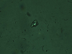

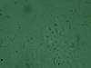

(c)

Figure (4-1a :i) shows the left hand side images of tracks and the right hand side illustrated an account tracks with histograms for nine groups every group contains ten pictures captured under new lightness sources of optical microscope.

(d)

(e)

(e)

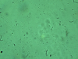
(g)
(h)

(i)

B. The Figures (4-2-a:i) show four No-reference image quality scales to get about better behavior of numbering nuclear tracks on the CR-39 detector with normalize power (intensities of light) by LUX.
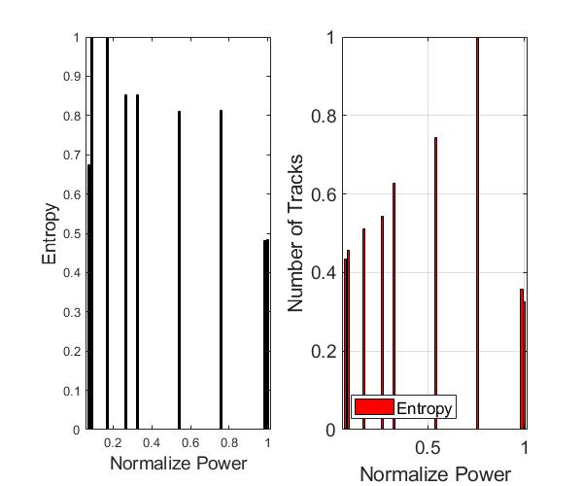
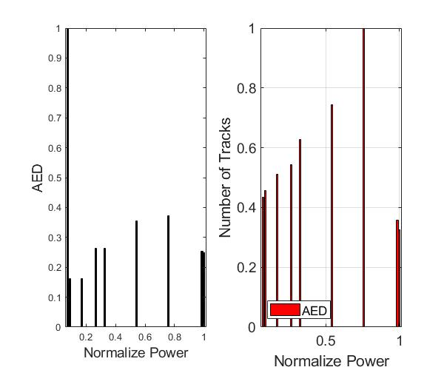

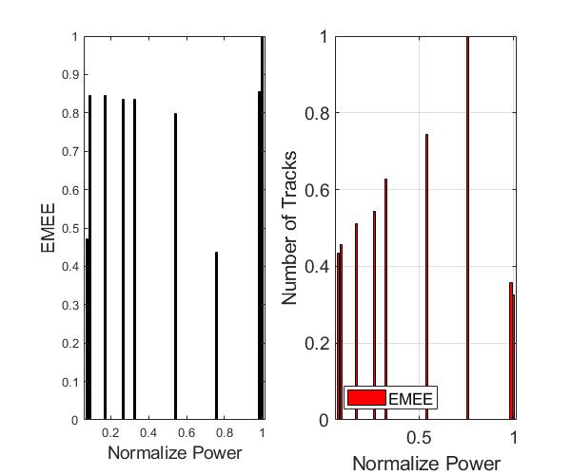

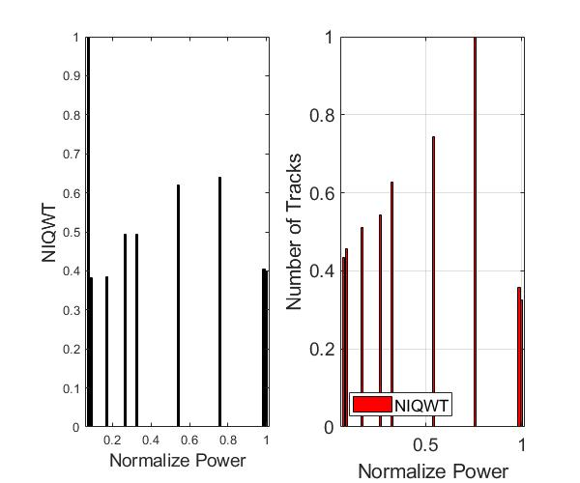

Figure ( 4-2-a ) Normalize quality (Entropy, AED, EMEE and NIQWT) and number of tracks as function of normalizing power for group (a) images.

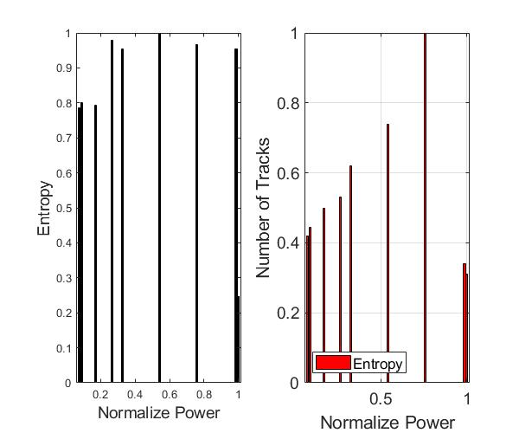

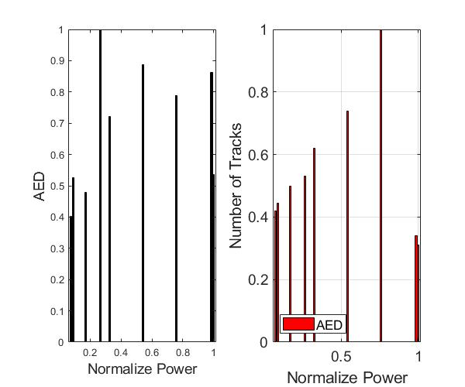

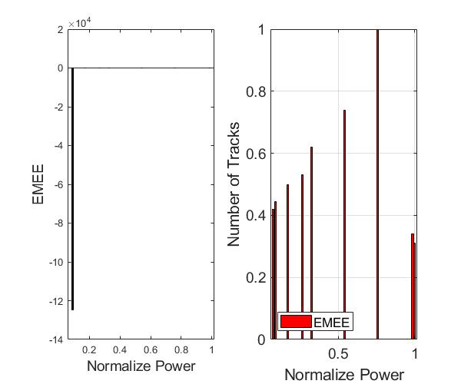

Figure ( 4-2-b) Normalize quality (Entropy, AED, EMEE and NIQWT) and Number of tracks as function of normalizes power for group (b) images.

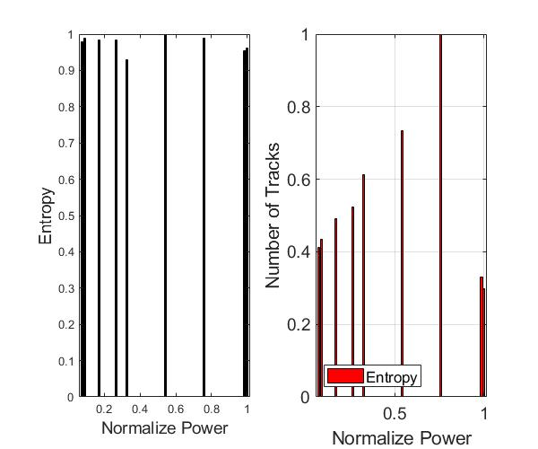
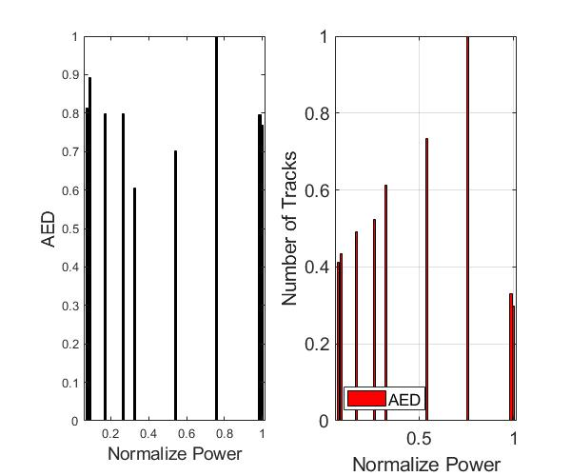
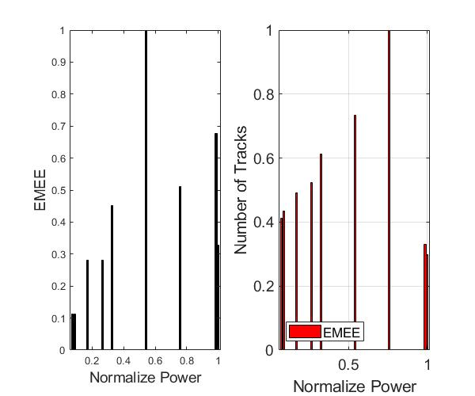
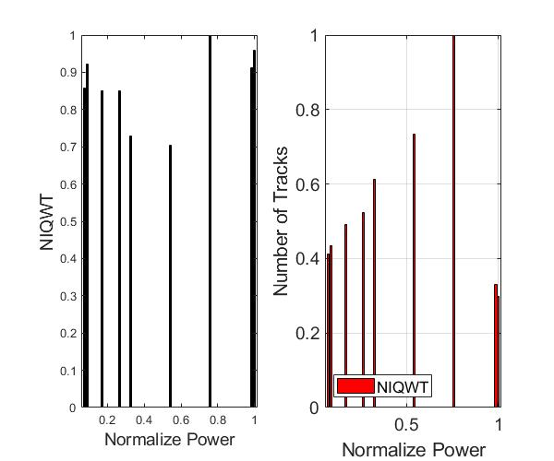

Figure (4-2-c) Normalize quality (Entropy, AED, EMEE and NIQWT) and Number of tracks as a function of normalize power for group (c) images.

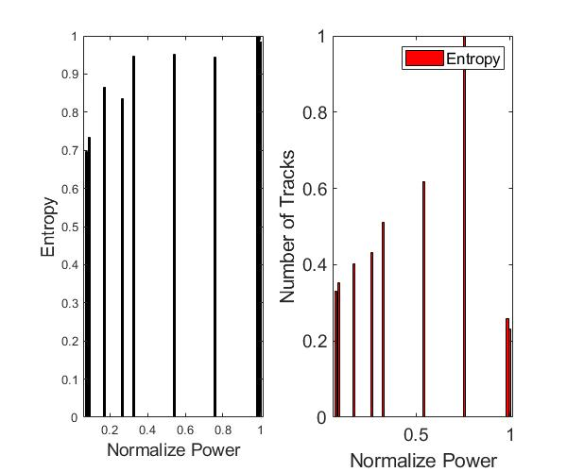

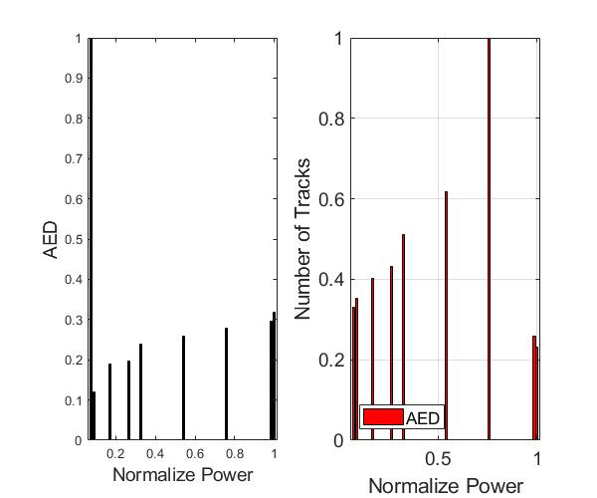

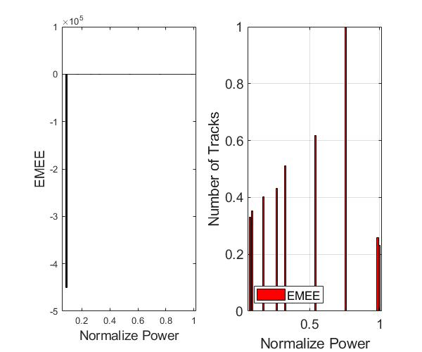

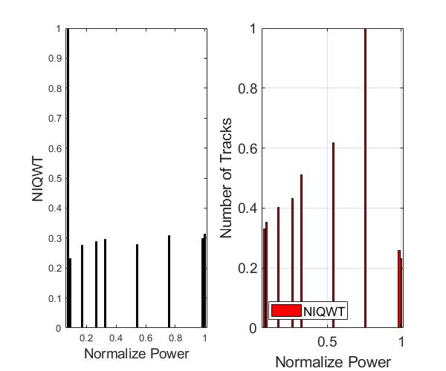

Figure ( 4-2-d) Normalize quality (Entropy, AED, EMEE and NIQWT) and Number of tracks as a function of normalizes power for group (d) images.

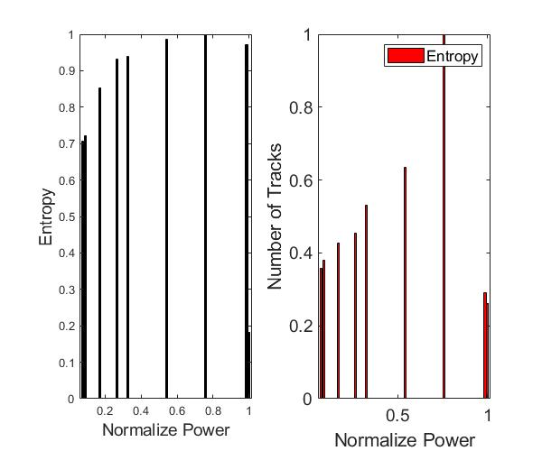
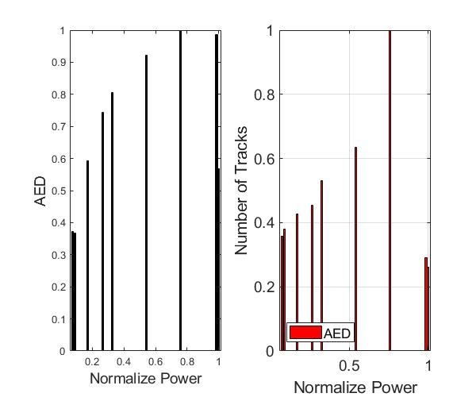

Figure (4-2-e) Normalize quality (Entropy, AED, EMEE and NIQWT) and Number of tracks as a function of normalizes power for group (e) images.

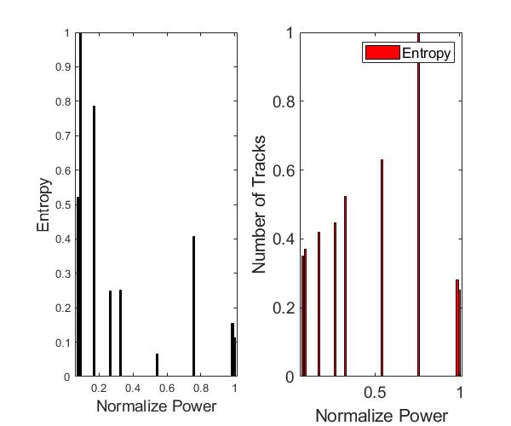
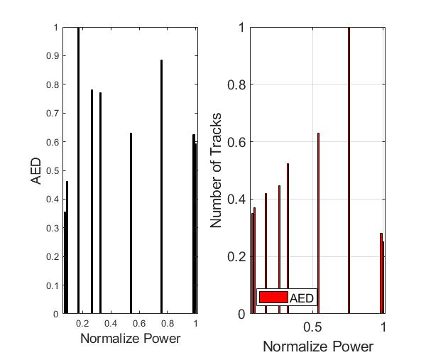
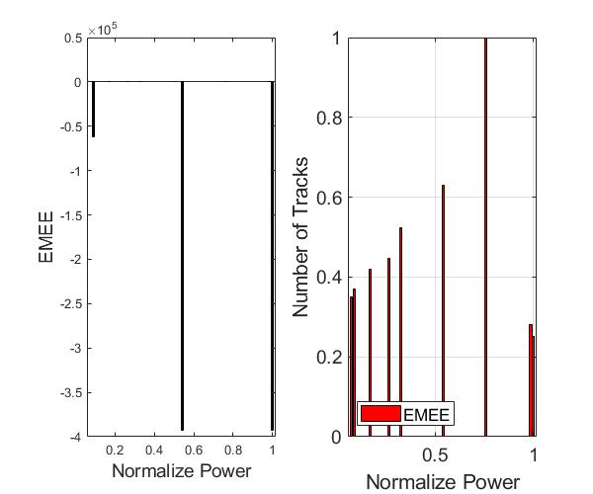
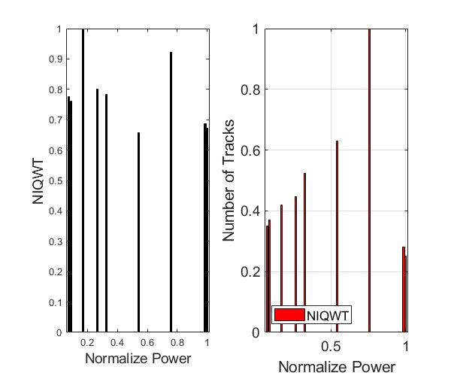

Figure (4-2-f) Normalize quality (Entropy, AED, EMEE and NIQWT) and Number of tracks as function of normalizes power for group (f) images.

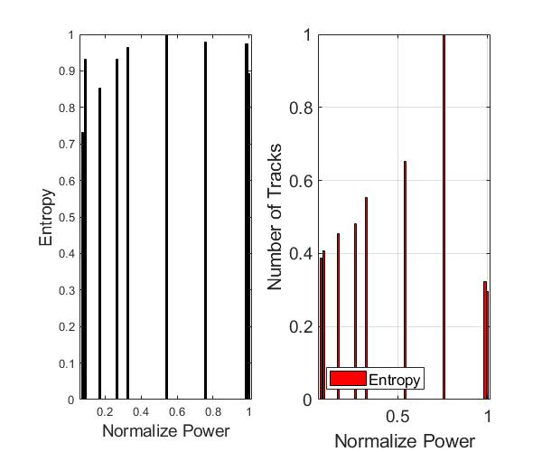
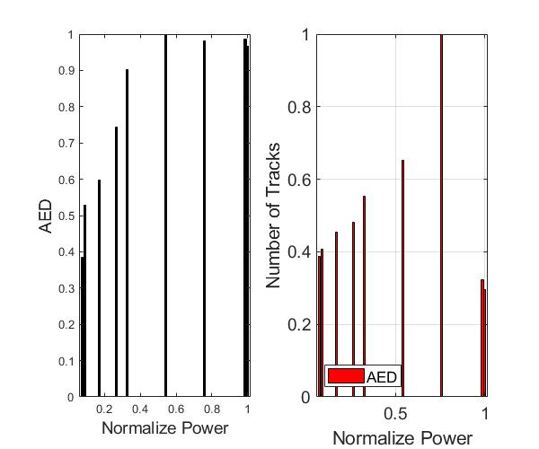
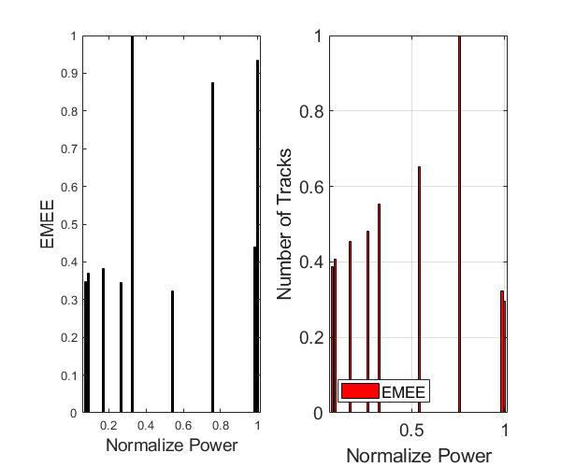
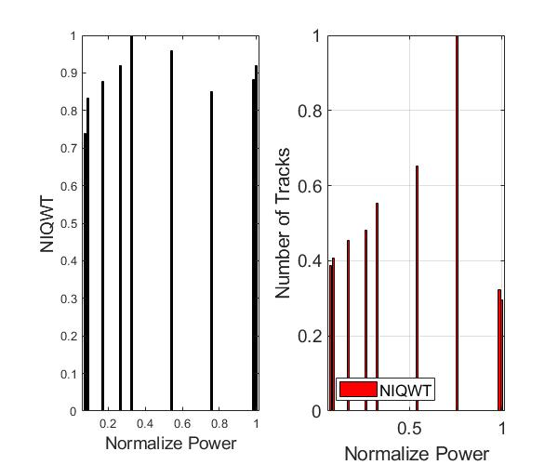

Figure ( 4-2-g) Normalize quality (Entropy, AED, EMEE and NIQWT) and Number of tracks as function of normalizes power for group (g) images.

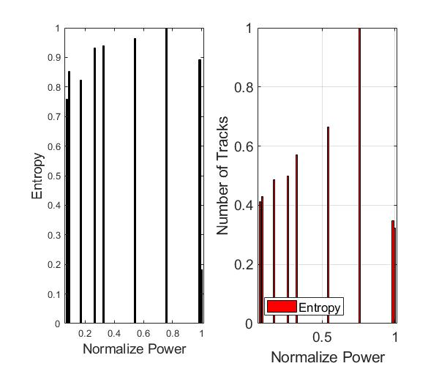
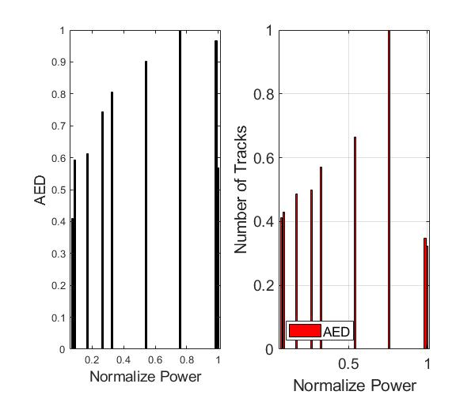
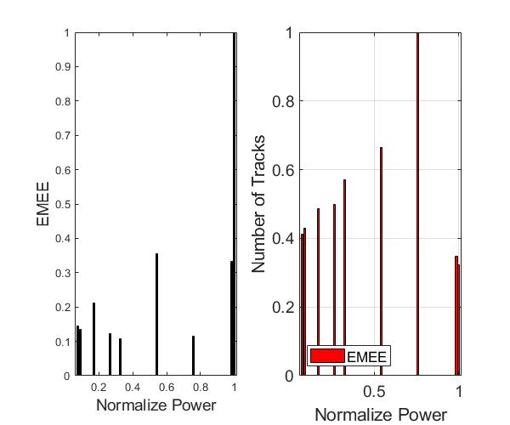
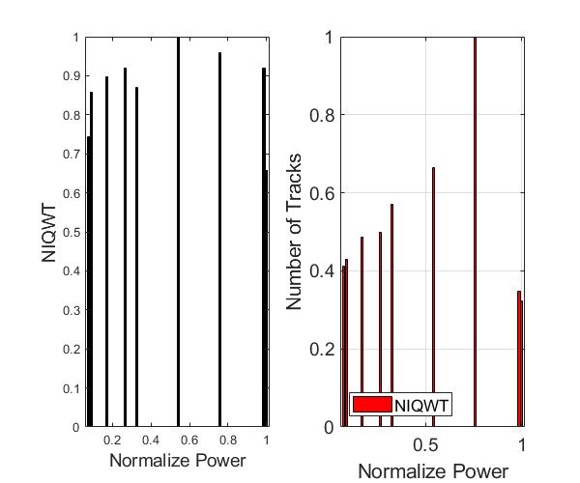

Figure (4-2-h) Normalize quality (Entropy, AED, EMEE and NIQWT) and Number of tracks as a function of normalizes power for group (h) images.

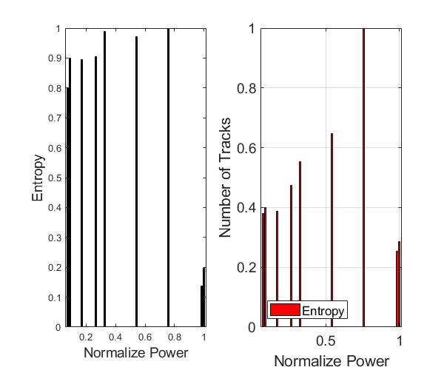
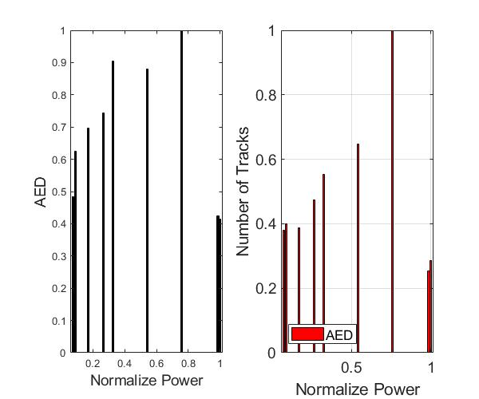
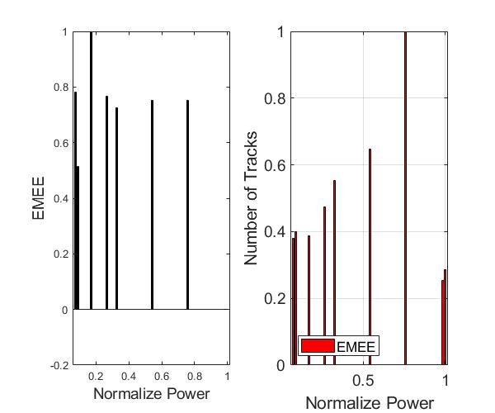
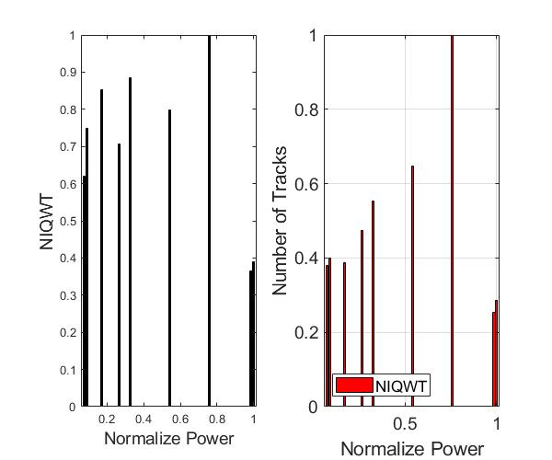

Figure ( 4-2-i )Normalize quality (Entropy, AED, EMEE and NIQWT) and Number of tracks as a function of normalizes power for group (h) images.

C. Three Diminsion plot of the crop track

The Figures (4-3) illustrated image (a) the extent to which the track of the detector is penetrated at 93 LUX of the lightness levl,then for image (b) the extent to which the track of the detector is penetrated at 112 LUX, for image (c) the extent to which the track of the detector is penetrated at 215 LUX, for image (d) the extent to which the track of the detector is penetrated at 334 LUX, for image (e) the extent to which the track of the detector is penetrated at 410 LUX,for image (f) the extent to which the track of the detector is penetrated at 673 LUX, for image (g) the extent to which the track of the detector is penetrated at 949 LUX, for image (h) the extent to which the track of the detector is penetrated at 1238 LUX, and for image (i) the extent to which the track of the detector is penetrated at 1255 LUX, all these images proccess in MATLAB program in 3D plot.

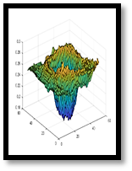
a
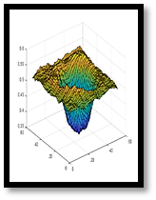
b
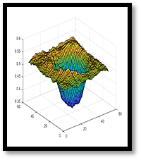
c
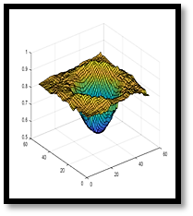
d
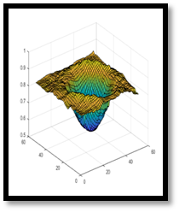
e
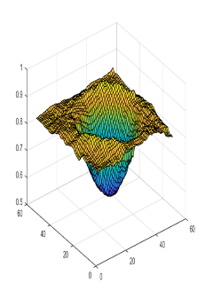
f

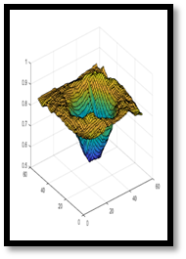
g
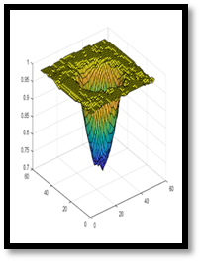
h
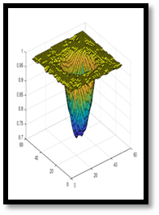
i

Figure (4-3) 3D track image by MATLAB program at a different intensity of light.

Table (4-1) Accounting of nuclear tracks for nine sets of images captured at different levels of lightness under the optical microscope.

NIQWT | EMEE | AG | EFD | Intensity (LUX)
0.8789 | 0.2155 | 0.6807 | 0.4204 | 93
0.6149 | 0.1741 | 0.3981 | 0.5509 | 112
0.0926 | 0.4103 | 0.2859 | 0.3423 | 215
0.2736 | 0.2837 | 0.2025 | 0.2033 | 334
0.6328 | 0.2835 | 0.5591 | 0.5434 | 410
0.2418 | 0.1046 | 0.4765 | -0.0648 | 678
0.9089 | 0.2894 | 0.3510 | 0.4367 | 949
0.6067 | 0.4121 | 0.5967 | 0.5516 | 1238
0.7870 | 0.4885 | 0.8794 | 0.6433 | 1255
Table (4-2) Correlation coefficients for four no-reference scales compared with manually account for the different intensity levels.

I | H | g | f | E | d | c | b | a | Intensity (LUX)
42 | 46 | 129 | 96 | 81 | 70 | 66 | 59 | 56 | 93
39 | 43 | 126 | 93 | 78 | 67 | 63 | 56 | 53 | 112
37 | 41 | 124 | 91 | 76 | 65 | 61 | 54 | 51 | 215
32 | 36 | 139 | 86 | 71 | 60 | 56 | 49 | 46 | 334
36 | 40 | 143 | 90 | 75 | 64 | 60 | 53 | 50 | 410
38 | 42 | 145 | 92 | 77 | 66 | 62 | 55 | 52 | 673
45 | 49 | 152 | 99 | 84 | 73 | 69 | 62 | 59 | 949
51 | 55 | 158 | 105 | 90 | 79 | 77 | 68 | 65 | 1238
43 | 38 | 150 | 97 | 83 | 71 | 58 | 60 | 57 | 1255

4.1.2 Step Two: Comparison between manual method and automatic method to account nuclear track on the CR-39 detector
These detectors were exposed to the Americium radioactive source Am-241 with an activity of 8.9 micro curies. Exposure time was 30, 60, 90, 120, 150, 180, 210, 240 and 270 second to obtain low energy under the alpha particle energy 5.485 MeV in the air. The detectors were placed directly in contact with the source at a 90-degree angle. After four hours of the chemical etching process, the track influences were read using a digital camera (HDEC-50B) software connected to the optical microscope. Before and after changed the light of the microscope by a LED source to the purpose of counting the numbers of heavy alpha particles, the intensity of the track at different times of irradiation. There are several previous studies in this field, given by Ho et al. (2002)which they employed variable light in optical microscopy system to evaluate the etching rate in CR-39 and LR-115 detectors [82]. While Vazquez-Lopez et al. (2001) studied the surface roughness and the function of different samples of CR-39 detector [83]. Also, Al-Jobouri et al. (2016) studied image analysis of CR-39 and CN-85 detector irradiation by thermal neutron [84].
The first step in this work was to modify the light source of an optical microscope LED light instead of the tungsten light. Relationship of output analysis between track number and light levels measured by Lux meter before and after light system change (lightness) in the optical microscope. In the second step, the tracking number was compared with a different irradiation time when the CR-39 was detected under Am-241 alpha source, the linear relationship between the irradiation time and the number of tracks can be obtained from Figure (4-4), (4-5). The behavior of this relationship is as a linear relationship reflected the increasing numbering of the track with irradiation time with different intensity of light as tabulated in table (4-3). In the third step, the MATLAB program was designed to identify image quality with four no-reference scales such as the average Gradient (AG), the measurement of Enhancement by Entropy (EMEE), and the (NIQWT) were calculated to be recommended, where a good correlation coefficient was obtained for these scales. The best correlated coefficient was 0.6431 for (NIQWT) scale as table (4-4). The statically results illustrate photography when using a much better-LED light than Tungsten light in optical microscopy. Therefore, these processes have increased the numbering of detected (discovered) nuclear track as shown in Figure (4-6) & (4-7).

Figure (4-4) Show the relation between the maximum number of tracks and time irradiation time with Tungsten light in optical microscope.

Figure ( 4-5) The relation between the manually maximum number of tracks and time irradiation time with LED light in optical microscope.

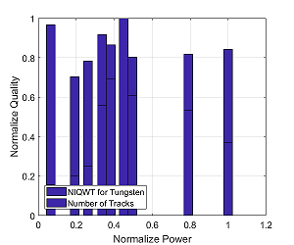
Figure (4-6) Normalize quality NIQWT scale and number of tracks as a function of normalizes power for group Tungsten images in MATLAB program.

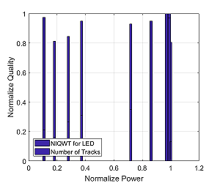

Figure (4-7) Normalize quality NIQWT scale and Number of tracks as a function of normalizes power for group LED images in MAT LAB program.

When Table (4-3) & (4-4) who worked in MATLAB program illustrated the results under LED light greater than tungsten light. At these processes led to augment visibility and numbering of nuclear tracks discovered. It is clear from the results that the correction coefficient that used in MATLAB program was high value because it corresponds to the manual counting using the source of the light emitting diode instead of the tungsten light of the nuclear tracks of alpha particles on the CR-39 irradiated detector with the Am-241 alpha source to increase the clarity and thus the accuracy of the number of nuclear tracks of alpha particles discovered.

Table(4-3) Illustrates manually the number of nuclear tracks before and after changing light optical microscope by LED light with different intensity of light and different irradiation time (30:30:270).
Number of nuclear tracks (after) | The intensity of LED light(Lux) | Number of nuclear tracks (before) | The intensity of tungsten light (Lux) | Irradiation time (sec) | Detector
446 | 139 | 33 | 16 | 30 | CR-39
338 | 233 | 42 | 46 | 60 | CR-39
557 | 358 | 52 | 63 | 90 | CR-39
658 | 477 | 117 | 81 | 120 | CR-39
736 | 919 | 145 | 92 | 150 | CR-39
2002 | 1102 | 209 | 108 | 180 | CR-39
2112 | 1241 | 127 | 119 | 210 | CR-39
2045 | 1267 | 111 | 190 | 240 | CR-39
277 | 1278 | 77 | 240 | 270 | CR-39

Table (4-4) Measurements of correlation coefficients for (AED, EMEE, NIQW) scales in MATLAB program comparison between Tungsten and LED source.

Images | Correlation coefficient  (NT, AED) | Correlation coefficient  (NT,EMEE) | Correlation coefficient  (NT,NIQE)
Group T | 0.5377 | 0.3621 | 0.4851
Group L | 0.6196 | 0.4649 | 0.6431

4-2 Design A New-program in MATLAB program to procuration on the features of the Alpha particle employment CR-39 detector
ASH-program is a direct algorithm to reap the tracks and its radius, one of the important ways to study the tracks of nuclear detectors in the bombing by charge particles. It gives accurate results and a fairly clear perception of the forms of the tracks and their growth with the appropriate etching time by using MATLAB program to facilitate the task of researchers in obtaining quick results and analysing of the features of the tracks in many respects and in a time not more than a minute, while the previous research used the technique of manual counting of the tracks and calculations of the features of the tracks also manually. So the results take a long time and boring and analyse the parameters with a percentage of error is not a few. Especially when using the illumination system of the ancient optical microscope of tungsten light have low efficiency and intensity with high voltage. We will present the most important experiments carried out on the CR-39 detector in a variety of conditions trying to obtain all the images capturing with new light of the light emitting diode, we then design a program in the MATLAB program to calculate the features of the nuclear tracks of the alpha particles (for example counting of track, the average area, radius, depth, and mean depth) under different circumstances, as will be listed in the following five trials:
4-2-1 The relation features of tracks with the time of direct irradiation
Table (4-5) describes the experiment that represented by irradiation source has activity 8.9µCi of the Americium (²⁴¹Am) for nine pieces of CR-39 for the different time where the distance between source and detector (X=0) then we performed the chemical etching of the detectors at a time of four hours.After that we picked up images for tracks under optical microscope by using LED light and saved them as a.JPG file to prepare them in MATLAB program to calculate features of nuclear track whereas the figure (4-8), (4-9) indicate to total number of track (tono),maximum probability (maxpro), enough area to maximize probability (area-atmax), average of area (ave). average of track radius (R), average of depth(mean-depth), and maximum depth (max-depth).Finally, the calculation of probability density for each track by MATLAB program in image processing see figure (4-10).

Table (4-5) illustrate direct irradiation source with features of nuclear track
max_depth | mean_depth | R | Ava | Area _atmax | maxpro | Tono | code  of  image | Irradiation of  Am 8.9 µci(sec)
0.2549 | 0.0003 | 5.7659 | 104.4444 | 20 | 0.1818 | 63 | a(1) | 30
0.3255 | 0.0004 | 3.7776 | 44.8321 | 20 | 0.2361 | 137 | a(2) | 30
0.5882 | 0.0018 | 6.0334 | 114.3593 | 20 | 0.1158 | 231 | a(3) | 30
0.549 | 0.0009 | 5.4832 | 94.4545 | 30 | 0.1522 | 154 | a(4) | 30
0.4118 | 0.0005 | 4.2345 | 56.3306 | 20 | 0.209 | 121 | a(5) | 30
0.4667 | 0.0006 | 5.6768 | 101.24 | 20 | 0.1731 | 75 | a(6) | 30
0.3804 | 0.0028 | 6.7383 | 142.6447 | 20 | 0.0844 | 304 | a(7) | 30
0.3804 | 0.0005 | 3.1954 | 32.0781 | 20 | 0.2564 | 192 | a(8) | 30
0.3843 | 0.0008 | 3.2046 | 32.2625 | 20 | 0.3098 | 400 | a(9) | 30
0.349 | 0.0009 | 4.1597 | 54.3599 | 20 | 0.2222 | 289 | a(10) | 30
0.3804 | 0.0047 | 8.7049 | 238.0544 | 40 | 0.0502 | 349 | a(11) | 60
0.5373 | 0.0047 | 10.6927 | 359.1902 | 40 | 0.0396 | 205 | a(12) | 60
0.4392 | 0.0011 | 7.2729 | 166.1727 | 20 | 0.0968 | 110 | a(13) | 60
0.4235 | 0.0012 | 7.4469 | 174.2203 | 30 | 0.0857 | 118 | a(14) | 60
0.4196 | 0.0013 | 7.6357 | 183.1654 | 20 | 0.0982 | 127 | a(15) | 60
0.3137 | 0.0008 | 6.5336 | 134.1068 | 20 | 0.1529 | 103 | a(16) | 60
0.502 | 0.0086 | 6.6772 | 140.0665 | 50 | 0.0665 | 948 | a(17) | 60
0.3686 | 0.0012 | 6.8003 | 145.2808 | 40 | 0.1111 | 146 | a(18) | 60
0.0005 | 0.0011 | 0.0062 | 0.1201 | 0.02 | 0.0001 | 1.066 | a(19) | 60
0.6235 | 0.0096 | 7.8084 | 191.5478 | 70 | 0.0479 | 628 | a(20) | 60
0.5333 | 0.0015 | 5.1164 | 82.239 | 20 | 0.1509 | 251 | a(21) | 90
0.349 | 0.0003 | 5.9961 | 112.9512 | 20 | 0.1667 | 41 | a(22) | 90
0.3176 | 0.0002 | 4.4974 | 63.5439 | 20 | 0.2143 | 57 | a(23) | 90
0.3176 | 0.0002 | 5.2507 | 86.6122 | 20 | 0.3214 | 49 | a(24) | 90
0.3333 | 0.0003 | 4.2429 | 56.5568 | 20 | 0.1509 | 88 | a(25) | 90
0.2549 | 0.0003 | 5.7659 | 104.4444 | 20 | 0.1818 | 63 | a(26) | 90
0.3255 | 0.0001 | 5.5662 | 97.3333 | 440 | 0.25 | 12 | a(27) | 90
0.3333 | 0.0001 | 4.6091 | 66.7407 | 70 | 0.125 | 27 | a(28) | 90
0.302 | 0.0001 | 5.1852 | 84.4643 | 20 | 0.2778 | 28 | a(29) | 90
0.3451 | 0.0003 | 4.9845 | 78.0536 | 20 | 0.1944 | 56 | a(30) | 90
0.5608 | 0.0034 | 4.7914 | 72.1238 | 30 | 0.1134 | 541 | a(31) | 120
0.5647 | 0.0038 | 4.6583 | 68.1704 | 30 | 0.1203 | 798 | a(32) | 120
0.5412 | 0.0035 | 5.0062 | 78.7352 | 30 | 0.1093 | 627 | a(33) | 120
0.5765 | 0.0022 | 5.1336 | 82.7927 | 30 | 0.1146 | 328 | a(34) | 120
0.5725 | 0.0008 | 5.2035 | 85.0625 | 30 | 0.1165 | 128 | a(35) | 120
0.5098 | 0.0012 | 4.515 | 64.0429 | 20 | 0.1511 | 303 | a(36) | 120
0.6196 | 0.0015 | 5.6286 | 99.5284 | 20 | 0.0915 | 176 | a(37) | 120
0.0008 | 0.0011 | 0.0054 | 0.0926 | 0.02 | 0.0001 | 1.262 | a(38) | 120
0.498 | 0.0009 | 6.4291 | 129.8526 | 60 | 0.0897 | 95 | a(39) | 120
0.6 | 0.0062 | 5.7876 | 105.2308 | 20 | 0.1022 | 715 | a(40) | 120
0.4039 | 0.0007 | 5.1924 | 84.7 | 20 | 0.1053 | 120 | a(41) | 150
0.4863 | 0.0029 | 5.7349 | 103.3239 | 20 | 0.0947 | 389 | a(42) | 150
0.3647 | 0.0005 | 5.3226 | 89 | 20 | 0.1475 | 87 | a(43) | 150
0.0005 | 0.001 | 0.0069 | 0.1118 | 0.02 | 0.0001 | 1.011 | a(44) | 150
0.4745 | 0.002 | 4.7499 | 70.879 | 20 | 0.1351 | 372 | a(45) | 150
0.3834 | 0.0021 | 3.2231 | 85.435 | 20 | 0.1233 | 233 | a(46) | 150
0.5098 | 0.0022 | 7.2299 | 164.2174 | 20 | 0.0805 | 161 | a(47) | 150
0.5569 | 0.0016 | 5.788 | 105.2449 | 30 | 0.1151 | 196 | a(48) | 150
0.4118 | 0.0004 | 5.2384 | 86.2069 | 20 | 0.1786 | 58 | a(49) | 150
0.4039 | 0.0004 | 5.2303 | 85.9403 | 20 | 0.1556 | 76 | a(50) | 150
0.7922 | 0.011 | 6.3321 | 125.9621 | 50 | 0.0687 | 818 | a(51) | 180
0.8353 | 0.0111 | 6.3229 | 125.5978 | 30 | 0.0738 | 808 | a(52) | 180
0.7961 | 0.0159 | 7.0715 | 157.1005 | 100 | 0.059 | 935 | a(53) | 180
0.7569 | 0.0049 | 6.9833 | 153.2029 | 50 | 0.0561 | 340 | a(54) | 180
0.7882 | 0.0025 | 5.8996 | 109.3423 | 20 | 0.0972 | 260 | a(55) | 180
0.6824 | 0.004 | 6.6324 | 138.1951 | 20 | 0.1062 | 369 | a(56) | 180
0.6745 | 0.0084 | 6.1097 | 117 | 20 | 0.0823 | 790 | a(57) | 180
0.7333 | 0.0074 | 5.932 | 110.5501 | 20 | 0.0851 | 729 | a(58) | 180
0.6392 | 0.0019 | 5.1604 | 83.6584 | 40 | 0.1142 | 243 | a(59) | 180
0.5176 | 0.0014 | 7.0834 | 157.6262 | 80 | 0.059 | 313 | a(60) | 180
0.4824 | 0.0018 | 5.3905 | 91.2873 | 30 | 0.0969 | 275 | a(61) | 210
0.5137 | 0.0016 | 5.3754 | 90.7773 | 20 | 0.1989 | 238 | a(62) | 210
0.2588 | 0.0001 | 6.5622 | 135.2857 | 50 | 0.2 | 14 | a(63) | 210
0.4 | 0.0066 | 7.1831 | 162.097 | 20 | 0.0735 | 732 | a(64) | 210
0.3333 | 0.0018 | 7.4445 | 174.107 | 20 | 0.1125 | 187 | a(65) | 210
0.3882 | 0.0007 | 5.0449 | 79.9571 | 20 | 0.1522 | 163 | a(66) | 210
0.4863 | 0.0008 | 5.2723 | 87.3288 | 20 | 0.1628 | 146 | a(67) | 210
0.5255 | 0.0009 | 5.206 | 85.1445 | 30 | 0.1481 | 173 | a(68) | 210
0.3294 | 0.0003 | 3.9742 | 49.619 | 30 | 0.1774 | 105 | a(69) | 210
0.3647 | 0.0008 | 5.1451 | 83.1637 | 20 | 0.1478 | 171 | a(70) | 210
0.3882 | 0.0004 | 5.2822 | 87.6543 | 30 | 0.1786 | 81 | a(71) | 240
0.4314 | 0.001 | 3.8784 | 47.2566 | 20 | 0.2008 | 304 | a(72) | 240
0.4353 | 0.0045 | 5.1335 | 82.7908 | 30 | 0.1179 | 822 | a(73) | 240
0.4784 | 0.0009 | 5.7654 | 104.4254 | 30 | 0.1505 | 136 | a(74) | 240
0.4471 | 0.0008 | 5.5767 | 97.7014 | 30 | 0.1386 | 144 | a(75) | 240
0.4275 | 0.0006 | 5.009 | 78.824 | 20 | 0.2152 | 125 | a(76) | 240
0.4824 | 0.0007 | 5.1822 | 84.3681 | 20 | 0.16 | 144 | a(77) | 240
0.4196 | 0.0006 | 5.4173 | 92.1979 | 30 | 0.1525 | 96 | a(78) | 240
0.6549 | 0.0007 | 6.2231 | 121.6625 | 20 | 0.2034 | 80 | a(79) | 240
0.4118 | 0.0006 | 5.5307 | 96.0964 | 30 | 0.1064 | 83 | a(80) | 240
0.4902 | 0.0062 | 8.9151 | 249.6909 | 30 | 0.0523 | 330 | a(81) | 270
0.4 | 0.0007 | 7.4146 | 172.7121 | 50 | 0.1481 | 66 | a(82) | 270
0.4431 | 0.0009 | 6.6838 | 140.3462 | 60 | 0.087 | 78 | a(83) | 270
0.4039 | 0.0002 | 5.0646 | 80.5833 | 30 | 0.2308 | 36 | a(84) | 270
0.4471 | 0.0006 | 5.4781 | 94.2778 | 10 | 0.127 | 90 | a(85) | 270
0.6941 | 0.001 | 6.8639 | 148.0103 | 20 | 0.1935 | 97 | a(86) | 270
0.651 | 0.0023 | 9.4776 | 282.1944 | 580 | 0.0476 | 108 | a(87) | 270
0.3961 | 0.0007 | 4.721 | 70.0207 | 10 | 0.1481 | 145 | a(88) | 270
0.3961 | 0.0002 | 4.4462 | 62.1064 | 20 | 0.2143 | 47 | a(89) | 270
0.4078 | 0.0006 | 4.5126 | 63.9744 | 30 | 0.1754 | 117 | a(90) | 270

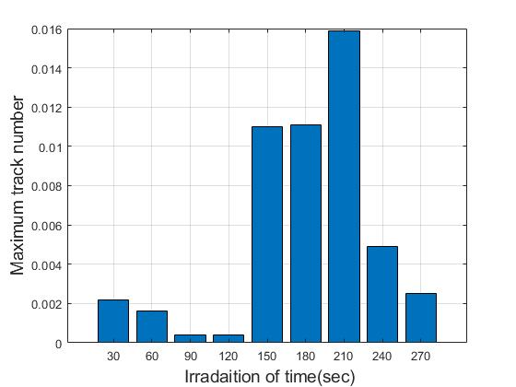

Figure (4-8) Behavior of maximum track number as function of direct irradiation time.

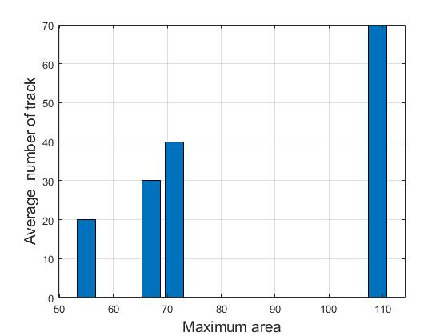

Figure (4-9) Describe increasing the numbering of a track with increasing maximum area when different irradiation times.

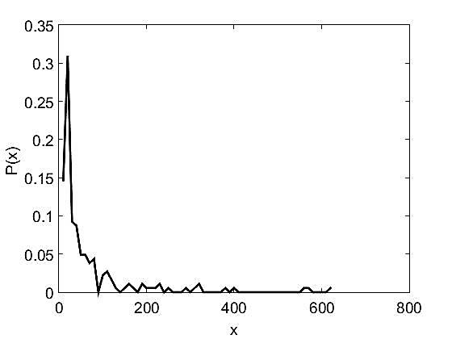 | 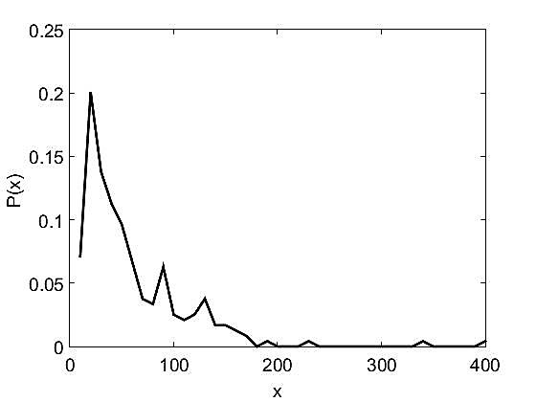
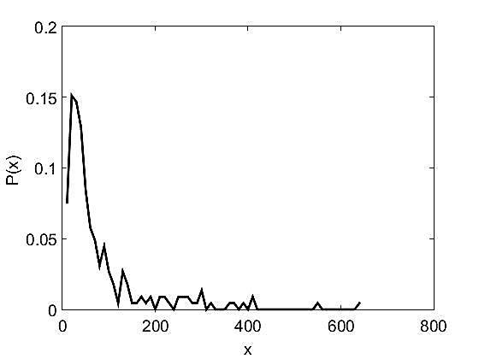 | 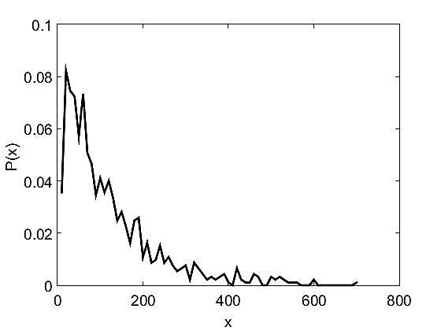

Figure (4-10) Shows relation of the probability density with (x) indicate to the area of finding of track on the CR-39 detector for direct irradiation times.

4-2-2 The relation time of etching with features of tracks
The table (4-6) shows change of number of tracks from fall alpha particles on the material of CR-39 detector for many time of etching (60,120,180, 240) Sec. whereas noticed through figures (4-11),(4-12) increasing of number of tracks to increase time of etching down to its maximum value then the number of track begins to decrease due to the damage of track or result at the end of the range of track located near the surface of the detector or because of physical changes in the surface of the detector(at low energy). The number of track depends not only the chemical etching circumstances condition but also on the irradiation activity as well as detection distances. Finally, the calculation of probability density for each track by MATLAB program in image processing see figure (4-13).
Table (4-6): The time of etching with features of tracks
max_depth | mean_depth | R | ava | area_atmax | maxpro | Tono | code  of  image | Time of etching  (sec)
0.3608 | 0.0014 | 8.7132 | 238.5108 | 20 | 11 | 186 | b(1) | 60
0.2784 | 0.0009 | 5.827 | 106.67 | 20 | 33 | 297 | b(2) | 60
0.3137 | 0.002 | 6.8759 | 148.5291 | 20 | 42 | 446 | b(3) | 60
0.349 | 0.0024 | 8.2116 | 211.8387 | 20 | 19 | 372 | b(4) | 60
0.5373 | 0.0016 | 6.9369 | 151.1746 | 20 | 28 | 338 | b(5) | 60
0.3333 | 0.0022 | 8.1032 | 206.2816 | 20 | 17 | 348 | b(6) | 60
0.2549 | 0.0002 | 4.3143 | 58.4762 | 20 | 14 | 126 | b(7) | 60
0.3294 | 0.0022 | 6.9002 | 149.581 | 20 | 33 | 494 | b(8) | 60
0.3451 | 0.0016 | 6.8548 | 147.6176 | 20 | 35 | 387 | b(9) | 60
0.3176 | 0.0014 | 7.0297 | 155.2492 | 20 | 21 | 305 | b(10) | 60
0.4139 | 0.0022 | 10.1174 | 321.5769 | 450 | 7 | 182 | b(11) | 120
0.4118 | 0.0023 | 9.2625 | 269.5277 | 170 | 9 | 235 | b(12) | 120
0.3765 | 0.002 | 10.0177 | 315.2737 | 490 | 6 | 179 | b(13) | 120
0.4941 | 0.0027 | 5.7159 | 102.6393 | 20 | 84 | 743 | b(14) | 120
0.4078 | 0.0034 | 7.2761 | 166.3232 | 230 | 26 | 622 | b(15) | 120
0.6078 | 0.0033 | 7.6093 | 181.901 | 40 | 26 | 525 | b(16) | 120
0.5765 | 0.0028 | 6.8697 | 148.2592 | 40 | 29 | 571 | b(17) | 120
0.6118 | 0.0032 | 7.6012 | 181.5164 | 20 | 28 | 519 | b(18) | 120
0.7059 | 0.0031 | 7.5689 | 179.9771 | 80 | 25 | 524 | b(19) | 120
0.7373 | 0.0032 | 6.9028 | 149.6929 | 60 | 47 | 687 | b(20) | 120
0.2196 | 0.0009 | 9.016 | 255.3761 | 230 | 6 | 117 | b(21) | 180
0.2039 | 0.0005 | 9.5238 | 284.9483 | 460 | 3 | 58 | b(22) | 180
0.2745 | 0.001 | 8.2893 | 215.8662 | 20 | 8 | 142 | b(23) | 180
0.3176 | 0.002 | 7.8994 | 196.0381 | 190 | 15 | 341 | b(24) | 180
0.1843 | 0.0007 | 7.6455 | 183.637 | 40 | 7 | 146 | b(25) | 180
0.3333 | 0.0014 | 10.0507 | 317.3521 | 20 | 6 | 142 | b(26) | 180
0.3176 | 0.0014 | 10.028 | 315.9209 | 690 | 5 | 139 | b(27) | 180
0.2745 | 0.0017 | 7.6312 | 182.9498 | 40 | 17 | 319 | b(28) | 180
0.2353 | 0.0005 | 5.7814 | 105.0057 | 20 | 17 | 174 | b(29) | 180
0.3333 | 0.0015 | 6.6312 | 138.1459 | 30 | 26 | 370 | b(30) | 180
0.2863 | 0.0023 | 9.0848 | 259.2868 | 340 | 9 | 272 | b(31) | 240
0.1961 | 0.0007 | 6.8693 | 148.2432 | 30 | 10 | 148 | b(32) | 240
0.2865 | 0.0021 | 9.1848 | 260.2868 | 340 | 8 | 270 | b(33) | 240
0.3176 | 0.0014 | 10.3587 | 337.0992 | 390 | 6 | 131 | b(34) | 240
0.298 | 0.0018 | 8.9054 | 249.1453 | 80 | 7 | 172 | b(35) | 240
0.4941 | 0.003 | 9.2847 | 270.821 | 100 | 9 | 257 | b(36) | 240
0.2784 | 0.0027 | 9.9979 | 314.0246 | 300 | 8 | 203 | b(37) | 240
0.3608 | 0.0021 | 6.1021 | 116.98 | 20 | 42 | 501 | b(38) | 240
0.4588 | 0.0014 | 7.9686 | 199.489 | 30 | 9 | 182 | b(39) | 240
0.4314 | 0.0006 | 4.6904 | 69.1148 | 20 | 20 | 244 | b(40) | 240

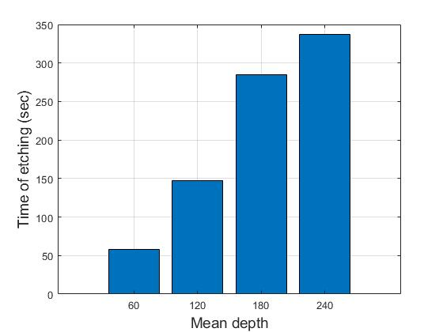
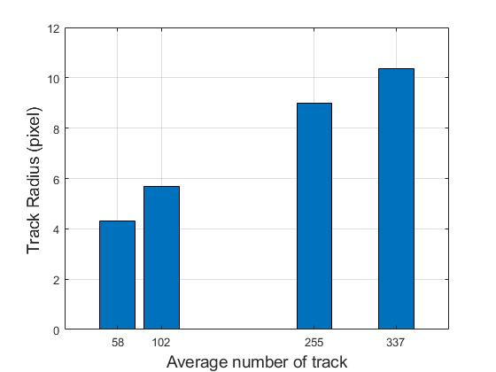Figure (4-11) Linear relation between mean depth of tracks with the chemical etching of time.

Figure (4-12)Describe increasing the average number of the track with increasing track radius when changing etching of time.

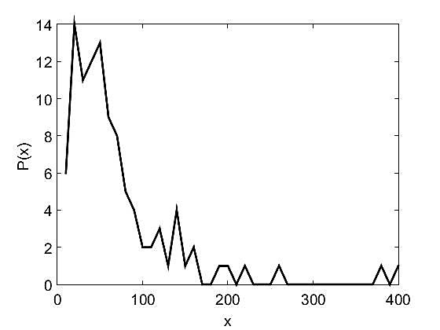 | 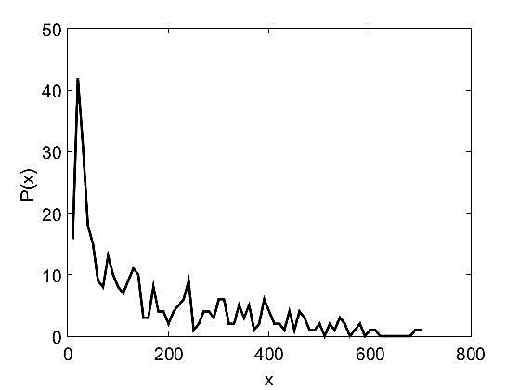
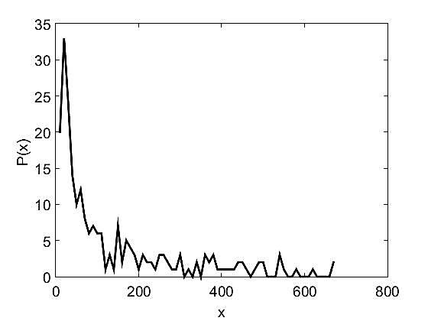 | 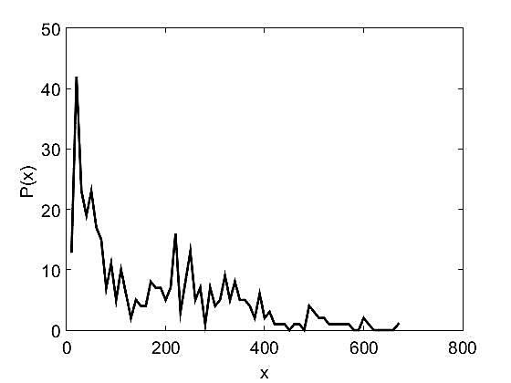

Figure (4-13) Shows relation of the probability density with (x) indicate to the area of finding of track on the CR-39 detector for direct irradiation times.

4-2-3 The relation energy of alpha particles with many features of tracks
The table (4-7) shows change of number of tracks from fall alpha particles on the material of CR-39 detector from Americium Beryllium with activity 12 µ Ci for ranging (0.2, 1, 1.5, 2, 2.5, 3.5, 5) MeV, whereas increasing number of tracks by increasing ranges of energy as Figure (4-14), (4-15). It is known that alpha energy rate emitted from the americium beryllium source used in this study is (5.485) MeV. When the alpha energy is less than this value, the number of particles that reach the reagents is reduced. For example, there is very little (0.2) MeV compared to the density of the tracks of high energies see figure (4-16). Finally, the calculation of probability density for each track by MATLAB program in image processing see figure (4-17).
Table (4-7) illustrate alpha particle energies with features of tracks
max_depth | mean_depth | R | Ava | area_atmax | maxpro | Tono | Code  of  image | Energy  of Alpha  (Mev)
0.2706 | 0.002 | 6.1571 | 119.0992 | 20 | 38 | 595 | d(1) | 0.2
0.2039 | 0.0016 | 6.246 | 122.5608 | 20 | 32 | 551 | d(2) | 0.2
0.251 | 0.0014 | 5.1526 | 83.4061 | 30 | 60 | 687 | d(3) | 0.2
0.2275 | 0.0008 | 3.9797 | 49.7561 | 20 | 79 | 652 | d(4) | 0.2
0.1843 | 0.0011 | 4.9089 | 75.7054 | 30 | 58 | 784 | d(5) | 0.2
0.2196 | 0.0008 | 5.4731 | 94.1042 | 30 | 24 | 355 | d(6) | 0.2
0.2549 | 0.0008 | 5.7036 | 102.2 | 30 | 23 | 315 | d(7) | 0.2
0.2784 | 0.001 | 5.309 | 88.5469 | 20 | 42 | 448 | d(8) | 0.2
0.3569 | 0.0009 | 4.6087 | 66.7279 | 20 | 63 | 588 | d(9) | 0.2
0.2039 | 0.0006 | 4.4728 | 62.8505 | 30 | 50 | 428 | d(10) | 0.2
0.3176 | 0.0015 | 7.8697 | 194.5636 | 60 | 15 | 275 | d(11) | 1
0.2 | 0.0012 | 8.1174 | 207.0082 | 20 | 16 | 243 | d(12) | 1
0.4275 | 0.0013 | 7.4678 | 175.1993 | 20 | 14 | 281 | d(13) | 1
0.4039 | 0.0014 | 7.5221 | 177.7553 | 30 | 16 | 282 | d(14) | 1
0.451 | 0.0019 | 8.2258 | 212.5696 | 40 | 20 | 316 | d(15) | 1
0.4235 | 0.0014 | 6.2455 | 122.5455 | 30 | 35 | 436 | d(16) | 1
0.5647 | 0.0016 | 6.1294 | 118.0269 | 20 | 46 | 484 | d(17) | 1
0.7569 | 0.0011 | 6.0437 | 114.7515 | 20 | 31 | 330 | d(18) | 1
0.749 | 0.0011 | 7.1334 | 159.8629 | 40 | 12 | 197 | d(19) | 1
0.7373 | 0.0014 | 7.4779 | 175.6768 | 20 | 18 | 263 | d(20) | 1
0.7529 | 0.0014 | 4.1748 | 54.7539 | 20 | 120 | 829 | d(21) | 1.5
max_depth | mean_depth | R | Ava | area_atmax | maxpro | Tono | code  of  image | Energy  of Alpha  (Mev)
0.6314 | 0.0016 | 4.457 | 62.4077 | 50 | 93 | 878 | d(22) | 1.5
0.6667 | 0.0017 | 4.4504 | 62.2225 | 20 | 120 | 863 | d(23) | 1.5
0.6157 | 0.0018 | 4.4358 | 61.8143 | 30 | 102 | 910 | d(24) | 1.5
0.0005 | 0 | 0.0047 | 0.0701 | 0.02 | 0.121 | 1.031 | d(25) | 1.5
0.3932 | 0.0016 | 4.3131 | 64.03451 | 30 | 116 | 915 | d(26) | 1.5
0.4667 | 0.002 | 4.7133 | 69.7922 | 20 | 104 | 953 | d(27) | 1.5
0.4235 | 0.0017 | 4.5151 | 64.0454 | 30 | 114 | 904 | d(28) | 1.5
0.3294 | 0.0014 | 5.0299 | 79.483 | 20 | 62 | 646 | d(29) | 1.5
0.8 | 0.0009 | 6.0127 | 113.5755 | 20 | 26 | 278 | d(30) | 1.5
0.2745 | 0.0003 | 4.7495 | 70.8687 | 40 | 22 | 198 | d(31) | 2.5
0.3059 | 0.0003 | 5.081 | 81.1063 | 30 | 15 | 160 | d(32) | 2.5
0.3647 | 0.0004 | 5.2858 | 87.7738 | 20 | 19 | 221 | d(33) | 2.5
0.5882 | 0.0005 | 5.3771 | 90.8342 | 20 | 17 | 193 | d(34) | 2.5
0.4902 | 0.001 | 5.3915 | 91.3197 | 30 | 44 | 488 | d(35) | 2.5
0.5098 | 0.0006 | 5.8312 | 106.8233 | 20 | 35 | 249 | d(36) | 2.5
0.4863 | 0.0003 | 5.9154 | 109.931 | 30 | 9 | 116 | d(37) | 2.5
0.4157 | 0.0006 | 6.8645 | 148.0382 | 40 | 8 | 157 | d(38) | 2.5
0.2863 | 0.0003 | 4.657 | 68.1349 | 30 | 24 | 215 | d(39) | 2.5
0.4353 | 0.0004 | 4.6754 | 68.6731 | 20 | 18 | 208 | d(40) | 2.5
0.6 | 0.001 | 6.0798 | 116.125 | 30 | 23 | 264 | d(41) | 3.5
0.5922 | 0.0009 | 5.888 | 108.9141 | 170 | 18 | 256 | d(42) | 3.5
0.5647 | 0.0008 | 6.2153 | 121.3587 | 170 | 19 | 184 | d(43) | 3.5
0.5922 | 0.0009 | 5.9041 | 109.5125 | 170 | 17 | 240 | d(44) | 3.5
0.4549 | 0.0009 | 6.661 | 139.3871 | 20 | 16 | 217 | d(45) | 3.5
0.5412 | 0.001 | 7.1084 | 158.7416 | 190 | 11 | 209 | d(46) | 3.5
0.4824 | 0.0009 | 6.9401 | 151.3168 | 210 | 14 | 202 | d(47) | 3.5
0.4039 | 0.0008 | 5.4964 | 94.91 | 30 | 28 | 311 | d(48) | 3.5
0.5098 | 0.0008 | 6.0228 | 113.9567 | 40 | 14 | 231 | d(49) | 3.5
0.2863 | 0.001 | 6.6444 | 138.6954 | 40 | 27 | 302 | d(50) | 3.5
0.5098 | 0.0018 | 7.1167 | 159.1137 | 20 | 39 | 475 | d(51) | 5
0.5333 | 0.0015 | 7.3251 | 168.5683 | 20 | 30 | 366 | d(52) | 5
0.3412 | 0.0008 | 5.5401 | 96.4231 | 20 | 34 | 390 | d(53) | 5
0.3176 | 0.0012 | 6.0644 | 115.5377 | 20 | 36 | 478 | d(54) | 5
0.5059 | 0.0016 | 6.4899 | 132.3183 | 20 | 36 | 509 | d(55) | 5
0.3059 | 0.0008 | 4.4645 | 62.6174 | 20 | 55 | 643 | d(56) | 5
0.3765 | 0.0014 | 5.6921 | 101.7889 | 20 | 46 | 578 | d(57) | 5
0.2863 | 0.0019 | 5.2028 | 85.0412 | 50 | 77 | 996 | d(58) | 5
0.3373 | 0.0013 | 4.901 | 75.4611 | 20 | 85 | 785 | d(59) | 5
0.3374 | 0.0009 | 5.8402 | 107.1528 | 20 | 43 | 373 | d(60) | 5
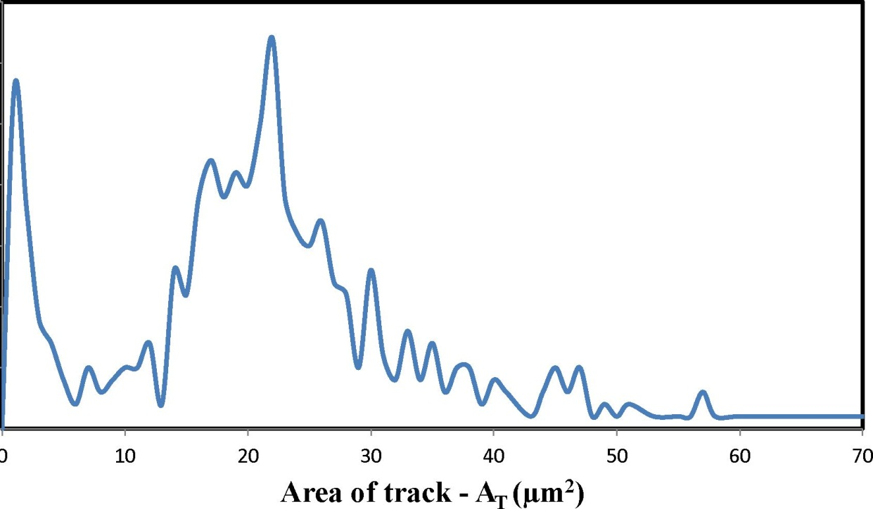

Figure (4-14) Behavior the tracking number as function the track area for irradiation CR-39 detector.

For 1h For 2h For 3h For4h
Time Different of Irradiation
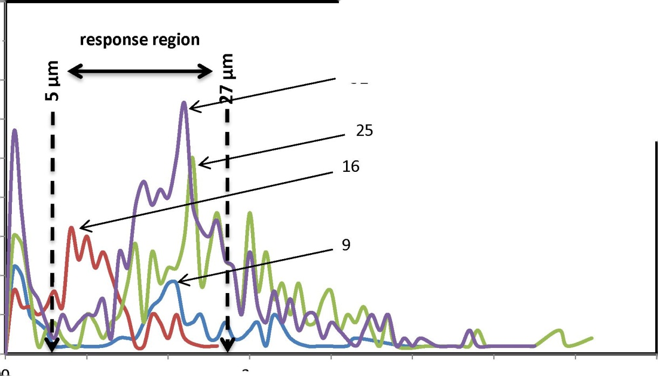
32
Maximum
Radius
Of
Track

Maximum Area (µm) ²
Figure (4-15) Relation between the numbers of track for CR-39 with track area at irradiation time.
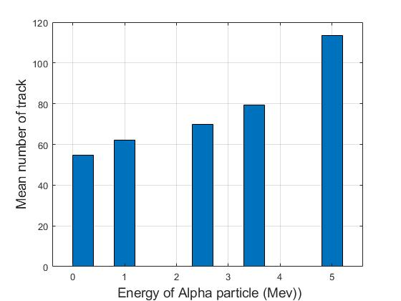
Figure (4-16) Relation between the mean numbers of track for CR-39 with alpha particles alpha energies (0.2, 1, 1.5, 2, 2.5, 3,5) MeV.

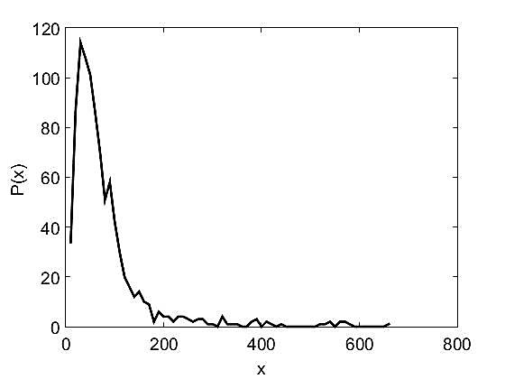 | 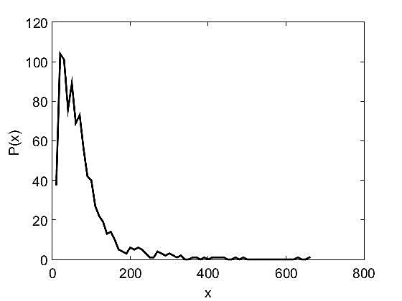
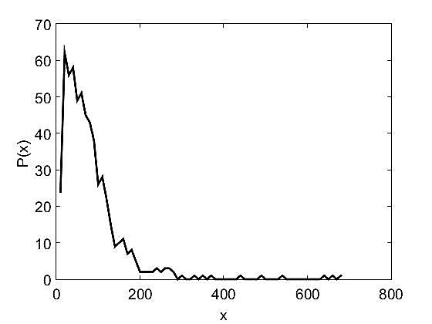 | 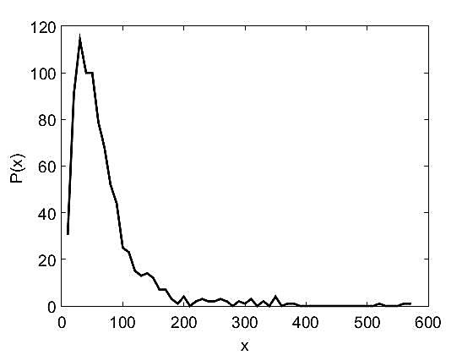

Figure (4-17) Shows relation of the probability density with (x) indicate to the area of finding of track on the CR-39 detector for direct irradiation times.

4-2-4 The relation between second irradiation source for different irradiation time and many features of tracks
The table (4-8) shows number of tracks by Americium - Beryllium with activity 12 curi, it founded in nuclear lab/ college of Ibn-al-Haithum/Baghdad university, whereas papered samples with boric acid pellets to made sandwich then irradiated for (1,2,3,4) hour for four pieces of CR-39 detectors, through images captured appear the resulting average of the number of track increasing in increased time of irradiation of time by MATLAB program as Figures (4-18), (4-19). Finally, the calculation of probability density for each track by MATLAB program in image processing see figure (4-20).
Table (4-8) illustrate the different time of ²⁴¹Am-¹⁰Be with features of tracks
max_depth | mean_depth | R | Ava | area_atmax | maxpro | Tono | code  of  image | Irradiation of Am-Be241  (hour)  12 Ci
0.2039 | 0.0004 | 4.6865 | 69 | 20 | 0.2 | 200 | c(1) | 1
0.3255 | 0.0003 | 3.6819 | 42.5897 | 20 | 0.2036 | 290 | c(2) | 1
0.451 | 0.0004 | 4.1841 | 55 | 30 | 0.142 | 251 | c(3) | 1
0.1843 | 0.0003 | 4.0034 | 50.3503 | 20 | 0.1667 | 177 | c(4) | 1
0.1686 | 0.0001 | 3.2537 | 33.2587 | 30 | 0.2 | 143 | c(5) | 1
0.2039 | 0.0002 | 3.6117 | 40.9808 | 20 | 0.2051 | 208 | c(6) | 1
0.1961 | 0.0003 | 3.9722 | 49.5687 | 30 | 0.1366 | 313 | c(7) | 1
0.2196 | 0.0003 | 4.3442 | 59.2887 | 20 | 0.1792 | 284 | c(8) | 1
0.3059 | 0.0002 | 3.5318 | 39.1868 | 20 | 0.1942 | 182 | c(9) | 1
0.302 | 0.0005 | 4.5834 | 56.996 | 40 | 0.1242 | 252 | c(10) | 1
0.5882 | 0.0008 | 5.4499 | 93.31 | 20 | 0.1643 | 271 | c(11) | 2
0.702 | 0.0009 | 5.2372 | 86.1699 | 20 | 0.1486 | 312 | c(12) | 2
0.5412 | 0.0011 | 5.3394 | 89.5639 | 20 | 0.1185 | 399 | c(13) | 2
0.7412 | 0.0009 | 5.1446 | 83.1475 | 20 | 0.1504 | 305 | c(14) | 2
0.5451 | 0.0005 | 4.9821 | 77.9794 | 30 | 0.1301 | 194 | c(15) | 2
0.5451 | 0.0007 | 5.44 | 92.9716 | 20 | 0.1156 | 211 | c(16) | 2
0.6784 | 0.0012 | 6.5429 | 134.4917 | 20 | 0.0813 | 240 | c(17) | 2
0.5765 | 0.0009 | 5.907 | 109.6198 | 20 | 0.1346 | 263 | c(18) | 2
0.7255 | 0.0011 | 5.3293 | 89.2251 | 20 | 0.1839 | 342 | c(19) | 2
0.6196 | 0.001 | 5.3169 | 88.8095 | 20 | 0.1055 | 336 | c(20) | 2
0.451 | 0.0016 | 5.2898 | 87.9076 | 20 | 0.1146 | 563 | c(21) | 3
max_depth | mean_depth | R | Ava | area_atmax | maxpro | Tono | code  of  image | Irradiation of Am-Be241  (hour)  12 Ci
0.4431 | 0.0012 | 4.7653 | 71.3405 | 30 | 0.1491 | 511 | c(22) | 3
0.4745 | 0.001 | 5.3453 | 89.7618 | 20 | 0.0959 | 319 | c(23) | 3
0.4863 | 0.001 | 5.2843 | 87.7239 | 20 | 0.1133 | 355 | c(24) | 3
0.4588 | 0.0007 | 4.6313 | 67.3848 | 20 | 0.1536 | 343 | c(25) | 3
0.3804 | 0.0015 | 4.8024 | 72.4559 | 20 | 0.139 | 658 | c(26) | 3
0.3686 | 0.001 | 4.8538 | 74.0136 | 20 | 0.1238 | 442 | c(27) | 3
0.5961 | 0.0014 | 4.5757 | 65.7751 | 20 | 0.1503 | 645 | c(28) | 3
0.549 | 0.0019 | 5.749 | 105.4963 | 20 | 0.0903 | 544 | c(29) | 3
0.4039 | 0.0009 | 4.9735 | 77.7086 | 30 | 0.125 | 350 | c(30) | 3
0.5725 | 0.0014 | 6.2173 | 121.4387 | 20 | 0.0827 | 351 | c(31) | 4
0.8118 | 0.0013 | 5.1344 | 82.8186 | 20 | 0.1301 | 474 | c(32) | 4
0.3451 | 0.0013 | 5.8461 | 107.3717 | 20 | 0.1324 | 374 | c(33) | 4
0.6118 | 0.001 | 5.9025 | 109.451 | 20 | 0.1091 | 255 | c(34) | 4
0.451 | 0.0007 | 4.8393 | 73.5714 | 20 | 0.1925 | 294 | c(35) | 4
0.4627 | 0.0006 | 5.0071 | 78.7633 | 20 | 0.1316 | 245 | c(36) | 4
0.6824 | 0.0009 | 5.307 | 88.4817 | 20 | 0.0928 | 301 | c(37) | 4
0.7176 | 0.001 | 5.0996 | 81.7014 | 20 | 0.1408 | 345 | c(38) | 4
0.8196 | 0.0013 | 5.2651 | 87.0878 | 20 | 0.1324 | 444 | c(39) | 4
0.6471 | 0.0013 | 5.4316 | 92.6826 | 20 | 0.1366 | 419 | c(40) | 4

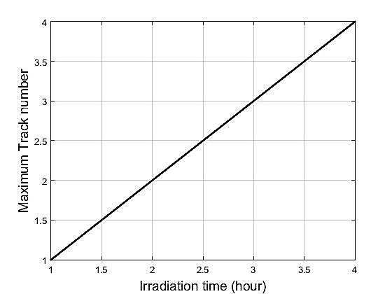

Figure (4-18) Linear relation between maximum track numbers with irradiation time (1, 2, 3, 4) hour.
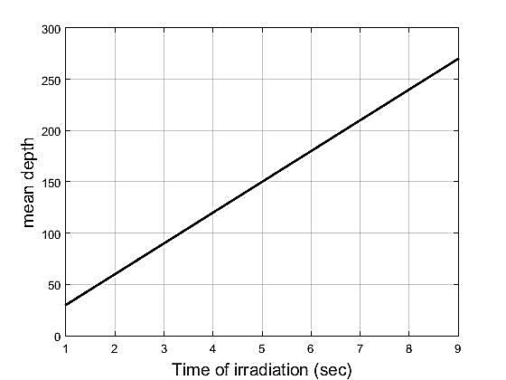

Figure (4-19) Linear relation between mean depth with a time of irradiation when changing values of alpha particle energy.

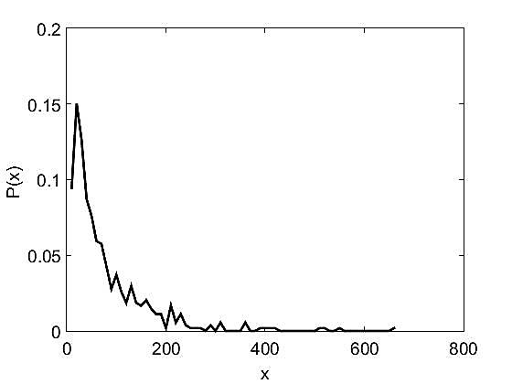 | 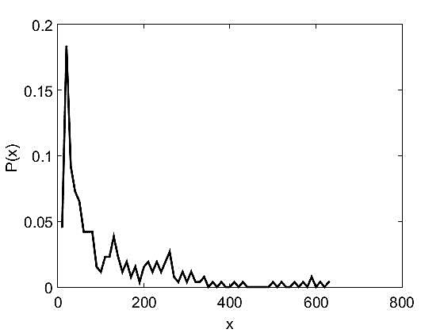
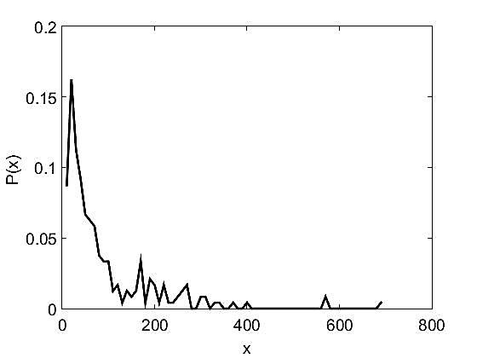 | 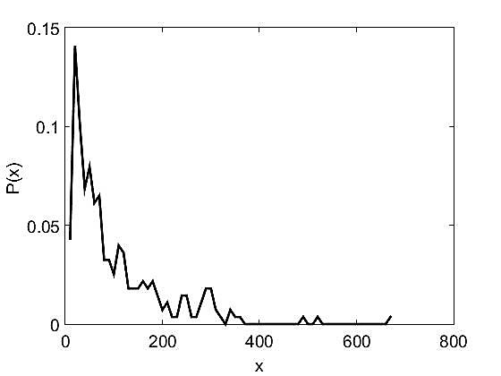

Figure (4-20) Shows relation of the probability density with (x) indicate to area of finding of the track on the CR-39 detector for direct irradiation times.

