Dealing with dialog boxes

Deal Visual Basic with two types of Mھmیn dialog boxes:

- Message boxes Message Boxes

- Funds AledjThe Namely Input Boxes dialog boxes ready in Visual Basic and TstkhaddM toaZھar text or request a simple user response either enter a single line or choose one ExceptZarrar. It Omtheltھa dialog boxes that appear to make sure the user kid who asks to delete a file or folder.

- Common dialog boxes: Common Dialog Boxes namely built into Windows, such as boxes select files, color, control printing .... etc.

Message Box : Message Box

It is a window of simple displays a message with one command button or more. These are usedExceptZarrar the program to make sure that the user read the message, even if there was a decision should be taken after reading the message, the buttons determine the user's choice.

There are two ways to use Message Box

First: Are the wordsMsgBox namely the return (give the value).

Second: Use the functionNamely MsgBox returns a value determines which button is selected.

Despite the usefulness of Message Box in the program, but some use imposes restrictions namely:

- No Accept MdechNoT of the user, messages only appear Vھa and only display and accept specific options.

- No Allow the use of more than four specific codes by Visual Basic and six buttons is inside the Dialog .Box

- The program stops until the user is given to the message, and this means that these funds No You can use it For Adhar The situation is constantly changing, the program waits until Allen A user then resumes its work.

The general formula of the term MsgBox

MsgBox "Prompt", buttons, "Title for The Window"

Where the factor prompt Text ferry (String), which is intended Azھarھa on the Message Box and must note that when writing two Alrsalh- text:

- No Increasing the number of AoharAndP for 1024 characters.

- The message text is placed between my reference citation "," if the value of fixed .kzlk can be added ExceptKawas in the absence of the rest of AlamaamNoT.

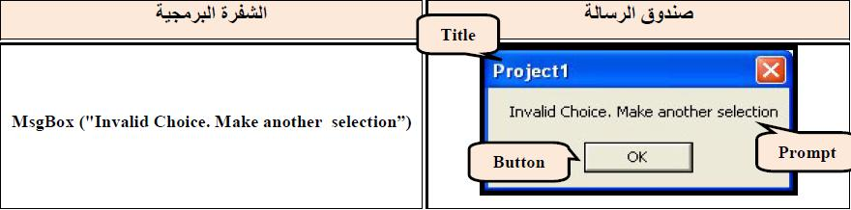

MNoHzat-:

- In the case of filling allocated only part of the message, the message box will contain a written message and one command button is OK, the Fund and the title of the same project name.

- When you read the message of the reNoS Fund is not returned to the value of the program to be tested and to change the program's progress by value feedback.

- The Fund is closed either by pressing the buttonOK or signal shutdown in the upper right corner.

- Laboratory title (Optional) represents the title Zaھr . Message Box

- It consists of laboratories (Buttons optional (of a total of four values ​​of numerical correct (Integer) represent blades or constants of numerical correct knowledge of the Visual Basic program is used instead "for cipher numerical order to prevent" error include each one of these groups on the options group, and each one of these options corresponds to numeric value, and collect values ​​approved for options that یrیdھa programmed are allocated fund.
❖ Values ​​are all four:

) A numerical value for the first specifies the number and type of buttons that appear on the Message Box namely as follows:
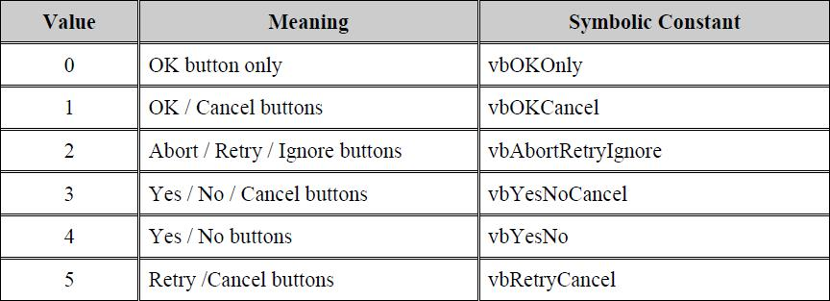

) B The second numerical value specifies the code shown on Message Box

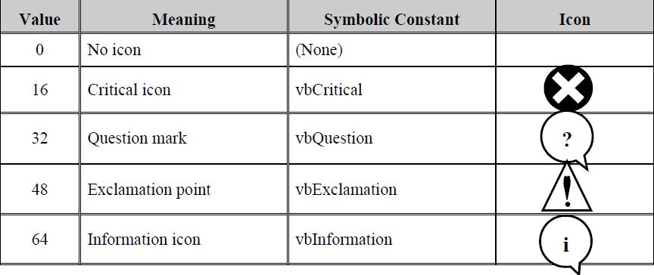

) C The third numerical value specifies the default button that is where the focus responds directly to the key .Enter
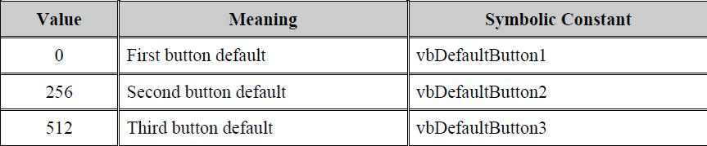

)d fourth numerical value determines the presence of the user icon on the title bar.

The laboratory response Determines the return value) given) that depend on the button that is chosen by the user and follows :
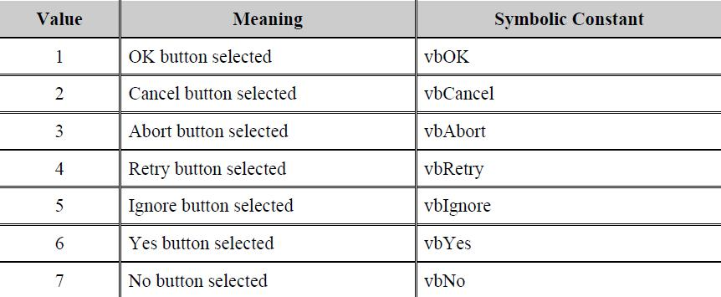

Example :The fact that a message box containing three buttons areYes, No, Cancel button is No button is the default and includes information icon:

result = MsgBox ( "save change", vbYesNoCancel + vbDefaultButton2 + vbInformation, "Exit")

- As possible in writing the previous code as the code Altala-:

result = MsgBox ( "save change", 3 + 256 + 64, "Exit")

- It can also be written as the previous code programming Altala-:

result = MsgBox ( "save change", 323, "Exit")

NoLuck reduced the possibility of some of the properties of bExceptFigures from the GNoFor collected in one number as in the case 3 +256 +64 = 323 323, where the figure was reduced eachExceptFigures and properties of one paragraph.

Where BalaPlace the use of reserved words or digital values ​​corresponding Lھa or total these values.
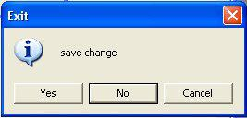

In such case, the message is re-numeric value fund program can take advantage of which to determine the course of the work program as the presence of more than a button within the message box means that there is more than the value of recycled and in this case we can use one of the terms Select Case or If follow-up program, according to the value returned from the dialog box.

Examples of a variety of different funds set up messages buttons and icons include:
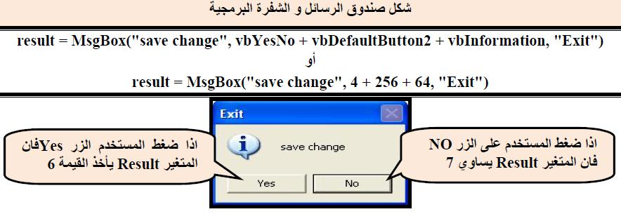

The following code shows us how to get feedback value from one of the options dialog box:

Private Sub Command1_ Click ()

r = MsgBox ( "Save Change", 323 + 4096, "Exit")

Print r

End Sub

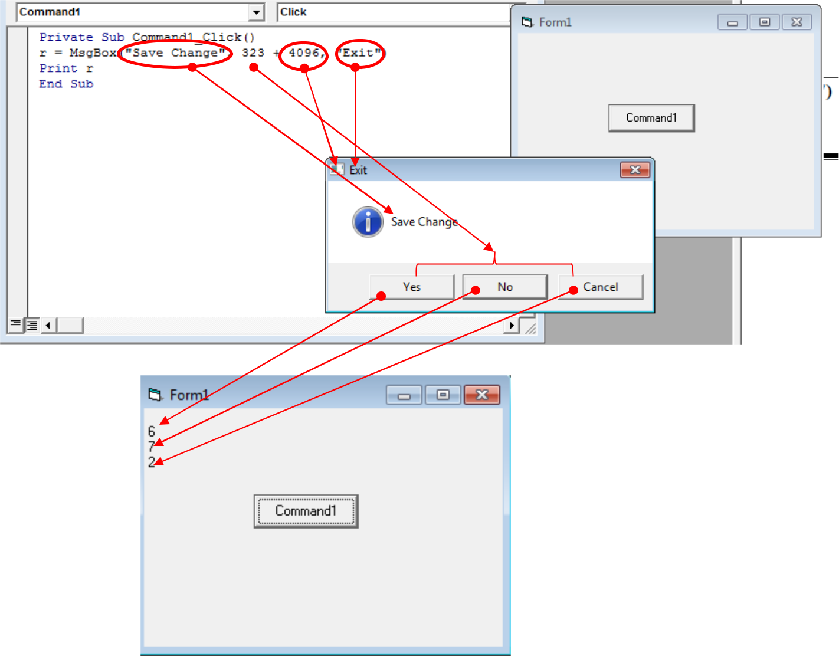

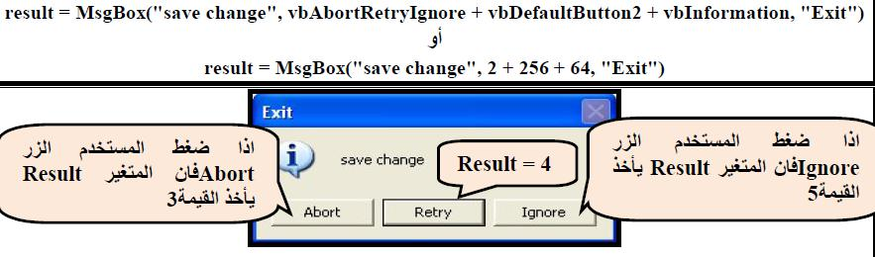

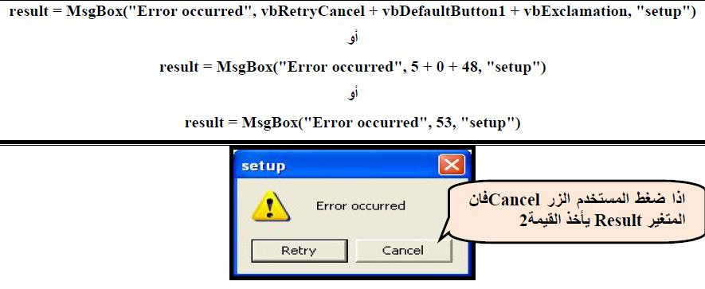

Example : Designed window include:

- three Text boxes To enter ExceptCm, age and academic achievement

- threeOf buttons to display the information is entered, a survey information and exit from the program

- Information presented in the message box, and if you want to clear the information یzھrsndouk message to confirm the desire to scan and if you want to get out message appears to confirm the exit.

3 Lables
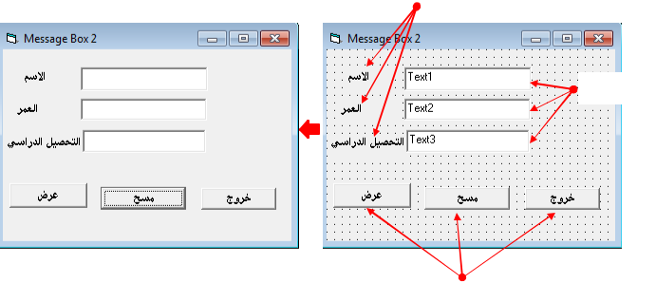

3 Text Box

3 CommandBotton

Example:

Design a project window used to enter person's name and age into two list boxes by using command button "Insert Data". The window must contain the following options:

1- If the insertion of age is abnormal then a warning message must be shown with one "OK" command which is "Age must be a number in the range of 1 to 99"

2- If the insertion is right then the window asks about the location of insertion for the new data in list (Top or Button).

3- When the user command button "Exit", the window ensure by using Query Message about the exiting.
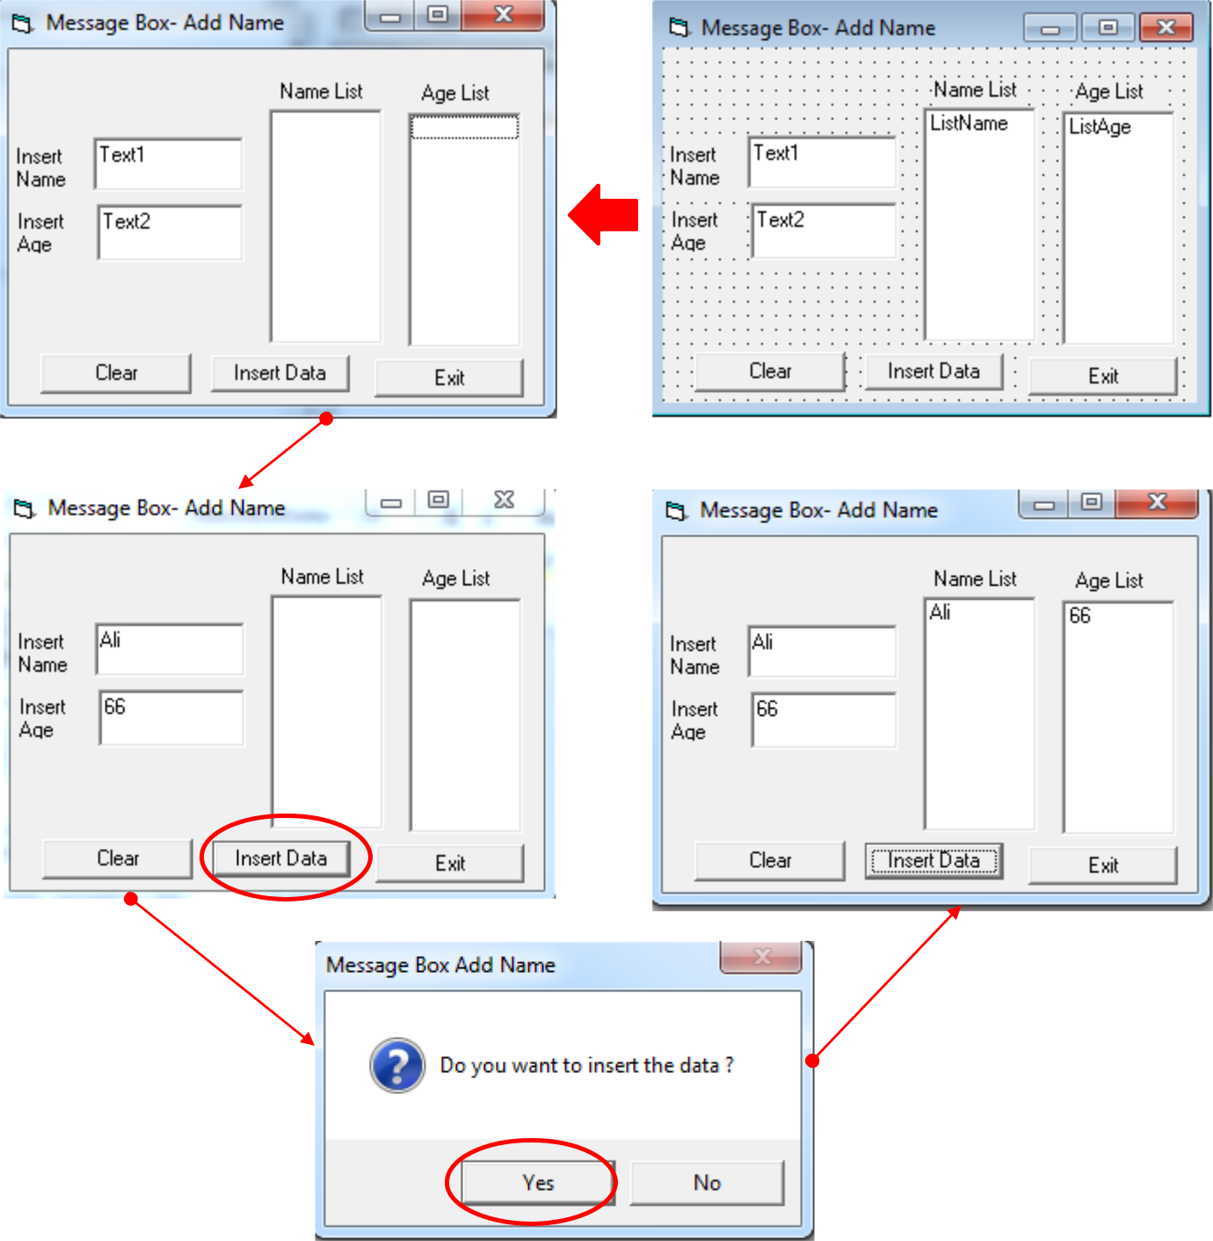

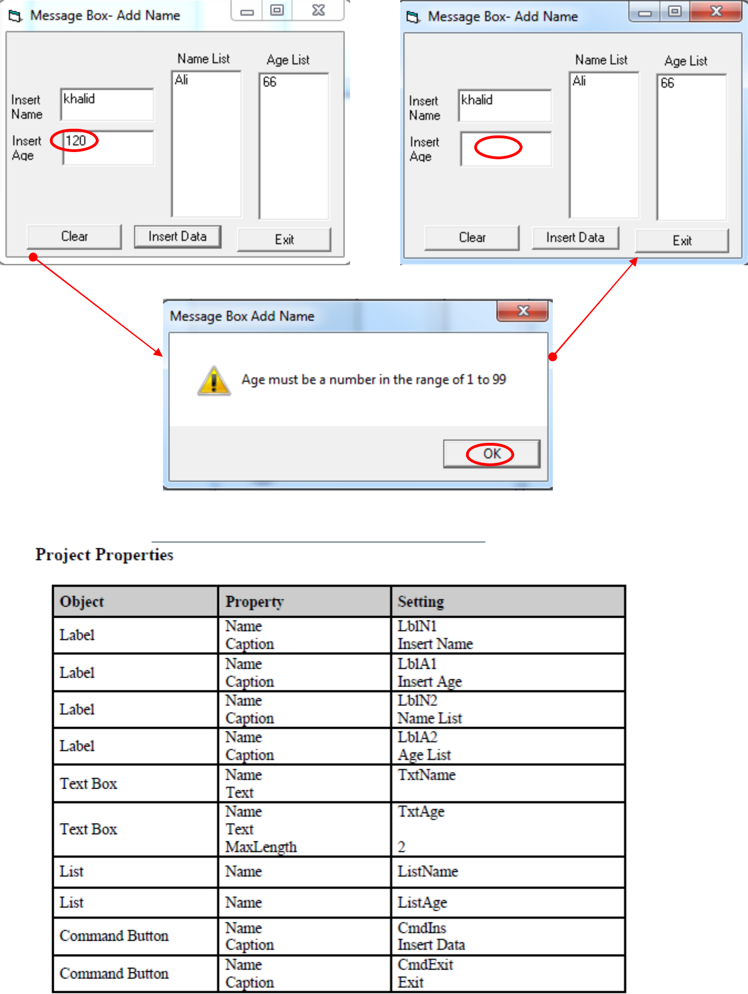
HW Rephrase program sectorNoIn order to deal with its ExceptThe wrong income in the old field if we enter letters instead of ExceptFigures?

