Introduction:

Languages ​​classified software to a range of levels to rely on programmatic style followed in the writing program and the degree of complexity and procedures, services and Alaudhaiv provided by the programming language, and this so-called Altchinvat High Level Language (HLL) to:

: Non-Procedural Language -1 programming languages ​​are not procedural

It characterized these languages ​​that the program is written as a single unit and is divided into several units.

- Disadvantages of these languages:

  - The program size is too large.

  - Difficult to control the operations of the program.

  - The difficulty of error handling.

: Procedural Language -2 programming languages ​​procedural

The ability of these languages ​​give the programmer to carry out the program to dividing several units Each unit unit is doing a particular when integrating all units with the construction of the program are some of which.

: Visual Language-3 languages ​​visual

These languages ​​are based on the principle of dividing the program into a set of objects (known as Oھo-oriented programming objects) where graphics are used in the programming process which saves time in the programming process and facilitates the programmed process of building the program.

Visual Basic Concepts and Terminology

- Object Oriented Programming OOP

This method allows the project by dividing Project into several parts and each part is called Object Object Valenavzh The main project is the object and its contents of the boxes tools Tool Box are the objects as well as the form Form is the object and others as well, the programmer then select specifications and functions of each object separately and application of these functions the purpose of the project is realized.

- Project

This is called the name on the file or group of files representing the application resulting from a language Visual Basic and configure any project language Visual Basic Valibd traffic in three steps are:

1. | Design windows and interfaces Window Interface using objects .Objects
2. | Determine the properties and specifications of windows and parts thereof.
3. | Writing the code Namely Code Programming programs are implemented or Astdaaiھa when applying happened to meyen | Event such as
 | Clicking the mouseMouse Click results when implementing these programs, such as the actions of numerous open windows or secondary | Survey
 | The contents of the current window or terminate the implementation of the project.

• Form Form

Oھo is a window that is placed objects Tool Box Alیھa contains model variables as well as Variable Events special events Bھ in addition to a range of functions .Function The model ground that is building the project Alیھa all its details and joints.

- Properties Properties

Objects are the specifications of which are determined (after the object was created) either Pachtیarھa of the menus available in the properties window Properties Window or enter their value by using the code based on what happened.

Methods •

Namely acts that Bھa objects are achieved only when the implementation of the code.

- Events

Namely a actions that the user Bamlھa during the implementation of the program and there are events linked to Mouse Events as well as linked to the keyboard events are called events Keyboard Keyboard Events and ھnalk some of the events associated with the objects of the Objects system.

- Modules

Are a Objects contain variables, and we mean here the general variables Global Variable and we mean they follow the model or return to a specific but rather are used in general in all components of the program or application forms.

- Visual Program Languages ​​Programming Languages ​​Esophagus

Are defined programming languages ​​on visual languages ​​that they are of use, during which visual expressions Visual Expression and these expressions graphics Graphics as well as animation Animation and Icons Icons of the most programs prevalent in the world as an example of visual programming are windows Windows like WinMe, Win98 consists environment code from a set of tools and a set of interfaces application used and which, during which the user can or programmed dealing with the environment, and provide a visual environment programming visual programming environment graphics icon and we mean Bھa graphics that are more icons that represent the user Objects that can handled when building the program.

- Advantages of Visual Languages

.1 The Big require knowledge in programming concepts

.2 Provide coherence between the well parts of the program.

.3 Showing the relationship is clearly between the components of the program or application objects.

.4 Save time during the operation code.

We will learn about the advantages and how the programming language Visual Basic, which is the programming language, graphical terms designed interface program on the shape you want, including display images, graphics, and put buttons and input elements and directing and writing the code for each to lead its work element as it should. Alfjwal BASIC supports programming directed by events
Events Driven Programming from where we respond in writing programs, during which the effective user, such as clicking the mouse or pressing the keyboard.
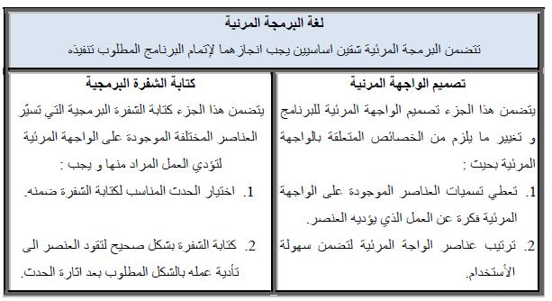

Tabel 1: Compare between the Menu Design and Writing the Code

Luck the following figure, which shows how important it is to take care of Ballowajھh visual program.
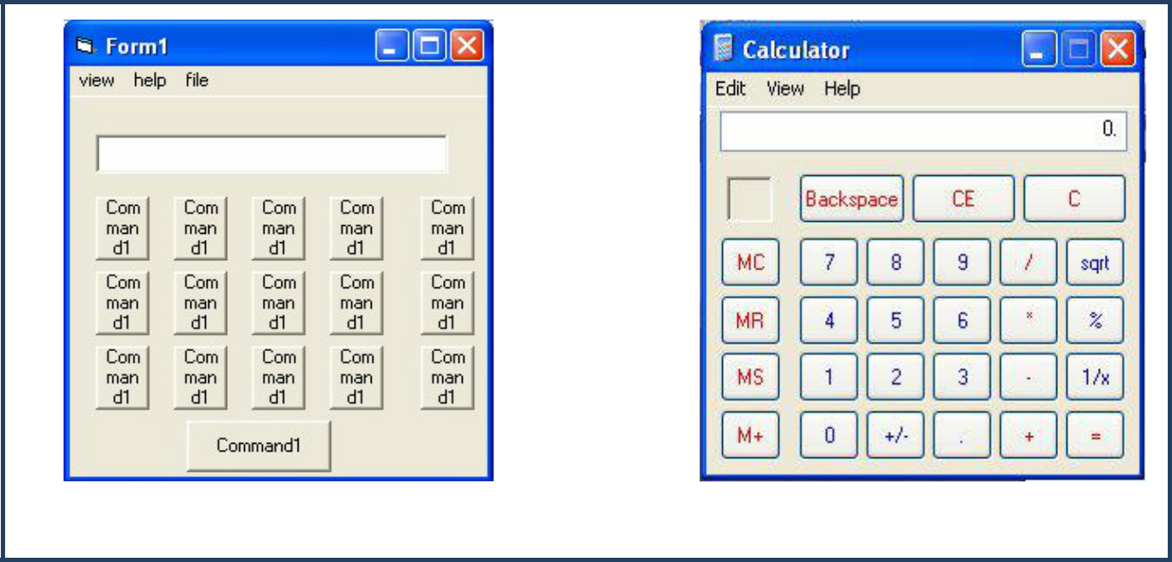

Figure 1: Compure between Two Menus Design

The program Visual Basic is an integrated environment evolutionary so-called Alیھa b Visual Basic IDE IDE is a third English characters means Integrated Design Environment and Manaھa AF development environment or integrated design. To use the tools and advantages Alfjwal Basic first last forever "of turned on as follows:
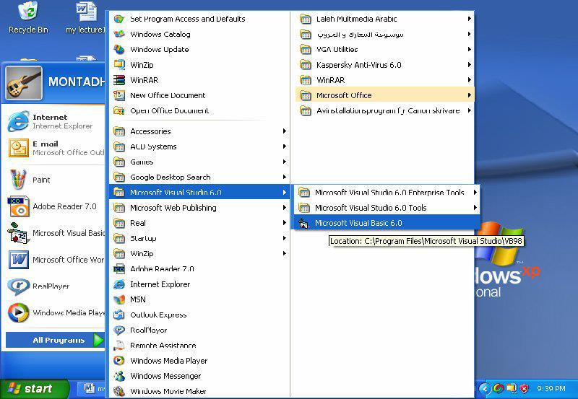

Figure 2: The Path to Run VB

When you run a program Visual Basic will appear a new New Project dialog box, and this box you can choose the type of program you want to create. The project of the new square New Project includes three tabs:

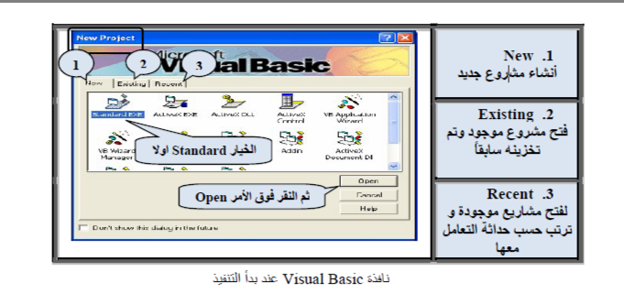

:

New • This allows you to choose the project for the new tab you want to create the type and once you choose the type of specific Projects establishes Visual Basic appropriate template for this project, Visual Basic automatically selects the type standard and a standard Manaھa.

- Existing: This allows you tab to review the existing projects you have.

- Recent: shows the names of other projects you Bchgیlھa. Any work that was of recently.

May nota Bzھor want the dialog box New Project at the beginning of the operation. In this case click on the investigation box (Do not show this dialog in the future) will start a project without a default appearance box talk show off the bottom Alsndouk.and of A Visual Basic new New Project

Usually demonstrate window New Project Select Tools from the menu bar, and then Options tab and then Environment and then did the option Prompt For Project and then click on the button .OK
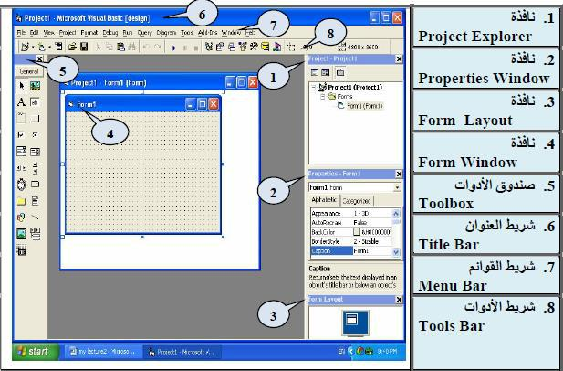

Figure 4: Visual Basic Inviroment

Work Area Work Area

Once you have selected the type of project of the box New Project will be displayed integrated design environment (IDE) design environment or some may differ from those Anasserھa that appear if you have what is set and modify the Visual Basic environment in advance. Visual Basic uses the same elements that you are using most of the programs .Windows window Alfjwal includes many BASIC of the tapes and windows that یbیnھa shape (No. 4). Where we notice in this form and three tapes are:

- Address bar (Title Bar), which includes the title of the project.

- Menu bar ( (Menu Bar, which includes a set of lists to perform different functions.

- Toolbar (Tools Bar) to ensure this access is easy to tape some of the functions in the drop-down menus. B added to Acrtھ shows a set form the next set of windows that enable us to deal with in A Visual Basic and Plain Below we will learn to deal with these tapes and windows as shown in the following figure) number: 5)

Elements of the design environment:

♦ menu bar Menu Bar

It contains a list of thirteen major and each list includes a number of commands needed by the user of which:

- File: contains commands related files, Add, Save, Open) file creation of an Executive Make Project1.exe, ...

etc(

- Edit: Orders update Undo (, Cut, Copy, Paste, (Find

- View: View and hide components Environment Project Window (Properties Window Visual Basic, Properties Window,) Tool Bars

- Project: Add project components form) Form, Unit procedures.) Module

- Format: project coordination components) alignment Align, unify Size Make Same Size, determine the distances and vertical horizontal.) Vertical and Horizontal Spacing

- Run: orders execution) start-up Start, stop the temporary implementation.) Break

- : Window orders to arrange the windows.

  - Tools Bar Toolbar

Toolbar contains a set of icons Icons, each of which serves as a function can be Astdaaھa directly as soon as you click Alیھa, instead of opening menus and select the commands of which, the first instance of a button in the left hand toolbar standard is the Add New Project and means box opens a new project. Visual Basic includes four bars instruments are:

- : Standard Toolbar any standard toolbar and appears automatically at startup.

- : Debug Toolbar contains buttons or tools help track and debug the program.

- : Edit Toolbar contains tools used while writing instructions, procedures.

- : Form Editor contains tools to help you control the existing tools within the form.

Azھar or hide any of the toolbars, select View then Toolbars and choose the name of the tape from the list.

