Transmission Medium
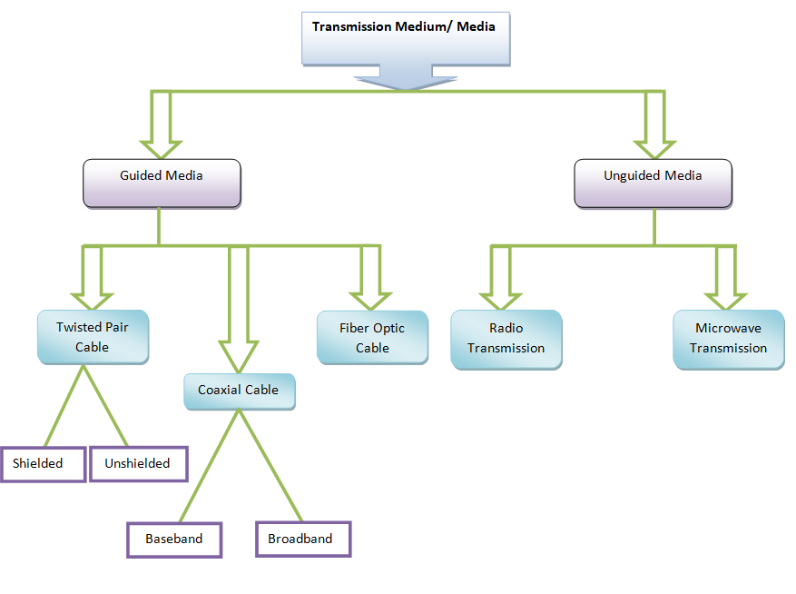

- Transmission Medium
The transmission medium is the physical path between transmitter and receiver in a data transmission system. Various physical media can be used for the actual transmission. Each one has its own bandwidth, delay, cost, and ease of installation and maintenance.Transmission media can be classified as “guided or unguided”. In both cases, communication is in the form of electromagnetic waves. With guided media, the waves are guided along a solid medium, such as copper twisted pair, copper coaxial cable, and optical fiber.

The purpose of the physical layer is to transport a raw bit stream from one machine to another.

The atmosphere , outer space , laser and radio are examples of unguided media that provide a means of transmitting electromagnetic signals but do not guide them; this form of transmission is usually referred to as wireless transmission.
The characteristics and quality of a data transmission are determined both by the characteristics of the medium and the characteristics of the signal. In the case of guided media, the medium itself is more important in determining the limitations of transmission.
For unguided media, the bandwidth of the signal produced by the transmitting antenna is more important than the medium in determining transmission characteristics.
One key property of signals transmitted by antenna is directionality. In general, signals at lower frequencies are omnidirectional (not having a specific direction), that is, the signal propagates in all directions from the antenna. At higher frequencies, it is possible to focus the signal into a directional beam.
In considering the design of data transmission systems, a key concern, isdata rate and distance: greater data rate and distance, is the better. A number of design factors relating to the transmission medium and to the signal determine the data rate and distance.

- Guided media
Which are those that provide conduit from one device to another includetwisted-pair cable,coaxial cable and fiber optic cable . A signal traveling along any of these media is directed and contained by physical limits of the medium. Twisted-pair and coaxial cable use metallic(copper) conductor that accept and transport signals in the form of electric current. Optical fiber is a cable that accepts and transport signals in the form of light.
1.Twisted Pair

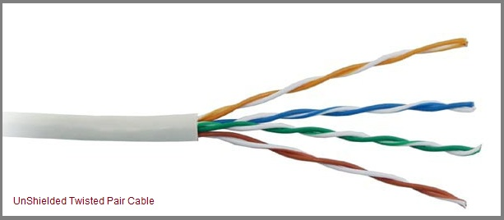

The oldest and still most common transmission medium is twisted pair. A twisted pair consists of two insulated copper wires, typically 1mm thick. The wires are twisted together in a helical form ,just like a DNA molecule. The purpose of twisting the wires is to reduce electrical interference from similar pairs close by. The most common twisted-pair cable used in communications is referred to as unshielded twisted-pair (UTP). Due to its low cost, UTP cabling is used extensively for local-area networks (LANs) and telephone connections.
UTP cabling does not offer as high bandwidth or as good protection from interference as coaxial or fiber optic cables, but it is less expensive and easier to work with. There are several UTP categories, which increase in bandwidth, for example:
CAT1 = up to 1Mbps | CAT2 = up to 4 Mbps | CAT5e = up to 1Gbps
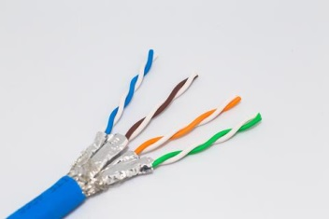

Also there is a version of twisted-pair cable used called shielded twisted pair (STP).STP cable has a metal foil jacket to cancel any external interference covering each pair of insulated conductors. Although metal casing improves the quality of cable by preventing the penetration of noise or crosstalk noise, it is bulkier and more expensive. STP cabling often is used in Ethernet networks, especially fast data rate Ethernets.

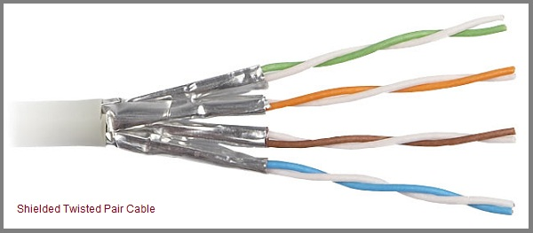

The most common application of the twisted pair is the telephone system. Twisted pairs can run several kilometers without amplification, but for longer distances, repeaters are needed. Twisted pairs can be used for either analog or digital transmission. The bandwidth depends on the thickness of the wire and the distance traveled .Due to their adequate performance and low cost, twisted pairs are widely used and are likely to remain so for years to come. Twisted pair cabling comes in several varieties, two of which are important for computer networks.
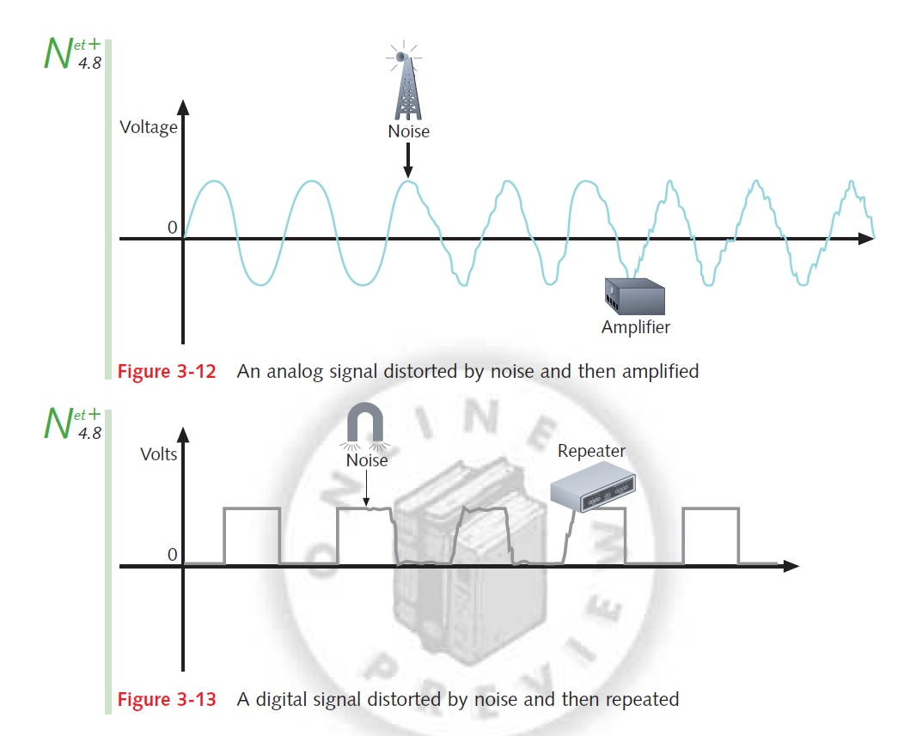

- Category3 twisted consist of two insulated wires gently twisted together. Four such pairs are typically grouped together in aplastic sheath for protection and to keep the eight wires together.

- Category 5 twisted pairs are similar to category 3 pairs, but with moretwists per centimeter and Teflon insulation, which results in less crosstalkand a better quality of signal over longer distances, making them moresuitable for high-speed computer communication. Both of these wiring typesare often referred to as UTP (Unshielded Twisted Pair).

2.Coaxial Cable
Another common transmission medium is the coaxial cable (known as coax), it has better shielding than twisted pair, so it can span longer distances at higher speeds, Coaxial cables are high-frequency transmission cables made up of a single solid-copper core. Data is transferred electrically over the inner conductor and has 80X more transmission capacity than twisted pair cables.
Coaxial cables do not produce external electric and magnetic fields and are not affected by them, This makes them ideally suited, although more expensive, for transmitting signals. This cable is suitable for point to point or point to multipoint applications.
- Two kinds of coaxial cables are widely used:
1. One kind, 50-ohm cable is commonly used for digital transmission.
2. The other kind, 75-ohm cable is commonly used for analog transmission.
A coaxial cable consists of a stiff copper wire as the core, surrounded by an insulating material. Insulating material is encased by a cylindrical conductor, often as a closely woven braided mesh. The outer conductor is covered in a protective plastic sheath. A cutaway view of a coaxial cable is shown in the figure below:
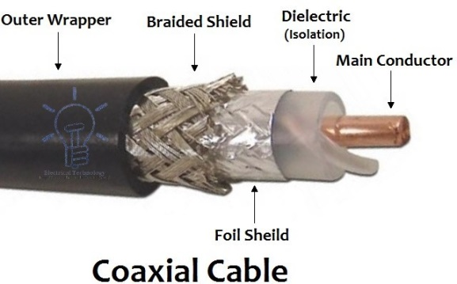

The construction and shielding of the coaxial cable give it a good combination of high bandwidth and excellent noise immunity. The bandwidth possible depends on the cable length. Coax is still widely used for cable television and some local area networks.

- Types of Coaxial Cables
There are two types of coaxial cables:
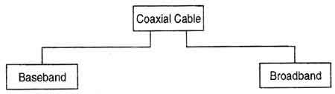

- A baseband coaxial cable
- Baseband coaxial cables are 50 ohm cables used for 'digital transmission'.
- Transmits a single signal at a time at very high speed.
- Baseband coaxial cable supports frequency range of a-4kHz and are used for digital signaling.

- A broadband coaxial cable
- Broadband coaxial cables are 75 ohm cables used for analog transmission.
- Can transmit many simultaneous signals using different frequencies. A baseband cable is mainly used for LANs.
- Broadband coaxial cable supports the frequency range above 4kHz and are used for analog signals.
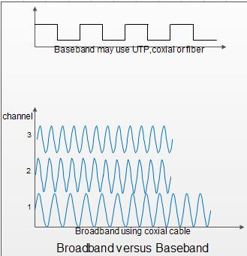

Advantages of Coaxial Cables:
1.It can be used for both analog and digital transmission.
2. It offers higher bandwidth as compared to twisted pair cable and can span longer distances.
3. Because of better shielding in coaxial cable, loss of signal or attenuation is less.
4. Better shielding also offers good noise immunity.
5. It is relatively inexpensive as compared to optical fibers.
6. It has lower error rates as compared to twisted pair.
7. It is not as easy to hack as twisted pair because copper wire is contained in plastic jacket.
Disadvantages of Coaxial Cables:
1. It is usually more expensive than twisted pair.
2. High installation cost. High maintenance cost.

3.Fiber Optics (Optical Fiber)
Introduction:
While copper wire cables were the traditional choice for telecommunication, networking and cable connections for years, fiber optics has become a common alternative. Optical fiber carries more information than conventional copper wire, due to its higher bandwidth and faster speeds. Because glass does not conduct electricity, fiber optics is not subject to electromagnetic interference, and signal losses are minimized. In addition, fiber optic cables can be flooded in water and are used in more at-risk environments like undersea cable. Fiber optic cables are also stronger, thinner and lighter than copper wire cables and do not need to be maintained or replaced as frequently.

Fiber optics, refers to the medium and the technology associated with the transmission of information as light pulses along a glass or plastic strand or fiber. A fiber optic cable can contain a varying number of these glass fibers from a few up to a couple hundred.
Surrounding the glass fiber core is another glass layer called cladding. A layer known as a buffer tube protects the cladding, and a jacket layer acts as the final protective layer for the individual strand or fiber.
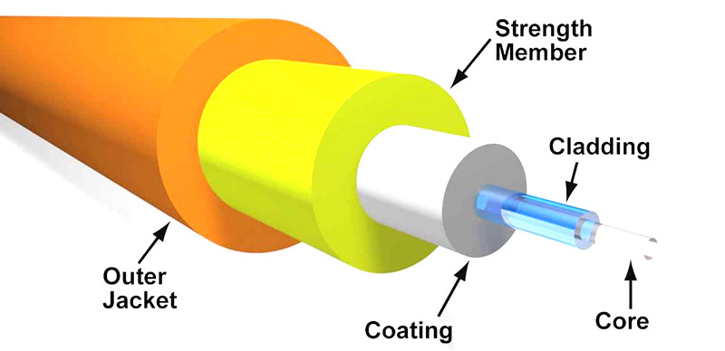
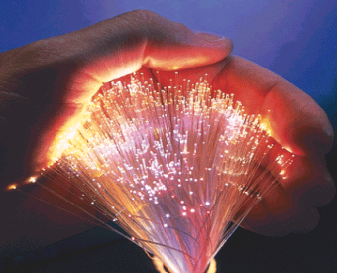
How Fiber Optics Works
Fiber optics transmit data in the form of light particles or photons that pulse through a fiber optic cable. The glass fiber core and the cladding each have a different refractive index that bends incoming light at a certain angle. When light signals are sent through the fiber optic cable, they reflect off the core and cladding in a series of zig-zag bounces, this process called Total Internal Reflection (TIR). The light signals do not travel at the speed of light because of the denser glass layers, instead traveling about 30% slower than the speed of light.
To renew, or boost, the signal throughout its journey, fiber optics transmission sometimes requires repeaters at distant intervals to regenerate the optical signal by converting it to an electrical signal, processing that electrical signal and retransmitting the optical signal as shown in the figure below:
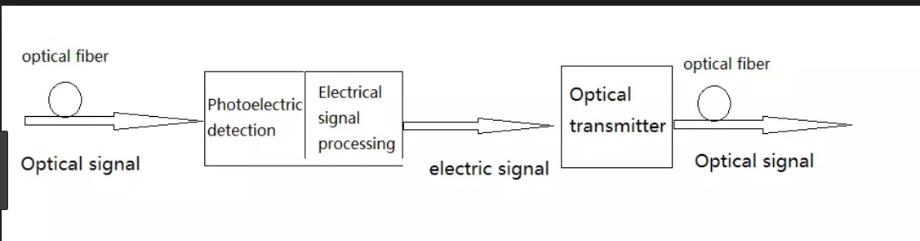
Types of Fiber Optic Cables
Multimode fiber and single-mode fiber are the two primary types of fiber optic cable.
- Single-mode fiber (SMF): Is used for longer distances due to the smaller diameter of the glass fiber core, which lessens the possibility for attenuation the reduction in signal strength. The smaller opening isolates the light into a single beam, which offers a more direct route and allows the signal to travel a longer distance. Single-mode fiber also has a considerably higher bandwidth than multimode fiber. The light source used for single-mode fiber is typically a laser. Single-mode fiber is usually more expensive because it requires precise calculations to produce the laser light in a smaller opening.

- Multimode fiber (MMF):Is used for shorter distances because the larger core opening allows light signals to bounce and reflect more along the way. The larger diameter permits multiple light pulses to be sent through the cable at one time, which results in more data transmission. This also means that there is more possibility for signal loss, reduction or interference, however. Multimode fiber optics typically use an LED to create the light pulse.
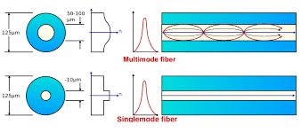
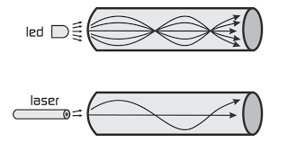
- Optical Transmission System has three components:

1. The light source: A pulse of light indicates a 1-bit and the absence of light indicates a Zero bit.
2.The transmission medium: The transmission medium is an ultra-thin fiber of glass.
3.The detector: The detector generates an electrical pulse when light falls on it, by attaching a light source to one end of an optical fiber and a detect or on the other, we have a unidirectional data transmission system that accepts an electrical signal, converts and transmits it by light pulses, and then reconverts the output to an electrical signal at the receiving end.

- Two different types of light source are used in fiber optic systems: the light emitting diode (LED) and the injection laser diode (ILD). Both are semiconductor devices that emit a beam of light when a voltage is applied. The LED is less costly, operates over a greater temperature range, and has a longer operational life. The ILD, which operates on the laser principle, is more efficient and can support greater data rates.

- Advantages and Disadvantages of Optical Fiber
- Advantages Fiber-optic cable has several advantages over metallic cable (twisted pair or coaxial):
1. Higher bandwidth. Fiber-optic cable can support dramatically higher band widths (and hence data rates) than either twisted-pair or coaxial cable. Currently, data rates and bandwidth utilization over fiber-optic cable are limited not by the medium but by the signal generation and reception technology available.
2.Less signal attenuation. Fiber-optic transmission distance is significantly greater than that of other guided media. A signal can run for 50 km without requiring regeneration. We need repeaters every 5 km for coaxial or twisted-pair cable.
3. Immunity to electromagnetic interference. Electromagnetic noise cannot affect fiber-optic cables.
4. Resistance to corrosive materials. Glass is more resistant to corrosive materials than copper.
5. Light weight. Fiber-optic cables are much lighter than copper cables.
6. Greater immunity to tapping. Fiber-optic cables are more immune to tapping than copper cables. Copper cables create antenna effects that can easily be tapped.

- Disadvantages There are some disadvantages in the use of optical fiber.

1. Installation and maintenance. Fiber-optic cable is a relatively new technology. Its installation and maintenance require expertise that is not yet available everywhere.
2. Unidirectional light propagation. Propagation of light is unidirectional. If we need bidirectional communication, two fibers are needed.
3. Cost. The cable and the interfaces are relatively more expensive than those of other guided media. If the demand for bandwidth is not high, often the use of optical fiber cannot be justified.

