The interactions of antibodies with soluble antigens
Lab. 6
(Precipitation Tests)

DEFINITIONs

Precipitation : In a solution, it means; that, “soluble” reactants (ag-ab) should be aggregated, condensed, and fall, thus; separated from a solution.

Precipitin : An antibody (soluble) that interacts with an antigen (soluble) to cause precipitate.

Precipitinogen : An antigen (soluble) that induces the formation of a specific precipitin (soluble antibody).

Lattice : A three-dimensional grid (network) .

If the reactants (ags and abs) both are soluble, then how the reaction can precip]itate and can be seen (detected) ?.
Precipitation will develop, when the antigens (the antigens must have at least two epitopes per molecule) are crosslinked and forms a lattice. For the lattice to be formed, the bivalent antibody will bind to epitopes on two different antigens. A second ab molecule combine with the second epitope on one of the antigen molecules and a third epitope on another antigen molecule, so that the complex is formed.
When repeated so many times, the complex continues to grow “until” it is sufficiently large to become insoluble and precipitate. Because the antigen is soluble, a large “number” of molecules are required for lattice formation.

Effect on the precipitation by changing the amount of antigens (concentrations)
When the ag concentration is very low and that of the ab is relatively superabundant (zone of ab excess), formation of “small” complexes occurs. If the mixture [ reactants (ag-ab) ] are centrifuged, residual abs will remain in the supernatant. This area (supernatant) containing excess antibodies is called PROZONE.

A more antigen is added, large aggregates form, when there is neither antigen nor antibody in the supernatant, the situation is called EQUIVALENCE ZONE . This where the maximal precipitation occurs .

With increasing the amounts of ag , the lattice size becomes too small to precipitate. This situation is called the POSTZONE (zone of ag excess). Instead of reaching the plateau, the curve comes back down to zero.

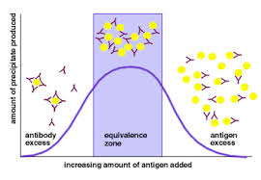

Precipitation Reactions in Gel (Agarose)

The gel is a derivative of agar and is called agarose. It is a polysaccharide polymers semi solid material that is generally extracted from seaweeds or red algea. agarose have a relatively large pore size, making them useful for separation of large molecules, such as proteins and protein complexes >200 kilodaltons, as well as DNA fragments >100 basepairs. These pores all the crossing of any material with a molecular weight under 200 Kda. So it will keep the immune complex(ag-ab complex) and will prcipitate as visible line or ring.

Agarose is preferred in immunologic reactions because its neutral nature does not interface with the ag or ab reactants, and it has low endosmosis. Agarose gel allows soluble ag and /or ab to diffuse through the pores until the ag and ab reach the optimal concentration for lattice formation.
The molecular size determines the rate of diffusion through the gel. In general, smaller molecules move through the gel faster than larger molecules. A mixture of ag and /or abs may result in several precipitin lines; each ag and the corresponding ab will form a lattice in its zone of equivalence. The diffusion rate also depends on temperature, gel viscosity, and hydration, electroendosmotic effect, and the interactions between the gel matrix and reactants.

TYPES OF PRECIPITATION REACTIONS in Gel

1. Double diffusion (Ouchterlony).
2. Single-diffusion radial immunoassay (RID).

Double diffusion in Gel

The Ouchterlony Technique : Both the ag and ab diffuse in a gel.
1. Agarose gel is placed on a solid surface (petri dish, glass slide, or plastic plate) and allowed to solidify.
2. Wells are cut into the gel and the agarose plug is removed.
{ Typically a central well is surrounded by multiple wells}
* If ag is to be detected, a known reagent ab is placed in the center well and the unknown samples are placed in the surrounding wells.
* If ab is to be detected, unknown ag is placed in the center.
3. After each of the samples and reagent have been added to the appropriate wells.
{Diffusion occurs, and a line of precipitation forms at the zone of equivalence}
* If multiple wells of ag are positioned around an ab well on the same plate, several patterns of reactivity may be observed
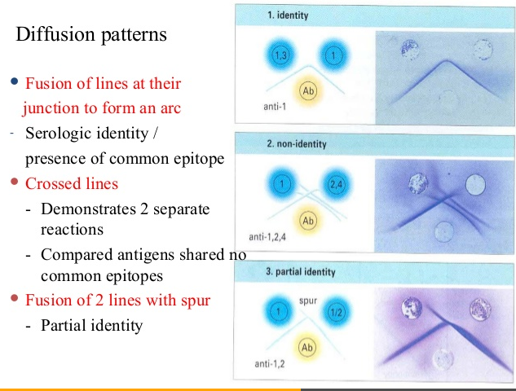

Application of ouchterlony test: is to identify an antigen in a mixture of antigens.

SINGLE RADIAL IMMUNODIFFUSION (SRID)
Mancini Test
SRID a commonly used gel precipitation technique . In this technique :
1. Antiserum is added to the liquified gel, which is poured into a plate and allowed to solidify by cooling to room temperature.
2. The antigen is added to wells cut into the agar.
{The antigen diffuses in all directions from the well, and the precipitate is a concentric ring. The incubation period for the diffusion depends on the molecular weight of the antigen; larger molecules diffuse more slowly, requiring more time for full diffusion and maximum precipitin ring formation}
