Hydrolysis of starch by salivary amylase
Amylases are digestive enzymes secreted by the salivary glands and the exocrine pancreas for the purpose of breaking down complex polysaccharides (starch and glycogen) into simpler saccharides like glucose, maltose (2glocose molecules) and limit dextran (5-8 glucose molecules, oligosaccharides). The isoenzymes of amylase are the pancreatic amylase which is designated as (p) and appears to be only of pancreatic origin whereas the salivary amylase (s) may also secreted by the fallopian tube and certain tumours. The salivary amylase, ptyalin, begins the digestion in the mouth, continues briefly in the stomach until the pH drops too low. Digestion is then completed in the intestine by the attack of pancreatic amylase. Both types digest polysaccharide by breaking down the α, 1-4 glycosidic linkage between glucose molecules while the 1-6 bond leaved untouched. In this experiment the effect of amylase enzyme in saliva on starch suspension will be studied.
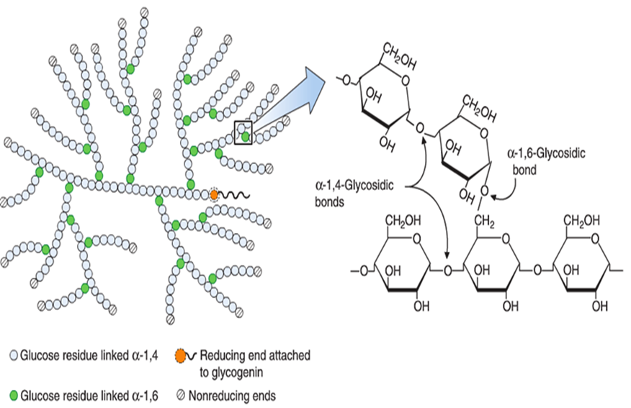
The structure of glycogen

Procedure:
1- Collect 5-10 ml of saliva in a beaker and filter through a wet filter paper.
2- Label 4 test tubes from (1-4).
3- In each tube add 20 drops starch +2 drops iodine solution + 3 ml distilled water and mix gently, and note the color.
4- Repeat the iodine test at 5 min, 10min and 20 min in tube 2, 3 and 4 respectively and note the color.
5- Compare the color produced in the 4 tubes.

