Curriculum Vitae

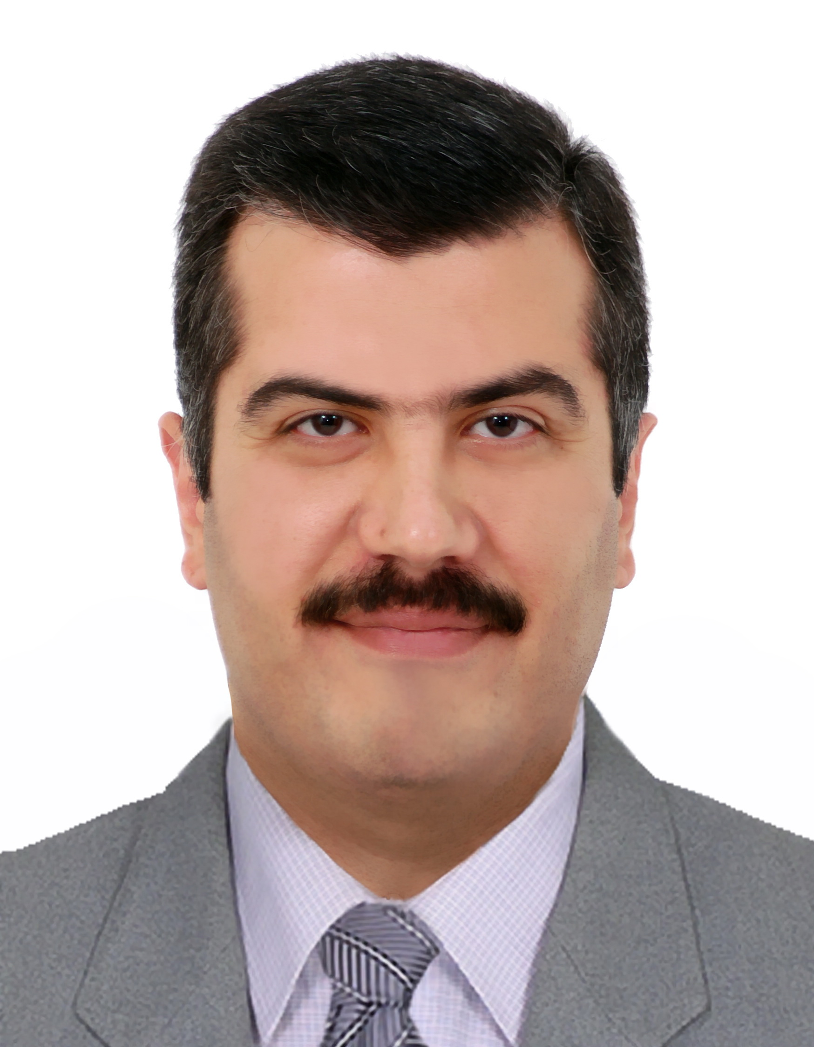
Name: Dr. Alauldeen Mudhafar Zubair Alqasim
( Consultant Hematopathologist)
الاسم: د.علاء الدين مظفر زبير القاسم
المرتبة العلمية: استاذ مساعد
الفرع: الأمراض و الطب العدلي
Personal information
- Date of birth: 18/3/1972
- Gender: male
- Place of birth : Baghdad
- Nationality: Iraqi
- Marital status: married
- Address: Iraq/ Baghdad / Al-Qadisiyah quarter
- e-mail aladdinalqasim@yahoo.com
- Phone number: 009647906208603

Languages
- Arabic (mother language)
- English (fluent)

Degrees
- M.B.Ch.B. : Al-Nahrain University /College of Medicine. 1996
- Fellow of the Iraqi Board for Medical Specializations (Hematopathology) F.I.B.M.S. 2002

Current position: Associate professor of hematopathology, Department of Pathology, College of Medicine, Al-Mustansiriya University since September 2010.
Previous positions:
- Lecturer. Department of Pathology, College of Medicine, A-Nahrain University. June 2003- July 2004.
- Lecturer. Department of Pathology, College of Medicine, Al-Mustansiriya University. July 2004 - September 2010.
- Head of Department of Pathology. College of Medicine/ Al-Mustansiriya University. November 2012 – February 2014.
- Senior hematopathologist at The National Center of Hematology, Al-Mustansiriya University. 2004-2009.
- Senior hematopathologist at hematology unit, teaching laboratories, Al-Yarmook teaching Hospital, Baghdad since 2010.
- Examiner for the Iraqi Board of Pathology (Hematology) since 2008.
- Member of the Consultant Committee of Hematology for the Iraqi Ministry of Health 2009 – 2014.
- Consultant hematopathologist since April 2013

Practical experience
• 1996-1998 internship as follows:
1. October 1996- December1996: department of gynecology & obstetrics /Al-Kadhimiya teaching hospital.
2. January 1997- February1997: department of general surgery / Al-Kadhimiya teaching hospital.
3. March 1997: Ibn Al-Baytar center of cardiac surgery.
4. April 1997- June 1997: department of medicine / Al-Kadhimiya teaching hospital.
5. July 1997- August 1997: CCU /Al-Kadhimiya teaching hospital.
6. September 1997- January 1998: outpatient clinic / Al-Nahrain University.
7. February 1998- June 1998: emergency department / Al-Kadhimiya teaching hospital.
- July 1998 – December 2002: demonstrator / department of pathology / College of Medicine / Al-Nahrain University.
- July 1998 – December 2002: resident / laboratory department / Al-Kadhimiya teaching hospital.

Academic experience:
- Teaching hematology to undergraduate students in Al-Mustansiriya University/ College of Medicine since 2004.
- Teaching hematology to postgraduate students in Al-Mustansiriya University/ College of Medicine since 2004.
- Teaching, training, and supervising residents of the Iraqi Board of Pathology(hematology) since 2008.
- Membership of examining committees of many MSc and PhD theses.

List of teaching and course coordination:
- Teaching general pathology and hematology to 3rd year medical students.
- Teaching clinical pathology to 5th year medical students.
- Coordinator of Molecules, Genes and disease module for 1st year medical students.
- Teaching and supervising postgraduate pathology students and residents of Iraqi Board of pathology.

Supervisory experience: Supervision of 10 Board theses, 2 Ph.D.’s and 1 M.Sc.

Editorial activities:
Associate editor for three international journals:
- Clinical Case Reports journal by Wiley.
- BMC Hematology.
- Journal of Medical Case Reports.

Reviewer for the following international journals: (both have impact factor)
- Medicine by Wolters Kluwer
- Annals of Saudi Medicine
- Turkish Journal of Hematology

Memberships
- Member of Iraqi Medical Association since 1996.
- Member of the Iraqi Society of Hematology since 2003.
- Member of International Iraqi Medical Association
- Member of International Society of Laboratory Hematology
- Member of the editorial board of Mustansiriya Medical Journal
- Member of the editorial board of Iraqi Journal of Hematology

Published papers:
- Al-Tememi WF, Alqasim AM, and Sabbah H. The Significance of Estimation of Anti- Apoptotic Protein in Acute Leukemia Cases. Mustansiriya Medical Journal. 2009 April; 8(1): 53-58.
- Al-Thwaini AN, Abdul-Sahib MA, and Alqasim AM. Molecular Diagnosis of Chronic Myeloid Leukemia & Monitoring Response to Different Types of Treatment. Journal of biotechnology center. 2011; 5 (1): 74-81.
- Alqasim AM. Factor XII level in patients with acute Myocardial Infarction. Iraqi Journal of Community Medicine 2011. Iraqi J. Comm. Med. 2011 Jan;24(1): 25- 29.
- Alwan AF, Alqasim AMZ, and Salman SW. Study of Plasma fibrinogen in pregnant women with severe preeclampsia. IOSR Journal of Dental and Medical Sciences (IOSR-JDMS). 2013 Jul-Aug; 8(5):55-59.
- Alwan AF, Alqasim AMZ, and Salman SW. Assessment of Plasma FXII:C in pregnant women with severe preeclampsia. Mustansiriya Medical Journal. 2015 Jun;14(1):79-84.
- Alqasim AMZ and Kareem AA. Flow cytometric Measurement of CD5, CD23, and CD38 expression as a diagnostic and prognostic means in CLL patients. Iraqi J. Hematology 2015 July; Vol 4(1):16-38.
- Alqasim AM. Allogeneic hematopoietic cell transplantation for solid tumors. Journal of Stem Cell Research and Therapy. 2014 Oct; Vol 4 (9): P 114.
- Alqsim AMZ and Al-Saidi DN. Study of Hepcidin Level in Samples of Iraqi Patients With Iron Overload and Iron Deficiency Disorders. AJPS, 2016, Vol. 16, No.1. p 10-16.
- Seah BT, Kadhim AA and Alqasim AMZ. Impact the Magnetic Field 1.5T on Packed Cell Volume (PCV) using Magnetic Resonance Imaging (MRI). Australian Journal of Basic and Applied Sciences, 10(4) February 2016, Pages: 109-113.
- Kadhim AA, Seah BT and Alqasim AMZ. Influence of Magnetic Field on Blood Viscosity. Advances in Environmental Biology, 10(1) January 2016, Pages: 107-110.
- Alqasim AMZ and Alanbari RAF. Effects of silver nanoparticles on pathogenic E.Coli & some haematological parameters. International Journal of Advanced Research. 2016; 4(3): 1156-1162.
- Alqasim AMZ. Reduction of T-lymphocytes in Blood Samples Using X-ray of Two Different Energies. International journal of biomedical and advance research. 2016 May; 7(4): 196-203.
- Abdalwahab ST, Kadhim HS, Alqasim AMZ and Gorial FI. Sclerostin and IL-1Ra in Rheumatoid Iraqi Patients after Biological Therapy. Int.J.Curr.Microbiol.App.Sci (2016) 5(9): 718-724.
- Abdalwahab ST, Kadhim HS, Alqasim AMZ and Gorial FI. T Regulatory Cell Frequency In Iraqi Rheumatoid Arthritis. Int J Adv Res. 2016; 4(9): 443-446
- Alwash MM, Alqasim AMZ and Hammodi SR. Evaluation of the Intrinsic Pathway of Coagulation in a Sample of Iraqi Patients with Acute Myocardial Infarction. AL- Kindy Col Med J 2016:Vol. 12 No.1. 31-37. http://iasj.net/iasj?func=issueTOC&isId=7018&uiLanguage=en

