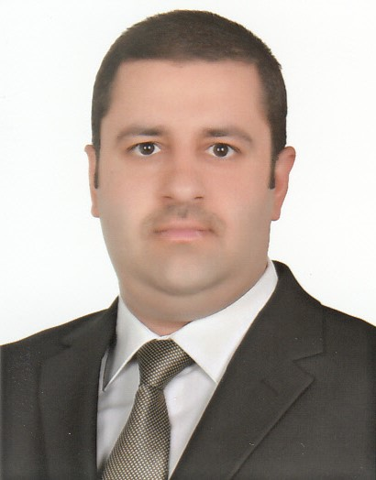
Curriculum Vitae

Name: Mohammed
Middle name: Abdulla
Surname: Al-Nuaimi
Sex: Male
Nationality: Iraqi
Place of Birth: Baghdad/Iraq
Marital Status: married

Institutions attended:

- College of Medicine, Al-Mustansiriya University, Baghdad, 1999-2005. Degree awarded: M.B.Ch.B. The fourth on my class (out of 189 students) (granted in 28/6/2005).
- The Iraqi Board for Medical Specialization/Medicine (2007-2011); degree awarded: Fellowship of Iraqi board of medical specialization/Medicine (FIBMS/M).
- The Iraqi Board for Medical Specialization/Gastroenterology and Hepatology (2012-2015); degree awarded: Fellowship of Iraqi board of medical specialization/ Gastroenterology and Hepatology (FIBMS/G&H).
- Pass the MRCP specialty certificate of gastroenterology and hepatology, 2016.

Society Memberships:
- Member of the Iraqi medical association (since 14 January 2006), registration number 35647.
- Fellow of the Iraqi Society of Gastroenterology and Hepatology (since October 2012).
- Member of European Society of Gastrointestinal Endoscopy (since February 2014, ID: 10419).
- Member of the American College of Physicians (since February 2015, ID: 02391958).

Currently I am lecturer at Al-Mustansiriya college of medicine since 2016.

