Firas Harith Ibrahim
( C.V )
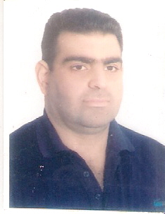
NAME : Firas Harith Ibrahim AL-wade.
Scientific Grade :Assistant Lecture.
Educational Background :
- 2002 Bachelor's degree in physics Science, at Baghdad university, IRAQ.
- 2009 Master of Science Physics of materials & Solid state Physics ,at Baghdad university, IRAQ.
Specialty :Physics of dental materials .
Interests :
- Medical physics .
- Biomedical materials.
- Physics of dental materials.
- Medical mathematics.
- Nano materials.
- Image processing.
Experience :
- Physical tests of Materials .
- Engineering tests of Materials.
- MATLAB PROGRAMING.
- TOFEAL LECINCE 2011
- IC3 LECENCE 2011.

Memberships :
- Member of Iraqi Association of physicist
- Member of Iraqi teacher Association.
Contact Information :
- Mobile : ++7902662202.
- E-mail : firasalwade@gmail.com

