1- Personal details

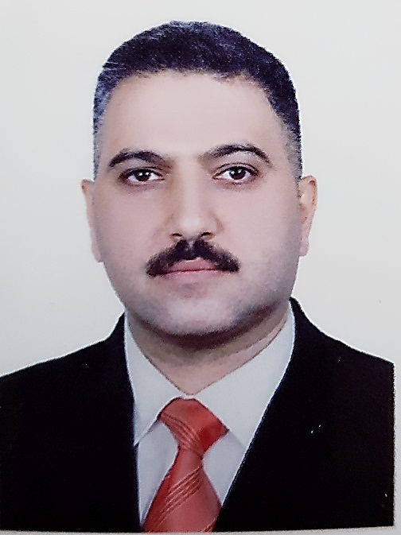 |  | AL-Taie |  |  | Surname
 |  | Ali Talib Mohammed |  |  | Full Name
Single | Social State | Assistant Lecturer / Mustansiriyah University / Ministry of Higher Education and Scientific Research |  |  | Academic  Titles
Iraq- Baghdad 19/06/1978 | Place / Date of Birth | Iraqi |  |  | Original  Nationality
180 cm | Length | Male | Sex | 39 years | Age
Contact Details
+9647712289040 | Mobile | alialtaie@uomustansiriyah.edu.iq |  |  | E-mail address /1
 |  | alialtaie78@gmail.com |  |  | E-mail address /2

2- Educations and Qualifications

Name of School, College or University | Date attended | Subjects/Courses taken and qualifications obtained
Al-Ahdamiya Secondary School | 1993-1996 | - Qualifications: School Diploma, With Good Grade the general average (78.85%)
University of Baghdad / College of Education for Pure Sciences / Ibn Al-Haitham | 1996-2000 | - Qualifications: Bachelor of Science (B.Sc.) in Biology Sciences  - Major Subjects : Biology, Immunity, Microbiology, Parasitology, Bio cell, Genetics, Mycology, Growth Psychology, Histology, Analytical Chemistry, Biochemistry, Embryology, Public Health (More detail in transcript).
University of Baghdad / College of Education for Pure Sciences / Ibn Al-Haitham | 2012-2015 | - Qualifications: Master of Science (M.Sc.) in Biology /Botany / Taxonomy, with Very Good Grade the general average (84.527%).  - Major Subject: Molecular Genetic, Biosystematic, Metabolic Pathway, Plant Evolution, Growth and Development of Plant, Biostatistics, Ecophysiology, (More detail in transcript).  - Msc. Thesis: " A Taxonomic Study of Some Taxa of the Genus Ranunculus L. ( Ranunculaceae) in Iraq”

3- Career Path

To | From | Workplace | Career | No.
2011 | 2008 | Tourism Board | Assistant observant | 1
2012 | 2011 | Mustansiriyah University | Assistant Biology | 2
2015 | 2014 | Mustansiriyah University | Biology | 3
Until Now | 2015 | Mustansiriyah University | Assistant Lecturer | 4

4- Published Scientific Research.

Year | Publisher | Place of Publication | Research Title | No.
2015 | Jurnal of The College of Basic Education / Vol.21 No.90 | Mustansiriyah University / College of Basic Education | Study of Flavonoid Compounds As Evidences of Chemotaxonomy for Some Taxa of Geuns Ranunculus L.  ( Ranunculaceae) in Iraq | 1
2017 | I.J.S.N.VOL.8(2)2017:298-302  ISSN 2229 – 6441 | international journal of science and nature | Phylogenetic relationships among genus Euphorbia species according to random amplification of polymorphice DNA (RAPD-PCR) markers | 2
2018 | Excellence in Research and Innovation  ISBN 978-81-936279-2-1  Page:4-8 | 9th International Conference on Advances in Engineering and Technology (RTET-18) March 27-28, 2018 London ( UK) | Anatomical and Palynological Feature of Heliotropium Supinum L. | 3
 | Jurnal of The College of Basic Education / Vol.25 No.103  ISSN 1815-7467  Page:427-443 | Mustansiriyah University / College of Basic Education | تسجيل نوع جديد من الجنس Euphorbia من العائلة Euphorbiaceae في العراق | 4

5- Work in progress: Scientific research
Year | Publisher | Work Submitted For Publication | Title of Scientific Research | No.
February 2020 | Annals Of Tropical Medicine And Public Health  ISSN:1755-6783  (Scopus) | Yes | Anatomical study of Combretum Indicum L. Defilipps cultivated in Iraq | 1
May 2020 | Biochemical And Cellular Archives  ISSN:0972-5075  Vol.20, No.(Issue 1)  (Scopus) | Yes | Venation pattern and leaf architectures of Cordia Myxa L. From Boraginaceae family | 2

6- Conferences and Seminars:
Year | Place | Name of conference or seminar | No.
2016 | Mustansiriyah University | Workshop (Different teaching methods and their impact on the development of the educational program) | 1
2016 | Mustansiriyah University | Seminar (Stem cells between medical treatment and the spiral of Islamic jurisprudence) | 2
2016 | Mustansiriyah University | Modern plant classification | 3
2017 | University of Salahaddin - Erbil - Iraqi Kurdistan | The 6th International Conference and Workshops on Basic and Applied Sciences | 4
2018 | London ( UK) | 9th International Conference on Advances in Engineering and Technology (RTET-18) March 27-28 | 5

7- Teaching Experience
Year | Name of Teaching Material | No.
2016 – Until Now | Practical Plant Classification | 1
2016– Until Now | Anatomy of Pant | 2

8- Training Courses
Year | Place | Course Title | No.
2001 | Baghdad University | Clinical Analysis | 1
2011 | Mustansiriyah University | Computer Basics | 2
2015 | Mustansiriyah University | Teaching Methods | 3
9- Administrative and scientific Positions.
Year | Position | No.
2012 | Training Manager / Continuous Learning Center / Mustansiriyah University | 1
2015 | Manager of Studies Unit / Continuous Learning Center / Mustansiriya University | 2
2016- Until Now | Training Manager / Continuous Learning Center / Mustansiriyah University | 3
2016- Until Now | Assistant Lecturer / Mustansiriyah University / College of Sciences | 4

10- Linguistic Proficiency.
Excellent in Structure and Writing Expression, Reading Comprehension, Listening Comprehension and Speaking | English
Native language | Arabic

11. Miscellaneous Qualifications

Computer Skills:

✓ Presentation Programs (MS Power Point).
✓ Word Processing (MS Word, Word Perfect, etc.).
✓ Spreadsheet Analysis (MS Excel, Lotus, etc.).
✓ Digital Image Processing (Adobe Photoshop, GIMP, Paint, etc.)

12. Hobbies

✓ Reading and Writing
✓ Playing Sports (Football, Bodybuilding, Swimming, Basketball)

13. Letters of Thanks and Appreciation

ت | Number | Donor | No.
2009 | 1 | Tourism Board | 1
2011 | 4 | Presidency of Mustansiriyah University | 2
2011 | 2 | Ministry of Higher Education | 3
2013 | 1 | Presidency of Mustansiriyah University | 4
2014 | 1 | Presidency of Mustansiriyah University | 5
2015 | 1 | Presidency of Mustansiriyah University | 6
2016 | 3 | Presidency of Mustansiriyah University | 7
2017 | 1 | Ministry of Interior / Police College | 8
2017 | 1 | Presidency of Mustansiriyah University | 9
2018 | 1 | Presidency of Mustansiriyah University | 10
2018 | 1 | Ministry of Interior/ Institute of Preparation Police Commissioners | 11
2018 | 1 | Ras Al-Bar General Trading Company / Canon's Official Company Agent in Iraq | 12
2019 | 1 | Presidency of Mustansiriyah University | 13
- | 19 | Total | -

