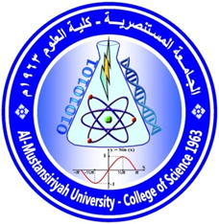
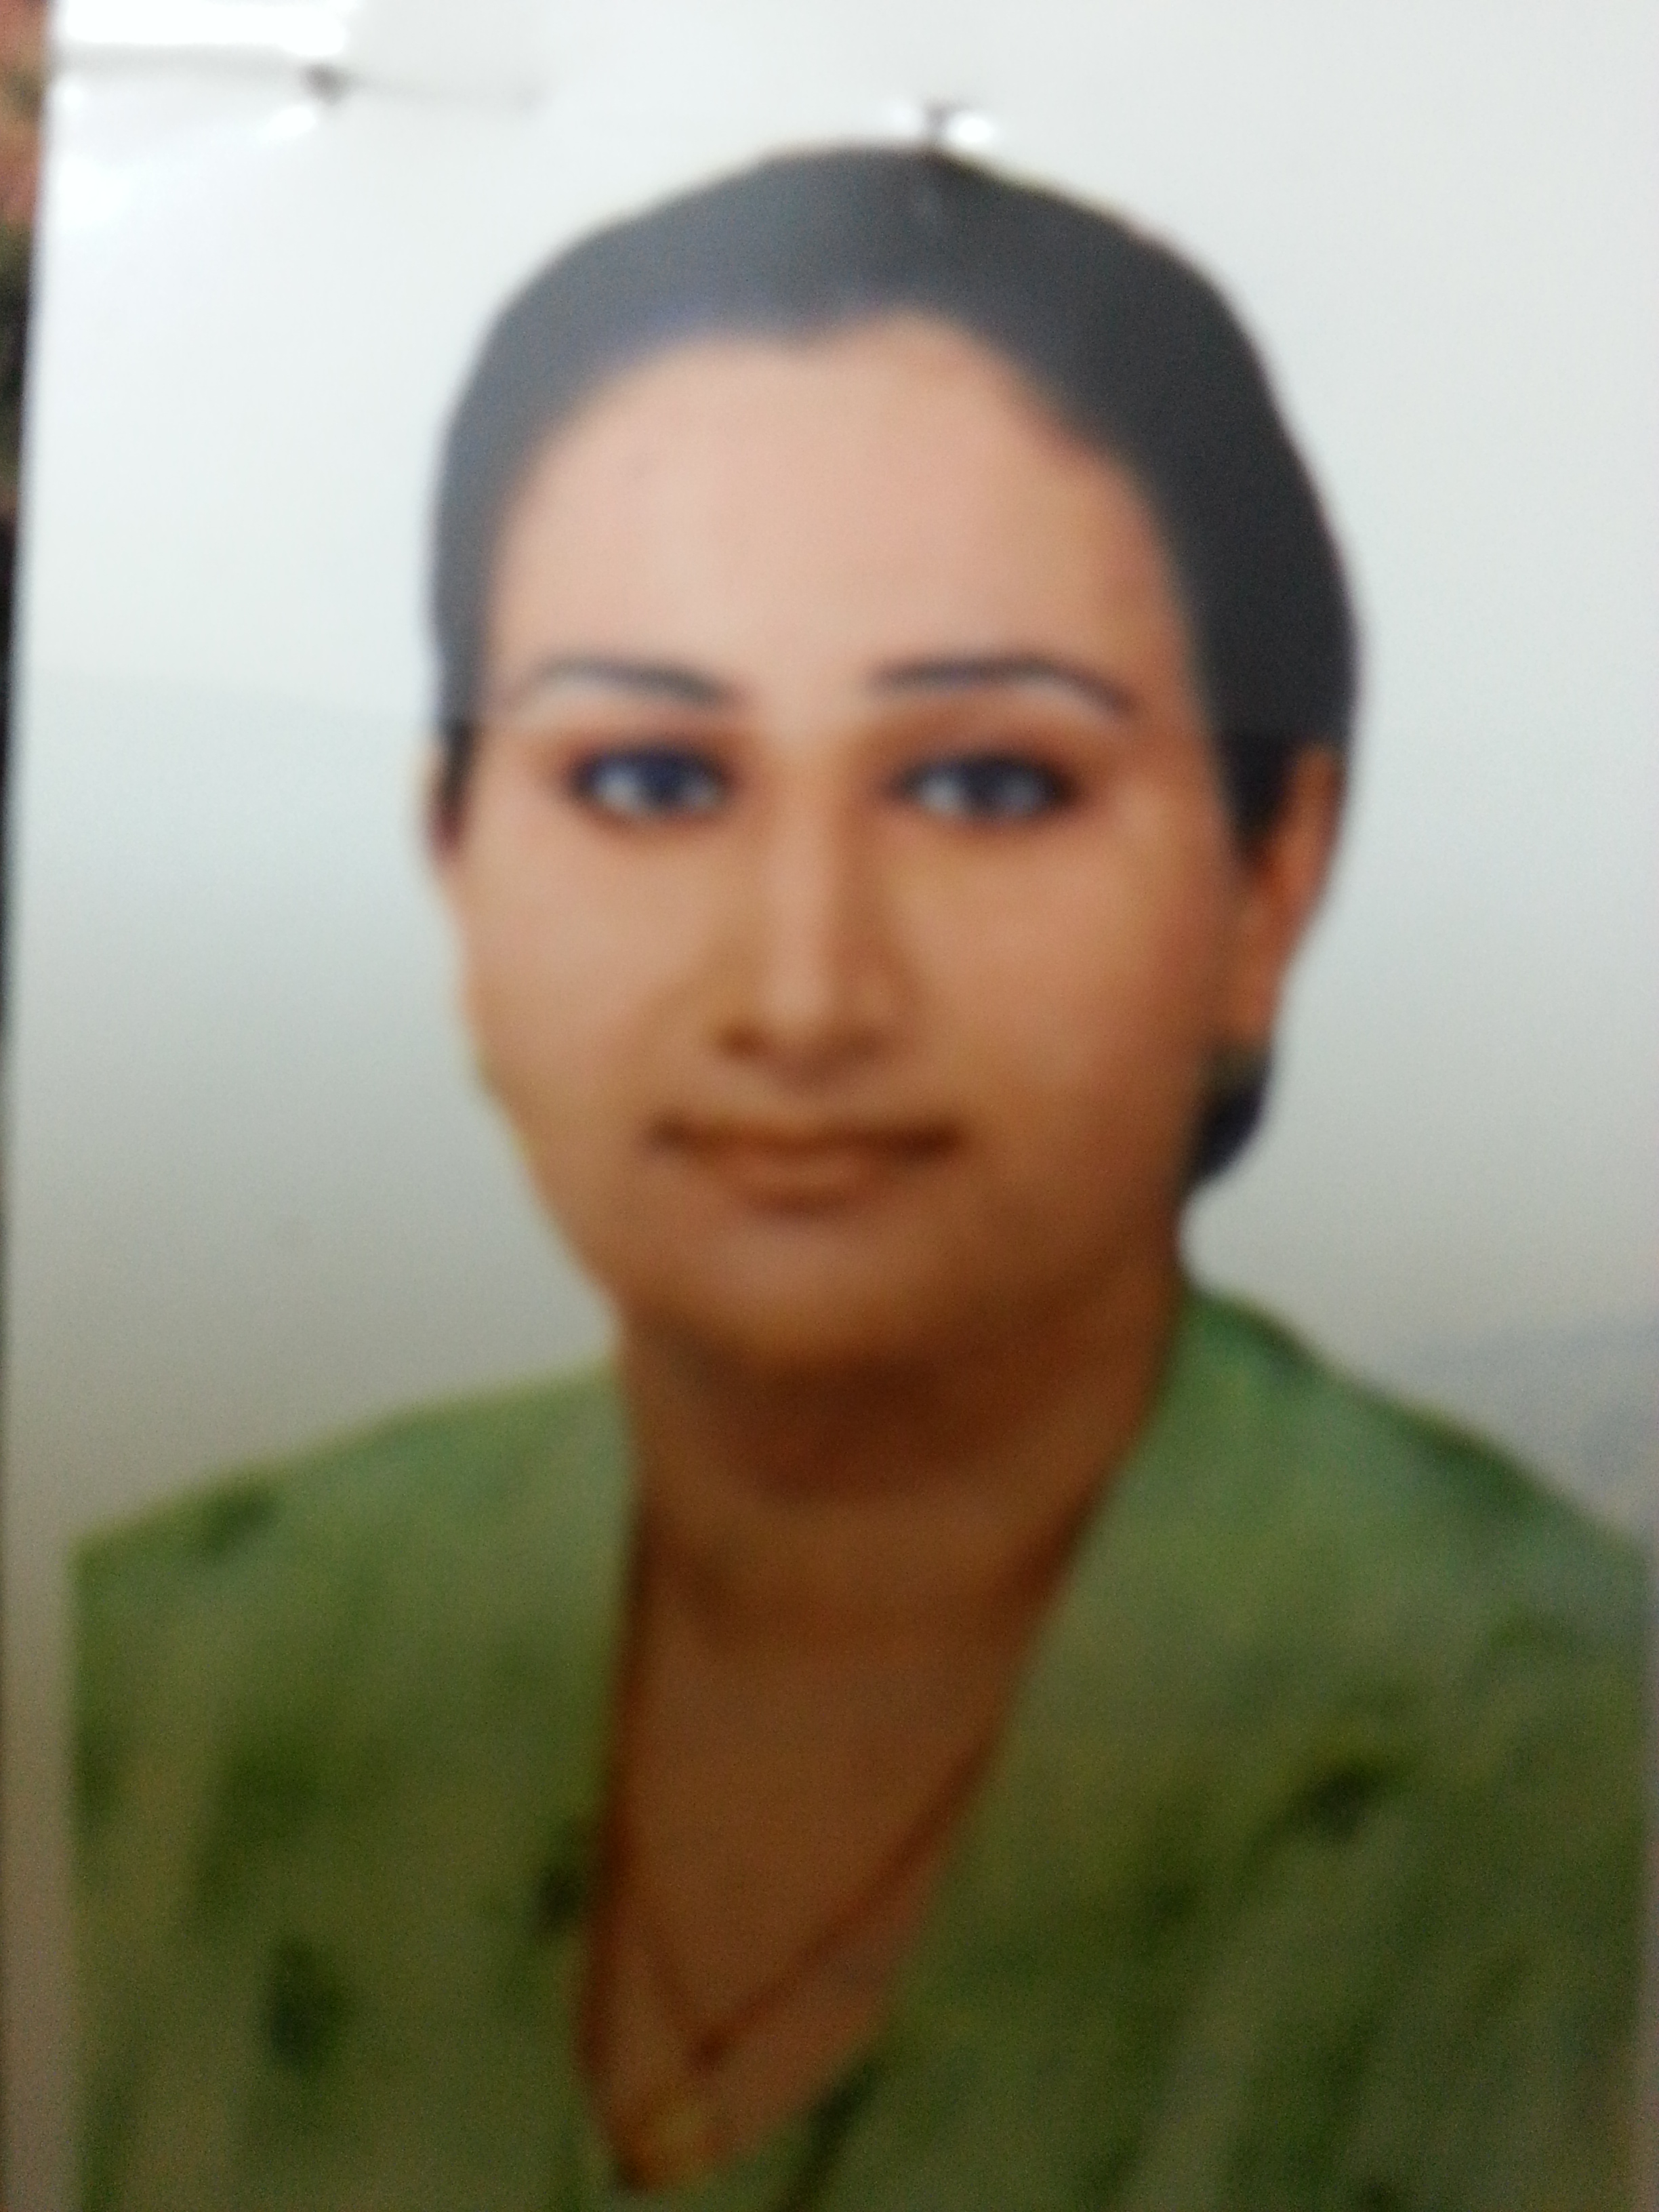

Name :.Saba saadoon khazaal
Specialization: Medical Microbiology
Email:sabask7@yahoo.com

Academic degree: Assisstant Lecturer
M.Sc. thesis : Bacterriological Study in Febril Leukaemic Patient Before and After Chemotherapy
Current field of interest: Medical Microbiology/Infectious diseases
Publication for the 5 years
1.The prevalence of Microorganisms in h1 n1 patient compared to seasonal influenza of Iraqi patients . Iraqi j pharm sci,vol.20 (2) 2011
2. Derermination of trace element s I sera of Iraqi patients with leukaemia.Iraqi j pharm sci ,vol.30 (2) 2012
3 Nitrostative stress status during seasonal and pdmH1N1 infection in Iraq.JiDc vol5 no.12

