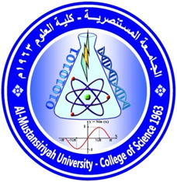

Name : Mustafa Hasan Zainel Talha.
Specialization: Microbiology/Clinical microbiology.
Email: mustafa.telha@uomustansiriyah.edu.iq
mustefan1972@yahoo.com
Phone No.: 00964 790 135 9626
Academic degree: MSc. degree in clinical microbiology.
M.Sc. thesis: Comparison of enzymatic activity of Escherichia coli isolated from urine of renal failure and urinary tract infection patients
Academic teaching experience:
16 years teaching in Al-Mustansiriyah university/Collige of Science / Dep. Of Biology laboratories of (clinical analysis & Antibiotics).
Courses Taught in Undergraduate:
- Practical Clinical analysis.
- Practical Antibiotics.
Current field of Interest:
: Study of surface-attached microbial communities known as biofilms. Biofilm microbes are typically surrounded by an extracellular matrix, which provides structure and protection to the community which makes it multi drug resistant, and understanding the verity of microbes spread in many locations of human body, in addition to isolation of food poisoning microorganisms and its wide range of pathogenicity and the effect of such microbes on man's health.
Key goal is to understand how biofilms form resistance to antibiotic therapy even if its sensitive to the specific antibiotic.
Publications for the last 5 years:
1- Mohammed mosa Jafaar., Mustafa .H. Zainel., GhusoonA.Abdulhasan., Khamees H.Motlug. The use of immunological and toxicological tests to compare between two isolates of Listeria monocytogenes isolated from poultry and soil.Baghdad university conference of Arabic culture scince.2013 dec.29.
2- The Emergence of Mupirocin-Non-Susceptibility and Virulence Determinants of Staphylococcus aureus from Skin Infections.
3- Eucalyptus camaldulensis Efficiency for Application against Pathogenic Microorganisms

