**C.V**

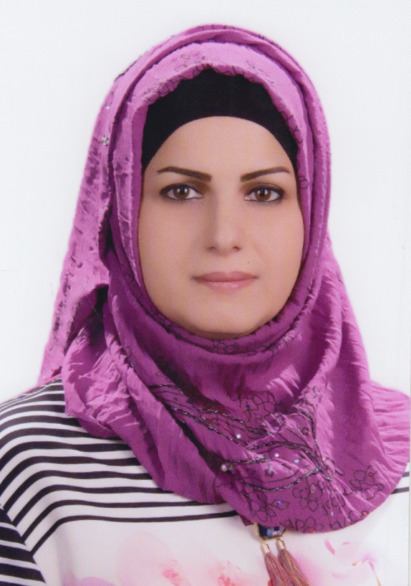

Photo

**Name: khalida jalil ibraheem**

**Date of Birth:**21/2/1976

**Religion:Muslim**

**Martial statues:Separate**

**No. of children:2**

**Position: Microbiology**

**Academic Degree: Teacher**

**Work Address:** Teaching

University : Mustansiriay

**Work Phone:**

**Mobile:** 07718494610

**E-mail: : sshhdd210@gmail.com**

* **First, Scientific Certification:**

|  |  |  |  |
| --- | --- | --- | --- |
| **Date** | **College** | **University** | **Degree science** |
| 1997 | Scince | Almustansiriyah | **B.S** |
| 2002 | Scince | Almustansiriyah | **M.Sc.** |
|  |  |  | **Ph.D.** |
|  |  |  | **Any other** |

|  |  |  |  |
| --- | --- | --- | --- |
| **From -To** | **Workplace** | **Career** | **No**  **No.** |
| 2006-2011 | Almustansiriyah | Assis -Teachear | 1 |
| 2011-2016 | Almustansiriyah | Teachear | 2 |
|  |  |  | 3 |

* **Second, Career:**
* **Third, University Teaching.**

|  |  |  |  |
| --- | --- | --- | --- |
| **From -To** | **The (Institute / College)** | **University** | **No.** |
| 2013-2006 | Biology/ scince | Almustansiriyah | 1 |
| 2016-2013 | Scince/Basic Education | Almustansiriyah | 2 |
|  |  |  | 3 |
|  |  |  | 4 |

**Fourth, Courses Which You Teach:**

|  |  |  |  |
| --- | --- | --- | --- |
| **Year** | **Subject** | **Department** | **No.** |
| 2007-2006 | Phisiology of bacteria | Biology | 1 |
| 2008 | Bacteria Satisfactory | Biology | 2 |
| 2013-2009 | Satisfactory Analyzes | Biology | 3 |
| 2013-2009  7 | Anti biotic | Biology | 4 |
| 2016-2013 | Health Education | Scince | 5 |
| 2016 | Zoology | Scince | 6 |

* **Fifth, Thesis** **which was supervised by** :p.h.d

|  |  |  |  |
| --- | --- | --- | --- |
| **Year** | **Department** | **Thesis Title** | **No.** |
|  |  |  | 1 |
|  |  |  | 2 |
|  |  |  | 3 |
|  |  | . | 4 |
|  |  |  | 5 |
|  |  |  | 6 |

**Thesis** **which was supervised by:-**

|  |  |  |  |
| --- | --- | --- | --- |
| **No** | **Thesis Title** | **Department** | **Year** |
| **1** |  |  |  |
| **2** |  |  |  |
| **3** |  |  |  |
| **4** |  |  |  |
| **5** |  |  |  |
| **6** |  |  |  |

**Seventh, Scientific Activities:**

|  |  |
| --- | --- |
| **Outside the College** | **Within the College** |
|  |  |
|  |  |
|  |  |

**Eighth, Research Projects in The field of Specialization to The benefit of Environment and Society or the Development of Education:**

|  |  |  |  |
| --- | --- | --- | --- |
| **No.** | **Research Title** | **Place of Publication** | **Year** |
| 1 | Diabetic foot infection (type of aerobic bacteria in Iraqi patients) | The Iraqi Board For Medical Specializations | 2004 |
| 2 | Metabolic syndrome in women with polycystic ovary syndrome | Al-Kindy College of Medicine | 2010 |
| 3 | The prevalence of antibiotic resistancein aerobic and anaerobic bacteria isolated from patient with diabetic foot ulcers | Journal of The College of Pharmacy | 2011 |
| 4 | Profile of microorganisms isolated fromblood and wound in the first week ofpost burn infection and antibacterial resistance pattern | Journal of The College of Pharmacy | 2011 |
| 5 | Astudy of some changes in blood and urine of preqnant women with bacterial isolation from urine specimens | Journal of College of Education/Al Mustansiriyah | 2009 |
| 6 | Haematological study for burns wound and urinary tract patients infected withklebsiella spp. And their antibiotic sensitivity | Journal of The Cillege of Education | 2011 |
|  |  |  |  |
|  |  |  |  |

* **Nineth, Membership:of local and international academic bodies**



* **Tenth, Awards and Certificates of Appreciation:**

|  |  |  |  |
| --- | --- | --- | --- |
| **Year** | **Donor** | **Name of Awards and Certificates** | **No.** |
|  |  |  | **1** |
|  |  |  | 2 |
|  |  |  | 3 |
|  |  |  | 4 |
|  |  |  | 5 |
|  |  |  | 6 |

* **Eleventh, Scientific literature:**

|  |  |  |
| --- | --- | --- |
| **Year of The Publication** | **Scientific Literature Title** | **No.** |
|  |  | 1 |
|  |  | 2 |
|  |  | 3 |

* **Twelfth, languages:**
* Arabic
* English