Vol. xx, No. xx, Month 2xxx ISSN 2520-0917
www.jeasd.org

Space with a font size 28
PAPER TITLE SHOULD BE limited to 25 words or less and should not contain abbreviations
Space with a font size 24
Dr. Zaid Ali Taha¹, Dr. Hiba Laith Ahmed², *Amer Zuhair Naji³
Space with a font size 12
- Prof., Civil Engineering Department, Al-Mustansiriayah University, Baghdad, Iraq.
- Assist Prof., Civil Engineering Department, Baghdad University, Baghdad, Iraq.
- Assist Prof., Civil Engineering Department, Al-Nahrain University, Baghdad, Iraq
Space with a font size 24
Abstract: This document is a live template. The various components of your paper [title, text, heads, etc.] are already defined on the style sheet, as illustrated by the portions given in this document. It should not exceed 200 words. It should briefly indicate the general scope and also state the main results obtained, methods used, the value of the work and the conclusions drawn. No figure numbers, table numbers, references or displayed mathematical expressions should be included.
Emphasis should be on what was found more than what was done.
Space with a font size 6
Keywords: 4 to 8 words; be separated by commas
Space with a font size 12
العنوان ينبغي أن يقتصر على 25 كلمة أو أقل و يجب ألا يتضمن المختصرات
Space with a font size 12
الخلاصة: هذه الوثيقة هي قالب حي. المكونات المختلفة من البحث [العنوان، النص، الأطراف، إلخ] قد تم تعريفها بالفعل على الورقة النمطية، كما يتضح من الأجزاء الواردة في هذه الوثيقة. وينبغي أن لا تتجاوز 200 كلمة. وينبغي أن يبين بإيجاز النطاق العام وكذلك تحديد النتائج الرئيسية التي تم الحصول عليها، الطرق المستخدمة، وقيمة العمل والاستنتاجات المستخلصة. ينبغي ألا تدرج أي أرقام شخصية، أرقام الجدول، مراجع أو التعبيرات الرياضية المعروضة. ينبغي أن يكون التركيز على ما عثر عليه، أكثر مما تم القيام به.
Space with a font size 24
- Introduction
The introduction should set the tone of the paper by providing a clear statement of the study, the relevant literature on the study subject and the proposed approach or solution. The introduction should be general enough to attract a reader’s attention from a broad range of scientific disciplines. This template, created in MS Word 2007 provides authors with most of the formatting specifications needed for preparing their papers. Margins, line spacing, and type styles are built-in; examples of
the type styles are provided throughout this document.
Space with a font size 16
2. Custom Title
Space with a font size 6
2.1. General
Space with a font size 6

*Corresponding Author az_ijkl@yahoo.com
First, confirm that you have the correct template for your paper size. This template has
been tailored for output on the A4 paper size. Do not bother about the header or footer or content of the article just paste your content in the template replacing the content. Please fit your article in this template exactly following the author guidelines without any deviation.
Space with a font size 16
  - Margins and Line Spaces

The template is used to format your paper and style the text. All margins, line spaces, and text fonts are prescribed; please do not alter them.
Space with a font size 16
    - Comments
Before you begin to format your paper, first write and save the content as a separate text file. Keep your text and graphic files separate until after the text has been formatted and styled. Do not add any kind of pagination anywhere in the paper. Do not number text heads, the template will do that for you.
Space with a font size 16
2.2.2. Abbreviations
Abbreviations should be defined at first mention in the abstract and again in the main body of the text and used consistently thereafter. Do not use abbreviations in the title or heads unless they are unavoidable. A list of symbols should be inserted before the references if such a list is needed. Symbols must be written clearly. The international system of units (SI units) should be used in the text, tables and figures. Symbols for physical quantities in the text should be written in Italics (e.g. v, T, etc.). Symbols for units that consist of letters should be in plain text (e.g. Pa, m, etc.).
Space with a font size 16
2.2.3. Equations
When writing mathematics, avoid confusion between characters that could be mistaken for one another, e.g. the letter 'l' and the figure one. Refer to equations using round brackets, e.g. (1).
Space with a font size 10
X+Y=Z (1)
Space with a font size 10
X₁+Y²=B (2)
Space with a font size 10
Note that the equation is centered using a center tab stop. Be sure that the symbols in your equation have been defined before or immediately following the equation. Use "(1)", not "Eq. (1)" or "equation (1)", except at the beginning of a sentence: "Equation (1) is . . ."
Space with a font size 16
3. Figures and Tables
Space with a font size 6
3.1. Figures
Figure captions should be below the figures. Insert figures and tables after they are cited in the text. Use the abbreviation "Fig. 1", even at the beginning of a sentence. When placing more than two figures and photos under the same number of title, assign subtitles by dividing each figure and photo by (a) or (b).The font style and size used in the figures should be equal or less than the font used in writing the manuscript (i.e. Times New Roman ≤ 12). Do not use a shadow or frame around the figure. Multi-curve graphs should have individual curves marked with a symbol; the meaning of the symbol should be explained in the figure caption. Good quality black-and-white photographs or scanned images should be supplied for the illustrations.
Space with a font size 12 before the figure
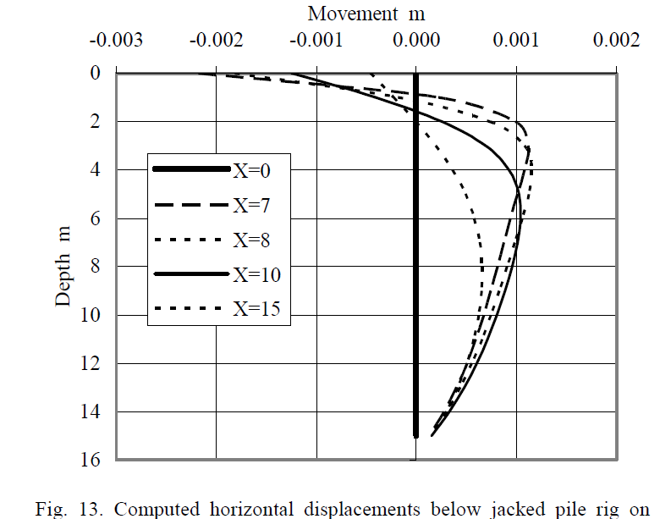

Figure 1. Black and white figure without shading or frame

Space with a font size 12 after the figure
3.2. Tables
Insert tables after they are cited in the text. Tables are referred to in the text by “Table n” (capital T). Table heads should appear above the tables. When placing more than two tables under the same number of title, assign subtitles by dividing each table by (a) or (b). For example: Table 1, Table 2(a) and 2(b). Avoid any colors or shadings in the table.
Space with a font size 12
Table 1. Follow the same table style without shadings

Column 1 | Column 1 | Column 1 | Column1
Row 1 | Row 1 | Row 1* | Row 1
Row 2 | Row 2 | Row 2 | Row 2
Row 3 | Row 3 | Row 3 | Row 3
Row 4 | Row 4 | Row 4 | Row 4
Row 5 | Row 5 | Row 5 | Row 5
Row 6 | Row 6 | Row 6 | Row 6
Any footnotes should be indicated by the use of a superscript*
Space with a font size 12
Abbreviations
A list of symbols should be inserted before the references if such a list is needed
A | coefficient matrix
E | modulus of elasticity
R_{f} | failure ratio
t | time
γ | unit weight of material
ѵ | Poisson’s ratio
φ | friction angle
ε_{v} | volumetric strain
Space with a font size 16
Acknowledgement
The author(s) may express his or her appreciation to relevant agencies and related personnel providing financial support or academic advice to his or her research.
Space with a font size 16
4. References
Ensure that every reference cited in the text is also present in the reference list (and vice versa). References should be cited by numbers in square brackets in the forms: [1], [1, 2], [1-6]. They should be listed and numbered in their order of citation in the text, not by name and date.
Refer simply to the reference number, as in [3], do not use "Ref. [3]" or "reference [3]". The actual authors can be referred to, but the reference number(s) must always be given. Example: “.... as demonstrated in [1,2]. Brandl and Blovsky [4] obtained a different result ...”. This effect has been widely studied [1-3, 7]
Unless there are three authors or more give all authors' names; do not use "et al". The list of references should include only works that are cited in the text and that have been published or accepted for publication. Please follow the reference method exactly as per journal guidelines.
Examples of the ways in which references should be cited are given below:
reference to a book [1], reference to a chapter in an edited book [2], reference to a journal publication [3], reference to conference proceedings [4], reference to thesis [5], reference to standards [6], reference to reports [7].

- Bowles, J. E. (1997). "Foundation Analysis and Design". 5th ed., McGraw-Hill.
- Mettam, G.R., Adams, L.B. (1999). "How to prepare an electronic version of your article", in: Jones, B.S., Smith , R.Z. (Eds.), Introduction to the Electronic Age. E-Publishing Inc., New York, pp. 281–304.
- Desai, C.S. (2007). Unified DSC constitutive model for pavement materials with numerical implementation. International Journal of Geomechanics, Vol. 7, No. 2, pp. 83-101.
- Brandl, H. and Blovsky, S. (2005). "Slope stabilization with socket walls using the observational method". Proc. Int. conf. on Soil Mechanics and Geotechnical Engineering, Bratislava, pp. 2485-2488
- Padgett, L. E. (1981). "Factors Affecting the Concentration of Heavy Metals in Municipal Sludge as Leachates". M.Sc. Thesis, Department of Civil Engineering; Notre Dame, Indiana.
- ASTM D4533-91. (1996). "Standard Test Method for Trapezoid Tearing Strength of Geotextiles". ASTM International, West Conshohoken, PA, USA.
- Horvath, J. S. (1990). "A Study of Miscellaneous Wall Problems". Research Report No.CE/GE‐90‐1, Manhattan College, School of Engineering, Civil Engineering Department, Bronx, NY.
Space with a font size 16
Appendix – A
If there is a need for some derivations or equations which is important to support the research, they should be inserted after the references. The equations are numbered according to the type of appendix. For example
Space with a font size 12
X+Y=Z (A-1)

