Master Budget
Budget is the quantitative expression of a proposed plan of action by management for a specified period and an aid to coordinate what needs to be done to implement that plan.
A budget generally includes both financial and nonfinancial aspects of the plan
Financial Budgets for example a budgeted income statement, a budgeted balance sheet, a budgeted statement of cash flows.
Nonfinancial Budgets for example number of employees, units sold, and number of new products being introduced.
Advantage of Budgets:
Budgets are an integral part of management control system, Budgets do the following:
1- Planning and controlling tool.
2- Promote coordination and communication among subunits within the company.
3- Provide a framework for judging performance.
4- Motivate managers and other employees.

Master Budget: expresses managements operating and financial plans for a specified period
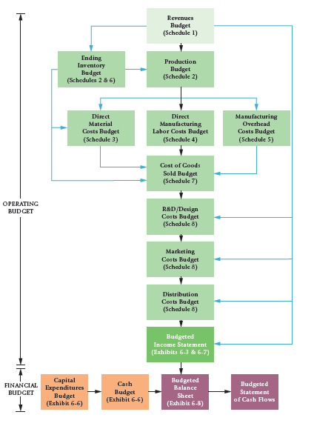

Steps in preparing an operating Budget:
1- Identify the problem and uncertainties.
2- Obtain information.
3- Make prediction about the future.
4- Make decisions by choosing among alternatives.
5- Implement the decision, evaluate performance, and learn.
Static Budget (Master Budget):
Is based on the level of output planned at the start of the budget period. The static budget variance is the difference between the actual result and the corresponding budgeted amount in the static budget.
Static Budget variance = Actual result - Static Budget amount

