Third-Year Classes- Seventh Lecture
Part One: Word Formation Processes
Word formation denotes the processes of creation of new lexical units “new words”. There are, of course, numerous word formation processes that do not arouse any controversies and are very similar in the majority of languages. The main word formation processes are as follows:
A-Derivation:
So many new words are formed or created by adding affixes. The new formed words may have a different or a similar part of speech. For instance:
-act: is a noun and a verb. By adding (-ive) to it, it is turned into an Adj.:
-Active, act- actor
-Create – creative, relate- relative,…
The process of adding is random. Here are some other examples:
-move-movement, use- useful- usefulness
-nation- national- nationality
-happy- happiness, read- reader, write- writer, visit-visitor,…
B-COMPOUNDING
Compounding is a process in which two different words are joined together to denote one thing. For example flower-pot is a compound made of two words: flower and pot, but it does not denote two things, it refers to one object.
C-Invention:
Inventing new words is a noticeable process in any language. Linguists say that language is creative in that new words come into existence from time to time. In English, there are so many examples of invented words such as: Kodak, nylon, dingbat, quark,…etc.
D-Echoism:
Echoism means the process of forming new words whose sounds suggest their meaning such as (peewee, hiss). Here, the sound is either natural like the roar of a waterfall or artificial such as the clang of a bell. The meaning may also be the creature that produces the sound such as (bobwhite, moan, click, murmur, quack, thunder).
E. Clipping:
It simply means cutting off the beginning or the end of a word or both leaving a part to stand for the whole. The left is called a clipped form or word. Various examples can be noticed here such as ( math for mathematics, lab for laboratory, exam for examination, Prof., mike, plane, phone)
F. Acronymy or Acronyms:
“Acronyms” refers to the process of forming new words by the initials or beginning segments of a succession of words. In some cases, the initials are pronounced as in (MP-Military Police, or Member of Parliament). In some other cases, the initials or beginning segments are pronounced as the spelled word would be. For example (NATO- National Atlantic Treaty Organization) which is pronounced as /neitəƱ/. Another example is (radar- radio detecting and ranging) which is pronounced as /reidə/.
-GAAP= Generally Accepted Accounting Principles

G. Blending:
It refers to the fusion of two words into one, usually the first part of one word with the last part of another as in (gasohol) from gasoline +alcohol. The resultant blend partakes of both original meanings.
Smog= smoke +fog
H. Back-Formation:
Many speakers may over generalize a certain rule while they are using language. For instance, if we ask someone (what’s the past form of the verb put) supposing that he does not know this verb. He will say that it is (putted) since he knows that adding –ed will turn a verb into the past form. This is what we call (Back formation).

J.Antonomasia:
It simply means the formation of a common noun, a verb, an adjective from the name of a person or a place. For example, history and literature have given us many common nouns. For instance, a lover is called (romeo, a don juan, a Casanova or a gay lathario). (ibid.:127).

K.Reduplication:
It is simple the process of forming a new word by doubling a morpheme “a part of it”, usually with a change of vowel or initial consonant as in tiptop, hanky-panky, singsong. In some of these words, the first part if the original one as in singsong, and some other cases it is the second as in dilly-dally.

Q-Identify the process of word formation followed:
1-roughneck 2-clink 3-pop 4-doodad 5-cream puff
6-wheeze 7-weirdoism 8-exflux 9-taxi 10-memo

Part Two: Reading Passages: page-43
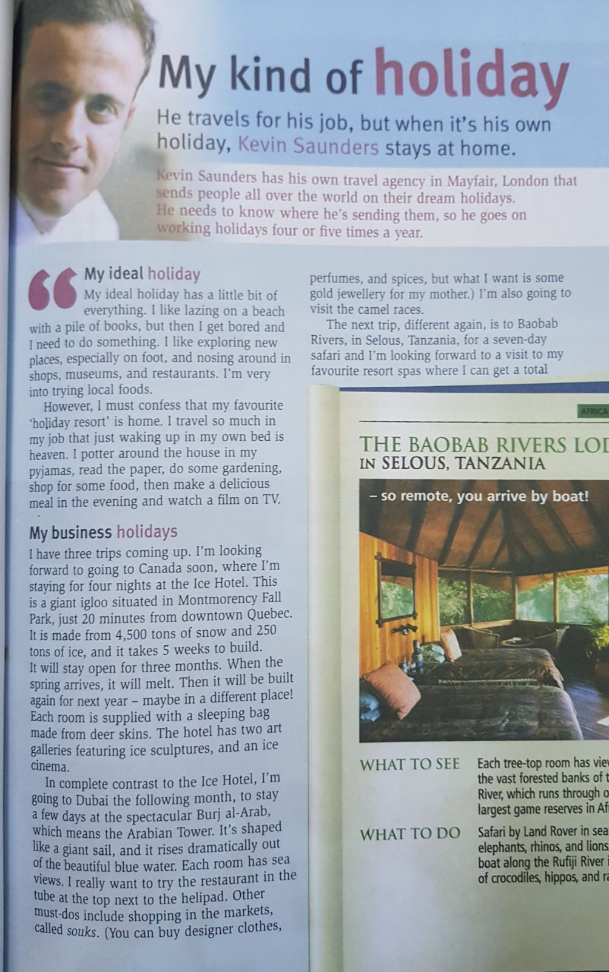

2- page- 51
