۞Culture media for Fungi ۞
Culture media: Balanced mixture of different nutrients necessary for the growth of microorganisms, it may be simple or complex composition In each case serves to provide the energy and basic units for building cells .
The purpose of using Culture media :
- Growing and preserving fungi .
- Study the effect of single nutrients found in media on the growth of fungus.
- Inducing fungi to produce and forming some material .
- Classification of fungi and study the cultural characteristics.
۞Division of Culture media۞
- According to the chemical composition:
- Chemically defined media : Must be known composition, consists of metal salts have added some sources of carbon or nitrogen, can be prepared each time the same precision ex: Czapekʹs Agar (CZ).
- Chemically no defined media: Not have a specific composition , composition changed depending on the nature of the material prepared, Difficult prepared each time the same precision ex: Potato Dextrose Agar (PDA) ,Corn Meal Agar (CMA) , Malt extract agar.
- Natural media : Use of natural materials without additions, ex: Extracts of the roots of potatoes or carrots , Prepared from wheat or barley or corn.
- According to the Textures:
- Solid media : It may be natural such as potato chips, Or it may be artificial, such as (PDA) Containing (Agar).
- Semi solid media: Contains a half or a quarter of the amount Agar added to solid media .
- Liquid media : Not contains Agar such as (PD) artificial, (Milk) natural.

- According to the purpose:
- General purpose media : Media are used to growth different types of fungi, such as :
- Water Agar (WA).
- Potato Dextrose Agar (PDA).
- Carrot Agar.
- Malt extract agar.
- Czapekʹs Agar (CZ).
- Corn Meal Agar (CMA) .
- Selective media : Contains a substance inhibits the growth of some fungi while helping growth another kind , such as add some antibiotics or modify the value of (PH) , or add salt , or use Rose Bengal ex:
- Selective Fusarium Agar .
- Phytophthora selective medium .
Notes: Some additives to the culture medium to get a pure Culture, contamination-free :
- Media with cyclohexamide (cycloheximide is added to inhibit the growth of rapidly growing contaminating molds )
- Media with or without an antibacterial agent (chloramphenicol, gentamicin and ciprofloxacin are commonly used antibacterial for this purpose).

Preparation of Culture Media General
- Broth & agar media are prepared by dissolving specified amount of powder in distilled water .
- Boiling is often required to dissolve the powder by autoclave in 121 C° for 15-20 min .
- Cool the flask containing the culture media to about 50 C°
- Pour the culture media on the Petri dishes let it until Solidify .

۞Sterilization۞
Sterilization: process to remove or kill all microbes in vegetative form or spores found in the media to be sterilized, as well as laboratory tools or solutions or different places , Sterilization be achieved by using the physical or chemical methods.
- physical methods: High Heat and Radiation the most important physical factors that are used in sterilization.
- Heating : Be either dry or wet heat
- Dry Heat :
Red heat and Flaming: by using Bunsen flame ,the red heat sterilize needles , loops ,straight wires, tips of forceps and spatulas ,while the Flaming sterilize mouth of test tubes, flasks, glass slides and cover slip.
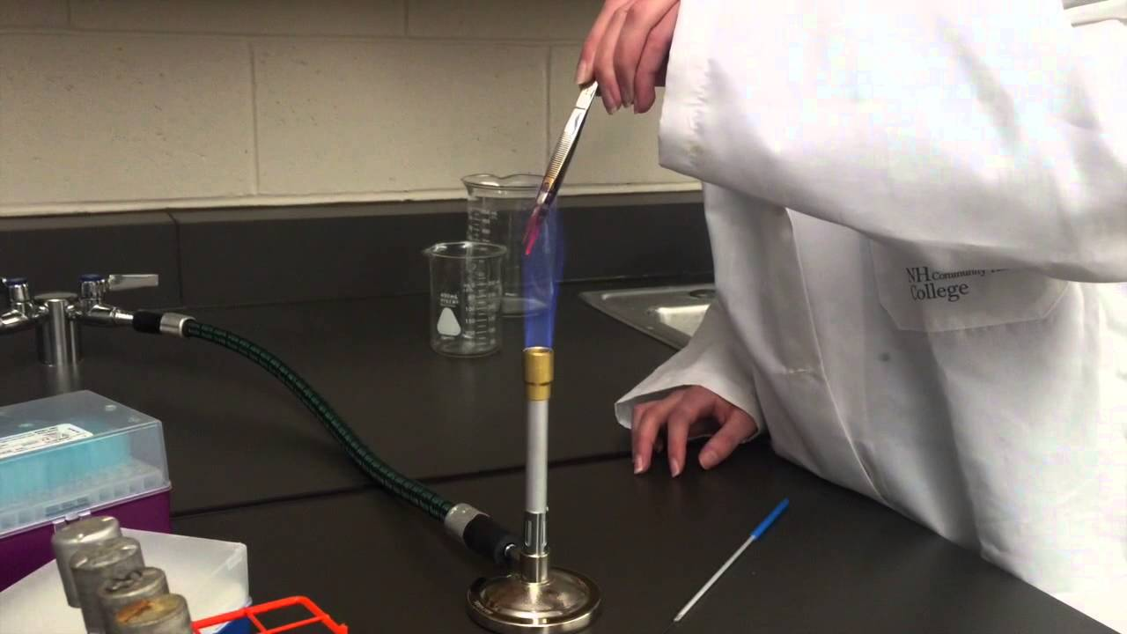
Burner flame
Hot air oven : sterilized by exposed to high heat 160°C for 60 min or 180°C for 20 min, this type is used to sterilized Glassware , petri dishes and pipettes, after sterilization leave period until cool and be usable without harm .
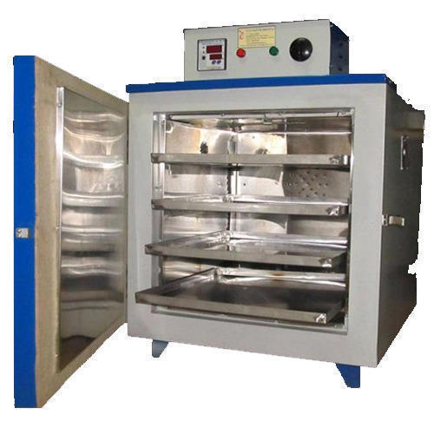
Hot air oven
- Moist Heat :
Means using the water vapor in the sterilization rather of hot air.
Autoclave : Best and fastest ways sterilization of the ability of moist heat to kill the vegetative cells and spores, Being under the temperature of 121 ° C and at a pressure of (1) bar for 15 minutes .
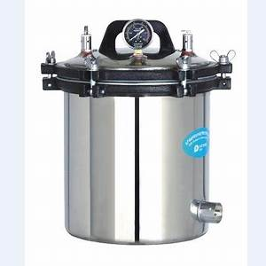
Autoclave
- Radiation : The harmful impact of radiation on some microorganisms useful in sterilization some places, such as chambers of surgical operations and in some food industries and sterilizing large surfaces and sterilizing water .
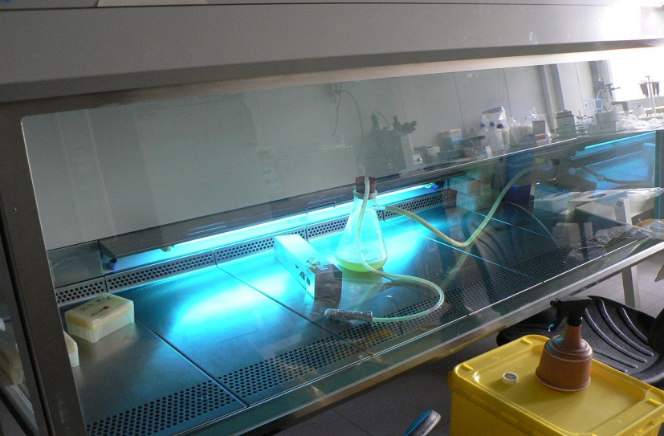
Hood UV radiation lab
- Ultraviolet Radiation: Used more than others in the sterilization due to the impact deadly effect on DNA that any cell , in the laboratory using special lamps with the color violet .
- Other Radiation : Can be used X-ray shortwave and Gamma ray for purposes sterilization.
- Filtration : frequently used to remove cells from the organisms in media , characterized as not change the physical or chemical properties of the materials so used in the preparation of enzymes and antibiotics solvents ٬serum ٬ proteins and some vitamins.
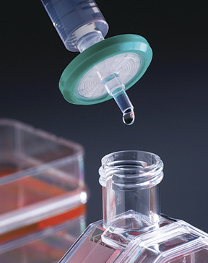
Millipore filter
- Chemical methods : Chemicals used solutions for surface sterilization ex:
- Halogens: It is an effective material against microbial such as Iodine and chlorine .
- Aldehydes : One of antimicrobial materials such as Formaldehyde and Formalin by fogging technique , This method is used to sterilize laboratories, incubators and refrigerators .
- Dettol (chloroxylenol B.F)

