Fungi Isolation:
Fungus spread in many environments heavily where there is no place free of the presence of one or more type of fungus or spores٬Which can be isolated from soil, air or water, fungi parasitize humans and plants and less on animal causing diseases and economic losses, so it is necessary to isolation and Diagnosis these fungi to reduce the danger.
Materials and tools:
- Slides and cover slips
- Petri dishes
- Burner
- Gloves
- Lactophenol cotton blue (LPCB)
- Pipettes
- Inoculating needle
- Flask and bakers
- Test tube
- Media
- Microscope
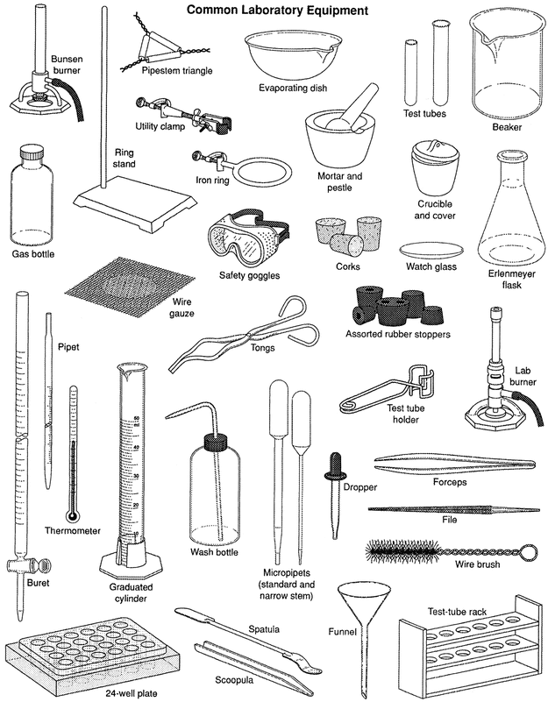
Materials and tools in laboratory
- Isolation fungi from soil
- Pour plate methods (Direct Isolation)
- Weighted 0.1 gm of soil and placed it in Petri dish.
- Poured the culture media in Petri dish near flame .
- Moved the Petri dish with a circular movement right and left for mixing the soil with media .
- Leave the plate until it solid , then incubated for 5 days at 25-28 °C.
Not: Can distribution the soil sample on the surface of solid culture media .

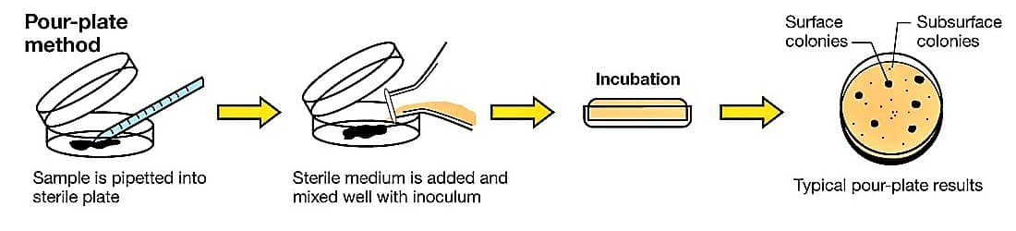
Pour plate method
- Indirect isolation :
It’s a modified method of poured plate methods, use to Purification fungi from bacteria .
- Add 10 ml of culture media in Petri dish and left to solid.
- Placed 0.1 gm of soil sample above the culture media .
- Poured 5 ml of culture media on the plate and left to solid.
In this case hyphal fungi grow to high because it Aerobic organisms while the bacteria (anaerobic) stay within the culture media .

- Dilution method:
- Weighted 1 gm of soil and placed it in test tube contain 10 ml Distilled water(DW) (stoke), Mixed it well.
- Prepare 5 test tube each contain 9 ml of (DW).
- Take 1ml of stoke to the first tube that will be first dilution 10 /1 (10⁻¹).
- Take 1ml of the first dilution to the second tube that will be the second dilution 100 /1 (10⁻²).
- Take 1ml of second dilution to the third tube that will be the third dilution 1000 /1 (10⁻³).
- Take 1ml of third dilution to the fourth tube that will be the fourth dilution 10000 /1 (10⁻⁴).
- Take 1ml of fourth dilution to the fifth tube that will be the fifth dilution 100000 /1 (10⁻⁵).
- Placed 1 ml of each filtrate dilution in a Petri dish and then poured the culture media, moved the dish for mixing the sample with the culture media.
- Leaf it until solid , then incubated for 5 days at 25-28°C.
Not: The dilution (1ml) can be distributed on surface of solid culture media .
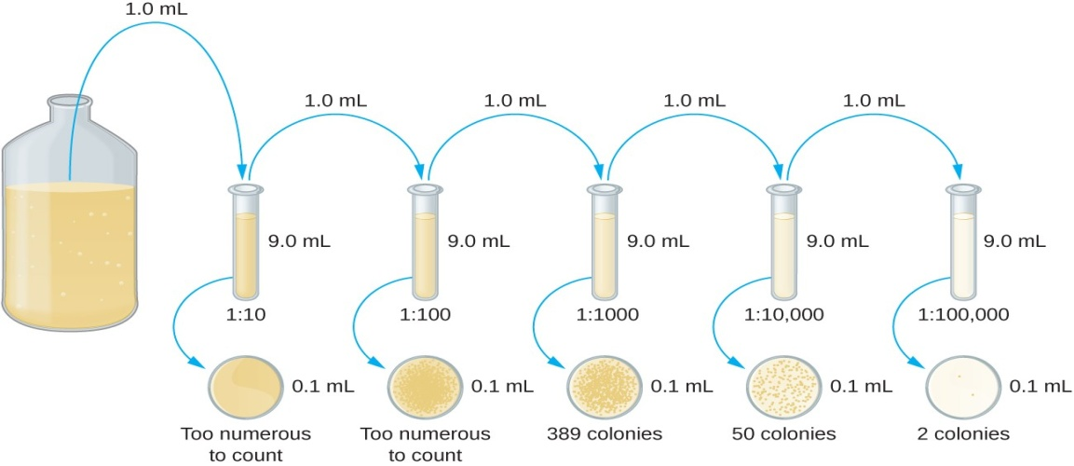 Dilution method
- Isolation fungi from air:
- Poured the media on Petri dishes and leave it until solid .
- Open the dished in several different places for 30 min.
- Incubated for 5 days at 25-28 °C.
- Isolation fungi from water:
- Dilution method:
- Take 1ml of water sample placed it in test tube contain 9ml of (D.W) , that will be first dilution 10 /1 (10⁻¹).
- Take 1ml of the first dilution to the second tube that will be the second dilution 100 /1 (10⁻²).
- Take 1ml of second dilution to the third tube that will be the third dilution 1000 /1 (10⁻³).
- Take 1ml of third dilution to the fourth tube that will be the fourth dilution 10000 /1 (10⁻⁴).
- Take 1ml of fourth dilution to the fifth tube that will be the fifth dilution 100000 /1 (10⁻⁵).
- Placed 1 ml of each filtrate dilution in a Petri dish and then poured the culture media, moved the dish for mixing the sample with the culture media.
- Leaf it until solid , then incubated for 5 days at 25-28°C.
Not: The dilution (1ml) can be distributed on surface of solid culture media .

- Filtration methods:
- Filtrate the water sample using cellulose filter Placed in a sterile suppression.
- After the passage the sample, Filter paper taken by sterile forceps and placed on surface of culture media then incubated the dishes for 5 days at 25-28 °C.
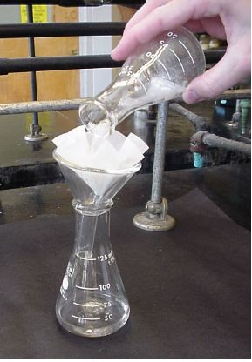
Filtration methods
- Isolation fungi from fruits and vegetables:
- Placed the media into the plate and left it until solid .
- Surface sterilization to rotten part by Sodium Hypochlorite or Potassium Permanganate (2%) .
- Washing the sample by (D.W) 2-3 times .
- Transfer part rotten to the Petri dish by a sterile needle.
- Incubated the dishes for 5 days at 25-28 °C.
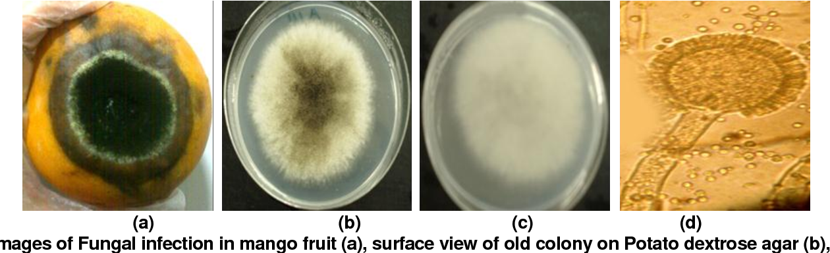
Isolation fungi from fruits
Not: Sometimes baits used to attract certain types of fungi, where a growth appear clear on these baits then transferred to the culture media , the baits may be some type of fruits , seeds, skin, hair .

