Pathogenicity : the ability of a microorganism to produce disease in a host.
Pathogenicity test :
- Use a seeds :
- Preparation spore suspension to The fungus specific to pathogenicity test .
- Bring certified seeds.
- Providing clean soil in pots ٬ With three pots as follows:
1 – The First Pot is a control (just put the seed).
2 – The second pot contains seed soaked spore suspension
3 - The third pot contains a soil sprinkled with spore suspension .
- Note : the seedling growth in a week and record results.

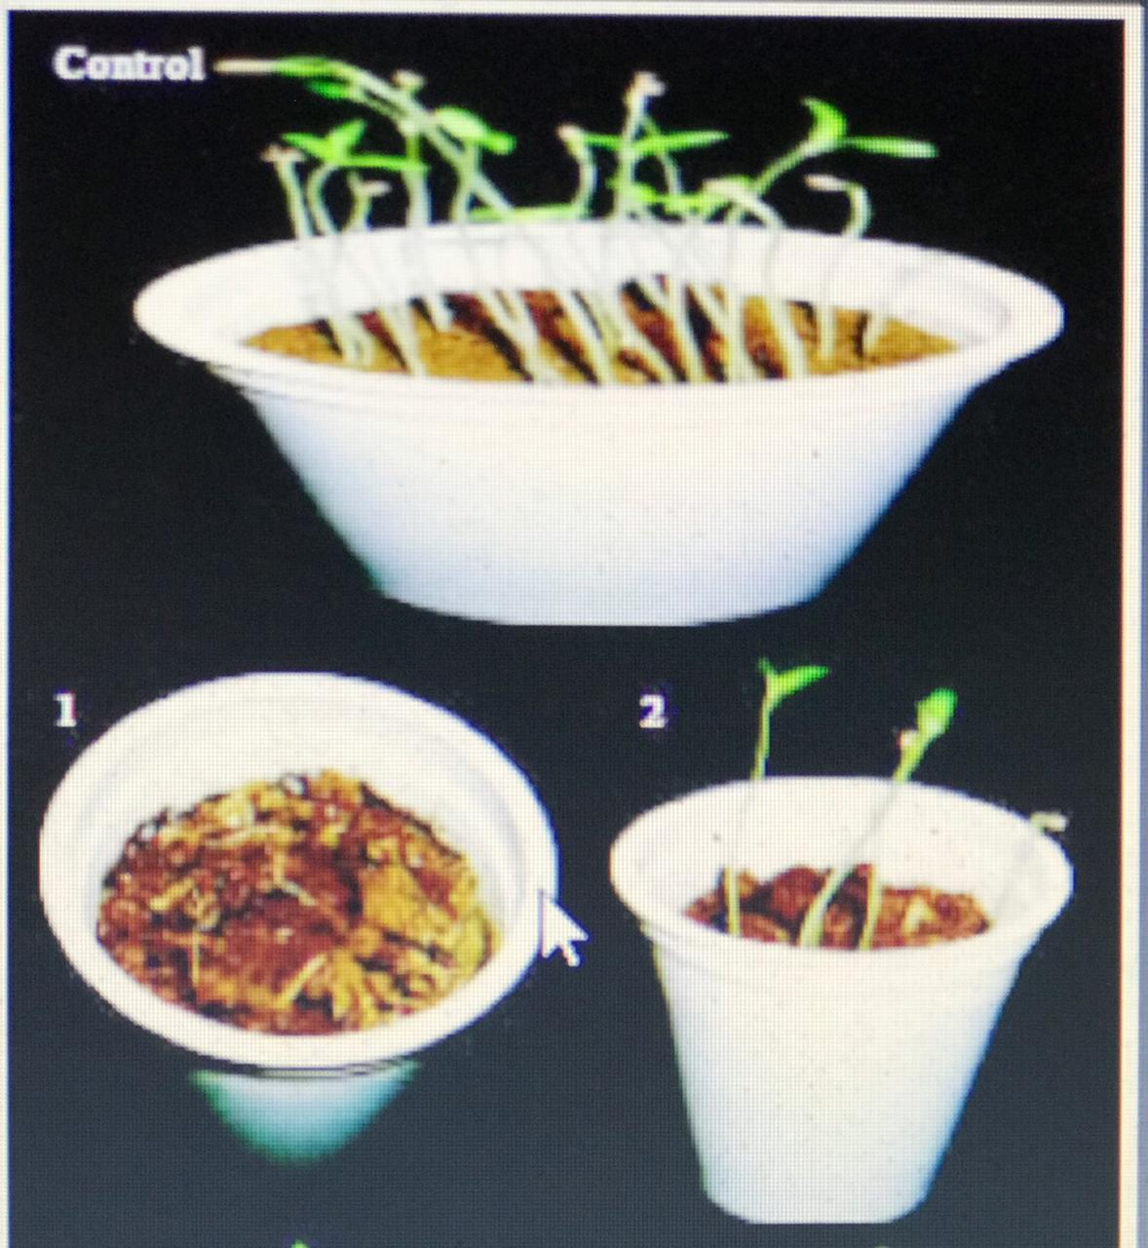
Figure(1) Pathogenicity test use seeds
- Use a fruits:
- Preparation spore suspension to The fungus specific to pathogenicity test .
- Bring fruits sound and free from any scratch (Any type).
- Hole the fruit of three equal places by needle.
- Each type of fungus two fruit as follows:
1 - The First fruit is a control (just hole three equal places).
2 - The second a fruit exposed to spray spore suspension on the holes areas .
- Put fruits inside a sterile bag ٬ and then inside the incubator for 5 to7 days at 25° with note appearance spots on the fruit, measured and compared with control.

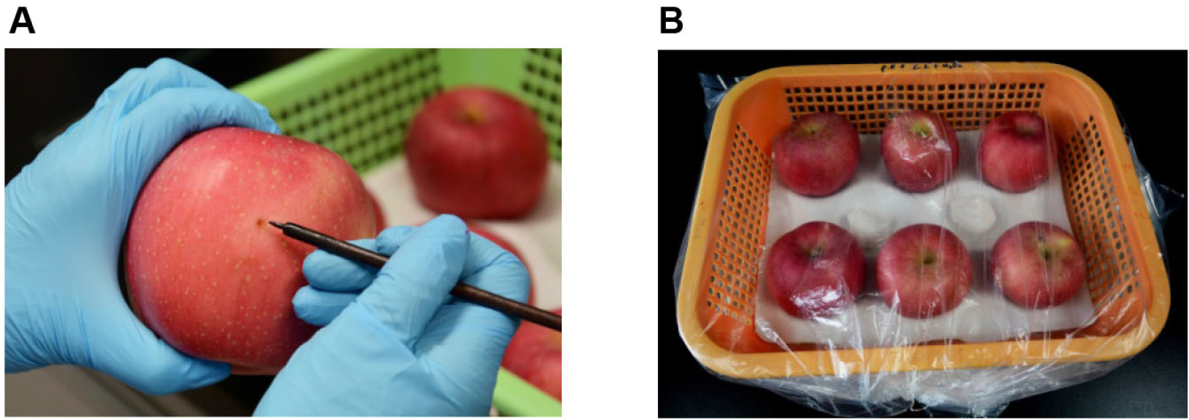
Figure(2) Pathogenicity test use fruit

Spore suspension preparation :
- Pour 10 ml of distilled water on the petri dish container fungal isolates under study .
- By a glass slide is harvested fungal inside dish .
- Filter by filter paper .
- Mixing tube by Vortex .
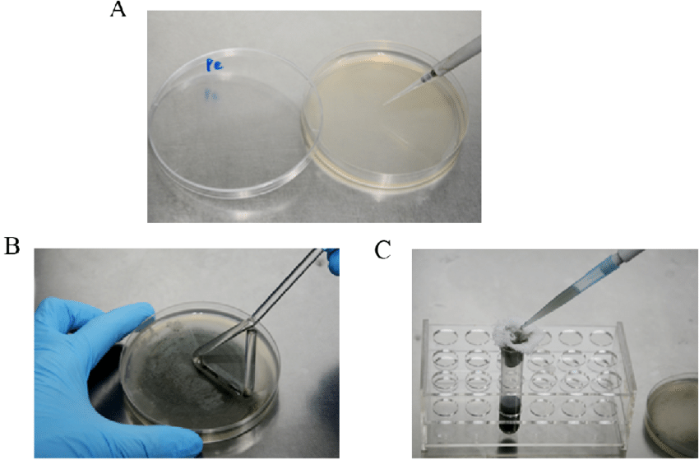
Figure(3) Spore suspension
Or
- Cutting disc the size of 1 cm from the petri dish containing the fungal .
- Placed inside the tube container 10 ml of distilled water.
- Mixing tube by Vortex .

