3.7. Distance Measures
For pixels p, q, and z, with coordinates (x, y), (s, t), and (v, w),respectively, D is a distance function or metric if
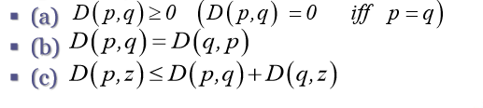
- The Euclidean distance between p and q is define as
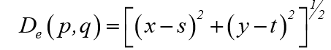

For this distance measure, the pixels having a distance less than or equal to some value r from (x,y) are the points contained in the disk of radius r centered at (x,y)

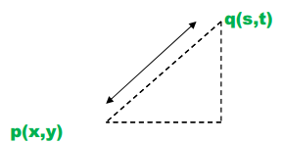

- The D₄ distance (called the city-block distance) between p and q is defined as:
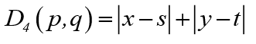

In this case, Pixels having a D₄ distance from (x,y) less than or equal to some value r from a Diamond centered at(x, y),.

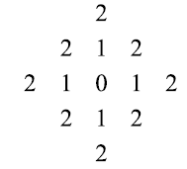
Example:
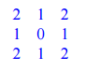

the pixels with D₄=1 are the 4-nighbors of (x, y).

- The D₈ distance (called the chessboard distance) between p and q is defined

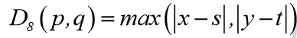

In this case, the pixels having a D₈ distance from (x,y) less than or equal to some value r from a square centered at (x, y).

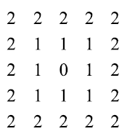
Example:

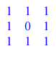

The pixels with D₈=1 are the 8-nieghbors of (x,y).

Note: that the D₄ distance & D₈ distance are independent of any paths that might exist between the points because these distances involve only the coordinates of the points.
أن المسافة D₄ و المسافة D₈ مستقلة عن أي المسارات التي قد توجد بين النقاط لأن هذه المسافات تنطوي فقط إحداثيات نقطة.

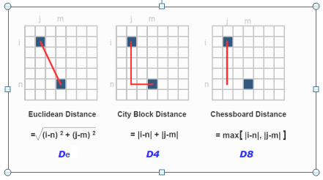

4. D_{m} – distance between two points is defined as the shortest m-path between the point.
In this case the distance two pixels will depend on the values of the pixels along the path as well as the values of their neighbors.

Example : consider the following arrangement of pixels and assume that p,p₂ and p₄ have value 1 and that p₁ and p₃ can have a value of 0 or 1:
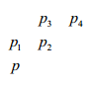

Suppose that we consider adjacency of pixels valued 1(i.e. v={1})
- If p₁ and p₃ are 0
The m- path (D_{m} distance between p and p₄is 2
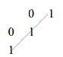

- If p₁ is 1
The D_{m} distance between p p₁ p₂ p₄ is 3
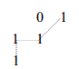
- If p₃=1 and p₁=0
The D_{m} distance between p p₂ p₃ p₄ is 3

 | 1 | 1
0 | 1
1

- If p₁ and p₃ are 1

The D_{m} distance between p p₁ p₂ p₃ p₄ is 4

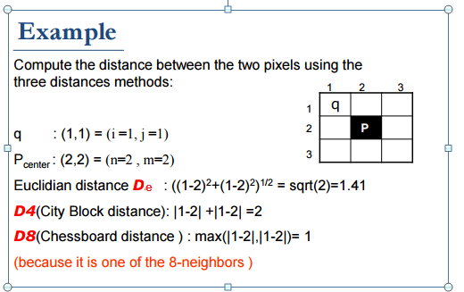

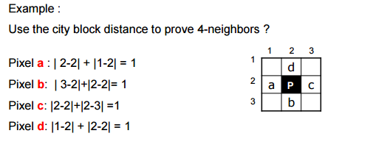

Homework: Try the chessboard distance to proof the 8-neighbors

