3.2. Histogram Equalization
Histogram Equalization is a popular technique for improving the appearance of a poor image. It's a function is similar to that of a histogram stretch but often provides more visually pleasing results a cross a wide rang of images. Histogram equalization is a technique where the histogram of the resultant image is as flat as possible (with histogram stretching the overall shape of the histogram remains the same).
The results in a histogram with a mountain grouped closely together to "spreading or flatting histogram makes the dark pixels appear darker and the light pixels appear lighter (the key word is "appear" the dark pixels in a photograph can not by any darker. If, however, the pixels that are only slightly lighter become much lighter, then the dark pixels will appear darker). The histogram equalization process for digital images consists of four steps:
1. Find the running sum of the histogram values
2. Normalize the values from step1 by dividing by total number of pixels.
3. Multiply the values from step2 by the maximum gray level value and round.
4. Map the gray-level values to the results from step 3, using a one-toone correspondence. The following example will help to clarify this process

Example:- We have an image with 3 bit /pixel, so the possible range of values is 0 to 7. We have an image with the following histogram:
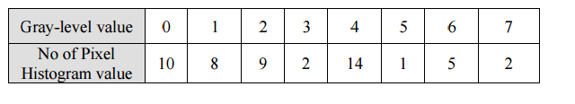
Step 1: Great a running sum of histogram values. This means that the first values is 10,
the second is 10+8=18, next is 10+8+9=27, and soon. Here we get
10,18,27,29,43,44,49,51.
Step 2: Normalize by dividing by total number of pixels. The total number of pixels is
10+8+9+2+14+1+5+2=51.
Step 3 : Multiply these values by the maximum gray-level values in this case 7 , and
then round the result to the closet integer. After this is done we obtain
1,2,4,4,6,6,7,7.
Step 4 : Map the original values to the results from step3 by a one –to- one
correspondence.
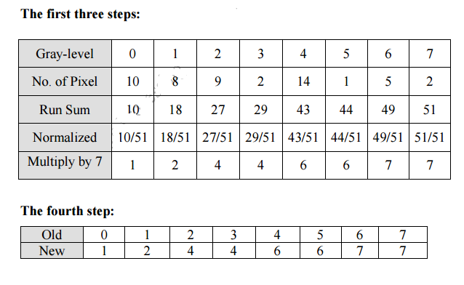

All pixel in the original image with gray level 0 are set to 1, values of 1 are set to 2,
2 set to 4, 3 set to 4, and so on.
you can see the original histogram and the resulting histogram equalized histogram.
Although the result is not flat, it is closer to being flat than the original

