7.Image Restoration: Image restoration methods are used to improve the appearance of an image by application of a restoration process that use mathematical model for image degradation.
Example of the type of degradation:
1. Blurring caused by motion or atmospheric disturbance.
2. Geometrics distortion caused by imperfect lenses.
3. Superimposed interface patterns caused by mechanical systems.
4. Noise from electronic source.
7.1. What is noise?
Noise is any undesired information that contaminates an image. Noise appears in image from a variety of source. The digital image a acquisition process, which converts an optical image into a continuous electrical signal that is then sampled is the primary process by which noise appears in digital images. At every step in the process there are fluctuations (تذبذب) caused by natural phenomena (ظاهره) that add a random value to exact brightness value for a given pixel. In typical image the noise can be modeled with one of the following distribution:
1. Gaussian (“normal”) distribution.
2. Uniform distribution.
3. Salt _and _pepper distribution

7.1 Noise Removal using Spatial Filters:
Spatial filtering is typically done for:
1. Remove various types of noise in digital images.
2. Perform some type of image enhancement. [These filters are called spatial filter to distinguish them from frequency domain filter]. The three types of filters are:
1. Mean filters
2. Median filters (order filter)
3. Enhancement filters

- Mean filters
Replace each pixel by the average of pixels in a square window surrounding this pixel
Trade-off between noise removal and detail preserving:
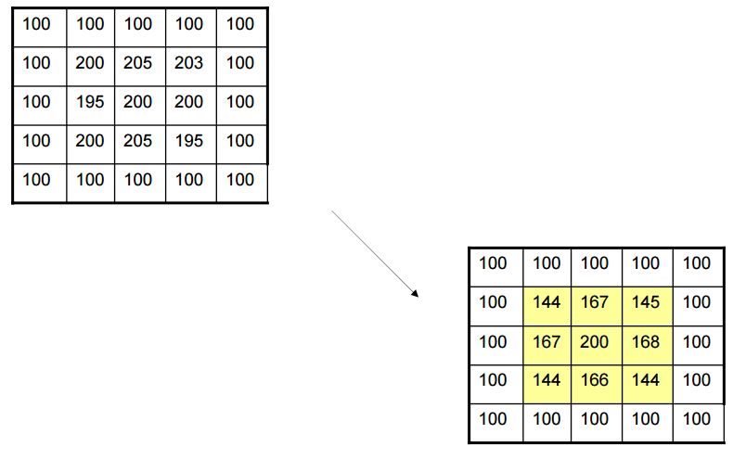
– Larger window -> can remove noise more effectively, but also blur the details/edges
Problem with mean Filter
– Blur edges and details in an image
– Not effective for impulse noise (Salt-and-pepper) •

2. Median Filter

– Taking the median value instead of the average of pixels in the window
• Median: sort all the pixels in an increasing order, take the middle one
given an NXN window (W) the pixel values can be ordered from smallest to the largest.
I₁ ≤ I₂ ≤ I₃...…………………< I_{N}
Where I₁, I₂, I₃...……, I_{N} are the intensity values of the subset of pixels in the image.

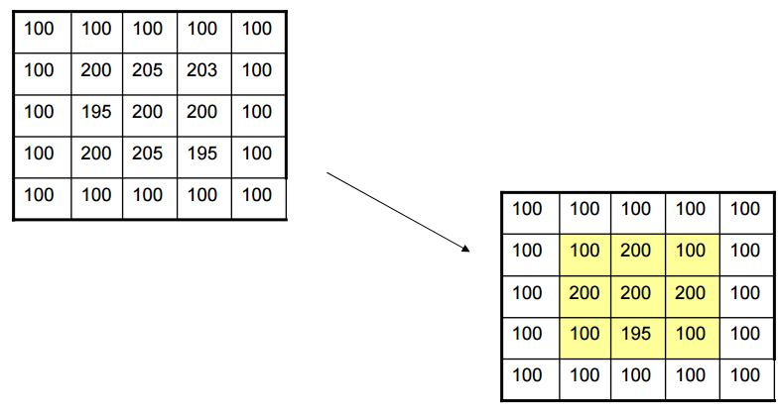

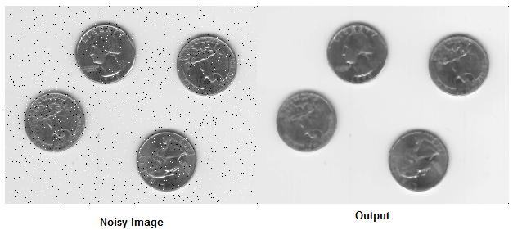

Examples: Apply median filter with mask 3x3?

$$\left[\begin{aligned}2 1 8 1 1 \\ 4 3 1 4 7 \\ 2 4 9 7 3 \\ 3 7 2 3 1\end{aligned}\right]$$

2 | 1 | 8 | 1 | 1
4 | 3 | 4 | 4 | 7
2 | 3 | 4 | 3 | 3
3 | 7 | 2 | 3 | 1

Solu:[1 1 2 2 3 4 4 8 9]
[1 1 1 3 4 4 7 8 9]
[1 1 1 3 4 4 7 8 9]

