7.3 Edge Detection
One of the most important uses of image processing is edge detection:

Edge detection methods are used as a first step in the line detection processes, and they are used to find object boundaries by marking potential edge points corresponding to place in an image where rapid changes in brightness occur. After these edge points have been marked, they can be merged to form lines and objects outlines.
Edge detection operations are based on the idea that edge information in an image is found by looking at the relationship a pixel has with its neighbors. If a pixel gray_level values similar to those around it, there is probably not an edge at that point. However, if a pixel has neighbors with widely varying gray levels, it may represent an edge point. In other words, an edge is defined by a discontinuity in gray-level values. Ideally, an edge separates two distinct objects. In practice, edges are caused by:
• Change in color or texture or
• Specific lighting conditions present during the image acquisition process.

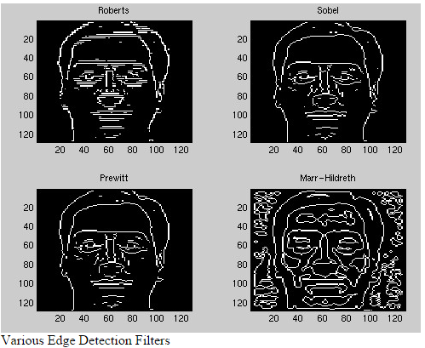

Notice that the facial features (eyes, nose, mouth) have very sharp edges.
Sobel Operator: The Sobel edge detection masks look for edges in both the horizontal and vertical directions and then combine this information into a single metric. The masks are as follows:
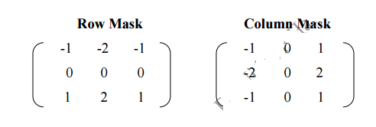

These masks are each convolved with the image. At each pixel location we now have two numbers: S₁, corresponding to the result form the row mask and S₂, from the column mask. the edge magnitude is defined as follows:
Edge Magnitude $=\sqrt{S_{1}^{2}+S_{2}^{2}}$

