New Headway

Beginner Student’s Book

Bilal Ali Burhan

Unit 8 : Where I live

Lecture (1)

There Is vs. There Are: How to Choose?

- The choice between the phrases there is and there are at the beginning of a sentence is determined by the noun that follows it.
- Use there is when the noun is singular (“There is a cat”). Use there are when the noun is plural (“There are two cats”).

There Is vs. There Are
You probably know that the choice between is vs. are depends on a noun. In most sentences, the noun comes before the verb. But in sentences that begin with there is and there are, the noun comes later.
- There is a cat on the porch.
In the sentence above, cat is singular, so it requires there is.
- There are many opportunities to learn at this company.
In the sentence above, opportunities is plural, so it requires there are.

There is - There are
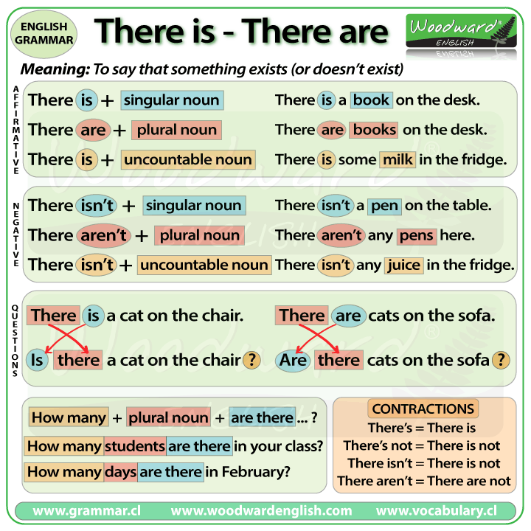

Positive Sentences
We use there is for singular and there are for plural.
- There is one table in the classroom.
- There are three chairs in the classroom.
- There is a spider in the bath.
- There are many people at the bus stop.
We also use There is with uncountable nouns:
- There is milk in the fridge.
- There is some sugar on the table.
- There is ice cream on your shirt.

Contractions
The contraction of there is is there's.
- There's a good song on the radio.
- There's only one chocolate left in the box.
You cannot contract there are.
- There are nine cats on the roof.
- There are only five weeks until my birthday.

Negative Form
The negative is formed by putting not after is or are:
- There is not a horse in the field.
- There are not eight children in the school.
- There is not a tree in the garden.
- There are not two elephants in the zoo.
We almost always use contractions when speaking.
The Negative contractions are:
- There's not = There isn't
- There are not = There aren't

There aren't with ANY
When we want to indicate that a zero quantity of something exists we use there aren't any.
- There aren't any people at the party.
- There aren't any trees in my street.
We also use this structure with uncountable nouns:
- There isn't any water in the swimming pool.
- There isn't any sugar in my coffee.

Questions
To form a question we place is / are in front of there.
Again we use any with plural questions or those which use uncountable nouns.
We also use there is / are in short answers.
- Is there a dog in the supermarket? - No, there isn't.
- Are there any dogs in the park? - Yes, there are.
- Is there a security guard in the shop? - Yes, there is.
- Are there any polar bears in Antarctica? - No, there aren't.
- Is there any ice-cream in the freezer? - Yes, there is.

How Many with Are There
If we want to find out the number of objects that exist we use How many in the following form:
How many + plural noun + are there (+ complement).
- How many dogs are there in the park?
- How many students are there in your class?
- How many countries are there in South America?
- How many Star Wars films are there?

Unit 8 : Where I live

Lecture (2)
Prepositions
Prepositions are short words (on, in, to) that usually stand in front of nouns (sometimes also in front of gerund verbs).
Even advanced learners of English find prepositions difficult, as a 1:1 translation is usually not possible. One preposition in your native language might have several translations depending on the situation.
There are hardly any rules as to when to use which preposition. The only way to learn prepositions is looking them up in a dictionary, reading a lot in English (literature) and learning useful phrases off by heart (study tips).
The following table contains rules for some of the most frequently used prepositions in English:

Prepositions – Time
English | Usage | Example
- on | - days of the week | - on Monday
- in | - months / seasons  - time of day  - year  - after a certain period of time (when?) | - in August / in winter  - in the morning  - in 2006  - in an hour
- at | - for night  - for weekend  - a certain point of time (when?) | - at night  - at the weekend  - at half past nine
- since | - from a certain point of time (past till now) | - since 1980
- for | - over a certain period of time (past till now) | - for 2 years
- ago | - a certain time in the past | - 2 years ago
- before | - earlier than a certain point of time | - before 2004
- to | - telling the time | - ten to six (5:50)
- past | - telling the time | - ten past six (6:10)
- to / till / until | - marking the beginning and end of a period of time | - from Monday to/till Friday
- till / until | - in the sense of how long something is going to last | - He is on holiday until Friday.
- by | - in the sense of at the latest  - up to a certain time | - I will be back by 6 o’clock.

Unit 9 : Times Past

Lecture (3)
Past Simple
The simple past tense is used to describe a completed activity that happened in the past. In other words, it started in the past and ended in the past.
The simple past tense (also known as the past simple or preterite) of regular verbs is marked by the ending -d, -ed, or -t. Irregular verbs have a variety of endings. The simple past is not accompanied by helping verbs.

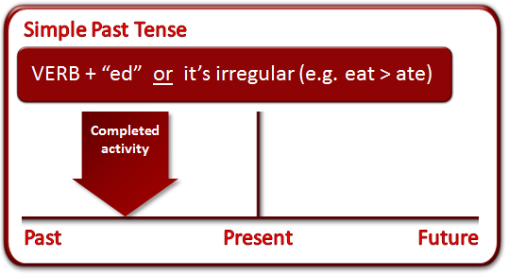

Regular Verbs
If it's a regular verb, the simple past tense is formed like this:
Add "ed" to most verbs:
- jump > jumped
- paint > painted
If a verb of one syllable ends [consonant-vowel-consonant], double the final consonant and add "ed":
- chat > chatted
- stop > stopped
If the final consonant is w, x or y, don't double it:
- sew > sewed
- play > played
- fix > fixed
If last syllable of a longer verb is stressed and ends [consonant-vowel-consonant], double the last consonant and add "ed":
- incur > incurred
- prefer > preferred
If the first syllable of a longer verb is stressed and the verb ends [consonant-vowel-consonant], just add "ed":
- open > opened
- enter > entered
- swallow > swallowed
If the verb ends "e", just add "d":
- thrive > thrived
- guzzle > guzzled
If the verb ends [consonant + "y"], change the "y" to an "i" and add "ed":
- cry > cried
- fry > fried

Irregular Verbs
If it's an irregular verb, the simple past tense is formed in all sorts of different ways. Here are some examples:
- break > broke
- catch > caught
Structure
Subject + was / were + Complement
e.g. She was a teacher in our college.
*The students were worried before the exam.
Negative
*She was not a teacher in our college.
* The students were not worried before the exam.
Questions
Was she a teacher in our college?
Were the students worried before the exam?
Structure
Subject + Main verb+ complement
*They played football yesterday
*I wrote a letter to my uncle two days ago.

Negative
Subject + did (not) + verb + complement
*They did not play football yesterday
* I did not write a letter to my uncle two days ago
Questions
*Did they play football yesterday?
*Did you write a letter to your uncle two days ago?
Note
Adverbs that occur with this tense are
( yesterday/ last month / last year/ ago )

