في التحليل العددي، طريقة نيوتن (بالإنجليزية:Newton's method) أو طريقة نيوتن-رافسون(بالإنجليزية: Newton–Raphson method) هي خوارزمية فعالة لإيجاد جذور تابع حقيقي. لذلك تعتبر مثالا لخوارزميات إيجاد الجذور. يمكن استخدامها لإيجاد الحدود العليا والحدود الدنيا لمثل هذه التوابع، عن طريق إيجاد جذور المشتق الأول للتابع.
الطريقة
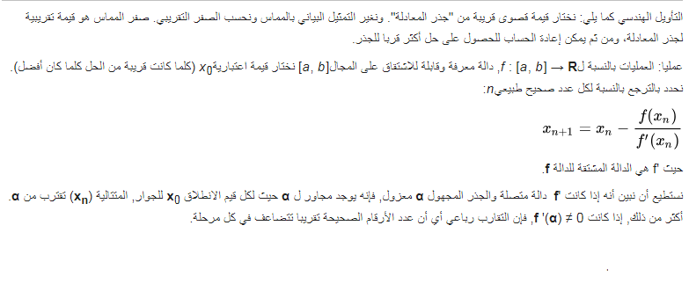

In numerical analysis, Newton's method (also known as the Newton–Raphson method), named after Isaac Newton and Joseph Raphson, is a method for finding successively better approximations to the roots (or zeroes) of a real-valued function. It is one example of a root-finding algorithm.
The Newton–Raphson method in one variable is implemented as follows:
The method starts with a function f defined over the real numbers x, the function's derivative f ′, and an initial guess x₀ for a root of the function f. If the function satisfies the assumptions made in the derivation of the formula and the initial guess is close, then a better approximation x_{n} is
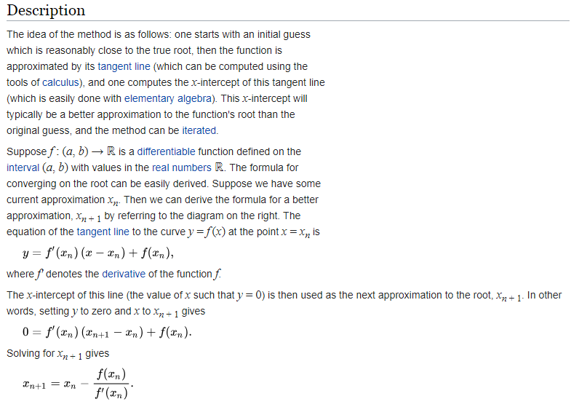

Example :- find the root by using Newton Raphson method for x₀=0.5
cos(x) = x³

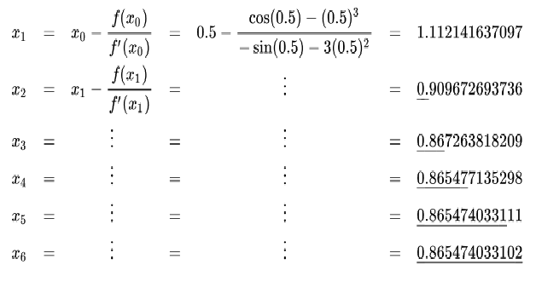

It's required to solve that equation: f(x) = x.^3 - 0.165*x.^2 + 3.993*10.^-4 using Newton-Raphson Method with initial guess (x0 = 0.05) to 3 iterations and also, plot that function.

The following code implements the Newton-Raphson method for your problem:
x = 0.05;
x_old = 100;
x_true = 0.0623776;
iter = 0;
while abs(x_old-x) > 10^-3 && x ~= 0
x_old = x;
x = x - (x^3 - 0.165*x^2 + 3.993*10^-4)/(3*x^2 - 0.33*x);
iter = iter + 1;
fprintf('Iteration %d: x=%.20f, err=%.20f\n', iter, x, x_true-x);
pause;
end

You can plot the function with, for example:
x = -10:0.01:10;
f = x.^3 - 0.165*x.^2 + 3.993*10^-4;
figure;
plot(f)
grid on

Find a real root of the function f(x)=tanh(x^2 - 9)using at least 3 iterations, using Newton-Raphson method. x= 3.2 show each iteration graphically.
clc

clear all

x=3.2;

fx=tanh(x^2-9);

iter=5;

pog=0.01;

br=1;

while br<10;

xk= x-((tanh(x^2-9))/(-2*x*(tanh(x^2 - 9)^2 - 1)));

fprintf ('x=%g\txk=%g\t%g\n', x,xk, abs(xk-x))

if pog>abs(xk-x);

break

end

x=xk;

br=br+1;

end

المصادر
- Ryaben'kii, Victor S.; Tsynkov, Semyon V. (2006), A Theoretical Introduction to Numerical Analysis, CRC Press, p. 243, ISBN 9781584886075.
- Kendall E. Atkinson, An Introduction to Numerical Analysis, (1989) John Wiley & Sons, Inc, ISBN 0-471-62489-6
- Kaw, Autar; Kalu, Egwu (2008). "Numerical Methods with Applications" (1st ed.).

