Simpsons rule
In numerical analysis, Simpson's rule is a method for numerical integration, the numerical approximation of definite integrals. Specifically, it is the following approximation for equally spaced subdivisions (where is even): (General Form)
n
n
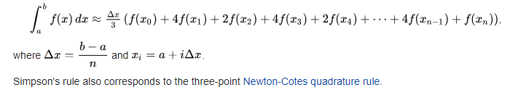

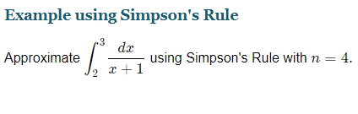

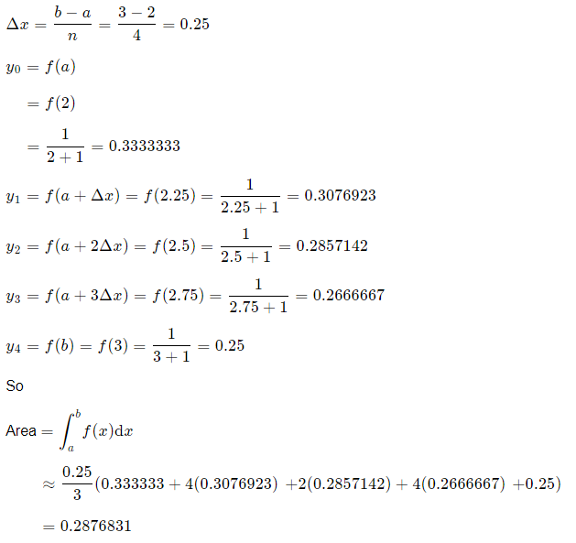

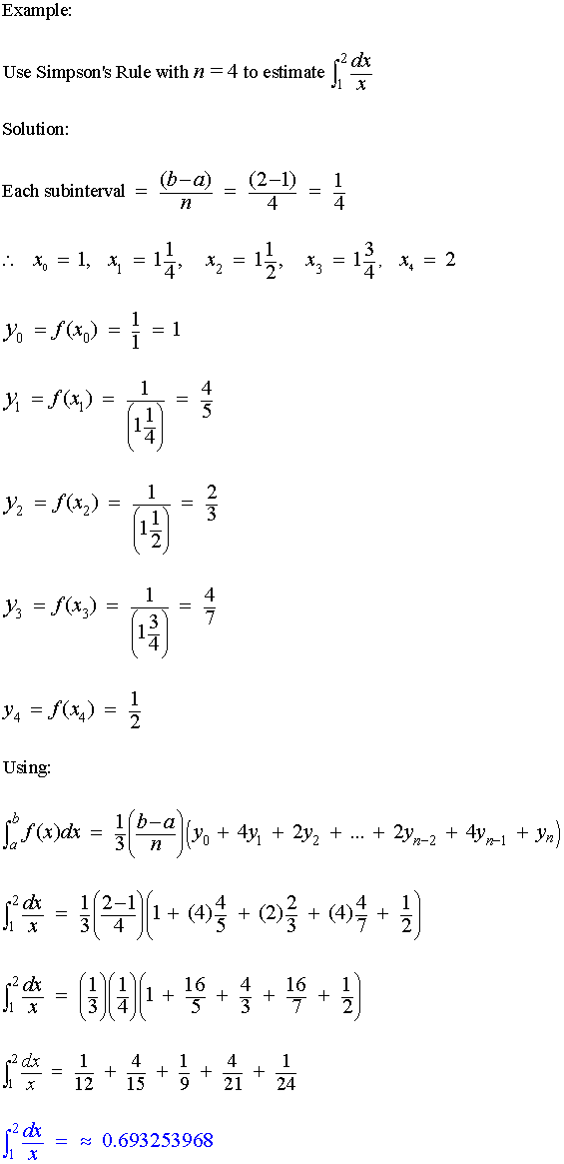

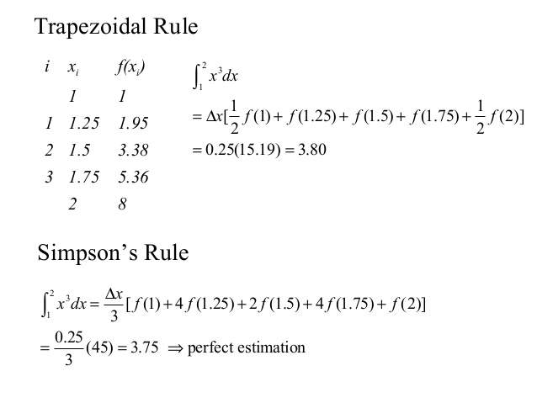

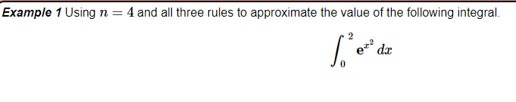

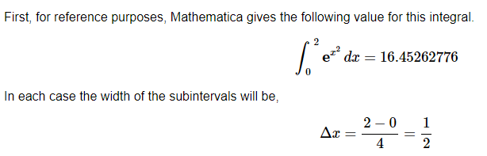

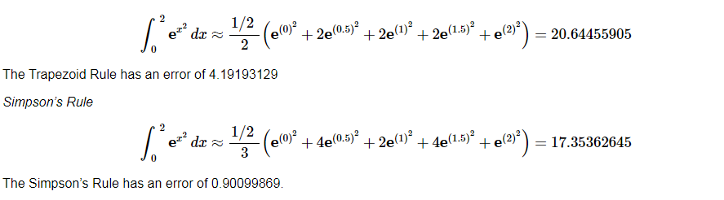

% Ask for user input

% Lower bound (a)

a = input('What is your lower bound (a)?')

% Upper bound (b)

b = input('What is your upper bound (b)?')

% Subintervals

N = input('How many subintervals (N)?')

% Defining function

f = @(x) (2*x)/((x.^2)+1)

% Finding h

h=(b-a)/N;

% Finding the values of x for each interval

x=linspace(a,b,N);

% Calculating the integral

for i = 1:N-1

I(i)= (h/3)*(f(x(i))+(4*f((x(i)+x(i+1))/2))+f(x(i+1)));

end

answer1 = sum(I)

References
- Atkinson, Kendall E. (1989). An Introduction to Numerical Analysis (2nd ed.). John Wiley & Sons. ISBN 0-471-50023-2.
- Burden, Richard L.; Faires, J. Douglas (2000). Numerical Analysis (7th ed.). Brooks/Cole. ISBN 0-534-38216-9.
- Pate, McCall (1918). The naval artificer's manual: (The naval artificer's handbook revised) text, questions and general information for deck. United States. Bureau of Reconstruction and Repair. p. 198.

