المرحلة : الثانية
المادة: التحليل العددي/Numerical Analysis
الجامعة المستنصرية
كلية التربية الأساسية
قسم الحاسبات

Q1:-- Fill in the blanks:-
- If ƒ(c) ƒ(a) < 0,then the root belongs to----------
- In bisection method ,we generate x by------------
- the cessation clouse to generate the points is-------------
- the no of iteration in bisection method satisfy the equ.--------
- In false position method to generate the points x=---------

Q2:-- Write correct or incorrect with discussion:-
- Bisection method can’t find the approximate root of ƒ(x) =1+e^{-x}
on [0,1], Є=0.01.
- Trapizume role $\int_{0}^{4}{\frac{1}{8}x^{2}+1}$ dx ≈10.75, where n=4
ϵ=0.00001
Q3:- Write three iteration using Newton- Raphson metod where

الحلول
Q1:-- Fill in the blanks:-
1) [a,c]
2)a+b/2
ǀ x_{n}-x_{n-1} ǀ<ϵ

3)

4) 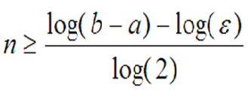

5)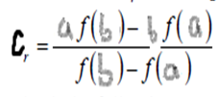

Q2:-- Write correct or incorrect with discussion:-

- true
Ƒ(a)= 1+e⁻⁰=2
Ƒ(b)= 1+e⁻¹=1.3678
Ƒ(a)* Ƒ(b)>0
- false=6.75

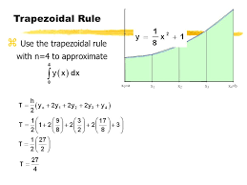

ϵ=0.00001
Q3:- Write three iteration using Newton- Raphson metod where
