**Unit Two**

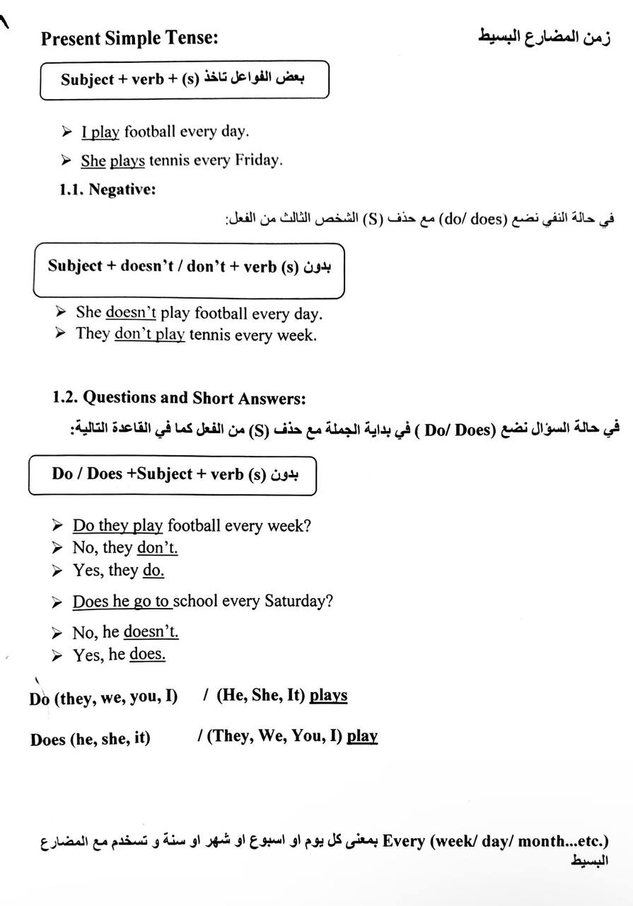

* **Examples for present simple tense**

-He plays football every day.

He doesn't play tennis every day.

Does he play tennis every day?

Yes, he does. , No, he doesn't.

**-**They go to school every day.

They don't go to school every day.

Do they go to school every day?

Yes, they do. , No, they don't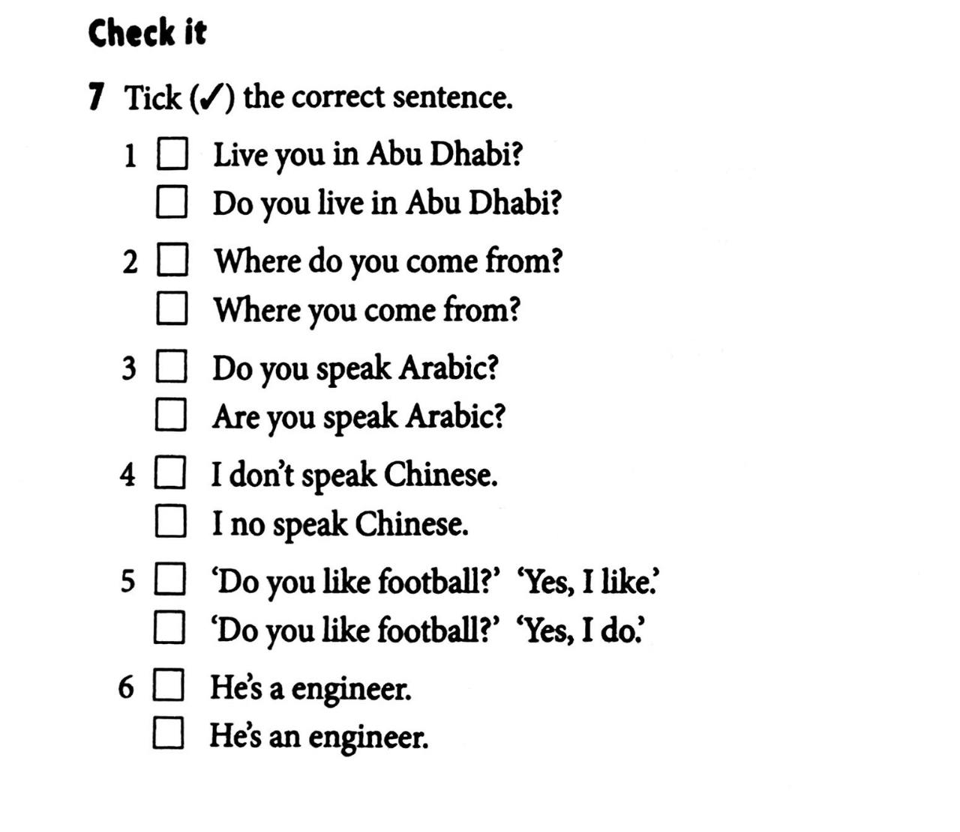

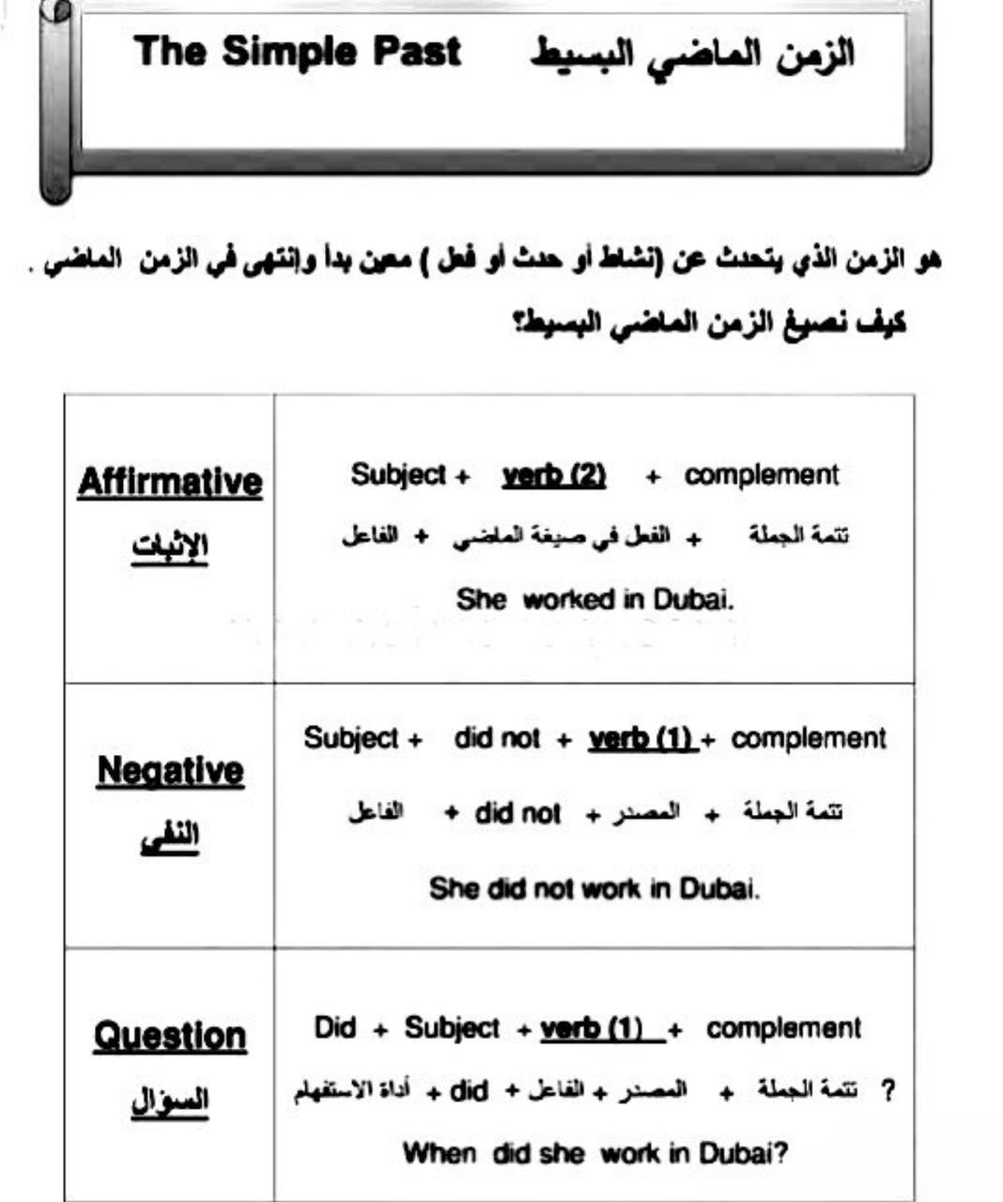

* **Examples for simple past tense**

-He played football yesterday.

He didn't play football yesterday.

Did he play football yesterday?

Yes, he did.

No, he didn't.

-She cleaned her room last night.

She didn't clean her room last night.

Did she clean her room last night?

Yes, she did.

No, she didn't.

**-**They went to school yesterday.

They didn't go to school yesterday.

Did they go to school yesterday?

Yes, they did.

No, they didn't.

**Regular and Irregular verbs هناك افعال منتظمة وافعال غير منتظمة**

play – played go - went

watch – watched eat- ate

study – studied drink – drank