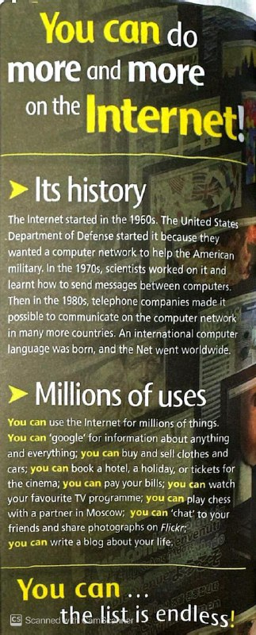

**Reading Text (1)**

**You can do more and more on the internet**

**1.**When did the internet start?

It started in the 1960s.

**2.**Who did start the internet?

The United States Department of Defense started it.

**3.**Why did the United States Department of Defense start the internet?

Because they wanted a computer network to help the American military.

**4.**What did the scientists work in the 1970s?

They worked on the internet and learnt how to send messages between computers.

**5.**What did the telephone companies do in the 1980s?

They made it possible to communicate on the computer network in many more countries.

**6.**What can we do with the internet?

We can use it for millions of things, such as booking, searching, buying, selling …etc.

**7.**What other things that we can do with the internet?

We can watch T.V programme, play chess with a partner in other country.

**8.** Can we pay our bills on the internet?

Yes, we can.

**9.**Can we chat to our friends and share photographs?

Yes, we can.

**10.**What is Flickr?

It is an online application for images and videos hosting**.**