Reading Text ( Reza the Shopkeeper)

My uncle's a shopkeeper. He has a shop in an old village by the River Thames near Oxford. The shop sells a lot of things bread, milk, fruit, vegetables, newspapers - almost everything! It is also the village post office. The children in the village always stop to spend a few pence on sweets or ice cream on their way home from school. My uncle doesn't often leave the village. He hasn't got a car, so once a month he goes by bus to Oxford and has lunch at the Grand Hotel with some friends. He is one of the happiest men I know.

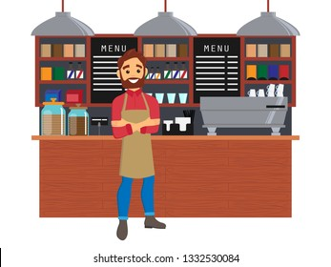

Good Luck*

