**Lecture12 الأسبوع الثاني عشر**

**Athletics**

Athletics contains the basic human skills; running, jumping and throwing. All these events, except pole vault, were used by Man to survive. It takes place in an oval shaped track of eight lanes that encloses a large field.

Athletics is divided into two events:

**1. Track Events**

1. Walking Events

2. Hurdles

3.Running events

4. Relay

some words look plural but they are singular in fact. They are ended with -s but they take a singular verb!

* • Acronym: news
* • Some Diseases: measles, mumps, rickets, shingles.
* • Subject Names in –ics : classics, linguistics, mathematics, phonetics, gymnastics,

athletics.

* • Some Games: billiards, darts, dominoes, checkers.
* • Some Proper Nouns: Athens, Wales, United Nations, United States.
* • They all have a singular verb when considered as one unit.

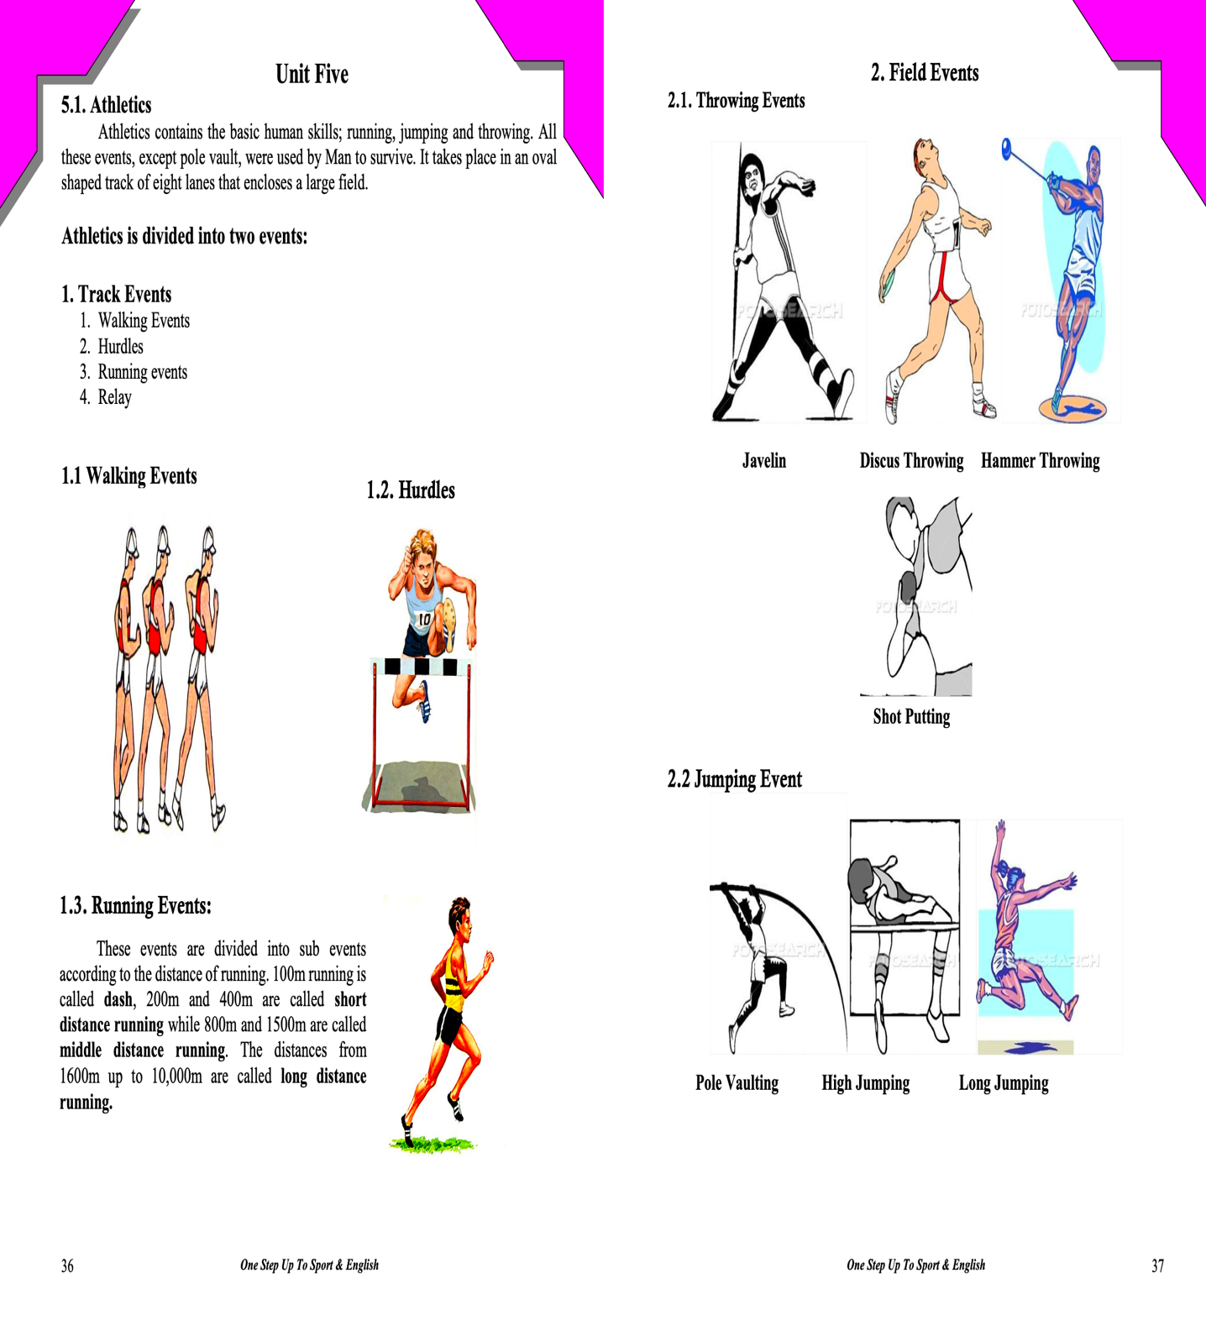

• Read the passage carefully and answer the following questions :

Running Events  
Running events are kind of Track events. These events are divided into sub events

according to the distance of running. The distance starts from 100m to 10,000m. 100m running is called dash, 200m and 400m are called short distance while 800m and 1500m are called middle distance. The distances from 1600m up to 10,000m are called long distance. Runners must be behind the starting line on the starting blocks. The starter gives the signals "on your marks" and "get set" which mean "being ready" then fires a pistol to start the race.

1. What kind are the running events?

-------------------------------------------------------

1. Are they divided according to the distance of running? ___________________________________________________
2. What is dash? ___________________________________________________
3. What are the 200m and 400m called? _____________________________________________________
4. What are the 800m and 1500m called? _____________________________________________________
5. The distance from 1600 up to 10,000 are called long distances, True or False? _____________________________________________________
6. What do we call the athletes who run? _____________________________________________________
7. Where must the runner be? _____________________________________________________
8. What do the signals "on your mark" and get set" mean? _____________________________________________________

10.Why does the starter fire a pistol? ____________________________________________________

