**الأسبوع الثالث عشر 13 Lecture**

**6.1. Swimming Unit Six**

Swimming is both an individual and team water sport. Swimmers compete in races and the first swimmer who completes the distance is the winner. Male Swimmers wear swimming trunks while female swimmers wear one – piece bathing suits. They both can wear caps and goggles. Swimmers usually swim in a pool that is divided into lanes.

about Plural Nouns End in –s M OR E

* • • Tools and articles of dress consisting of two equal parts which are joined constitute summation plurals. Countability can be imposed by means of a pair of: a pair of scissors, three pairs of trousers.
* • • More Pairs like: clippers, tweezers, tongs, pliers, shears, braces, shorts, glasses, pajamas, suspenders, goggles, , swimming fins.
* • • Many of the summation plurals can take the identified article, especially with premodification : a garden shears.

Which Word ? Male/female/Man/ woman

* • • Male=Man
* • • Female=women
* • • Male & Female are used to refer to the sex / gender of an animal, a plant or

a

person.

* • • Man & Woman are typically used to refer to adult male and female human beings.

37

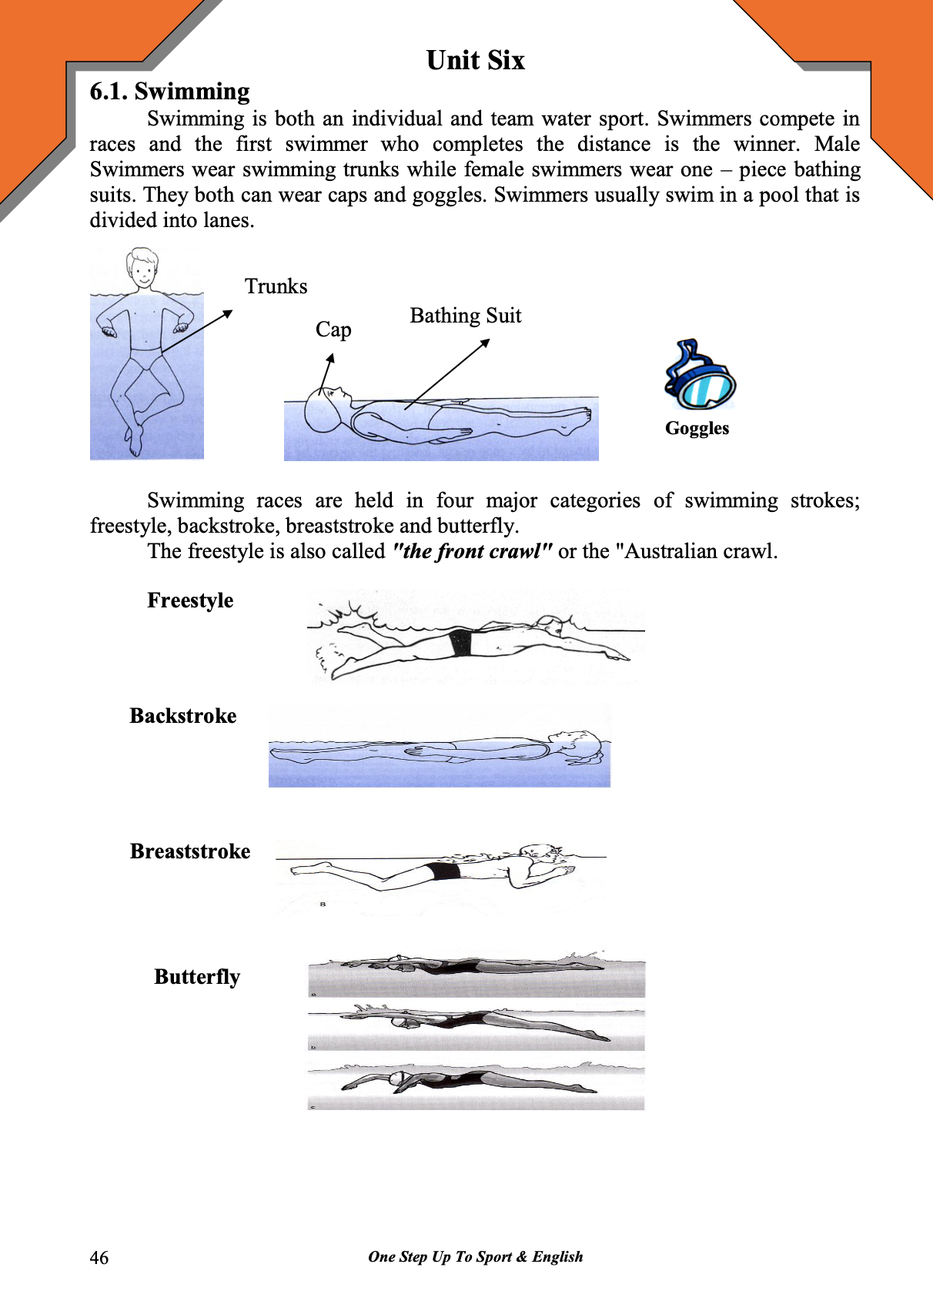

38

