Liver Function tests

Liver is a large organ (1.6 kg wt.). 70% of blood supply by portal vein & only 30 % by hepatic artery. Its shares with the kidney in the excretory or detoxifying and product of metabolism.

Function of livers:

- Circulatory function: Transfers blood (postal systemic circulations & blood storage (regulation of blood volume) .
- Excretory function: bile , conjugated bilirubin, cholesterol , bile salt , heavy metals & dye (bromsulphathalin).
- Metabolic function: CHO. Protein, lipid, minerals & vitamins.
- Protective function & detoxification: kupffer cells activity in removing foreign bodies from the blood (phagocytosis), conjugation, methylation, oxidation, reduction & conversion of ammonia into urea.
- Haematolytic function: blood formation in embryo, plasma protein synthesis (except immunoglobulins) & most of coagulation factors (VII, IX, X, prothrombine , fibrinogen) which need Vit. K for production.
- Storage function: Glycogen, lipid, Vit A, D, B₁₂ .

Bilirubin metabolism :

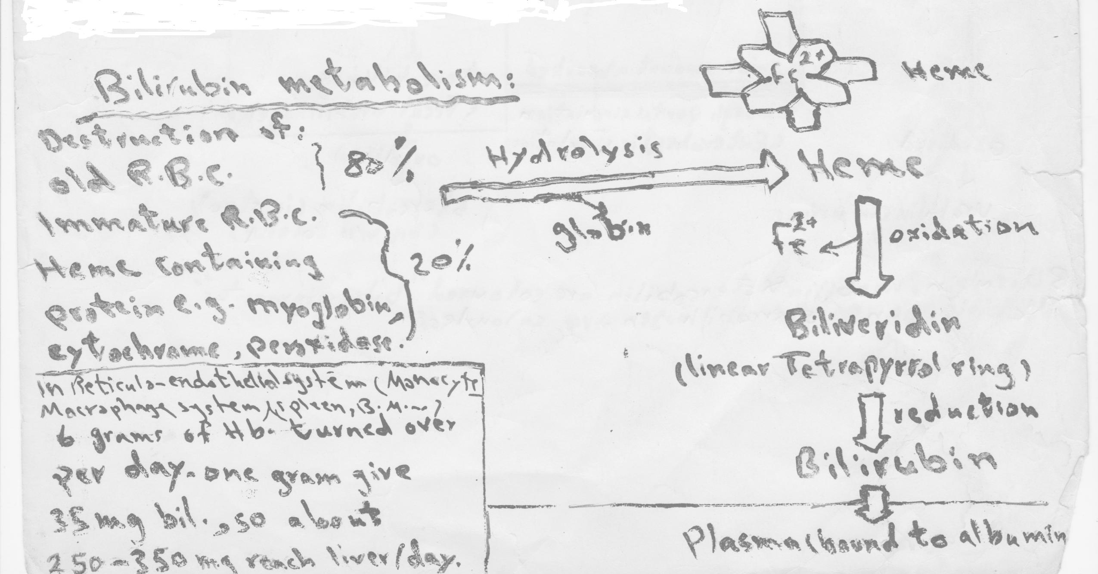

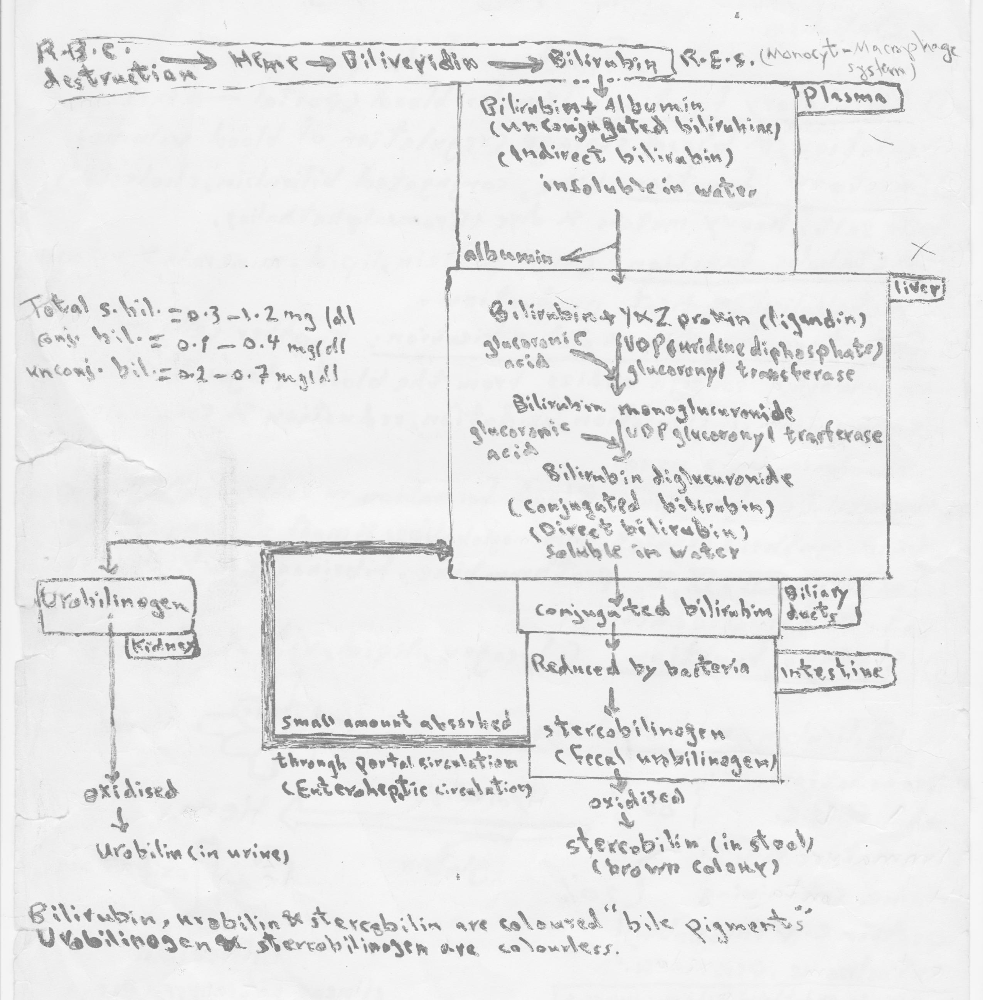

Jaundice (icterns):
When the bil. In the blood exceeds 1.2 mg/dl(19 Mmol/L) hyperbilirubinaemia exists, so lead to accumulation of bil. in the blood & diffuse into the tissues which then become yellow & the condition called jaundice or icterus.
This may be:
- Pre-hepatic jaundice (Haemolytic Jaundice):
An increase rate of bil. production that exceeds normal excretory capacity like neonatal physiological jaundice, acute & chronic haemolytic anaemia.

- Hepatic jaundice (Hepatocellular juandice):
The normal load of bil. cann't be conjugated &/or exercted by damaged liver cells due conjugated failure, biliary transport failure, hepatocellular necrosis or intrahepatic obstruction.

- Post –Hepatic jaundice (obstructive jaundice):
Reduced biliary flow that conjugated bil. cann't flow into the intestine due to stone, neoplasm, or spasm of biliary canaliculi.

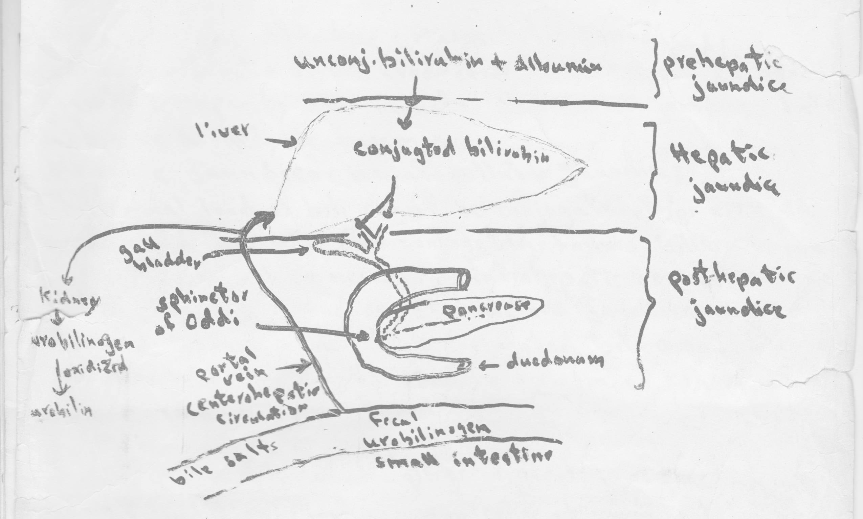

Neonatal physiological jaundice:

Transient condition. Most common cause of unconjugated hyper-bilirubinaemia. In first few days of life. It results from an accelerated haemolysis & an immature hepatic system (for uptake, conjugation(reduced activity of UDP glucoronyl transferase), & secretion of bil.). The concentration of unconj. bil. exeeds that which can be tightly bound to albumin, this can lead to production of unbound free unconj. bil. (lipid soluble) & can enter & damage brain cells (neonatal kernicturus) .

Inherited hyperbilirubinaemia:
- Unconjugated hyperbilirubinaemia:

- Gilbert's disease: common, at any age. Plasma bil. May exceed 3 or 6 mg/dl due to defect in hepatic clearance of bil. Due to either a defect in the uptake of bil. by liver cells or reduced activity of UDP gluronyl transferase enzyme.

- The Grigler-Najjar syndrom:deficiency of UDP glucuronyl transferase enzyme either partial (type I) or complet (type II). Unconj. bil. may exceed the binding capacity of plasma albumin kernicturus .

- Conjugated hyperbilirubinaemia: in both conditions there is a defect in hepatic excretion of conj. bil. Bile.

- Dubin – johnson syndrom: bil. appaers in urine. Hepatomegaly & the live is pigmented .

- Roto syndrom: bil. appears in urine. Hepatomegaly but the liver is not pigmented.
Unconj. Bil.
Gilbert's disease
UDP Glucuronyl Transferase
Conjugated bil.

Grigler- Najjar
Syndrom(I&II)
Dub.- Jon.
& Rotor syndroms bile

Pathological process in liver disease:
They may be present singly or in combination.
- Liver –cell damage:
- Viral hepatitis (A,B,C,…….., Delta) .
- Infectiors mononucolsus.
- Toxin or drugs such as paracetamol (acetaminophen), carbon tetrachorid or alcohol.
- Hypoxia & / or congesion such as occur in congestive cardiac failure & shock .
- Cellular destruction of known or unkown cause.
- Chronic hepatitis .
- Secondary to prolonged biliary obstruction.
- Tumour deposit .

- Cholestasis: (impraired secretion of bile)
- Intrahepatic : a- viral hepatitis b- some druge like chloropromazine (Largectil) c- cholengitis d- biliary atresia e- liver cirhosis f- infiltration of liver (hodgkin's disease, malignancy) g- intrahepatic atresia.
- Extrahepatic: a- gall stone b- carcinoma of head of pancrease c- fibrosis of bile duct d-external pressure by tumour or glands e- extrahepatic biliary atresia.

- Reduced –functioning tissue mass:
The synthetic and metabolic functions of liver are impaired like in chronic liver damage.

The importance of liver function tests:
- To assess the severity of liver damage.
- To defferentiate different types of jaundice.
- To find out the presence of latent liver disease.

