Porphyrins
Porphyrins are cyclic compounds formed by linkage of 4 pyrrole rings through methenyl bridge ( HC ) (Tetra pyrrole).
A characteristic property of the porphyrins is the formation of complexes with metal ion bound to nitrogen atom of the porphyrin rings
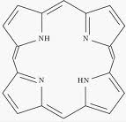
Pyrrole ring
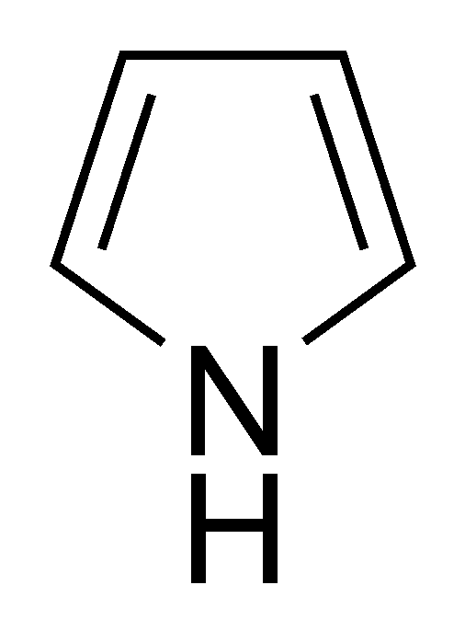
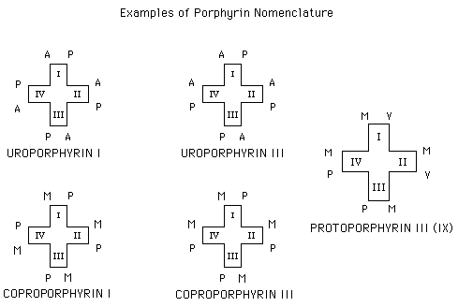
(Atom always contain substitution group(no H- atom) substitution of 1,2,3….. by methyl group, Ethyl group, acetic acid,… )

In nature the metalloprophyrin are conjugate to protein to form many compounds important in biological processes. These include:
- Haemoglobin: O2 carrier.
- Myoglobin: respiratory protein occur in muscle cell (similar to subunit of Hb.).
- Cytochrome: acts as electron transfer agent in oxidative-reduction reaction e.g. cytochrome C.
- Catalase: iron porphyrin enzyme that degrade hydrogen

Glycine+
Succinyl – CoA
ALA synthase
ALA ( γ - aminolevulenic acid)
ALA dehydrase
Porphobilinogen (PBG)
(monopyrrole)

Uroporphyrinogen I synthase
Uroporphyrinogen III cosynthase
Spontanus 4 mdecules bound
To form 2 isomers

6H
6 H
Uroporphyrin Uroporphyrinogen I Uroporphyninogen III
Light
Light

← Uroporphyrinogen → Uroporphyrin
Decarboxylase
6H light 6H
Coproporphyrin coproporphyrinogen I coproporphyrinogen III

Light
C oproporphyrin III

Coproporphyrinogen o oxidase
___
Protoporphyrinogen IX
Protoporphyrinogen oxidase
Protien Fe⁺⁺ Protoporphyrin IX F Ferrocheletas
Hemeprotein Heme

Heme synthesis:
Each step is controlled by a specific enzyme. It starts by condensation of Succinyl –Co A from citric acid cycle with amino acid glycine in the mitochondria. This reaction is catalyzed by the enzyme γ - aminolevulenic acid synthase. This enzyme is regulated by feed-back inhibition by heme. Only Protoporphyrin is of use in our body, copro- & uroporphynogen are found in R.B.Cs, urine & stool. Only protoporphyrin can combine with iron.
The porphyrinogen (uro- & copro-) and their precursors, ALA & PBG are colourless compound. Porphyrinogen, however, oxidase spontaneously to the corresponding prophyrin which are dark red in colour and which fluorescence in ultraviolet light .PBG, too, may spontaneously form uroporphyrin when exposed to air & light. A urine specimen containing large amount of porphyrinogen or their precursors wills gradually darken if left standing.

Execration:
Any excess of the intermediates on the heme pathway is excreted. ALA, PBG, and uroporphyrin (ogen) are water soluble and appear in the urine. Protoporphyrin is excreted in the bile and appears in the feces. Coproporphyrin (ogen) may by excreted by either route. Normal urine contains ALA, PBG & prophyrin at conc. undetectable by screening tests. Feces may contain sufficient prophyrin to import a slight Fluorescence to extracts.

ALA PBG URO COPRO PROTO Heme

Urine Feces

PORPHYRTA:
Groups of disease caused by a deficiency or depression in the activities of one of the enzymes on the heme pathway, so production of heme is affected and production of precursors is increased. Most are inherited. They are uncommon but medical practitioners, dermatologist, & psychiatrist must aware of them.
The clinical signs & symptoms result from either a deficiency of metabolic product beyond the enzymatic block or from an accumulation of metabolites behind the block.
1-Neurological disturbances:
Peripheral neuritis or abdominal pain or both in acute cases. It occurs in porphyria associated with increase in ALA & PBG (like in acute intermittent porphyria), which accumulate in body tissue and fluid. One or both of these compounds can cause toxic effects in abdominal nerves and in the C.N.S. resulting in abdominal pain and neuropsychiatric symptoms. Possible biochemical bases for these symptoms are that ALA may inhibit ATPase in nervous tissue and/or that ALA may taken up by brain and somehow cause a conduction paralysis. It is not known whether the neurological damage is due to heme deficiency in the nervous system or to direct toxic effect of ALA or PBG.

2-Skin lesion:
Accumulation of porphyrinogen in skin & Tissue. Their oxidative products, the corresponding porphyrin derivatives, cause photosensitivity. The porphyrin when exposed to light (visible) of about 400nm (sun light) will be excited and then react with molecular oxygen to from oxygen radicles (O⁻₂). These latter species injure lysosomes and other organelles. Damaged lysosomes release their degradative enzyme (like protease) causing variable degrees of skin damage varying from mild photosensitivity to sever blistering.

Mutation in DNA

Abnormalities of the enzyme of heme synthesis

Neuropsychiatric signs & symptoms
Photosensitivity
Spontaneous oxidation of porphyrinogen to prophyrin
Accumulation of ALA & PBG and/or decrease in heme in cell & body fluid
Accumulation of porphyrinogen in skin & tissues

-Biochemical causes of the major signs & symptoms of the porphyria-

