Longitudinal temporal bone fractures normally occurs parallel to the long axis of thepetrous bone.

Epidemiology
Longitudinal fractures represent the majority (70-90%) of temporal bone fractures. Peri auricular swelling and retro auricular ecchymosis (Battle sign) is common and almost all have otorrhagia.

Pathology

Mechanism
Such a fracture typically originates from squama temporalis with inferior propagation of the fracture line through the mastoid into the lateral wall of the middle ear, passing behind, through, or in front of the external auditory canal and ends in middle cranial fossa adjacent to the foramen spinosum and lacerum. Involvement of the otic capsule is rare. Depending on the force of impact, the fracture line may extend, deviated by the strong petrous bone, through the anteromedial wall of the middle ear.

Complications
- facial paralysis in 20% of cases
- may cause conductive hearing loss
- pneumocephalus
- incudostapedal dislocation
- herniation of temporal lobe

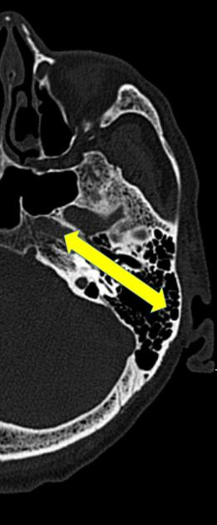

Transverse temporal bone fractures
Dr Bruno Di Muzio et al.
A transverse temporal bone fracture is orientated perpendicular to the long axis of the petrous bone with the line of force running roughly anterior to posterior

Epidemiology
They are thought to make up 20-30% of temporal bone fractures.

Mechanism
Transverse fractures are associated with blows to the frontal bone or occiput. These fractures normally cross the fallopian canal and otic capsule.

Complications
- >30% have facial nerve palsies (disruption of fallopian canal containing the facial nerve)
- sensorineural hearing loss (disruption of vestibulocochlear nerve)
- vertigo
- injury to the internal carotid artery and/or jugular vein
- fracture through the tegmen tympani results in CSF otorrhoea
