Dr.Manal Madany 5th year
Senior lecturer 2016-2017

OPERATIVE GYNECOLOGY
The ultimate goals of preoperative medical assessment are to reduce the patient’s surgical and anesthetic perioperative morbidity or mortality, and to return him to desirable functioning as quickly as possible. It is imperative to realize that "perioperative" risk is multifactorial and a function of the preoperative medical condition of the patient, the invasiveness of the surgical procedure and the type of anesthetic administered. A history and physical examination, focusing on risk factors for cardiac and pulmonary complications and a determination of the patient’s functional capacity, are essential to any preoperative evaluation. Laboratory investigations should be ordered only when indicated by the patient’s medical status, drug therapy, or the nature of the proposed procedure and not on a routine basis. Persons without concomitant medical problems may need little more than a quick medical review. Those with comorbidity should be optimized for the procedure. Proper consultations with appropriate medical services should be obtained to improve the patient’s health. These consultations should ideally not be done in a "last second" fashion. The preoperative preparation involves procedures that are implemented based on the nature of the expected operation as well as the findings of the diagnostic workup and the preoperative evaluation.

The following primary goals of preoperative evaluation and preparation:
- Documentation of the condition(s) for which surgery is needed.
- Assessment of the patient’s overall health status.
- Uncovering of hidden conditions that could cause problems both during and after surgery.
- Perioperative risk determination.
- Optimization of the patient’s medical condition in order to reduce the patient’s surgical and anesthetic perioperative morbidity or mortality.
- Development of an appropriate perioperative care plan.
- Education of the patient about surgery, anesthesia, intraoperative care and postoperative pain treatments in the hope of reducing anxiety and facilitating recovery.
- Reduction of costs, shortening of hospital stay, reduction of cancellations and increase of patient satisfaction.

General postoperative complications
- Immediate:
  - Primary haemorrhage: either starting during surgery or following postoperative increase in blood pressure - replace blood loss and may require return to theatre to re-explore the wound.
  - Basal atelectasis: minor lung collapse.
  - Shock: blood loss, acute myocardial infarction, pulmonary embolism or septicaemia.
  - Low urine output: inadequate fluid replacement intra-operatively and postoperatively.

- Early:
  - Acute confusion: exclude dehydration and sepsis.
  - Nausea and vomiting: analgesia or anaesthetic-related; paralytic ileus.
  - Fever
  - Secondary haemorrhage: often as a result of infection.
  - Pneumonia.
  - Wound or anastomosis dehiscence.
  - DVT.
  - Acute urinary retention.
  - Urinary tract infection (UTI).
  - Postoperative wound infection.
  - Bowel obstruction due to fibrinous adhesions.
  - Paralytic Ileus.

- Late:
  - Bowel obstruction due to fibrous adhesions.
  - Incisional hernia.
  - Persistent sinus.
  - Recurrence of reason for surgery - eg, malignancy.
  - Keloid formation.

OPERATIONS ON THE CERVIX
Cervical incompetence(CI)
- In most cases, the etiology is unknown
- Known causes include Congenital weakness as Mullerian abnormalities (cervical hypoplasia, in utero diethylstilbestrol [DES] exposure), traumatic abnormalities (prior surgical or obstetric trauma), and connective tissue abnormalities (Ehlers-Danlos syndrome).
Diagnosis:
- There is no precise method for diagnosing CI
- Strongest evidence for diagnosis of CI is lack of any other causes for reccurrent pregnancy loss eg : chromosomal abnormalities,infection,endocrine disorders,immunologic disease)
- With history of consistent with condition
- Painless premature cervical diltation during pregnancy and before onset of labour
- a sudden unexpected rupture of the membranes followed by painless expulsion of the fetus
- Resulting in repeated mid trimester spontaneous miscarriage or premature delivery
- Or + Prepregnancy physical findings
  - Ability to introduce a number 8 Hegar dilator or equivalent through the internal os when patient is not pregnant.
  - Hysterosalpingogram demonstrating cervical funneling.
  - Clinical evidence of extensive obstetric or surgical trauma to cervix.
Ultrasonography is useful
- before cerclage – length of cervical canal , width of isthmus , funneling of upper part of cervical canal with protrusion of the membranes(when the cervical os (opening) is greater than 2.5 cm, or the length has shortened to less than 20 mm. Sometimes funneling is also seen )
- After cerclage – determine exact site of cerclage,proximal cervical canal segment length above cerclage ,distal cervical canal segment length below cerclage,internal os diameter ,funneling if present , and protrusion of membranes)

Cervical Cerclage
Definition:
A procedure in which sutures are used to close the cervix during pregnancy to prevent preterm birth or miscarriage.Used for the treatment of cervical incompetence.It usually done after 13 week of pregnancy (between 12 -14 weeks) no earlier ,so that early abortions due to other factors will be completed & to avoid anesthetic drug effect & not after 14 week as it may stimulate uterine contraction & shortening of the cervix which make cerculage difficult to be performed
When should the cerclage be removed?
- It should be removed before labour, usually at 37+0 weeks of gestation, unless delivery is by elective caesarean section, in which case suture removal could be delayed until this time.
- In women presenting in established preterm labour, the cerclage should be removed to minimise potential trauma to the cervix.
- A Shirodkar suture will usually require anaesthesia for removal.
- All women with a transabdominal cerclage require delivery by caesarean section, and the abdominal suture may be left in place following delivery.
- It should be removed following PPROM
- In women with PPROM between 24 and 34 weeks of gestation and without evidence of infection or preterm labour, delayed removal of the cerclage for 48 hours can be considered, as it may result in sufficient latency that a course of prophylactic steroids for fetal lung maturation is completed and/or in utero transfer arranged.
Contraindications for cerculage includes: Bleeding, uterine contractions, or ruptured membrane
Preoperative evaluation
- Cerclage should generally be delayed until after 14weeks so that early abortions due to other factors will be completed
- Obvious cervical infection should be treated,
- cultures for gonorrhea, chlamydia, and group B streptococci are recommanded
- Sonography to confirm a living fetus and to exclude major fetal anomalies
- For at least a week before and after surgery , there should be no sexual intercourse
- More advanced the pregnancy, the more likely surgical intervention will stimulate preterm labor or membrane rupture
Cerclage is performed prophylactically before cervical dilatation. In some cases, this is not possible, and rescue cerclage is performed emergently after the cervix is found to be dilated or effaced. Elective cerclage generally is performed between 12 and 16 weeks

Types:
McDonald Cerclage;.1
McDonald cerclage procedure for incompetent cervix. A. Start of the cerclage procedure with a number monofilament suture being placed in the body of the cervix very near the level of the internal os. B. Continuation of suture placement in the body of the cervix so as to encircle the os. C. Completion of encirclement. D. The suture is tightened around the cervical canal sufficiently to reduce the diameter of the canal to 5 to 10 mm, and then the suture is tied. The effect of the suture placement on the cervical canal is apparent

2. Modified Shirodkar cerclage
. A. A transverse incision is made in the mucosa overlying the anterior cervix, and the bladder is pushed cephalad. B. A 5-mm Mersiline tape on a Mayo needle is passed anteriorly to posteriorly. C. The tape is then directed posteriorly to anteriorly on the other side of the cervix. Allis clamps placed so as to bunch the cervical tissue to diminish the distance the needle must travel submucosally facilitate placement of the tape. D. The tape is snugly tied anteriorly, after ensuring that all slack has been taken up. The cervical mucosa is then closed with continuous stitches to bury the anterior knot.
3. Transabdominal cerclage
with the suture placed at the uterine isthmus is used in some cases of severe anatomical defects of the cervix or cases of prior transvaginal cerclage failure
Indications: 1) previous failed vaginal cerclage with scarring or laceration s rendering vaginal cerclage technically very difficult or impossible. 2) Absent or very hypoplastic cervix with history of pregnancy loss.
Disadvantages: 1) patient must undergo tow laparotomies; one for cerclage placement & another for C/S delivery. 2) The pregnancy may result in fetal death or preterm labour prior to viability which needs hysterectomy.
Emergency cerclage
When a patient presents with an open cervical os and bulging membranes before viability, the idea of closing the cervix by passing a stitch around it seemslogical. A dilatation of more than 3 cm with an effaced cervix poses extreme difficulties, even for the most experienced operator. Every effort should be made to detect and treat other causes of the uterine instability. Bleeding, contractions and infection are all contraindications to cerclage. Depending on the initial dilatation of the cervix, the chance of the pregnancy proceeding beyond 26 weeks may be less than 50 per cent.

Complications 1) Risk of anaesthesia. 2) Preterm labour. 3) Infection.
4) Injury to cervix or bladder. 5) Bleeding. 6) Cervical dystocia; may need C/S.
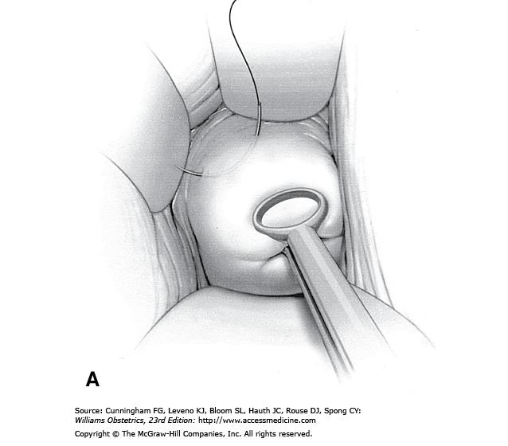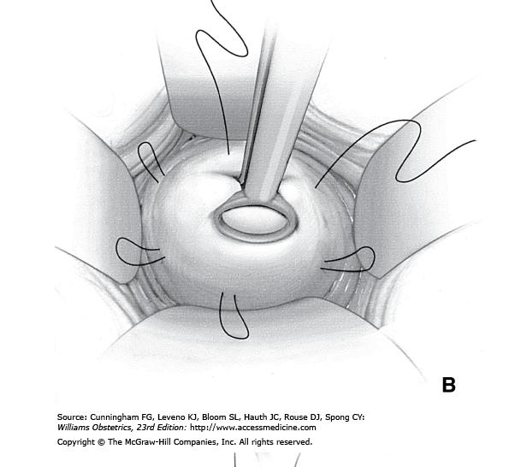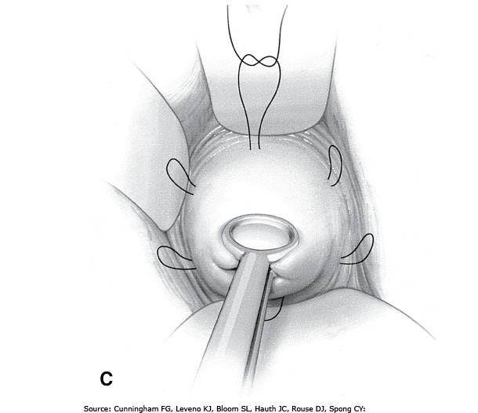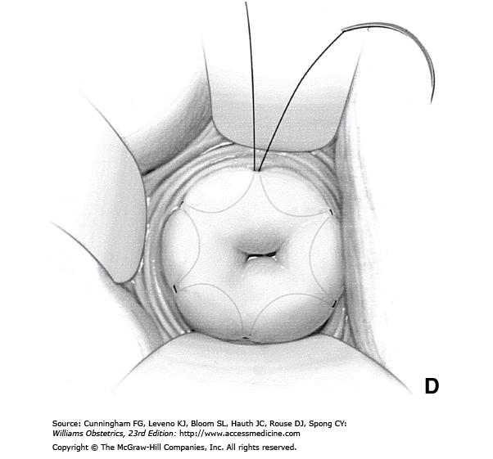
Modified Shirodkar cerclage

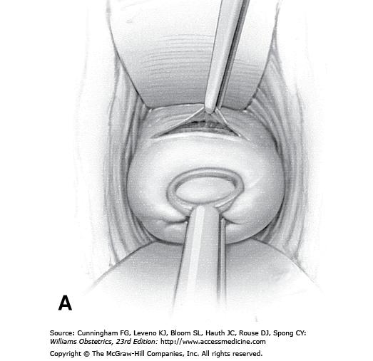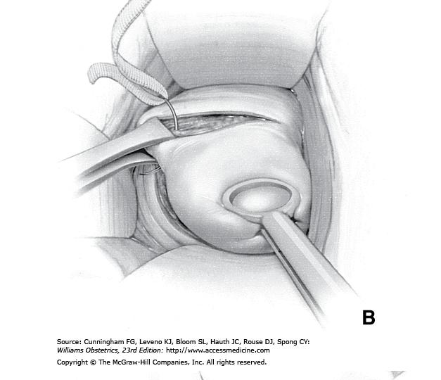

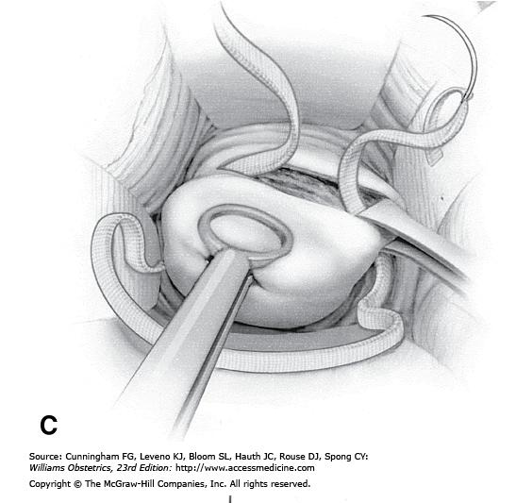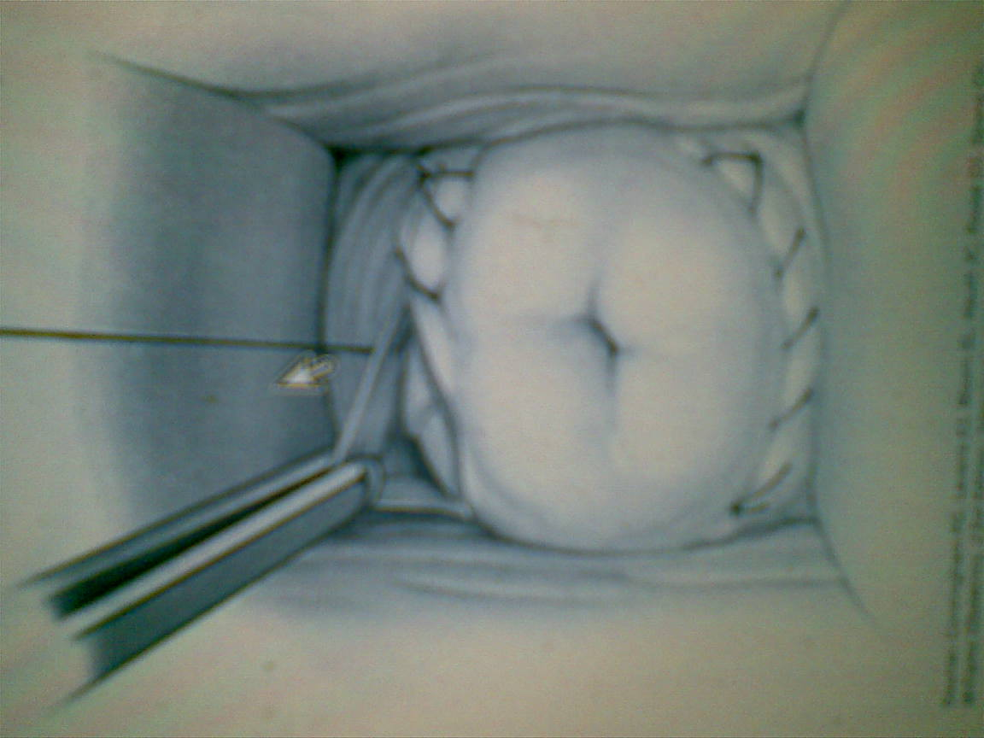

DILATATION & CURRITAGE
Definition:
It refers to a procedure involving dilatation (widening /opening) of the cervix & surgical removal of part of the lining of the uterus &/or content of uterus.
Procedure:
Woman is usually put under GA, bimanual examination is done, Sim's speculum is introduced into vagina to expose the cervix, the anterior lips of the cervix is grasped with volsellum & drown down using uterine sound to determine the uterine size & direction, then gradual introduction of dilator is done to dilate the cervix. A small ovum forceps (sponge) is next introduced & the cavity gently & carefully explored .the curette is then introduced into cavity of uterus & the endometrium scraped away.
Notes: Dilatation of cervix can lead to vasovagal attack &even cardiac arrest.
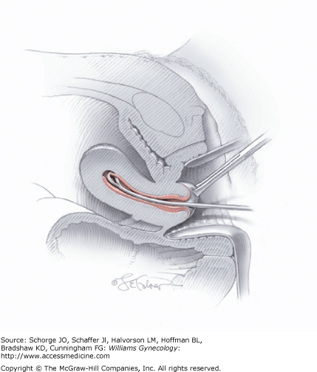

Indications:
1-Abnormal uterine bleeding.
2- To remove RPOC in case of missed or incomplete abortion.
Complications:
A) Adverse effect of anesthesia. B) Uterine perforation. C) Infection. D) Bleeding.
Asherman's syndrome: due to excessive curette that remove the basalis layers of endometrium leading to adhesions.

OPERATIONS ON THE UTERUS
HYSTERECTOMY
Definition:
It is the surgical removal of the uterus, it may be total (complete) i.e. removal of the uterus &the cervix or subtotal (partial) i.e. removal of the uterine body while leaving the cervix intact.
Indications:
- Treatment of reproductive system cancers (uterine, cervical, ovarian).
- Treatment of severe intractable endometriosis &/ adenomyosis.
- Treatment of uterine fibroid not responding to treatment in woman who completed her family.
- Placenta accrete. 5) Severe form of vaginal prolapse. 6) Prophylaxis.
Types:
*Radical hysterectomy: complete removal of uterus, cervix, upper vagina, parametrium. Lymph nodes, ovaries & Fallopian tubes are also removed (Wertheim's hysterectomy).It is indicated for cancer of uterus.
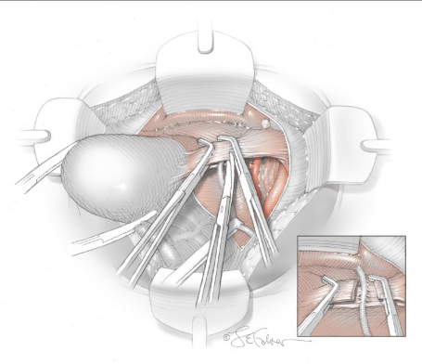
*Total hysterectomy: complete removal of the uterus, cervix with or without oopherectomy.
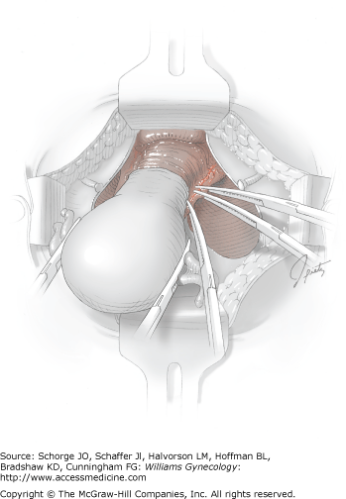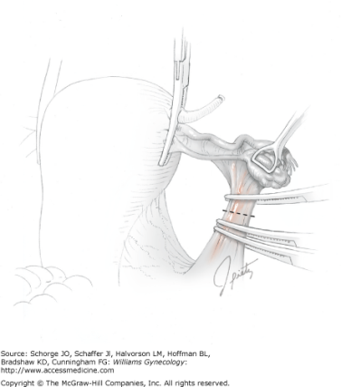
*Subtotal hysterectomy: removal of uterus leaving cervix in situ. 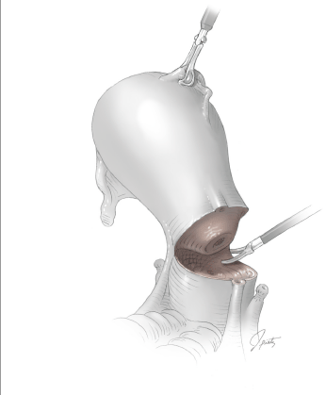

Technique (Routes):
1)Abdominal hysterectomy: via laparotomy (abdominal incision).
2) Vaginal hysterectomy: is done through vaginal canal (advantage: few complications, short healing time, and short hospital stay).
3) Laparoscopic – assisted vaginal hysterectomy: It begins by laparoscopy & completed via the vaginal canal.
4) Total laparoscopic hysterectomy: is performed entirely via laparoscopy (e.g. robotic hysterectomy).

Postoperative
Following abdominal hysterectomy, postoperative care follows that for any major abdominal surgery.
-Hospitalization typically varies from 1 to 4 days, and return of normal bowel function and febrile morbidity usually dictate this course.
-Postoperative activity in general can be individualized, although intercourse usually is delayed until 4 to 6 weeks after surgery to allow time for vaginal cuff healing.
-Febrile morbidity is common following abdominal hysterectomy and exceeds that seen with vaginal or laparoscopic approaches .Frequently, fever is unexplained, but pelvic infections are common. Additionally, abdominal wound infection, urinary tract infection, and pneumonia should be considered. Because of the high rate of unexplained fever, which resolves spontaneously, observation for 24 to 48 hours for mild temperature elevations is reasonable. Alternatively, in those at higher risk of infection, a second-generation cephalosporin may be administered. Additional testing, including transvaginal sonography or computed tomographic scanning, may be indicated if a pelvic hematoma or abscess is suspected.

Endometrial Ablation
Definition:
is a medical procedure that is used to remove (ablate) or destroy the endometrial lining of a uterus. This technique is most often employed for people who suffer from excessive or prolonged bleeding during their menstrual cycle but cannot or do not wish to undergo a hysterectomy
Methods of endometrial ablation
First generation
Trans Cervical Resection of the Endometrium (TCRE)
Endometrial Laser Resection (ELA)
Roller Ball Endometrial Ablation (REA)

Second generation
Thermal Balloons (Thermachoice, Cavatherm)
Microwave Endometrial Ablation (MEA)
Circulating Hot Saline (Hydro therm Ablator)
Cryotherapy

Effectiveness
Approximately 80% of those who undergo this procedure will have reduced menstrual bleeding. Of those, approximately 45% will stop having periods altogether. However, a second procedure or a hysterectomy will be required in approximately 22% of cases

Complications:
Although uncommon, the procedure can have serious complications including:
*Perforation of the uterus
*Burns to the uterus (beyond the endometrial lining)
edema or embolism*Pulmonary
burn leading to death *Bowel
Post-ablation tubal sterilization syndrome *
*Placenta accreta may occur if the patient becomes pregnant after endometrial ablation
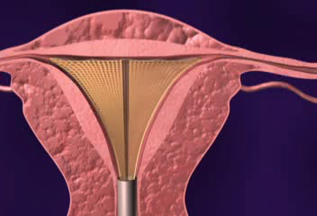NovaSure® Procedure
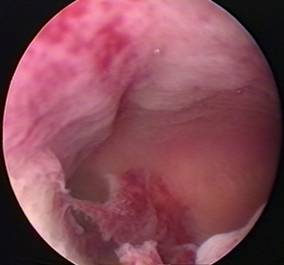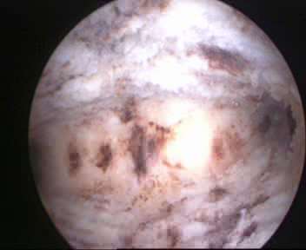
Before After
Uterine Cavity, Hysteroscopic View, After 85-Second Treatment

Female & Male Sterilization
What information should I receive before I decide to be sterilised?
You should get full information and counselling if you want to be sterilised. This gives you a chance to talk about the operation in detail and any concerns you may have. You should be told about other highly effective long-acting reversible contraception (LARC), sterilisation failure rates, any possible complications and reversal difficulties , the need to use contraception until the sterilisation has been confirmed as a success. You will have to sign a consent form
Male sterilisation (vasectomy) About one in 2,000 male sterilisations fail. Female sterilisation (tubal occlusion) The overall failure rate is about one in 200.
Female sterilization (Tubal ligation)
Definition:
Tubal ligation is a surgical procedure for sterilization in which a woman's fallopian tubes are clamped and blocked which prevents eggs from reaching the uterus for sterilization and birth control.
Effectiveness
A tubal ligation is approximately 99% effective in the first year following the procedure.
Tubal ligation Methods
1) Open
Bipolar Coagulation: The most popular method of laparoscopic female sterilization, this method uses electrical current to cauterize sections of the fallopian tube.
Monopolar Coagulation: Less common than Bipolar Coagulation, Monopolar Coagulation uses electrical current to cauterize the tube together, but also allows radiating current to further damage the tubes as it spreads from the coagulation site. Many cases involve a cutting of the tubes after the procedure.
Fimbriectomy: By removing a portion of the fallopian tube closest to the ovary, fimbriectomy eliminates the ovary’s ability to capture eggs and transfer them to the uterus.
Tubal Clip: The tubal clip (Filshie Clip or Hulka Clip) technique involves the application of a permanent clip onto the fallopian tube. Once applied and fastened, the clip disallows transference of eggs to the ovary.
Tubal Ring: The silastic band or tubal ring method involves a doubling over of the fallopian tubes and application of a silastic band to the tube.
Pomeroy Tubal Ligation: In this method of tubal ligation, a loop of tube is “strangled” with a suture. Usually, the loop is cut and the ends cauterized or “burned“. This type of tubal ligation is often referred to as cut, tied, and burned.
2) Hysteroscopic
Essure Tubal Ligation: In this method of tubal ligation, two small metal and fiber coils are placed in the fallopian tubes. After insertion, scar tissue forms around the coils, blocking off the fallopian tubes and preventing sperm from reaching the egg.
3)Laparoscopic
It is done by application of clips , rings or electrocautery via laparoscopy under GA
Reversal
Tubal reversal is microsurgery to repair the fallopian tube after a tubal ligation procedure.
The procedure that connects these separated parts of the fallopian tube is called tubal reversal or microsurgical tubo-tubal anastomosis.
In vitro fertilization may overcome fertility problems in patients not suited to a tubal reversal.

complications

IMMEDIATE COMPLICATIONS
1 The mortality from laparoscopic sterilization is less than 8 per 100,000 operations. The commonest cause of death is anaesthesia.
2 Damage to major blood vessels, bowel or other internal organs may occur.
3 Gas embolisms.
4 Thromboembolic disease is rare, but more likely immediately post-partum.
5 Wound infection.

LONG-TERM COMPLICATIONS
1 Menstrual disorder
2 Abdominal pain and dyspareunia.
3 Psychological and psychosexual problems are rare.
4 Bowel obstructions from adhesions is a very rare complication.

Postoperative
The recovery following minilaprotomy typically is rapid and without complication, and women may resume their regular diet and activities as tolerated. Sterilization is immediate following surgery, and intercourse may resume at the patient's discretion. Aside from regret, the risk of long-term physical or psychological sequel is low.. Moreover, interval tubal ligation is unlikely to result in changed sexual interest or pleasure

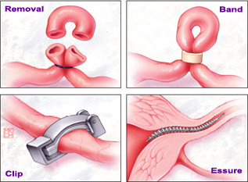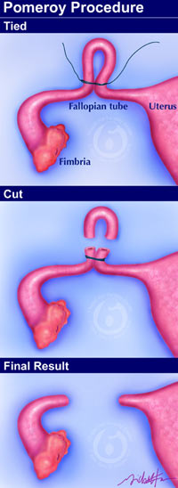
- 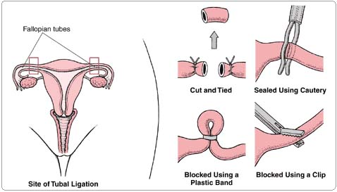

Male sterilisation (vasectomy)
How is vasectomy done?
Under a local anaesthetic. To reach the tubes, the doctor will make either a small puncture, known as the no-scalpel method, or a small cut on the skin of your scrotum. The doctor will then cut the tubes and close the ends by tying them or sealing them with heat. Sometimes a small piece of the tubes is removed when they are cut. The opening(s) in the scrotum will be very small and you may not need to have any stitches afterwards. If you do, dissolvable stitches or surgical tape will be used. The operation takes about 10–15 minutes and may be done in a clinic, hospital outpatient department or some general practice settings.

When will vasectomy be effective?
About 12 weeks after the operation, a semen test should be taken to see if the sperm have gone. Sometimes more than one test is needed. Sexual intercourse between two and seven days after the operation, but you can only rely on male sterilisation for contraception after you have been told that the semen test is negative. Following the operation the patient need to use alternative contraception until the sperm left in the tubes have cleared. The time it takes for the sperm to clear the tubes varies from man to man.

Are there any serious risks or complications?
Research shows that there are no known serious long-term health risks caused by having a vasectomy. Occasionally, some men have bleeding, a large swelling, or an infection. In this case, see your doctor as soon as possible. Sometimes sperm may leak out of the tube and collect in the surrounding tissue. This may cause inflammation and pain immediately, or a few weeks or months later. If this happens it can be treated. A small number of men experience ongoing pain in their testicles, scrotum, penis or lower abdomen. This is known as chronic post-vasectomy pain . Drug treatments may be effective in easing the pain and some men require further surgery. Permanent relief is not always achieved. The majority of men having a vasectomy will have a local anaesthetic but very rarely a general anaesthetic is used. All operations using a general anaesthetic carry some risks, but serious problems are rare.

