Secondary amenorrhea
D.Hind
Lecturer
2016
Definition:
Cessation of menstruation for more than 6 months, in a normal female, of reproductive age, that is not due to pregnancy.
- Physiology
- Circulating estradiol stimulates growth of the endometrial tissue. Progesterone, produced by the corpus luteum formed after ovulation, transforms proliferating endometrium into secretory endometrium. If pregnancy does not occur, this secretory endometrium breaks down and sheds as a menstrual blood. 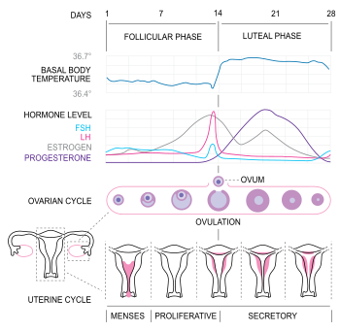

- Prevalence
(Prevalence about 3%)

physiological amenorrhea may be due to pregnancy , lactation & outside the reproductive age there is absence of menses during childhood & menopause.

Classification:
Can be classified according to the site of disorder that lead to 2nd amenorrhea

ASherman's syndrome  Cervical stenosis | Uterine causes
Polycystic ovarian syndrome  Premature ovarian failure  Resistant ovary syndrome | Ovarian causes
Weight loss  Exercise ,chronic illness  Physiological distress | Hypothalamic causes  (hypogonadotrophic hypogonadisim)
Hyperprolactinaemia,  hypopituitarism ,Sheehan syndrome(ischemic necrosis of the pituitary gland) | Pituitary causes
Tumor(craniopharyngioma,glioma)  Irradiation  Head injury  Sarcoidosis  Tuberculosis | Causes of the hypothalamic \pituitary damage
debilitating illness  Weight loss  Thyroid disease  Cushing syndrome | Systemic causes Chronic

History:
Risk of pregnancy
Associated symptoms, e.g. galactorrhoea, hirsutism, hot flushes, dry vagina, symptoms of thyroid disease
Recent change in body weight
Recent emotional upsets
Level of exercise
Previous menstrual and obstetric history
Previous surgery, e.g. endometrial curettage, oophorectomy
Previous abdominal, pelvic, or cranial radiotherapy
Family history, e.g. of early menopause
Drug history, e.g. progestogens, combined oral contraceptive, chemotherapy
Examination
Height and weight: calculate body mass index if appropriate.
Signs of excess androgens, e.g. hirsutism, acne
Signs of virilization, e.g. deep voice, clitoromegaly in addition to hirsutism, and acne
Signs of thyroid disease .
Acanthosis nigricans: this hyperpigmented thickening of the skin folds of the axilla and neck is a sign of profound insulin resistance. It is associated with polycystic ovary syndrome (PCOS) and obesity.
Breast examination for galactorrhoea.
Fundoscopy and assessment of visual fields if there is suspicion of pituitary tumour.
Pelvic examination
Look for signs of cushing syndrome(central obesity,moon face ,buffalo hump ,thin skin)
Investigation:
Step 1:
Initial hormonal tests
pregnancy test
prolactin
thyroid function
FSH&LH
testosterone
Progesterone withdrawal test
give medroxyprogesteron acetate 10 mg for 5 days then stopping
if normal out flow & sufficient endogenous oestrogen to induce endometrial proliferation progesterone will decidualized endometrium.
Step2:
If the patient does not bleed in response to progesterone so should be given oestradiol 2 mg for 21 days followed by progesterone
Step 3:
Measurement of LH&FSH should be repeated after 6 weeks if >40 IU/L &30IU/L respectively suggest ovarian failure.

Uterine causes:
Asherman s syndrome
Definition
Intrauterine adhesion that prevent the growth of normal endometrium
Causes:
vigorous curettage that affect the basalis layer of the endometrium
adhesion following endometritis (e.g.tuberculosis)
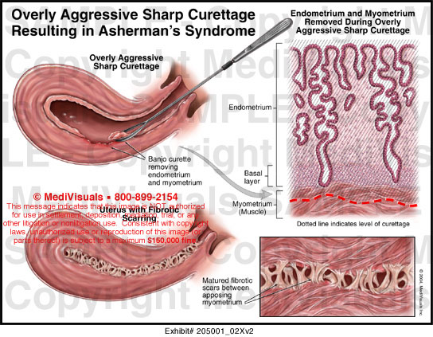

Pathophysiology:
The cavity of the uterus is lined by the endometrium. This lining is composed of two layers, the functional layer (adjacent to the uterine cavity) which is shed during menstruation and an underlying basal layer (adjacent to the myometrium), which is necessary for regenerating the functional layer.
Diagnosis:
hystrosalpigogram(HSG)
hysteroscopy
Treatment: Operative hysteroscopy is used for visual inspection of the uterine cavity during adhesion dissection (adhesiolysis)
Methods to prevent adhesion reformation include the use of mechanical barriers (Foley catheter, saline-filled, IUCD insertion)
A common pharmacological method for preventing reformation of adhesions is sequential hormonal therapy with estrogen followed by a progestin to stimulate endometrial growth and prevent opposing walls from fusing together.

Cervical stenosis:
means that the opening in the cervix (the endocervical canal) is more narrow than is typical. In some cases, the endocervical canal may be completely closed
Is an occasionally cause of 2nd amenorrhea ,it can occur after
- Surgical procedures performed on the cervix such as cone biopsy, or a cryosurgery procedure.
- Trauma to the cervix.
- Repeated vaginal infections.
- Atrophy of the cervix after menopause.
- Cervical cancer.
- Radiation.
Treatment :
Careful cervical dilatation

Ovarian causes
Polycystic ovary syndrome
This condition is characterized by hirsutism, acne, alopecia, infertility, obesity, and menstrual abnormalities (amenorrhoea in 19% of cases).
Ultrasound examination of the ovaries typically shows multiple, small peripheral cysts. up to a third of women in the general population have polycystic ovaries on ultrasound examination .
Endocrine abnormalities include increased serum concentrations of testosterone, prolactin, luteinizing hormone (LH) (with normal follicle-stimulating hormone [FSH] levels), and insulin resistance with compensatory hyperinsulinaemia

Premature ovarian failure
Menopause/ovarian failure occurring before the age of 40 years is considered premature.
Auto-immune disease is the most common cause; auto-antibodies to ovarian cells, gonadotrophin receptors, and oocytes have been reported in 80% of cases.
Before puberty or in adolescents, ovarian failure is usually due to a chromosomal abnormality, e.g. Turner mosaic, or previous radiotherapy, or chemotherapy
Pituitary causes:
Hyperprolactinaemia
A prolactinoma is the commonest cause of hyperprolactinaemia (60% of cases).
Other causes include non-functioning pituitary adenoma (disrupting the inhibitory influence of dopamine on prolactin secretion);
dopaminergic antagonist drugs (e.g. phenothiazines, haloperidol, clozapine, metoclopramide, domperidone, methyldopa, cimetidine); primary hypothyroidism (thyrotrophin-releasing hormone stimulates the secretion of prolactin), or it may be idiopathic.
Prolactin acts directly on the hypothalamus to reduce the amplitude and frequency of pulses of gonadotrophin-releasing hormone
Hypothalamic causes:
Primary causes:
Craniopharngioma,glioma treated surgically
Secondary causes:
May result from systemic cause like T.B,following head injury or cranial irradiation.
Systemic disorder causing secondary amenorrhea:
Chronic disease;
Chronic renal disease, chronic liver disease, renal disease
Weight-related amenorrhoea
A regular menstrual cycle is unlikely to occur if the body mass index (BMI) is less than 19 (normal range 20-25).
Weight loss may be due to illness, exercise, or eating disorders, among which anorexia nervosa lies at the extreme end of the spectrum.

Post-pill' amenorrhoea
This is defined as absence of menstruation for 6 months following cessation of the combined oral contraceptive pill.
It probably results from A transient inhibition of gonadotrophin-releasing hormone .
Complications and prognosis
osteoporosis
cardiovascular disease
endometrial hyperplesia
psychological problem
infertility

Types of 2ry Amenorrhoea

Estrogen - ve
Estrogen +ve

FSH low
CNS tumors
Stress
Hyperprolactinemia
Sheehan’s syndrome
Asherman’s syndrome
Polycystic ovarian syndrome….
FSH,LH,Prolactin, testosterone
FSH high
Premature ovarian failure
(idiopathic, genetic, autoimmune

Pregnancy test
VE -

Progesteron.challenge test

withdrawal bleeding without withdrawal bleeding

compromised outflow
+ve.est,progest,challenge test tract. Anovulation
+
-ve est.prog.
challenge test
FSH low FSH>30-40

Normal FSH
repeat
hypothalamic-pituitary failur

PROF
HSG OR hysteroscopy PROF
Asherman syndrome

Secondary amenorrhea

Student-learning objective

The student will be able to list:
- Definitions of primary secondary amenorrhea and oligomenorrhea
- Causes of amenorrhea
- Evaluation methods
- Treatment options

