Subfertility
D.Hind 2016 C.A.B.O.G, Lecturer

Semen analysis:
- Volume:1.5-5 ml
- Liquification time :within 30 minutes
- Sperm concentration =>20 million \ml
- Sperm motility :=<50% progressive motility
- Sperm morphology : <30% normal forms
- Lucocyte cells<1million\ml

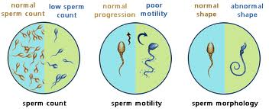
Causes of male subfertility:
- Disorder of spermatogenesis
- Impaired sperm transport
- Ejaculatory dysfunction
- Immunological &infective factors
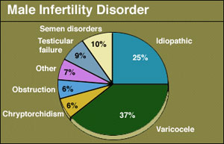

TREATMENT OF MALE INFERTILITY
- Male fertility depends on sperm quality rather than the absolute number of sperm present. Men with hypogonadotrophic hypogonadism are treated with exogenous gonadotrophins and hCG to restore testicular volume and spermatogenesis.
- Hormonal therapy is, however, ineffective at restoring sperm production or function in men with idiopathic oligospermia.
- In these men intrauterine insemination with ovarian stimulation may be an appropriate treatment.
- Alternatively,couples may choose to proceed to IVF with
intracytoplasmic sperm injection.
- Men with obstructive azoospermia can be offered sperm aspiration followed by IVF with ICSI treatment. Although 25 per cent of men with abnormal sperm parameters have a varicocele, there is no evidence that surgical ligation improves fertility.
Assissted conception
Assisted conception techniques have, since their introduction in the late 1970s, enabled more than a million babies to be conceived.
These conceptions have depended on the development of laboratory,
clinical and pharmaceutical advancements that have simplified and improved the treatment of subfertility.
Intrauterine insemination, IVF and ICSI are widely used throughout the world to assist conception.
Intrauterine insemination
Intrauterine insemination involves the placement of a sample of purified sperm in the uterus at the time of ovulation. It is most successful if it is combined with ovarian stimulation to produce up to three mature
follicles.
Close monitoring of the treatment is essential as there is a high risk of multiple pregnancy if treatment continues when more than three follicles have formed. It is used to treat mild male factor subfertility as well as unexplained subfertility. Although the success rate varies between assisted conception units, approximately 10-15 per cent of couples manage to conceive by this method.
GIFT
In the technique of gamete intrafallopian transfer (GIFT), a laparoscope is used to transfer the eggs and sperm to the fimbrial part of the Fallopian tube.
This allows fertilization to occur in the natural location and has the advantage of requiring minimal laboratory facilities. However, GIFT has the disadvantage of requiring a general anaesthetic and laparoscopy.

The treatment still requires controlled ovarian stimulation, but egg retrieval may be by a laparoscopic technique or by the more usual ultrasound-assisted transvaginal method.
ZIFT
Zygote intrafallopian transfer (ZIFT) is an infertility treatment where a blockage in the fallopian tubes are the cause. Egg cells are removed from a woman's ovaries, and in vitro fertilized. The resulting zygote is placed into the fallopian tube by the use of laparoscopy.

A typical IVF-Embryo transfer cycle
- Initial consultation
- Pituitary down-regulation
- Superovulation ovarian stimulation
- Ovulation trigger with hCG trigger
- Oocyte collection
- Insemination of oocytes
- Embryo transfer
- Luteal support
- Pregnancy test

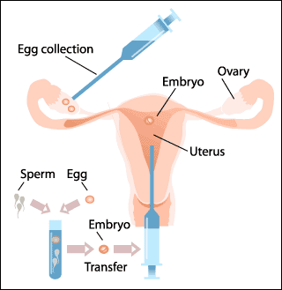

Initial consultation
Initial consultation involves a detailed history and provides an opportunity to assess the cause of subfertility and the most appropriate treatment technique.
Prior to commencing IVF, a recent baseline FSH level, semen analysis and pelvic ultrasound are assessed.

Pituitary down-regulation
Pituitary down-regulation is essential to prevent a natural LH surge during follicular stimulation as this would result in follicular rupture prior to egg retrieval. Treatment with GnRH analogues, given by daily injection, implant or nasal spray, prevents the natural LH surge and is continued throughout the treatment cycle
Alternatively, GnRH antagonists can be administered during the mid- and late follicular phases of a super ovulation cycle to prevent the LH
surge. A low serum oestradiol level < 100 u/L) or thin endometrium on ultrasound scan are used to confirm down-regulation of the pituitary.
Ovarian stimulation
Ovarian stimulation is achieved by daily injections of gonadotrophins (either recombinant or urinary). The injections are continued for 11-14 days until the lead follicles are 18 mm in diameter on transvaginal ultrasound scan.

Ovulation trigger with hCG
In the stage of ovulation trigger with HCG, HCG is used in place of LH to trigger ovulation. The oocytes are retrieved 34-38 hours after the injection.

Oocyte collection
Oocyte collection is normally an outpatient procedure carried out under transvaginal ultrasound guidance with the woman under intravenous sedation.
The follicular fluid is aspirated from each follicle using a controlled pressure vacuum pump using a microscope; the embryologist identifies the oocytes removed in the follicular fluid and then transfers these to culture medium in an incubator.
During sperm preparation, the sperm sample is washed to remove seminal plasma, leukocytes and bacteria. A laboratory process that allows the sperm to mature and undergo capacitation is performed, and the motile sperm can then be selected for use in the insemination process.

Insemination

In insemination the prepared sperm is mixed with the oocytes 4-6 hours after collection and incubated. For ICSI the eggs require an additional step to remove the surrounding cumulus cells prior to the injection of a
single sperm into the cytoplasm of each oocyte.
Whatever the process of insemination, the next stage involves incubating the oocytes with the sperm for 16-18 hours.
Next is fertilization and embryo cleavage. The oocytes are examined for fertilization on the day after oocyte retrieval. The presence of two pronuclei and two polar bodies indicates normal fertilization. After
48 hours in culture, the embryos are examined for cleavage, and any cleaved embryos are assessed for quality. An embryo with minimal fragmentation will be graded more highly than one with many fragments.
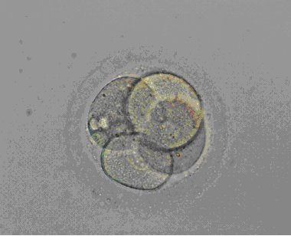

A four cell pre-embryo. Each of the cells is called a blastomere. The embryo is surrounded by a protein matrix "shell" called the zona pellucida.

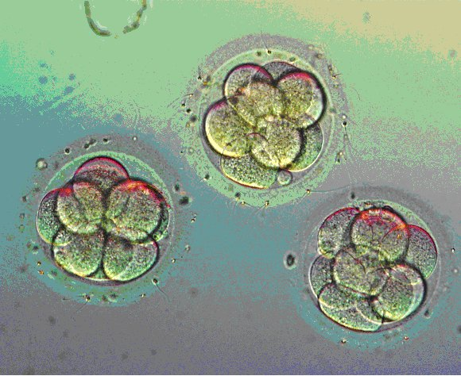

On the third day after egg retrieval eight cell pre-embryos can be transferred to the uterus. On average, 15 to 25% of embryos will implant after being transferred.

Embryo transfer
In embryo transfer, the embryos are transferred into the uterus using a trans cervical catheter on the second or third day of culture. In the UK regulations permit only two embryos to be transferred, except in
Exceptional circumstances.
Any spare embryos of good quality can be subject to embryo cryopreservation, with storage in liquid nitrogen for use in a frozen embryo replacement cycle in the future. The embryos can remain in storage without deterioration until they are required.

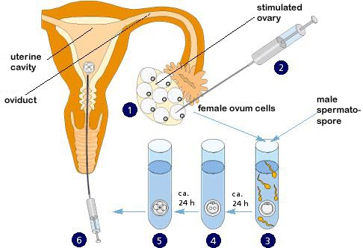

Luteal support and establishment
of pregnancy
Luteal support can be provided by progesterone supplements
in the form of vaginal pessaries, suppositoriesor injections. Alternatively, low-dose hCG injections are used to stimulate progesterone production by the ovary. Pregnancy is detected by a urinary pregnancy test or by analysis of the serum HCG 14 days after embryo transfer.
Intracytoplasmic sperm injection
Is an in vitro fertilization procedure in which a single sperm is injected directly into an egg.

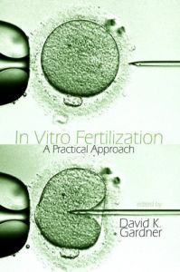
Indications for IVF

•used to overcome female infertility where it is due to problems with the fallopian tubes
•Assist in male infertility, in those cases where there is a defect in sperm quality; in such situations intracytoplasmic sperm injection (ICSI) may be used, where a sperm cell is injected directly into the egg cell. This is used when sperm has difficulty penetrating the egg, ICSI is also used when sperm numbers are very low. When indicated, the use of ICSI has been found to increase the success rates of IVF.
•unexplained infertility for women that have not conceived after 2 years of regular unprotected sexual intercourse.
•preimplantation genetic diagnosis (PGD) to rule out presence of genetic disorders.
•egg donation or surrogacy.

Pre implantation diagnosis of genetic disease
For couples at risk of a child with an inherited genetic disease, the offers the opportunity to select unaffected embryos for transfer. It involves the creation of embryos by IVF followed by the removal and subsequent genetic testing of one or two of the cells. Alternatively, the sex of the embryos can be determined for sex-linked disorders.
Unaffected embryos are then transferred back to the uterus.

Complications of assisted conception
Complications of assisted conception include the development of ovarian
hyperstimulation syndrome, ectopic pregnancy and multiple pregnancy.

Ectopic pregnancy
Four per cent of pregnancies arising from IVF treatment will be ectopic, with an increased risk in women with known tubal damage. The embryos may migrateto the Fallopian tubes or are inadvertently placed there during the embryo transfer procedure.

Multiple pregnancy
Assisted conception often results in a twin or higher order pregnancy. This condition can be prevented by prevent the transfer of more than two embryos except in exceptional circumstances, when three may be transferred .
In stimulated intrauterine cycles or in ovulation induction with gonadotrophins or anti-oestrogens, careful monitoring is paramount in avoiding multiple pregnancies. Multiple pregnancies have increased
morbidity and mortality for both the mother and the fetus.

Classification:

Ultrasound picture | Clinical and laboratory findings | Severity
Ovaries< 8 cm | Abdominal bloating with some pain | Mild
Ovarian size  8 – 12 cm | Nausea ,vomiting & increased abdominal discomfor  Evidence of ascites | Moderate
Ovaries over 12 cm  Ascites | Clinical ascites (with or without hydrothorax) with hypovolemia ,oliguria (with normal S.creatinine),PCV>45%,WBC > 15000/ml & liver dysfunction | Severe
Ovaries >12 cm  Gross ascites | Tense ascites , PCV > 55% ,WBC > 25000/ ml ,oliguria (with  raised S. creatinine ), renal failure ,thromboembolic complication , Adult respiratory Distress Syndrome may be seen. | Critical

Pathophysiology
Abdominal pain, nausea, and vomiting
Enlargement of the ovaries causes abdominal pain, nausea, and vomiting.
Ascites and tense distention
Ascites and tense abdominal distention occur because of
- extravasation and increased leakage of protein-rich fluid from the intravascular space into the abdominal cavity.
- Leakage of fluid from large follicles.
- Increased capillary permeability (due to the release of vasoactive substances).
- or frank rupture of follicles .

Localized or generalized peritonitis
Caused by peritoneal irritation secondary to blood from ruptured cysts, protein-rich fluid, and inflammatory mediators.

Acute abdominal pain
Acute abdominal pain may be due to ovarian torsion, intraperitoneal hemorrhage, or rupture of cysts secondary to enlarged ovaries with fragile walls.
Hypotension and/or hypovolemia
Follicular fluid and perifollicular blood containing large amounts of vascular endothelial growth factor (VEGF), which is thought to increase vascular permeability, escape into the peritoneal cavity.
Blood vessels within and outside the ovary become functionally impaired, resulting in the leakage of fluid through those vessels and a massive fluid shift from the intravascular to the extravascular compartment. This process results in intravascular hypovolemia with the concomitant development of edema, ascites, hydrothorax, and/or hydropericardium.
Hypotension and/or hypovolemia are also caused by compression of the inferior vena cava because of enlarged cysts or ascites. As a result, venous return and preload decrease. Eventual outcomes are reduced cardiac output and hypotension.
Dyspnea
Pulmonary function may be compromised as enlarged ovaries and ascites restrict diaphragmatic movement.
Other possible causes of dyspnea are the relatively rare manifestations of OHSS, such as pleural effusion, pulmonary edema, atelectasis, pulmonary embolism, acute respiratory distress syndrome (ARDS), and pericardial effusion.
Hypercoagulable state
A hypercoagulable state is likely due to hemoconcentration and hypovolemia resulting from third spacing and fluid shift. It is also related to increased estrogen levels. Patients have an increased risk of developing deep venous thromboses and pulmonary embolisms.
Electrolyte imbalance
Electrolyte imbalance occurs due to the extravasation of fluid and resultant renal dysfunction resulting from decreased perfusion. Increased reabsorption of sodium and water occurs in the proximal tubule, leading to oliguria and low urinary sodium excretion.
The exchange of hydrogen and potassium for sodium in the distal tubule is reduced. As a result, hydrogen and potassium ions accumulate and cause hyperkalemia and a tendency to develop acidosis. Compensatory and electrolyte-retaining mechanisms fail.
Acute renal failure
Hypovolemia in OHSS leads to hemoconcentration and creates a hypercoagulable state. Microthrombi form in tubules, leading to decreased renal perfusion. Acute renal failure may result.

Investigations:

• Full blood count including PCV & WBC
• Renal & liver function tests
• Clotting factors
• U/S which show ovarian enlargement & multiple cysts formation
• CXR

Treatment: Treatment of OHSS depends on the severity of the hyperstimulation
• Mild OHSS can be treated conservatively with monitoring of abdominal girth, weight, and discomfort on an outpatient basis until either conception or menstruation occurs. Conception can cause mild OHSS to worsen in severity.
• Moderate OHSS is treated *with bed rest, fluids, and close monitoring of lab.investigations such as electrolytes and blood counts.
• Ultrasound may be used to monitor the size of ovarian follicles.
• Aspiration of accumulated fluid (ascites) from the abdominal/pleural cavity may be necessary,
• opioids for the pain.
• severe OHSS in addition to all the treatment in moderate condition
If OHSS develops within an IVF protocol, it can be prudent to postpone transfer of the pre-embryos since establishment of pregnancy can lengthen the recovery time or contribute to a more severe course.

Indications for paracentesis include the following

- severe abdominal distension and abdominal pain secondary to ascites
- shortness of breath and respiratory compromise secondary to ascites and increased intra-abdominal pressure
- oliguria despite adequate volume replacement, secondary to increased abdominal pressure causing reduced renal perfusion.
Paracentesis should be carried out under ultrasound guidance and can be performed abdominally or vaginally.
Intravenous colloid therapy should be considered for women who have large volumes of fluid removed by paracentesis.
Women with severe or critical OHSS should receive LMWH prophylaxis.
The duration of LMWH prophylaxis should be individualised according to patient risk factors and outcome of treatment.
Surgery is only indicated in patients with OHSS if there is a coincident problem such as adnexal torsion, ovarian rupture or ectopic pregnancy

