Dr Henan Dh. Skheel 4th year lecture on obstetrics

2016-2017

Ovulation, fertilization, implantation
Objectives:

This lecture will enable you to:
1. Explain the process of ovulation & list the hormones influencing it
2. Explain the luteinization & the formation of corpus luteum (of menstruation & of pregnancy), their functions & fate
3. Explain the precondition of the sperm for fertilization
4. Describe phases of fertilization
5. Explain the reaction of oocyte to the fertilization & results of fertilization
6. Describe the different stages from zygote to blastocyst
7. Define implantation & its normal sites in the uterus
8. Explain the decidua reaction of the uterus during implantation
9. Explain the abnormal implantation & its results
Ovarian Cycle
• Monthly cycle for female at puberty
• Control by hypothalamus
• Release GnRH anterior pit gland gonadotrophins (FSH & LH)
• FSH & LH act on ovaries
• FSH: stimulates the development of ovarian follicles and production of estrogen by follicular cells
• LH: Trigger ovulation and stimulates follicular cells and corpus luteum to produce progesterone
Ovarian Cycle
Beginning of Ovarian Cycle
• FSH stimulates 15-20 primary stage follicles to grow only one reaches full maturity and only one oocyte is discharged others degenerate and become atretic
• FSH stimulates maturation of follicular (granulosa) cells

• Proliferation of follicular cells is mediated by GDF-9
• Granulosa and thecal cells produce estrogens
• Effects of estrogen:
1. Thinning of cervical mucus
2. Uterine endometrium to enter follicular/proliferative phase
3. Stimulate pituitary gland to secrete LH
Ovarian Cycle
Mid-cycle
• LH surge causes:
1. Oocyte complete meiosis I and initiate meiosis II
2. Stimulates production of progesterone by follicular cells
3. Follicular rupture and ovulation
Ovulation
• Secondary follicle expanse rapidly under the influence of FSH and LH and become preovulatory follicle
• Meiosis II is initiated and arrested at the metaphase II, 3 hours before ovulation
• Follicle is displaced to the surface of ovary where it forms a bulge and stigma
• LH collagenase activity increases causes digestion of collagen fibers surrounding the follicle
• LH increase in prostaglandin causes muscular contraction on the ovarian wall release of oocyte with surrounding cumulus oophorus
Corpus luteum
• The granulosa cells and theca interna remaining in the wall of ruptured follicle are vascularized by surrounding vessels
• Under the influence of LH, the remaining cells develop into yellowish pigment and change into lutean cells (corpus luteum) which secretes progesterone
• Progesterone and estrogen causes endometrial layer to enter secretory phase (preparation for implantation)
. Corpus albicans
• If fertilization does not occur, on day 9 of ovulation, corpus luteum shrinks, degenerate and form a mass of fibrotic scar tissue (corpus albicans) reduce progesterone level menstrual bleed
• If fertilization occur, degeneration of corpus luteum is prevented by hCG (human chorionic gonadotropin) (secreted by syncytiotrophoblast of developing embryo). CL continue to grow at the end of 3rd month of pregnancy CL size is half of ovary secretes progesterone until 4 month of pregnancy
• After that CL regress slowly as secretion of progesterone by trophoblastic component of placenta becomes adequate for maintenance of pregnancy
Oocyte transport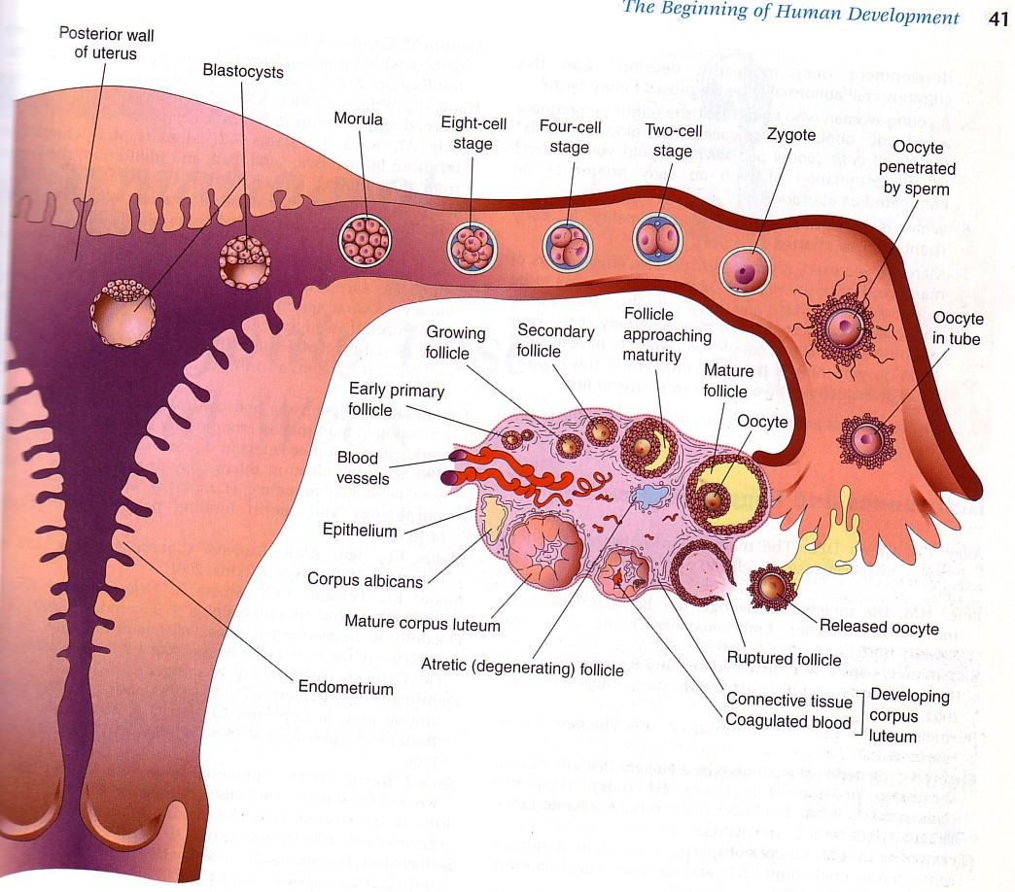
• Fimbriae sweep over the surface of the ovary and catch the oocyte that are released from the ovary
• In the tube, the oocyte move towards the uterine cavity by the contraction of the tube and propelled by cilia
• Fertilized egg reach uterine lumen 3-4 days
Fertilization • Begins with contact between sperms and secondary oocyte and ends at metaphase I of zygote
• Occur in the ampulla of uterine tube
• 200-500 million sperms ejaculated into the vagina, only 200 sperms reach secondary oocyte
• Occur 12-24 hours after ovulation
• Sperm remains viable for 48 hours, secondary oocyte viable for 24 hours after released from the ovary
• Sperm swim from vagina to cervix by propelled whiplike movement of their tail
• Movement from cervix to the tube - help by contraction of uterus and tube
• Sperm need to wait for 7 hours to fertilize the oocyte, must undergo:
- Capacitation
2. Acrosome reaction

Capacitation: • Functional changes that causes the tail of sperms to beat vigirously
• For fusion of plasma membrane of the sperm and plasma membrane of oocyte
• Removal of glycoprotein coat and seminal plasma proteins from plasma membrane that overlies acrosomal region of spermatozoa (head)
• Capacitated sperm pass through corona radiata and undergo acrosome reaction 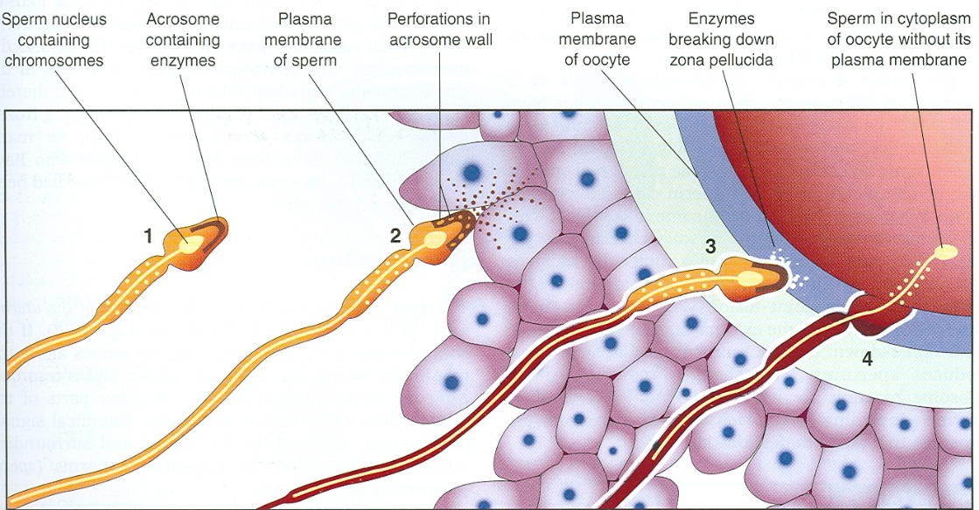

Is a sequence of coordinated events?
- Passage of sperm through corona radiata (CR)
- Only capacitated sperm able to pass CR
- . Penetration of zona pellucida (ZP)
- ZP is a glycoprotein layer contain ligand ZP3 (zona protein)
- ZP3 bind with protein on acrosome causes release of acrosomal enzymes (acrosin) penetration of ZP head of sperm comes in contact with plasma membrane of oocyte plasma membrane of oocyte release lysosomal enzymes alteration on ZP become impermeable to other sperms (prevent polyspermy)
Acrosome reaction
• Needed to penetrate zona pellucida
• Acrosome is a helmet like structure that covers the head of sperm which contains several enzymes
• Release of acrosomal enzymes (acrosin) after glycoprotein in ZP bind to a specific membrane proteins on the acrosome
. Fusion of cell membranes of oocyte and sperm
• Plasma membrane of oocyte and sperm fuse and break down at the area of fusion
• Head and tail of sperm enter the cytoplasm of oocyte but plasma membrane of sperm is left behind on oocyte surface . Completion of second meiotic division of oocyte and formation of female pronucleus
• Oocyte finishes second meiotic division after entry of sperm forming a mature oocyte and a second polar body
• Female pronucleus (22 + X) is formed following decondensation of maternal chromosomes
Fertilization . Usual site is the ampulla of the fallopian tubes .Restores the normal diploid number of chromosomes Determines chromosomal sex of the embryo.
- Formation of male pronucleus • Nucleus of sperm enlarges within the cytoplasm of the oocyte and form male pronucleus
- Tail of the sperm degenerates
- Male and female pronucleus are morphologically indistinguishable
- Each pronucleus must replicate its DNA. As the pronuclei fuse into a single diploid aggregation of chromosomes, it become zygote
- Chromosomes in the zygote become arranged on a cleavage spindle in preparation for a normal mitotic division
6- Zygote has 23 maternal and 23 paternal (double) chromosomes- new combination of chromosomes that are different • Zygote - a diploid cell with 46 chromosomes -undergoes cleavage into blastomeres ¬

- Fertilization by X- bearing sperm produces a 46 XX zygote (female)
- • Fertilization by Y- bearing sperm produces a 46 XY zygote (male)
Cleavage
- Repeated mitotic divisions of the zygote
- • Cell numbers increase without increase in cell size (overall size)
• Blastomeres = progressively smaller cells produced by clevage
• Occurs as the zygote passes along the uterine tube to the uterus
• 1st division of zygote begins 24 hr after fertilization
• 16 cell morula (day 4 fertilization): Morula..a solid mulberry-like ball of cells ¬ The morula enters the uterine cavity about 3 days after fertilization ¬ Gradual accumulation of fluid between the cells of the morula ……..early blastocyst

Blastocyst
Blastocystic cavity (fluid-filled space) appears inside the morula – day 4 of fertilization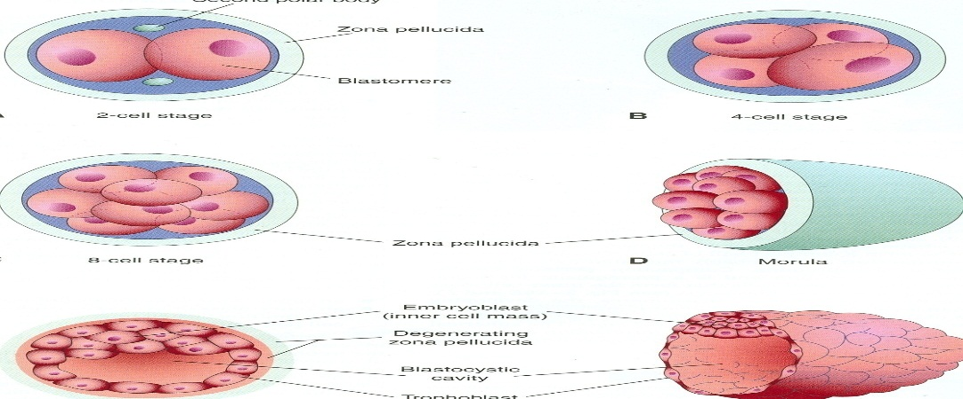
• Fluid from uterine cavity passes zona pellucida to form the cavity
• Fluid increases separate blastomeres into 2 parts:
• Trophoblast • thin, outer layer ,give rise to embryonic part of the placenta
• Embryoblast . Inner cell mass give rise to embryo
zona pellucida degenerates and disappears allow the blastocyst to increase its size rapidly .In the uterus, the embryo is nourished by secretions from uterine glands
. Blastocyst • Trophoblast cells begin to penetrate between the epithelial cells of the uterine mucosa on day 6 of fertilization
• As it attaches to the endometrium, it will proliferates and differentiates into 2 layers:
• Inner layer of cytotrophoblast and outer layer of syncytiotrophoblast
. Implantation Takes place 6 or 7days after fertilization Divided in to 3 phases 1) APPOSITION -initial adhesion of the blastocyst to the uterine wall 2) ADHESION -increased physical contact b/n the blastocyst & uterine epithelium, & 3) INVASION -penetration & invasion of syncytiotrophoblasts & cytotrophoblasts in to the endometrium.

• Wall of uterus has 3 layers: a. Endometrium b. Myometrium c. Perimetrium
• During menstrual cycle, endometrium becomes follicular/proliferative phase, secretory/progestational phase and menstrual phase
• Proliferative phase: Under the influence of estrogen secreted by follicles occur after the menstrual phase. Secretory phase: start after ovulation influence by progesterone secreted by corpus luteum
• If fertilization occur, endometrium will assist with implantation. Implantation occur during secretory phase of endometrium blastocyst implants, stimulates decidual reaction.The adjacent cells of the endometrial stroma respond to its presence and to the progesterone secreted by the corpus luteum by differentiating into metabolically active, secretory cells called decidual cells. (The endometrial glands enlarged, uterine wall becomes highly vascularized and edematous). Blastocyst implants at the anterior/posterior wall of uterine fundus embedded between uterine glands
. • If no fertilization, endometrium shed off menstrual phase blood comes out from superficial arteries and small pieces of stroma and glands break away
Succesful implantation requires receptive endometrium Uterine receptivity is limited to days 20-24 of the cycle Implantation most commonly occurs on the upper posterior uterine wall At the time of interaction with the endometrium, the blastocyst is composed of 100-250 cells. By the 10th day the blastocyst becomes totally encased with in endometrium.

Ectopic pregnancy • Implantation can occur outside uterus

• Epithelium at these abnormal sites responds to the implanting blastocyst with increased vascularity and other supportive changes, so that the blastocyst is able to develop

