Carbohydrate Metabolism (7)
Dr. Walaa AL – Jedda 2016

Regulation of blood glucose (Homeostasis)
Blood glucose levels is maintained within physiological limits to (65-110 mg/dl) "true glucose" in fasting state, and (100-140 mg/dl) following ingestion of carbohydrate containing meal ,or even under circumstances when a person does not eat for extended periods of time, blood glucose levels decrease only slowly, by a balance between two sets of factors :
A) Rate of glucose entrance into the blood stream, and
B) Rate of its removal from the blood stream.

A) Rate of supply of glucose to blood.
Blood glucose may be derived directly from the following sources:
- By absorption from the intestine.
- Breakdown of glycogen of liver (Hepatic glycogenolysis).
- By gluconeogenesis in liver; source being glucogenic amino acids, lactate and pyruvate, glycerol and propionly CoA.
- glucose obtained from other carbohydrates, e.g., fructose, galactose, …

B) Rate of removal of glucose from blood.
- Oxidation of glucose by the tissues to supply energy.
- Glycogen formation from glucose in the liver (Hepatic glycogenesis).
- Glycogen formation from glucose in muscles (Muscle glycogenesis).
- Conversion of glucose to fats (lipogenesis) especially in adipose tissue.
- Synthesis of compounds containing carbohydrates-blood glucose is utilized e.g.:
- Formation of fructose in seminal fluid, formation of lactose (sugar of milk) in lactating mammary gland, synthesis of glycoproteins and glycolipids.
-Formation of ribose sugars from glucose required for nucleic acid synthesis.
- Excretion of glucose in urine (glycosuria), when blood glucose level exceeds the renal threshold (180 mg/dl).
- ((All the above processes are under substrate, end-product, nervous and hormonal control )).

The major hormones that regulate blood glucose are insulin and glucagon
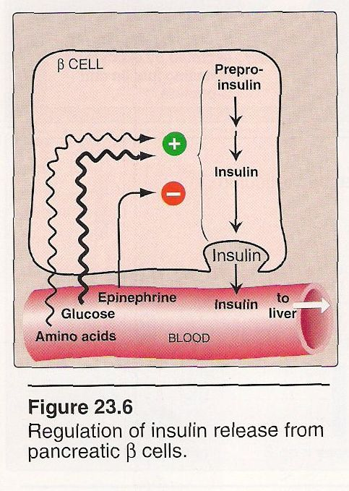
1.
A) Biologic effects of insulin:

Insulin is a polypeptide hormone produced by β-cells of the islets of Langerhans of the pancreas.
Insulin is the most important hormone coordinating the use of fuels by tissues.
Its metabolic effects are anabolic, favoring, for example, synthesis of glycogen, triacyl- glycerol, and protein.

The effects of insulin on glucose metabolism are most prominent in three tissues: liver, muscle and adipose tissue.
- In the liver: insulin decreases the production of glucose by inhibiting gluconeogenesis and glycogenolysis.
- In the muscle and liver, insulin increases glycogenesis.
- In the muscle and adipose tissue, insulin increases glucose uptake.

Biologic effects of insulin
Increases (↑) | Decrease (↓)
- Glucose uptake  - Glycogenesis  - Protein synthesis  - Fat synthesis | - Gluconeogenesis  - Glycogenolysis  - Lipolysis

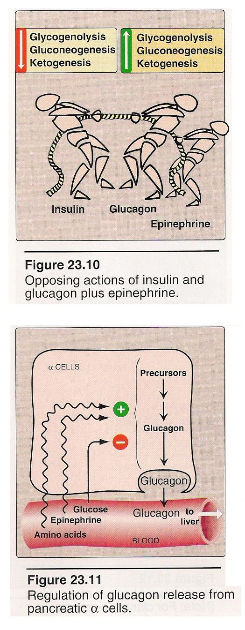
B) Biologic effects of glucagons:
2.
Glucagon is a polypeptide hormone secreted by the α-cells of the pancreatic islets of Langerhans.
Glucagon, along with epinephrine, cortisol, and growth hormone (The "counter regulatory hormones"), opposes many of the actions of insulin.

3.
Stimulation of glucagons secretion by:
- Low blood glucose: A decrease in plasma glucose concentration stimulates glucagon release.
During an overnight or prolonged fast, elevated glucagon levels prevents hypoglycemia.
- Amino acids: stimulate the release of both glucagon and insulin.
- Elevated levels of Epinephrine.

Biologic effects of glucagon

Increases (↑) | Decrease (↓)
- Glycogenolysis  - Gluconeogenesis  - Ketogenesis  - Uptake of amino acid | - Glycogenesis

Blood glucose levels in the fed state:

1- Changes in insulin and glucagon levels:
a- Blood insulin levels increases as a meal is digested, following the rise in blood glucose. (Also increases certain amino acids (particularly arginine and Lucien) cause the releases of insulin).
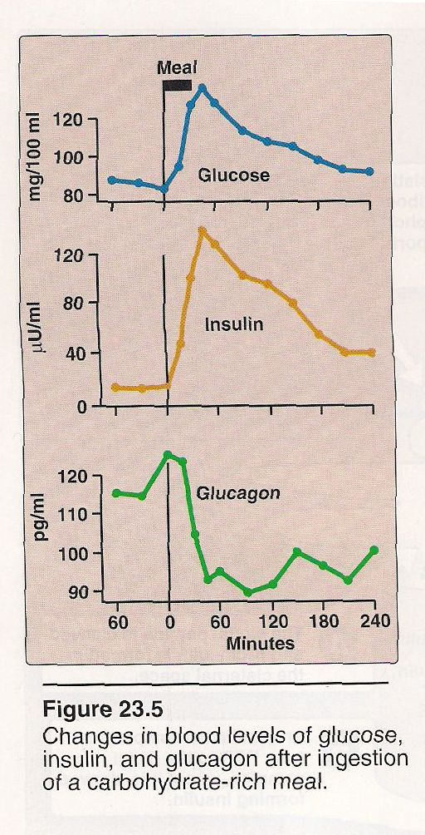
4.
b- Blood glucagon levels change depending on the content of the meal. A high carbohydrate meal cause decreases in glucagon levels, while high protein meal causes glucagon to increase.

* On a normal mixed diet, glucagon will remain relatively constant after a meal while insulin increases.

2- Fate of dietary glucose in the liver.
- Glucose is oxidized for energy. Excess glucose is converted to glycogen and to the triacylglycerols of very low density lipoprotein VLDL, by the following mechanisms :
A-Increased phosphorylation of glucose: the enzyme glucokinase has a high K_{m} for glucose, thus its velocity increases after a meal when glucose levels are elevated.
B- Increased glycogen synthesis: is promoted by insulin which activates glycogen synthase.
C- Increased activity of the HMP pathway: The well-fed state, combined with the active use of NADPH in hepatic lipogenesis.
This pathway accounts for (5-10%) of the glucose metabolized by the liver.
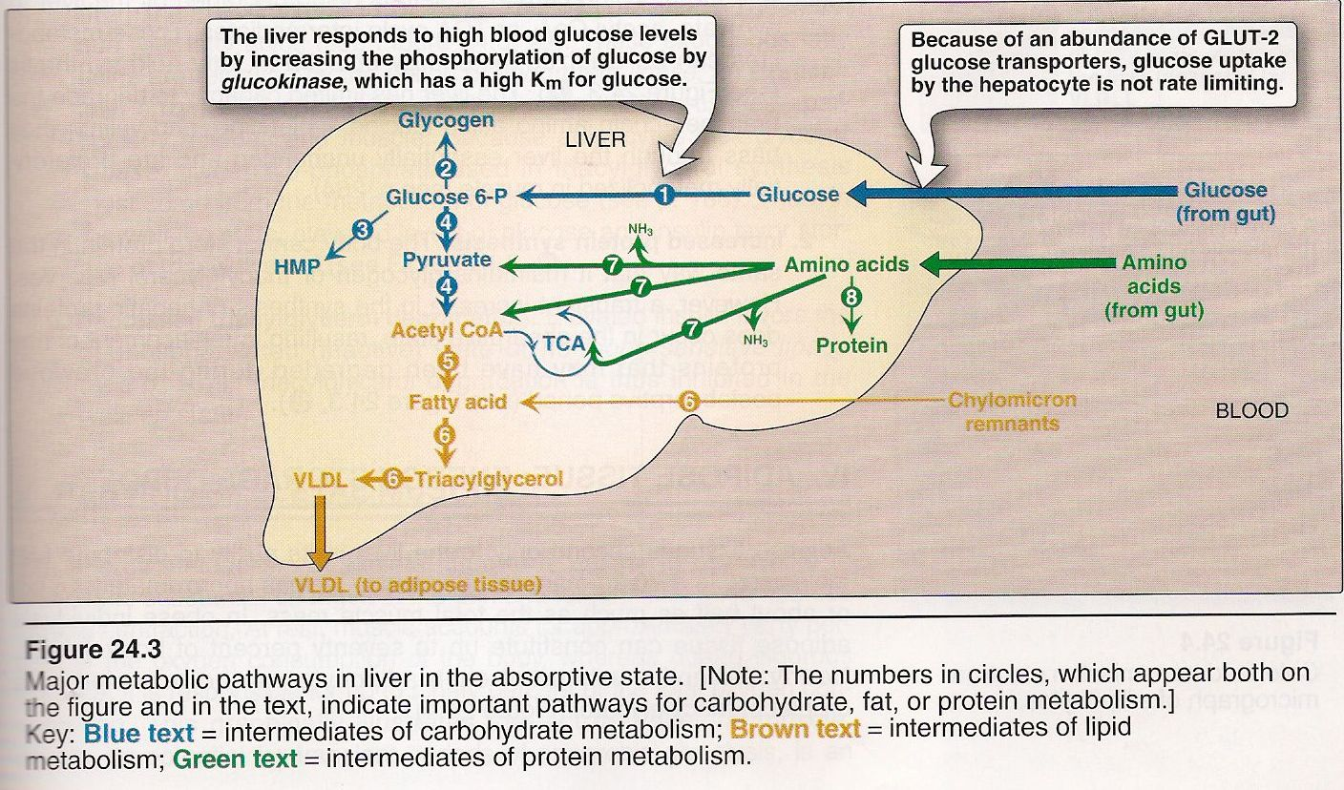
5.

D- Increased glycolysis: is significant only during the absorptive period following a carbohydrate – rich meal.
The conversion of glucose to Acetyl CoA is stimulated by elevated insulin to glucagons ratio. Acetyl CoA is used either a building block for triaceylglycerol synthesis which converted to VLDL and released into the blood.
Note: gluconeogenesis is decreased in the fed state.
3- Fate of dietary glucose in
Adipose tissue:
A- Increased glucose transport: circulating insulin levels are elevated in the fed – state resulting in an influx of glucose into adipocytes.
B- Increased glycolysis: increased intracellular availability of glucose results in an enhanced rate for glycolysis which serves a synthetic function by supplying glycerol phosphate for triacylglycerol synthesis.

C- Increases activity in HMP pathway: which provide NADPH for fat synthesis.
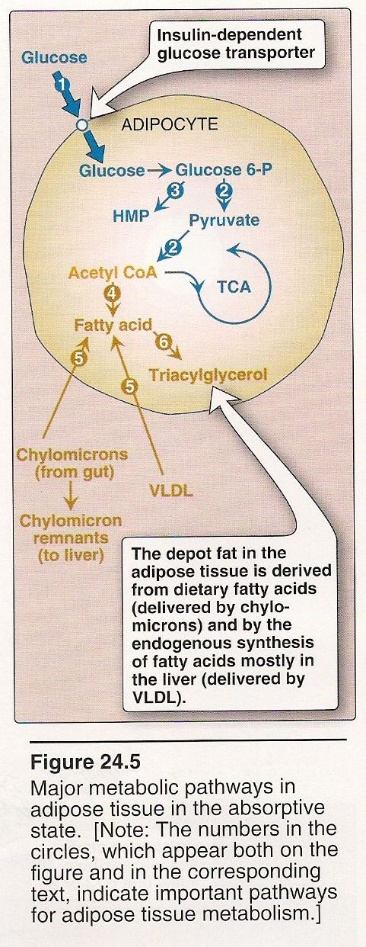
6.

4- Fate of dietary glucose in resting skeletal muscle:
A- Increased glucose transport.
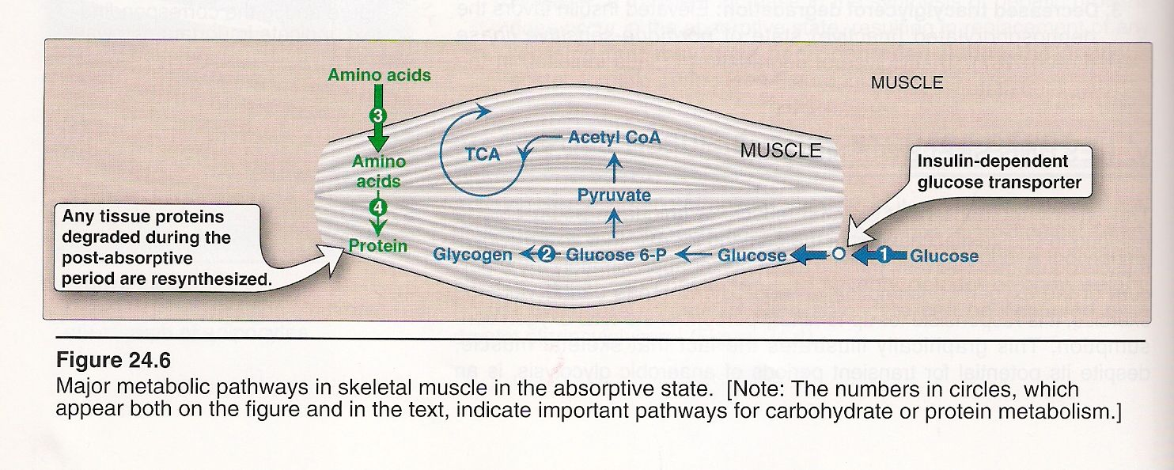
B- Increased glycogen synthesis.
7.

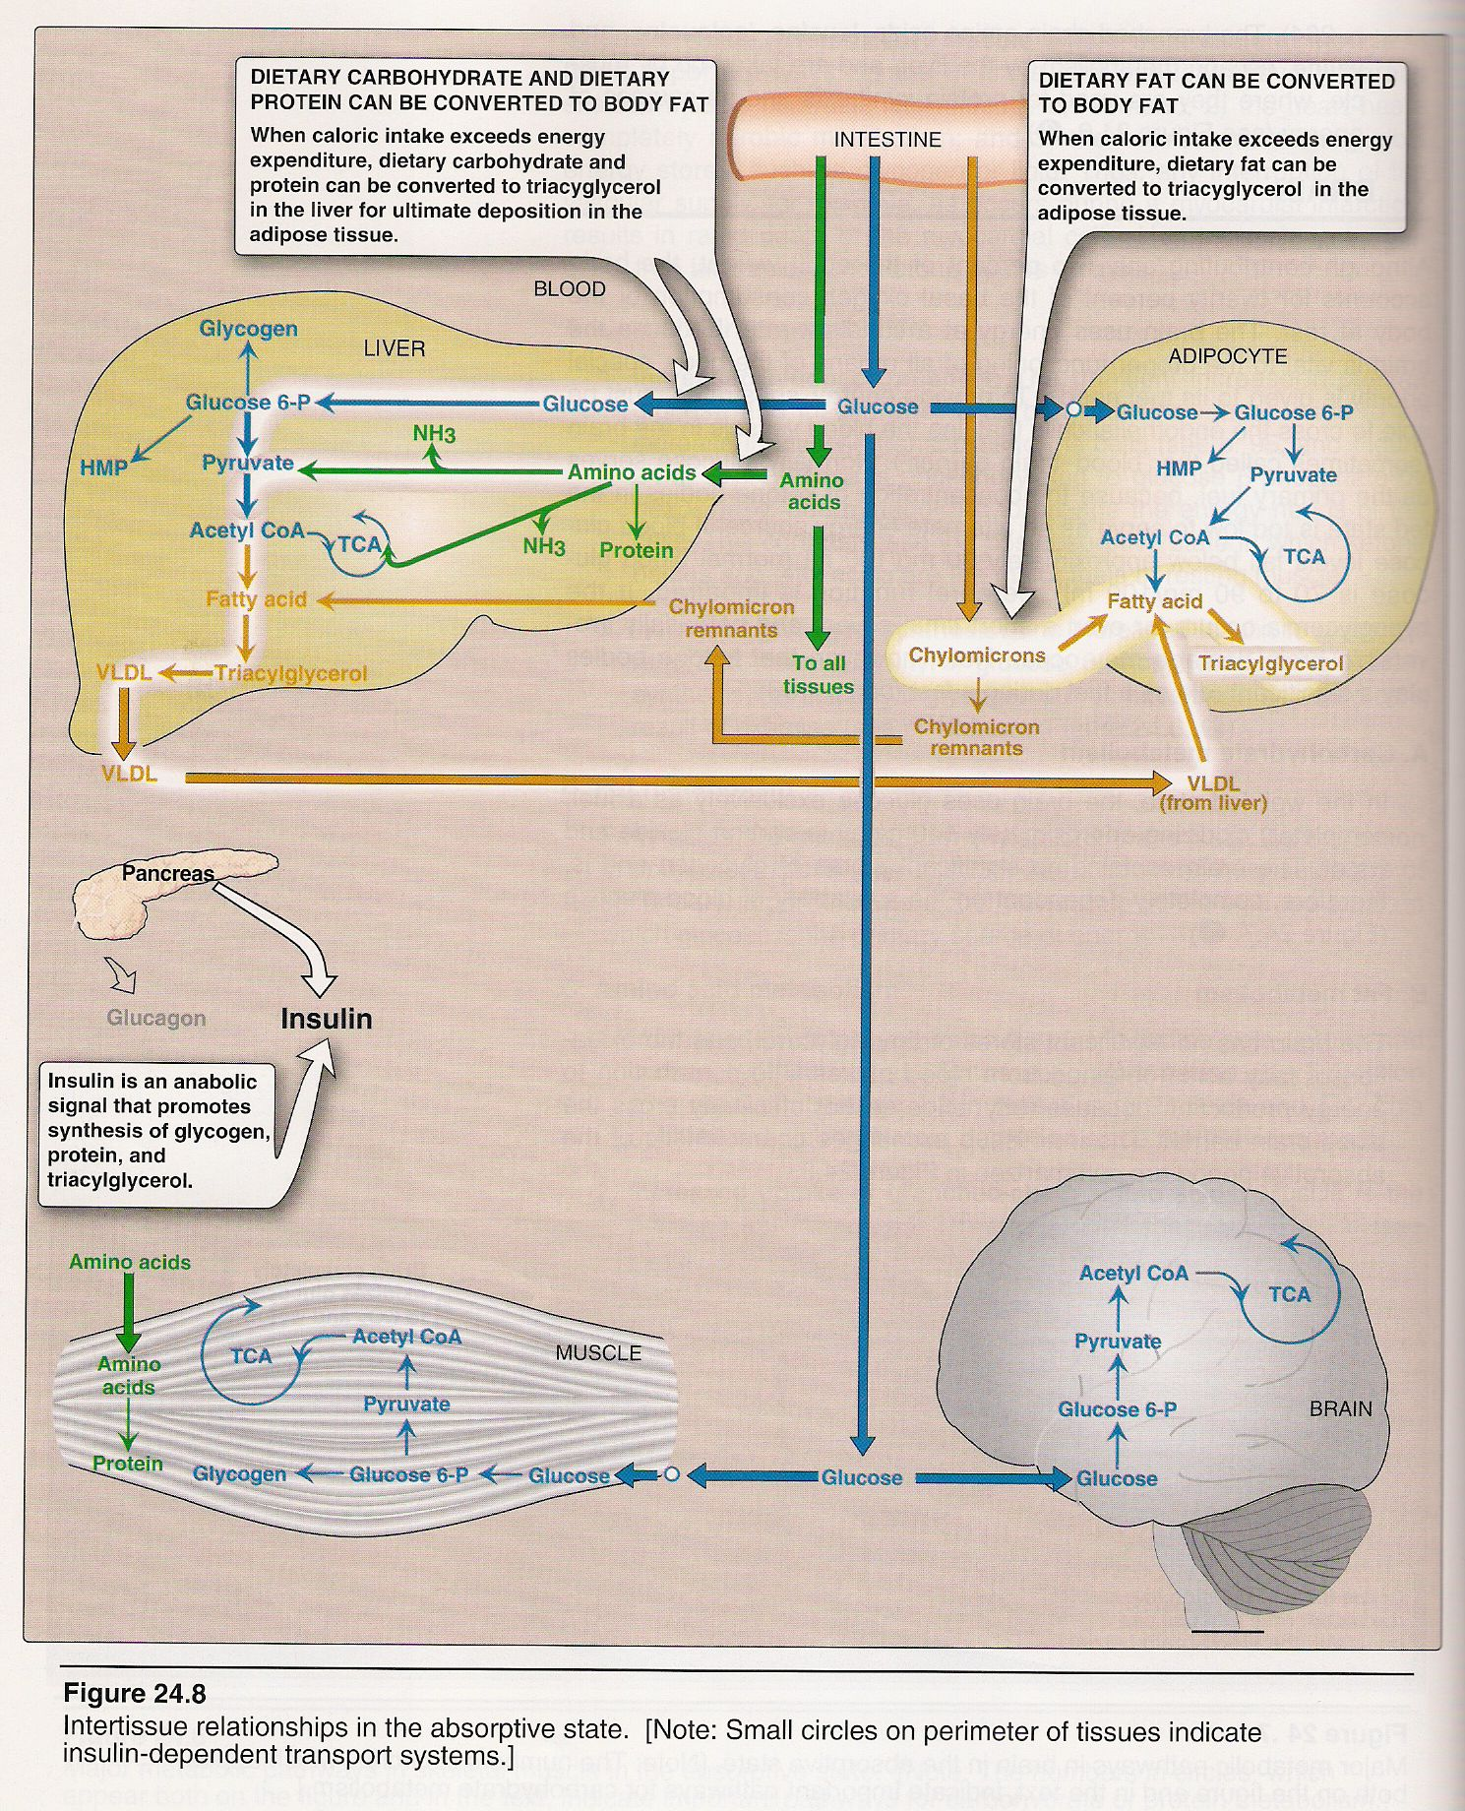
5- Fate of dietary glucose in the brain:
9.
In the well-fed state, the brain uses glucose exclusively as a fuel, completely oxidizing (about 140g/day) to carbon dioxide and water. The brain contains no significant stores of glycogen and therefore, completely dependent on the availability of blood glucose.

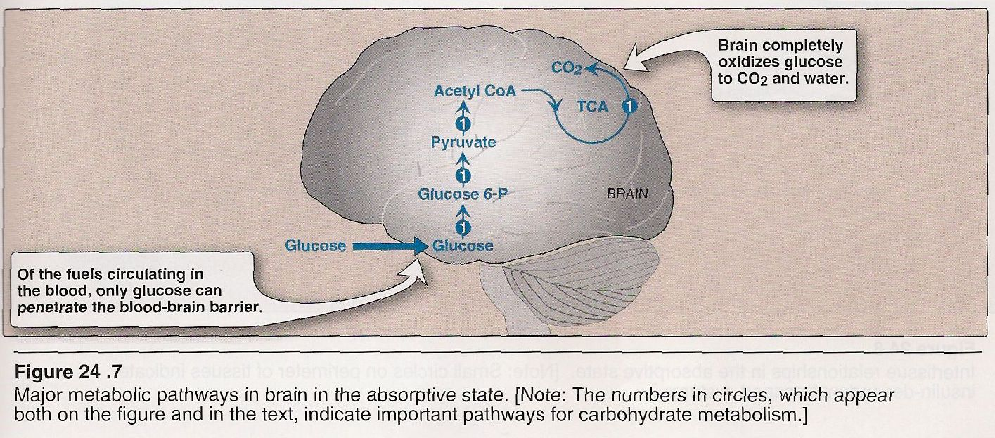
8.

6- Return of blood glucose to fasting levels:
A- The uptake of dietary glucose causes blood glucose to decrease.
B-By 2 hours after a meal, blood glucose has returned to the fasting level of
( 5 mmol/l or 80-100 mg/dl).

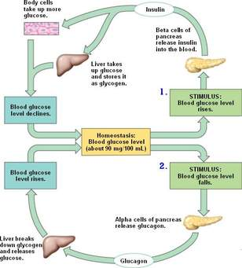

Blood glucose levels in the fasting state:
Fasting may result from inability to obtain food, from the desire to lose weight rapidly, or in clinical situations in which an individual cannot eat because of trauma, surgery, burns and so forth. The decreased availability of circulating substrates makes the period of nutrient deprivation a catabolic period characterized by degradation of triacylglycerol, glycogen and protein.

1- Changes in insulin and glucagon levels:
During fasting, insulin levels decrease and glucagon levels increase.

2- Liver in fasting:
a- Stimulation of glycogenolysis: the increased levels of glucagon stimulate glycogenolysis and begin to supply glucose to the blood.
Liver glycogen is nearly exhausted after (10-18) hours of fasting; therefore, hepatic glycogenolysis is a transient response to early fasting.
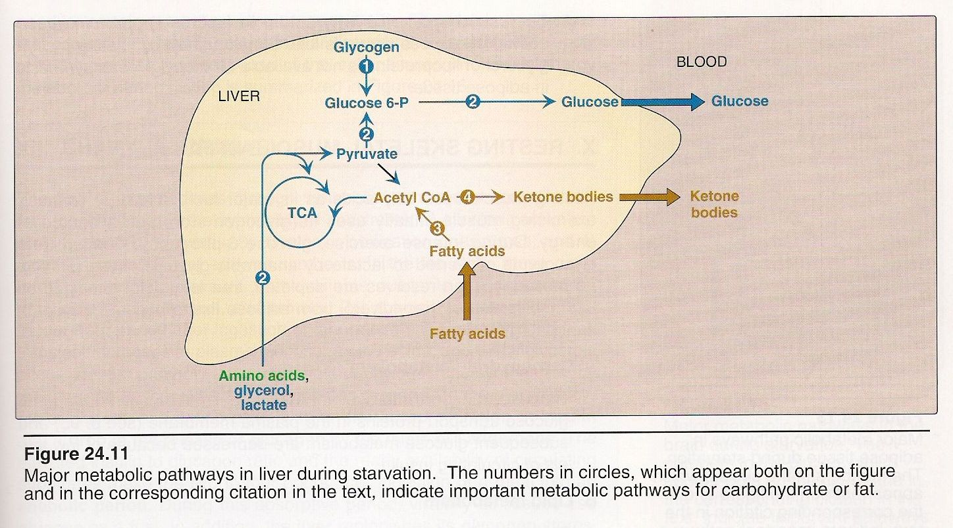
10.
b- Stimulation of gluconeogenesis: Gluconeogenesis begins (4-6) hours after the last meal and becomes fully active as stores of liver glycogen are depleted. Gluconeogenesis plays an essential role in maintaining blood glucose during both overnight and prolonged fasting.
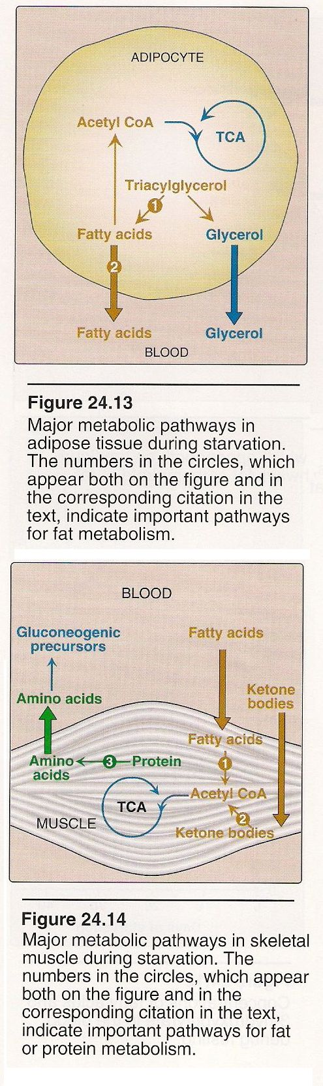
11.
12.
3- Adipose tissue in fasting:
Low levels of insulin leads to a decrease in fatty acid and triacylglycerol synthesis, fasting stimulate lipolysis.
a- During fasting, the breakdown of adipose triacylglycerol, is stimulated, and F.A and glycerol are released into the blood.
b- Glycerol is a source of carbon for gluconeogenesis in the liver.

4- Resting skeletal muscle in fasting.
Low levels of insulin caused a depressed in glucose metabolism. Resting muscle uses F.A as its major fuel source, while exercising muscle uses glycogen stores as a source of energy.

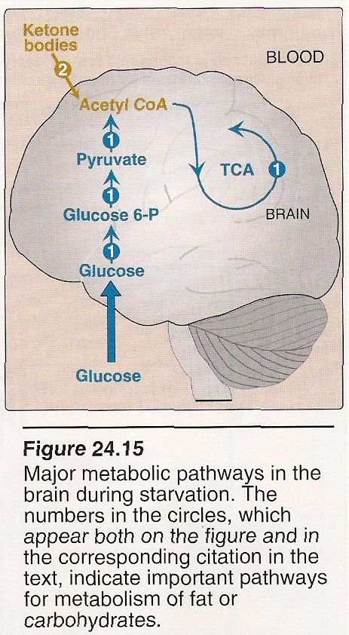
13.
5- Brain in fasting:
During the first days of fasting, the brain continues to use glucose exclusively as a fuel.
In prolonged fasting (greater than 2-3 weeks), plasma ketone bodies, reach significantly elevated levels, are used in addition to glucose as a fuel by the brain.

Blood glucose levels during prolonged fasting (starvation).

- Even after (5-6) weeks of starvation, blood glucose levels are still in the range of (65mg/dL).
- Changes in fuel utilization by various tissues prevent blood glucose levels from decreasing during prolonged fasting.
1- The levels of ketone bodies rise in the blood, and the brain uses ketone bodies for energy, decreasing its utilization of blood glucose.
2- The rate of gluconeogenesis and, therefore, urea production by the liver decreases.
3- Muscle protein is spared: less muscle protein is used to provide amino acids for gluconeogenesis.
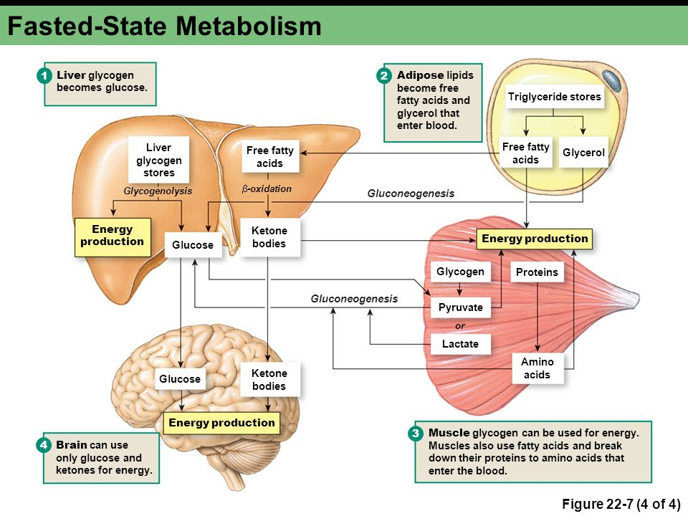
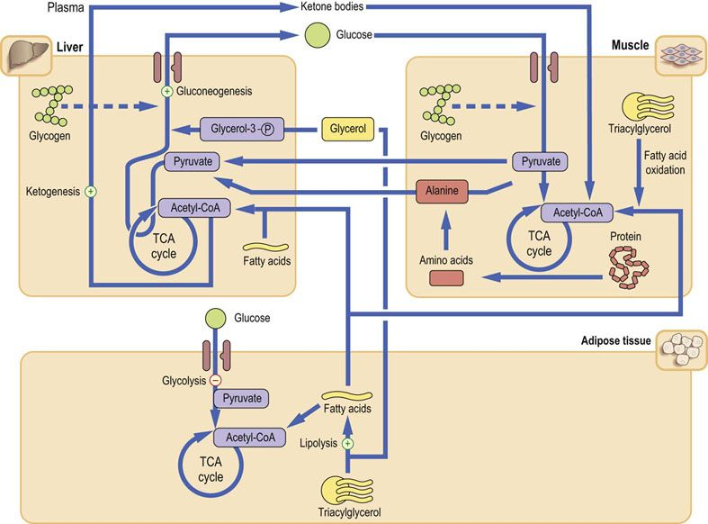
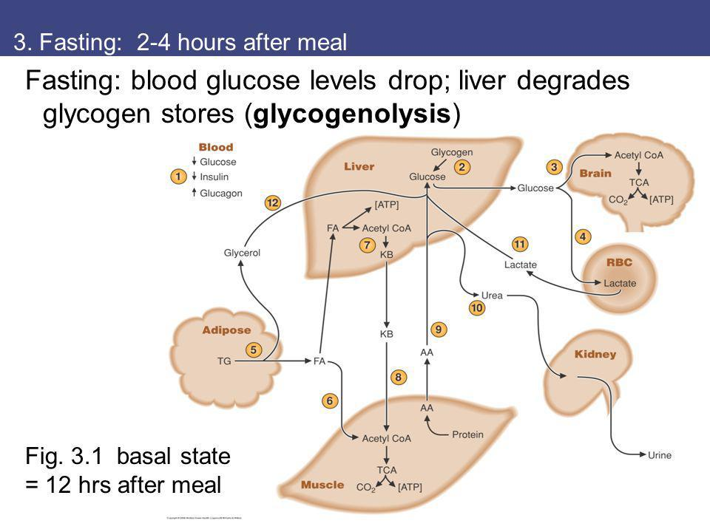

Blood glucose levels during exercise.
During exercise, blood glucose is maintained by essentially the same mechanisms that are used during fasting.
1- Use of endogenous fuels.
a- As the exercising muscle contracts, ATP is utilized.

b- ATP is regenerated initially from creatine phosphate.

c- Muscle glycogen is oxidized to produce ATP. The hormone epinephrine causes the stimulation of glycogenolysis.

2- Use of fuels from the blood.
a- As blood flow to the exercising muscle increases, blood glucose and fatty acids are taken up and oxidized by muscle.

b- As blood glucose levels begin to decreases, the liver, by the processes of glycogenolysis and gluconeogenesis, acts to maintain blood glucose levels.

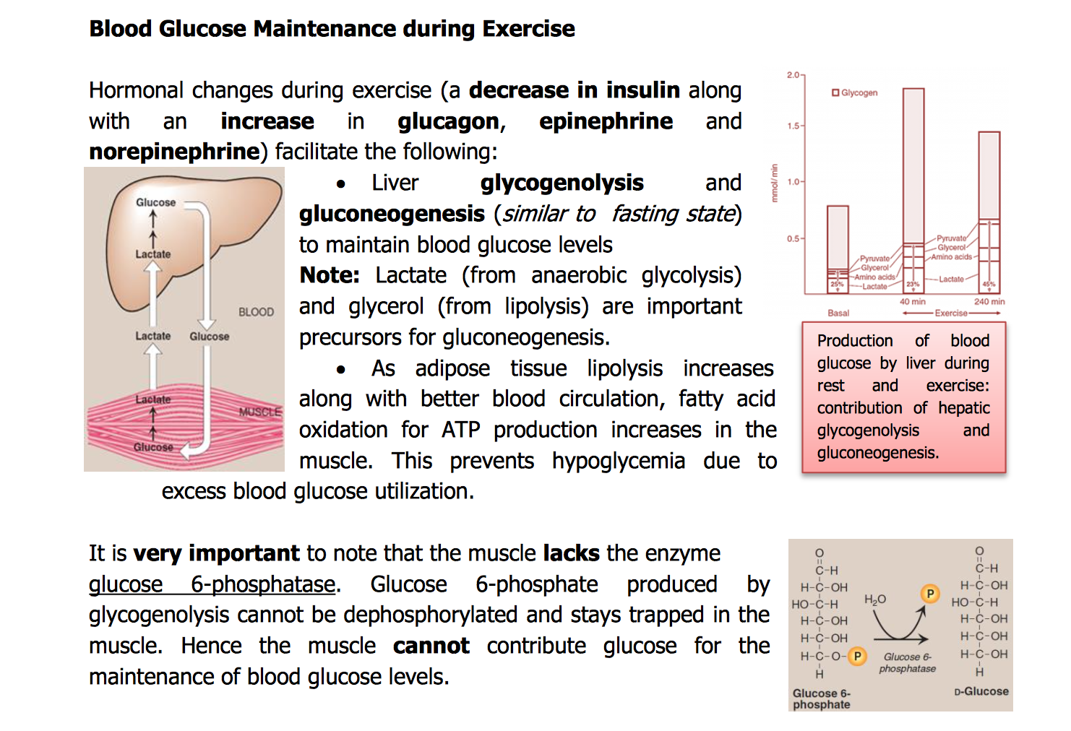

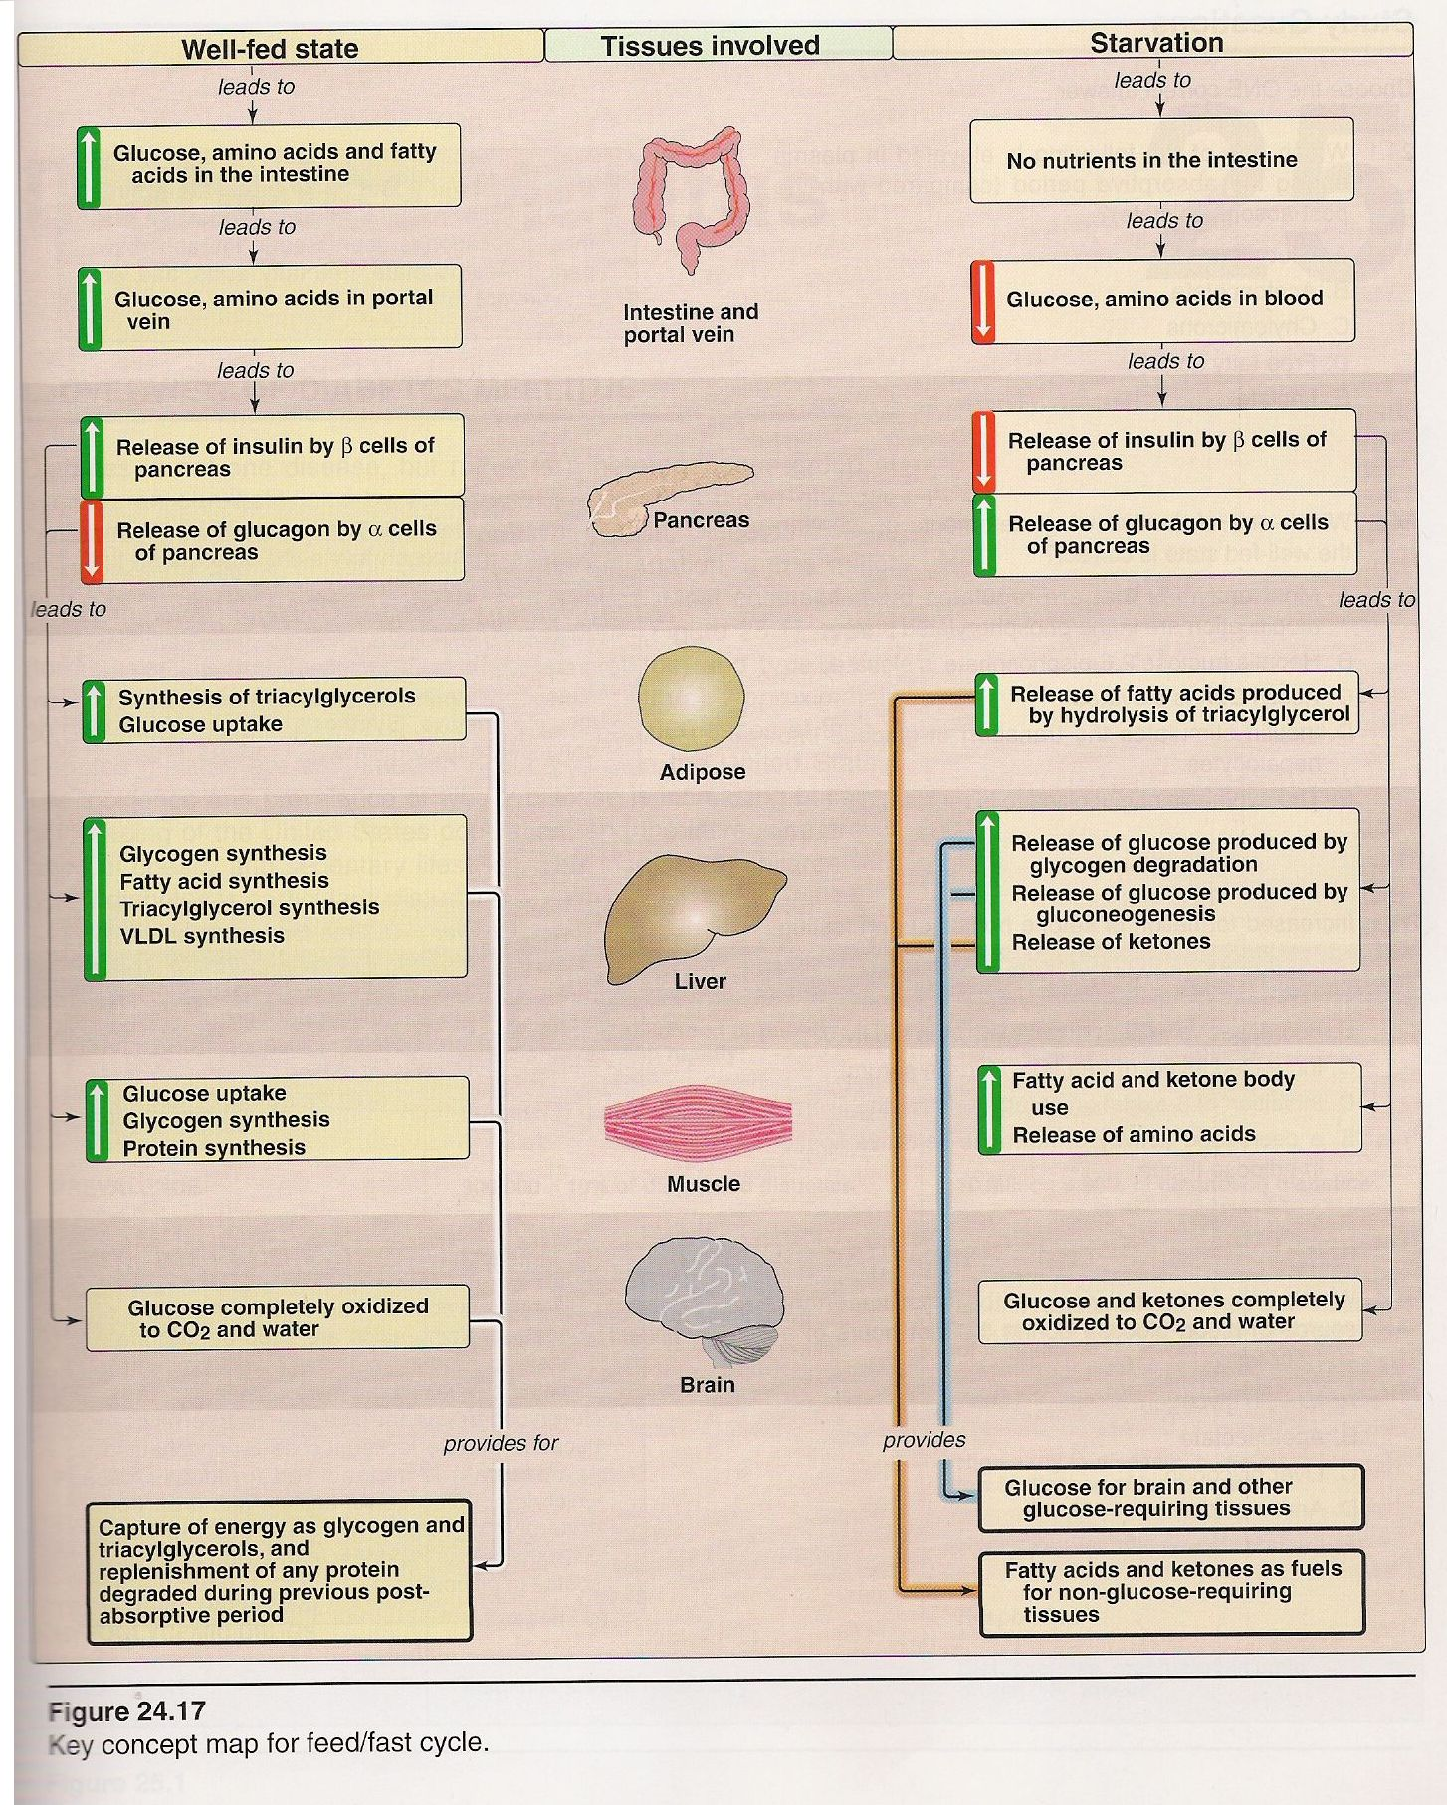
15.

