Autonomic Nervous System Dr.hayder al-kuraishy Lec.1
The autonomic nervous system consists of three main anatomical divisions: sympathetic, parasympathetic and enteric nervous systems. The sympathetic and parasympathetic systems provide a link between the central nervous system and peripheral organs. The enteric nervous system comprises the intrinsic nerve plexuses of the gastrointestinal tract, which are closely interconnected with the sympathetic and parasympathetic systems.
The main actions of ANS are:
- Contraction and relaxation of vascular and visceral smooth muscle
- All exocrine and certain endocrine secretions
- The heart beat
- Energy metabolism, particularly in liver and skeletal muscle.
A degree of autonomic control also affects many other systems, including the kidney, immune system and somatosensory system. The autonomic efferent pathway consists of two neurons arranged in series, whereas in the somatic motor system a single motor neuron connects the central nervous system to the skeletal muscle fiber. The two neurons in the autonomic pathway are known, respectively, as preganglionic and postganglionic.
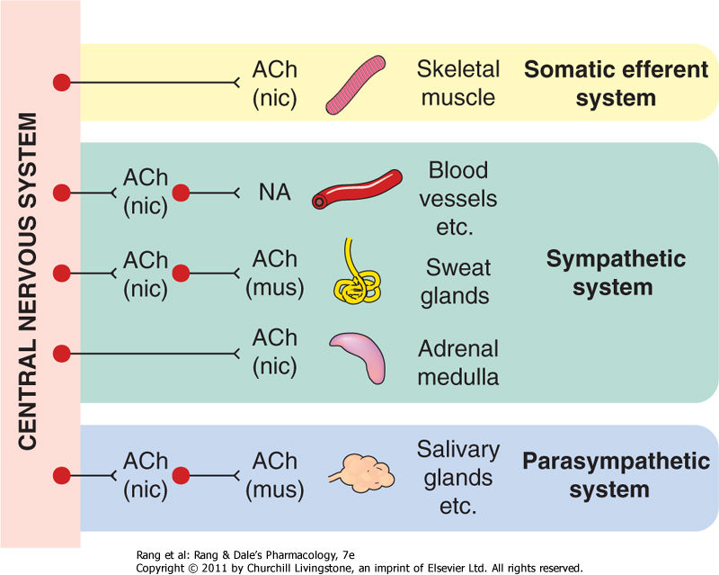
The only exception to the two-neuron arrangement is the innervation of the adrenal medulla. The catecholamine-secreting cells of the adrenal medulla are, in effect, modified postganglionic sympathetic neurons, and the nerves supplying the gland are equivalent to preganglionic fibres.
The enteric nervous system consists of the neurons whose cell bodies lie in the intramural plexuses in the wall of the intestine. Some enteric neurons function as mechanoreceptors or chemoreceptors, providing local reflex pathways that can control gastrointestinal function without external inputs. The enteric nervous system is pharmacologically more complex than the sympathetic or parasympathetic systems, involving many neuropeptide and other transmitters (such as 5-hydroxytryptamine, nitric oxide and ATP).

In some places (e.g. in the visceral smooth muscle of the gut and bladder, and in the heart), the sympathetic and the parasympathetic systems produce opposite effects, but there are others where only one division of the autonomic system operates. The sweat glands and most blood vessels, for example, have only a sympathetic innervation, whereas the ciliary muscle of the eye has only a parasympathetic innervation. Bronchial smooth muscle has only a parasympathetic (constrictor) innervation (although its tone is highly sensitive to circulating adrenaline-acting probably to inhibit the constrictor innervation rather than on the smooth muscle directly). Resistance arteries have a sympathetic vasoconstrictor innervation but no parasympathetic innervation; instead, the constrictor tone is opposed by a background release of nitric oxide from the endothelial cells. There are other examples, such as the salivary glands, where the two systems produce similar, rather than opposing, effects.
The main effects of the autonomic nervous system

Organ | Sympathetic effect | Adrenoceptor typeª | Parasympathetic effect | Cholinoceptor typeª
Heart
Sinoatrial node | Rate ↑ | β₁ | Rate ↓ | M₂
Atrial muscle | Force ↑ | β₁ | Force ↓ | M₂
Atrioventricular node | Automaticity ↑ | β₁ | Conduction velocity ↓ | M₂
 |  |  | Atrioventricular block | M₂
Ventricular muscle | Automaticity ↑ | β₁ | No effect | M₂
 | Force ↑
Blood vessels
Arterioles
Coronary | Constriction | α | No effect | -
Muscle | Dilatation | β₂ | No effect | -
Viscera, skin, brain | Constriction | α | No effect | -
Erectile tissue | Constriction | α | Dilatation | M₃^{b}
Salivary gland | Constriction | α | Dilatation | M₃^{b}
Veins | Constriction | α | No effect | -
 | Dilatation | β₂ | No effect | -
Viscera
Bronchi
Smooth muscle | No sympathetic innervation, but dilated by circulating adrenaline (epinephrine) | β₂ | Constriction | M₃
Glands | No effect | - | Secretion | M₃
Gastrointestinal tract
Smooth muscle | Motility ↓ | α₁, α₂, β₂ | Motility ↑ | M₃
Sphincters | Constriction | α₂, β₂ | Dilatation | M₃
Glands | No effect | - | Secretion | M₃
 |  |  | Gastric acid secretion | M₁
Bladder | Relaxation | β₂ | Contraction | M₃
 | Sphincter contraction | α₁ | Sphincter relaxation | M₃
Uterus
Pregnant | Contraction | α | Variable | -
Non-pregnant | Relaxation | β₂
Male sex organs | Ejaculation | α | Erection | M₃^{b}
Eye
Pupil | Dilatation | α | Constriction | M₃
Ciliary muscle | Relaxation (slight) | β | Contraction | M₃
Skin
Sweat glands | Secretion (mainly cholinergic via M₃ receptors) | - | No effect | -
Pilomotor | Piloerection | α | No effect | -
Salivary glands | Secretion | α, β | Secretion | M₃
Lacrimal glands | No effect | - | Secretion | M₃
Kidney | Renin secretion | β₁ | No effect | -
Liver | Glycogenolysis | α, β₂ | No effect
 | Gluconeogenesis |  |  | -

Transmitters of the autonomic nervous system

- The principal transmitters are acetylcholine (ACh) and noradrenaline.
- Preganglionic neurons are cholinergic, and ganglionic transmission occurs via nicotinic ACh receptors Postganglionic parasympathetic neurons are cholinergic, acting on muscarinic receptors in target organs.
- Postganglionic sympathetic neurons are mainly noradrenergic, although a few are cholinergic (e.g. sweat glands).
- Transmitters other than noradrenaline and acetylcholine (NANC transmitters) are also abundant in the autonomic nervous system. The main ones are nitric oxide and vasoactive intestinal peptide (parasympathetic), ATP and neuropeptide Y (sympathetic).
- All motor nerve fibres leaving the central nervous system release acetylcholine, which acts on nicotinic receptors
- All postganglionic parasympathetic fibres release acetylcholine, which acts on muscarinic receptors.
- All postganglionic sympathetic fibres (with one important exception) release noradrenaline, which may act on either α- or β-adrenoceptors . The exception is the sympathetic innervation of sweat glands, where transmission is due to acetylcholine acting on muscarinic receptors
GENERAL PRINCIPLES OF CHEMICAL TRANSMISSION

  - Dale's principle: A mature neuron releases the same transmitter (or transmitters) at all of its synapses.
2. DENERVATION SUPERSENSITIVITY: after denervation, responds by contracture to much smaller amounts. mechanisms contribute to denervation supersensitivity are:

- Proliferation of receptors
- Loss of mechanisms for transmitter removal.
- Increased postjunctional responsiveness.

3-PRESYNAPTIC MODULATION
The presynaptic terminals that synthesise and release transmitter in response to electrical activity in the nerve fibre are often themselves sensitive to transmitter substances and to other substances that may be produced locally in tissues Such presynaptic effects most commonly act to inhibit transmitter release, but may enhance it. The release of noradrenaline from nearby sympathetic nerve terminals can also inhibit release of acetylcholine. Noradrenergic and cholinergic nerve terminals often lie close together in the myenteric plexus, so the opposing effects of the sympathetic and parasympathetic systems result not only from the opposite effects of the two transmitters on the smooth muscle cells, but also from the inhibition of acetylcholine release by noradrenaline acting on the parasympathetic nerve terminals.. This type of autoinhibitory feedback acts powerfully at noradrenergic nerve terminals.

.

- Cholinergic and noradrenergic nerve terminals respond not only to acetylcholine and noradrenaline, but also to other substances that are released as co-transmitters, such as ATP and neuropeptide Y.
- Presynaptic receptors regulate transmitter release mainly by affecting Ca²⁺ entry into the nerve terminal.
- Transmitter release is inhibited when calcium channel opening is inhibited, or when potassium channel opening is increased.
- Presynaptic regulation by receptors linked directly to ion channels.
3-POSTSYNAPTIC MODULATION
- The slow excitatory effect produced by various mediators, including acetylcholine and peptides such as substance P
- Neuropeptide Y (NPY). enhance the vasoconstrictor effect of noradrenalin,
neuromodulation, involves slower processes (taking seconds to days) than neurotransmission (which occurs in milliseconds).
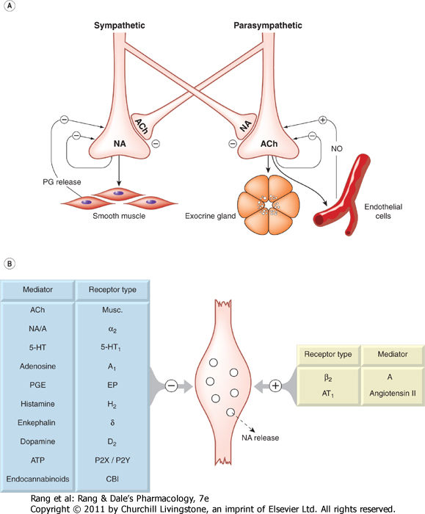
4- CO-TRANSMISSION:
neurons release more than one transmitter or modulator each of which interacts with specific receptors and produces effects the advantages are :

- Longer-lasting effects.
- Differential effects.

