**Assist Professor Dr. Hayder M Al-Kuraishy**

**Cardiac Arrhythmias**

Arrhythmia (a-rhythm) means no rhythm, whereas dysrhythmia (dys-rhythm) means an abnormal heart rhythm. In practice, both terms are used interchangeably to mean an abnormal or irregular heart beat.

Cardiac arrhythmias are a frequent problem in clinical practice, occurring in up to 25% of patients treated with digitalis, 50% of anesthetized patients, and over 80%of patients with acute myocardial infarction .Arrhythmias may require treatment because rhythms that are too rapid, too slow, or asynchronous can reduce cardiac output.

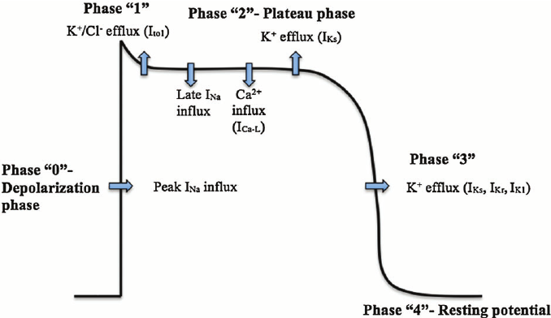

**Mechanisms of Cardiac Arrhythmias:**

1. **Abnormal impulse generation**
   1. **Enhanced Automaticity:**

Occur in cells that normally display spontaneous diastolic depolarization (the sinus and AV nodes and the His–Purkinje system).

* 1. **Triggered Automaticity**:

Normal cardiac action potential interrupted or followed by an abnormal depolarization

Two major forms of triggered rhythms are recognized:

* 1. Early after depolarization (EAD)

Occurs when there is marked prolongation of the cardiac action potential as in low extracellular K+ & use of certain drugs that prolong action potential duration.

2) Delayed after depolarization (DAD): Occurs in intracellular Ca2+ overload as in myocardial ischemia & digitalis intoxication

* 1. **Abnormal Automaticity**

Automatic behavior occur in sites that ordinarily lack spontaneous pacemaker activity; e.g., depolarization of ventricular cells (e.g., by ischemia) may produce such "abnormal" automaticity.

1. **Abnormal impulse conduction**
   1. Conduction block (heart block)
   2. Re-entry

1) Anatomically defined re-entry: Occur when impulses propagate by more than one pathway between two points in the heart, and those pathways have heterogeneous electrophysiological properties.

* 1. Functionally defined re-entry: Occur in the absence of a distinct, anatomically defined pathway Occur when ischemia or other electrophysiological perturbations result in an area of sufficiently slow conduction in the ventricle, impulses exiting from that area may find the rest of the myocardium re-excitable, in which case arrhythmia may ensue.



**Treatment of Cardiac Arrhythmias**

* 1. Nonpharmacological treatment Acute
     + - Vagal manoeuvres
       - DC cardioversion Prophylaxis
       - Radiofrequency ablation
       - Implantable defibrillator
       - Implantation of artificial pacemaker
  2. Pharmacological treatment (Antiarrhythmic drugs)

These drugs classified according to Vaughan-Williams classification :-

1. **Class** sodium channel blockers

**Ia** Disopyramide, procainamide, quinidine

**Ib** Lidocaine, mexiletine

**Ic** Flecainide, propafenone

1. **Class II** β-Adrenoceptor blocking drugs, e.g. atenolol, propranolol, esmolol
2. **Class III** potassium channel blockers e.g. amiodarone, sotalol
3. **Class IV** Calcium-channel blockers, e.g. verapamil, diltiazem
4. **Other** Adenosine, digoxin

**Na+ channel blockers (class I)**

Block Na channels →slows the rate of rise of phase 0 of the action potential thus ↓ maximal rate of depolarization (Vmax) → ↓conduction velocity (CV) & ↓ excitability.

* Inhibit spontaneous diastolic depolarization of automatic tissue → ↓rate of discharge.
* Are state dependent (i.e., selectively depress tissue that is frequently depolarized, e.g., fast tachycardia).

**Class1a**: quinidine, procainamide& disopyramide.

* + Act by blocking the sodium channel for an intermediate duration of time moreover they also block k+ channels
  + ↑ APD.

[https://upload.wikimedia.org/wikipedia/commons/thumb/b/ba/Action_potential_class_Ia.svg/120px-Action_potential_class_Ia.svg.png](https://en.wikipedia.org/wiki/File:Action_potential_class_Ia.svg)

**Class 1b**: lidocaine , mexiletine, tocainide &phenytion.

-Act by blocking the sodium channel for short duration of time

* + No effect on CV in atria and AVN.
  + ↓ APD ( shortening repolarization).
* [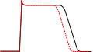](https://en.wikipedia.org/wiki/File:Action_potential_Class_Ib.svg)

**Class 1c**: Flecainide , encainide & propafenone.

* + Act by blocking the sodium channel for long duration of time
  + Marked ↓ in CV.
  + No effect on APD
* [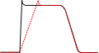](https://en.wikipedia.org/wiki/File:Action_potential_class_Ic.svg)

**Quinidine (class Ia)**

**Mechanism of Action**

* + - Moderate block of activated Na+ channel
    - Block K + channel
    - Atropine like action
    - α- blocking effect

**Actions**

* + **Heart**
    - 1. Anti-Arrhythmic
         * ↓ Excitability
         * Slight ↓Conductivity (by direct effect)
         * Long Refractory Period
    - ↓ Automaticity
  1. -ve inotropic effect
  2. E. C. G.:
     + - Long P-R & Q-T intervals especially in large dose.
       - Long Q.R.S
* **Other Actions**
  1. Local anaesthetic action: block of Na+ channels
  2. Anti-malarial
  3. Skeletal muscle relaxant

**Side effects**

1. Cardiac depression
2. Paradoxical tachycardia
3. Quinidine syncope and fainting
4. Cinchonism: (dose related) Headache, blurring of vision, tinnitus, deafness , nausea, vomiting .
5. G.I. : esp. diarrhea. Common SE .
6. Hypotension : esp. if used IV due to alpha-blocking action and myocardial depression; avoid IV

**Procainamide (class Ia)**

* Similar to Quinidine. However, with no anticholinergic/ α-AR blockade activity
* Rarely used due to development of systemic lupus erythematosis .

**Disopyramide (class Ia)**

* + Similar to quinidine with marked anticholinergic & -ve inotropic effects.
  + SE. Glaucoma, Prostatic hyperplasia

**Lidocaine (class IB)**

* **Mechanism of Action**
  + Block mainly inactivated Na+ channel
  + May activate K + channel
  + No effect on atrial or AVN conduction → ineffective in supraventricular arrhythmias (AF, Flutter, SVT).
  + Acts mainly on inactivated Na channels → selective on chronically depolarized ventricular tissue in myocardial ischemia and digitalis toxicity.
* Given parentally only (has extensive hepatic metabolism).

**Actions**

* + **Heart**
    - Anti-Arrhythmic
      * ↓ Excitability
      * ↓Conductivity
      * ↓ Refractory Period.
      * ↓ Automaticity
    - In therapeutic doses:
      * No atropine like effect
      * No effect on contractility
      * No effect on SAN, little effect on AVN
      * No effect on Bl. pr.
  + **Other Actions**

Local anaesthetic action: block of Na+ channels

**Uses:**

Drug of 1st choice for VA including those complicating acute myocardial infarction (MI).

Also useful for V. arrhythmias of digoxin toxicity .

**Toxicity:**

C.N.S.: Paraesthesia, drowsiness, tremors

**Mexiletine & Tocainide (class IB)**

Given orally in chronic treatment of ventricular arrhythmias of previous myocardial infarction.

Tocainide can cause pulmonary toxicity.

**Phenytion (class IB)**

Used in digitalis toxicity.

**Flecainide (class IC)**

* **Mechanism of Action**
* Marked block of activated Na + channel so it markedly ↓ Excitability& conductivity

➢ Its high potency and selectivity for cardiac Na+ channels with slow dissociation of the drug from the Na+ channels.

* Uses:
  + in life-threatening ventricular arrhythmia
* Pro-arrythmogenic → ↑ mortality, AV block, HF; so are restricted to case not responding to other drugs (class IC is of serious toxicity).

**β-Adrenoceptor blocking drugs( Class II)**

* + They are classical β-adrenoceptor antagonists such as propranolol, atenolol, metoprolol or the short-acting substance esmolol.
  + **Mechanism of Action**
    - Their antiarrhythmic properties is by their blockade to β-AR receptors and direct membrane stabilizing effects
    - Since sympathetic nervous system increase SA node automaticity, increase conduction velocity at AV node and stimulate aberrant pacemaker activity

(ectopic foci) so through β1-blockade→ ↓SA rate, ↓AV conduction and inhibit aberrant pacemaker activity

**Uses**

* + - * Supraventriculr tachycardia to control ventricular rate
      * Esmolol (IV short acing used during surgery) Adverse effects
        1. Bradycardia, ↓BP
        2. Bronchspasm
        3. Fatigue
        4. Sleep disturbance
        5. Depression

**Potassium channel blockers (Class III)**

**Amiodarone (class III)**

Heavily iodinated drug**.**

* **Mechanism of Action**
* Block K channels delaying repolarization →prolongation of APD and ERP.
* Na channel & a weak Ca channel blocker and β receptor blocker (I, IV & II respectively).
* Slows sinus rate and AVN conduction.
* Vasodilator on coronary and peripheral vessels.

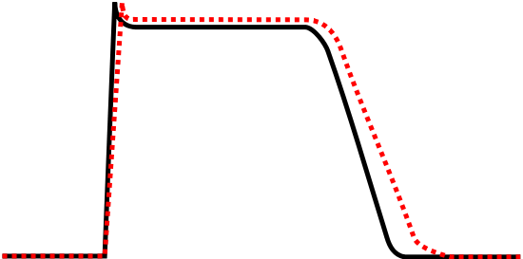

**Therapeutic uses (broad spectrum):**

1- Treatment &prophylaxis of SV arrhythmias (especially AF). 2- WPW syndrome.

3- Ventricular arrhythmias (reserved for refractory cases).

**Adverse effects:**

➢ Serious due to long half life →cumulative (t1/2is many weeks with delayed onset).

1- Alteration of thyroid function

2- Precipitation of corneal deposits.

3- Photosensitivity.

4- Pulmonary infiltrates and fibrosis.

5- AV block, sinus bradycardia.

**Dronedarone (class III**)

* It lacks iodine and was designed to be less lipophilic than amiodarone in hopes of reducing thyroid and pulmonary toxicities.
* Its elimination t1/2 is shorter than that of amiodarone
* It improved survival in patients with atrial fibrillation

**Sotalol (class III)**

* Nonselective beta blocker with additional K+ blocking effect
* Unchanged drug excreted through kidney
* Decrease the rate of sudden death following acute MI, because it has the ability to suppress ectopic beats and to reduce myocardial oxygen demand.
* Sotalol have strong antifibrillatory effects, particularly in ischemic myocardium

**Ibutilide (class III)**

* Prolong APD by blocking delayed rectifier K+ current.
* Used IV for acute conversion of atrial flutter (more effective) or fibrillation to normal sinus rhythm.
* Rapidly eliminated by liver; t ½ is 6 h .
* It prolongs QT interval, and may cause torsade de pointes.

**Dofetilide (class III)**:

* similar to ibutilide, but is orally effective.
* Eliminated by kidney.
* It is useful to maintain sinus rhythm after conversion of atrial fibrillation.

**Calcium-channel blockers** (**Class IV)**

**Verapamil and Diltiazem**

* **Mechanism of Action**
* They block Ca++ channel, thus their effect is more marked in tissues whose activation depends exclusively on Ca++ current such as SA and AV nodes
* ↓conduction velocity ↑ERP
* **Uses**
* Supraventricular tachycardia ( to control Vent rate)
* angina and hypertension

**Adverse effects**

Bradycardia, ↓BP, edema, constipation

**Adenosine**

* **Mechanism of Action**
* Stimulates Adenosine receptors (A1) in AV node so it reduces calcium

currents , hyperpolarize AV node , and thus produces AV node block. ➢ Also stimulates K channels in atria and shorten ERP of atrium.

t½ is very short acting (~10 sec) due to rapid uptake by cells including endothelium and inactivation by adenine deaminase. Dose may be repeated after 1 min

**Uses**

* + Drug of 1st choice for control of PSVT due to AV node re-entry (given IV).

**Adverse effects**

* + Sinus bradycardia, AV blocks, ↓ BP
  + Chest tightness (bronchospasm)
  + Flushing (vasodilatation ˝A2˝), headache

إننا نكتب الروايات لنقتل الأبطال لا غير، وننتهي من الأشخاص الذين أصبح وجودهم عبئا على حياتنا، فكلّما كتبنا عنهم فرغنا منهم وامتلأنا بهواء نظيف.